Theoretical Basis for Meteosat SEVIRI-IASI
Inter-Calibration Algorithm for GSICS

Tim Hewison (EUMETSAT)

Version: 2010-05-28

Incorporating documentation of Prototype Implementation (v0.3)
and draft ATBD for Operational Implementation (v0.4)

Introduction
The Global Space-based Inter-Calibration System (GSICS) aims to inter-calibrate a diverse range of satellite instruments to produce corrections ensuring their data are consistent, allowing them to be used to produce globally homogeneous products for environmental monitoring. Although these instruments operate on different technologies for different applications, their inter-calibration can be based on common principles: Observations are collocated, transformed, compared and analysed to produce calibration correction functions, transforming the observations to common references. To ensure the maximum consistency and traceability, it is desirable to base all the inter-calibration algorithms on common principles, following a hierarchical approach, described here.

This algorithm is defined as a series of generic steps revised at the GSICS Data Working Group web meeting (November 2009):
- Subsetting
- Collocating
- Transforming
- Filtering
- Monitoring
- Correcting
Each step comprises a number of discrete components, outlined in the Contents.

Each component can be defined in a hierarchical way, starting from purposes, which apply to all inter-calibrations, building up to implementation details for specific instrument pairs:
- Describe the purpose of each component in this generic data flow.
- Provide different options for how these may be implemented in general.
- Recommend procedures for the inter-calibration class (e.g. GEO-LEO).
- Provide specific details for each instrument pair (e.g. SEVIRI-IASI).

Each component is defined independently and may exist in different versions. The implementation of the algorithm need only follow the overall logic – so the components need not be executed strictly sequentially. For example, some parts may be performed iteratively, or multiple components may be combined within a single loop in the code.

GSICS aims to define a “baseline” algorithm by identifying one version of each component, against which the performance of other versions may be compared.
Masks, flags, …
SRFs, PSFs, …
2. Collocating
3. Transforming
4. Filtering
6. Correcting
GSICS Correction
Archive ~1 month
Archive ~1 month
Archive ~ 1 year
Archive ~ 1 year
Correction Coeffs
Analysis Data
Comparison Data
Collocated Data
Subset MON Data
Subset REF Data
MON Lvl 1 Data
Re-Cal Data
Plots and Tables
1. Subsetting
Orbital Prediction
Colloc. Criteria
MON Level 1 Data
REF Level 1 Data
Reports
5. Monitoring
7. Diagnosing
Collocation
Transformation
Analysis
Products
Users

Figure 1: Diagram of generic data flow for inter-calibration of monitored (MON) instrument with respect to reference (REF) instrument

EUMETSAT’s Meteosat SEVIRI-IASI Inter-Calibration Algorithm
This document forms the Algorithm Theoretical Basis Document (ATBD) for the inter-calibration of the infrared channels of SEVIRI on the Geostationary (GEO) Meteosat Second Generation satellites with the Infrared Atmospheric Sounding Interferometer (IASI) on board LEO Metop satellites. This document includes different versions of each component of the SEVIRI-IASI specific algorithm, which are labelled with a version number. This identifies whether they were implemented in the development code (v0.1/0.2), prototype code (v0.3) or are being proposed for the operational code (v0.4).

v0.1 is the post facto designation of the initial version of this ATBD, which was presented at the GSICS Research Working Group (GRWG-II, February 2007) and articles in the GSICS Quarterly newsletter (König, 2007 and Hewison, 2008a). It was described in detail in a EUMETSAT internal report [Hewison, 2008b], which was later extended to include a physical model to explain the changing bias found in one of Meteosat’s channels [Hewison and König, 2008].

v0.2 generally refers to development code that has not been fully implemented.

v0.3 designates the prototype of an operational routine developed at EUMETSAT. This is implemented in the IDL suite ICESI (Inter-Calibration EUMETSAT SEVIRI-IASI), which is documented in Annex A. This allows routine, automatic processing of data delivered by standing orders set up on EUMETSAT’s Unified Meteorological Archive and Retrieval Facility (U-MARF) after conversion to netCDF formats. Many components of the inter-calibration have been revised when coding this algorithm.

v0.4 incorporates comments from other GSICS partners and attempts to align EUMETSAT’s prototype ATBD towards those of our partner organisations. Once reviewed, it is intended that revised versions of this document are issued to document the prototype and operational ATBDs – stripping out the irrelevant parts for clarity. (Unless mentioned otherwise, the latest version of higher level parts of the algorithm is assumed when defining specific details.)

Contents

1. Subsetting 5
1.a. Select Orbit 6
2. Find Collocations 8
2.a. Collocation in Space 9
2.b. Concurrent in Time 11
2.c. Alignment in Viewing Geometry 12
2.d. Pre-Select Channels 14
2.e. Plot Collocation Map 15
3. Transform Data 16
3.a. Convert Radiances 17
3.b. Spectral Matching 18
3.c. Spatial Matching 21
3.d. Viewing Geometry Matching 22
3.e. Temporal Matching 23
4. Filtering 24
4.a. Uniformity Test 25
4.b. Outlier Rejection 26
4.c. Auxiliary Datasets 27
5. Monitoring 28
5.a. Define Standard Radiances (Offline) 29
5.b. Regression of Most Recent Results 30
5.c. Bias Calculation 33
5.d. Consistency Test 34
5.e. Trend Calculation 35
5.f. Report Results 36
Flow Summary of Step 5 for SEVIRI-IASI 37
6. GSICS Correction 38
6.a. Define Smoothing Period (Offline) 39
6.b. Smooth Results 40
6.c. Re-Calculate Calibration Coefficients 41
Annex A Inter-Calibration (EUMETSAT) of SEVIRI-IASI (ICESI) v0.3 45

Subsetting
To be completed by a willing volunteer...

Acquisition of raw satellite data is obviously a critical first step in an inter-calibration method based on comparing collocated observations. To facilitate the acquisition of data for the purpose of inter-comparison of satellite instruments, prediction of the time and location of collocation events is also important.

Archive ~1 month
Subset MON Data
Subset REF Data
1. Subsetting
Orbital Prediction
MON Level 1 Data
REF Level 1 Data
Figure 2: Step 1 of Generic Data Flow, showing inputs and outputs.
MON refers to the monitored instrument. REF refers to the reference instrument.

Select Orbit

Purpose
We first perform a rough cut to reduce the data volume and only include relevant portions of the dataset (channels, area, time, viewing geometry). The purpose is to select portions of data collected by the two instruments that are likely to produce collocations. This is desirable because typically less than 0.1% of measurements are collocated. The processing time is reduced substantially by excluding measurements unlikely to produce collocations.
Data is selected on a per-orbit or per-image basis. To do this, we need to know how often to do inter-calibration – which is based on the observed rate of change and must be defined iteratively with the results of the inter-calibration process (see 5.f).

General Options
      - The simplest, but inefficient approach is “trial-and-error”, i.e., compare the time and location of all pairs of files within a given time window.
      - A more sophisticated option is to use the observed orbital parameters (such as the Two Line Elements or TLE) with orbit prediction software such as Simplified General Perturbations Satellite Orbit Model 4 (SGP4). For instrument that has fixed or stable scan pattern such that the measurement time and location are determined by the satellite locations, this is very effective.

Infrared GEO-LEO inter-satellite/inter-sensor Class
      - For inter-calibrations between geostationary and sun-synchronous satellites, the orbits provide collocations near the GEO Sub-Satellite Point (SSP) within fixed time windows every day and night. In this case, we adopt the simple approach outlined in general option v0.1.
We define the GEO Field of Regard (FoR) as an area close to the GEO Sub-Satellite Point (SSP), which is viewed by the GEO sensor with a zenith angle less than a threshold. Wu [2009] defined a threshold angular distance from nadir of less than 60° based on geometric considerations, which is the maximum incidence angle of most LEO sounders. This corresponds to ≈ ±52° in latitude and longitude from the GEO SSP. The GEO and LEO data is then subset to only include observations within this FoR within each inter-calibration period.

Mathematically, the GEO FoR is the collection of locations whose arc angle (angular distance) to nadir is less than a threshold or, equivalently, the cosine of this angle is larger than min_cos_arc. We chose the threshold min_cos_arc = 0.5, i.e., angular distance less than 60 degree.

Computationally, with known Earth coordinates of GEO nadir G (0, geo_nad_lon) and granule centre P (gra_ctr_lat, gra_ctr_lon) and approximating the Earth as being spherical, the arc angle between a LEO pixel and LEO nadir can be computed with cosine theorem for a right angle on a sphere (see Figure 3):
Equation 1 $\text{cos}\left(\text{GP}\right)=\text{cos}\left({\text{gra}}_{{\text{ctr}}_{\text{lat}}}\right)\text{cos}\left({\text{geo}}_{{\text{nad}}_{\text{lon}}}−{\text{gra}}_{{\text{ctr}}_{\text{lon}}}\right)$
If the LEO pixel is outside of GEO FoR, no collocation is considered possible. Note the arc angle GP on the left panel of Figure 3, which is the same as the angle ∠GOP on the right panel, is smaller than the angle ∠SPZ (right panel), the zenith angle of GEO from the pixel. This means that the instrument zenith angle is always less than 60 degrees for all collocations.

6.63R_{e}
P
G
G
P
R_{e}
Z
O
N
E
S
Figure 3: Computing arc angle to satellite nadir and zenith angle of satellite from Earth location

SEVIRI-IASI specific
      - For SEVIRI, the GEO FoR is further reduced to include only data within ±30° lat/lon of the SSP. A single Metop overpass is selected with a night-time equator crossing closest to the GEO SSP. The IASI data within this overpass is then geographically subset to only include data within this smaller GEO FoR by applying time filtering. This selection was performed manually and attempted every 10 days.
      - Never implemented.
      - As v0.1, except that a fixed GEO time frame is taken every day at the nominal LEO local equator crossing time (21:30) and the FoR is extended to ±35° in the North-South direction. This is implemented as a standing order from EUMETSAT’s Unified Meteorological Archive and Retrieval Facility (U-MARF) delivering data in NetCDF format every night, as described in Annex A.
      - Both Meteosat and IASI data shall be geographically subset to cover the area of ±52° N/S and ±52° E/W of the nominal Meteosat SSP.
All IASI data within this area shall be collected from every overpass each 24 h period, beginning 00:00:00 UTC. The mean observing time within each subset IASI orbit shall be extracted and stored.
The subset Meteosat images shall be extracted with equator crossing times closest to the mean observation time within each subset IASI orbit.

Find Collocations
A set of observations from a pair of instruments within a common period (e.g. 1 day) is required as input to the algorithm. The first step is to obtain these data from both instruments, select the relevant comparable portions and identify the pixels that are spatially collocated, temporally concurrent, geometrically aligned and spectrally compatible and calculate the mean and variance of these radiances.

2. Collocating
Archive ~1 month
Collocated Data
Subset MON Data
Subset REF Data
Colloc. Criteria
Figure 4: Step 2 of Generic Data Flow, showing inputs and outputs

Collocation in Space

Purpose
The following components of the first step define which pixels can be used in the direct comparison. To do this, we first extract the central location of each instruments’ pixels and determine which pixels can considered to be collocated, based on their centres being separated by less than a pre-determined threshold distance. At the same time we identify the pixels that define the target area (FoV) and environment around each collocation. These are later averaged in 3.c.

The target area is defined to be a little larger than the larger Field of View (FoV) of the instruments so it covers all the contributing radiation in event of small navigation errors, while being large enough to ensure reliable statistics of the variance are available. The exact ratio of the target area to the FoV will be instrument-specific, but in general will range 1 to 3 times the FoV, with a minimum of 9 'independent' pixels.

General Options
      - Each pixel in both instrument’s datasets are tested sequentially to identify those separated by less than a pre-determined threshold. Surrounding pixels are used to define the collocation target area and environment.
      - A more efficient method of searching for collocations is to calculate 2D-histograms of the locations of both instruments’ observations on a common grid in latitude/longitude space. Non-zero elements of both histograms identify the location of collocated pixels and their indices provide the coordinates in observation space (scan line, element, FoV, …).
      - v0.2 does not capture pixel pairs that straddle bin boundaries of the histograms. This may be refined in future by repeating the histograms on 4 staggered grids, offset by half of the grid spacing, and rationalising the list of collocated pixels returned by the 4 independent searches to remove any duplication. (Not implemented yet.)
      - Where an instrument’s pixels follow fixed geographic coordinates, it is possible to used a look-up table to which identify pixels match a given target’s location. This is the most efficient and recommended option where available (often for geostationary instruments).

Infrared GEO-LEO inter-satellite/inter-sensor Class
      - The spatial collocation criteria is based on the nominal radius of the LEO FoV at nadir. This is taken as a threshold for the maximum distance between the centre of the LEO and GEO pixels for them to be considered spatially collocated. However, given the geometry of the already subset data, it is assumed that all LEO pixels within the GEO FoR will be within the threshold distance from a GEO pixel. The GEO pixel closest to the centre of each LEO FoV can be identified using a reverse look-up-table (e.g. using a McIDAS function).

SEVIRI-IASI Specific
      - The IASI iFoV is defined as a circle of 12 km diameter at nadir. The SEVIRI FoV is defined as square pixels with dimensions of 3x3 km at SSP. An array of 5x5 SEVIRI pixels centred on the pixel closest to centre of each IASI pixel are taken to represent both the IASI iFoV and its environment.
      - Never implemented.
      - As v0.1, except that SEVIRI and IASI pixels are selected that fall within the same bin of a 2-D histograms with 0.125° lat/lon grid, covering ±35° lat/lon. This is implemented in the routine icesi_collocate (see Annex A).
      - The GEO pixel closest to the centre of each IASI iFoV is identified using a reverse look-up-table (e.g. using a McIDAS function). The IASI iFoV is defined as a circle of 12km diameter at nadir. The SEVIRI FoV is defined as square pixels with dimensions of 3x3km at SSP. An array of 5x5 SEVIRI pixels centred on the pixel closest to centre of each IASI pixel are taken to represent both the IASI iFoV and its environment.

Concurrent in Time

Purpose
Next we need to identify which of those pixels identified in the previous step as spatially collocated are also collocated in time. Although even collocated measurements at very different times may contribute to the inter-calibration, if treated properly, the capability of processing collocated measurements is limited and the more closely concurrent ones are more valuable for the inter-calibration.

General Options
      - Each pixel identified as being spatially collocated is tested sequentially to check whether the observations from both instruments were sampled sufficiently closely in time – i.e. separated in time by no more than a specific threshold. This threshold should be chosen to allow a sufficient number of collocations, while not introducing excessive noise due to temporal variability of the target radiance relative to its spatial variability on a scale of the collocation target area – see Hewison [2009a].

Infrared GEO-LEO inter-satellite/inter-sensor Class
      - The time at which each collocated pixel of the GEO image was sampled is extracted or calculated and compared to for the collocated LEO pixel. If the difference is greater than a threshold of 300s, the collocation is rejected, otherwise it is retained for further processing.
Equation 2: $\left|{\text{LEO}}_{\text{time}}−{\text{GEO}}_{\text{time}}\right|<\text{max_sec}$, where max_sec=300s
      - The problem with applying a time collocation criteria in the above form is that it will often lead to only a part of the collocated pixels being analysed. As the GEO image is often climatologically asymmetric about the equator, this can lead to the collocated radiances having different distributions, which can affect the results. A possible solution to this problem is to apply the time collocation to the average sample time of both the GEO and LEO data. This would ensure either all or none of the pixels within each overpass are considered to be collocated in time.

SEVIRI-IASI Specific
      - The time at which each collocated pixel of the SEVIRI image was sampled is approximated by interpolating between the sensing start and end time given in the meta data, according to the scan line number, which increments linearly from 1, just ‘below’ the South Pole to 3712, just ‘above’ the North Pole. This is compared to the sample time given in the IASI Level 1.5c dataset. If the difference is greater than a threshold of max_sec=900s, the collocation is rejected, otherwise it is retained for further processing.
This is implemented in the routine icesi_collocate (see Annex A).
      - Not implemented.
      - As v0.1.
      - As v0.1, except that the threshold is reduced to 300s.

Alignment in Viewing Geometry

Purpose
The next step is to ensure the selected collocated pixels have been observed under comparable conditions. This means they should be aligned such that they view the surface at similar incidence angles (which may include azimuth and polarisation as well as elevation angles) through similar atmospheric paths.

General Options
Each pixel identified as being spatially and temporally collocated is tested sequentially to check whether the viewing geometry of the observations from both instruments was sufficiently close. The criterion for zenith angle is defined in terms of atmospheric path length, according to the difference in the secant of the observations’ zenith angles and the difference in azimuth angles. If these are less than pre-determined thresholds the collocated pixels can be considered to be aligned in viewing geometry and included in further analysis. Otherwise they are rejected.

Infrared GEO-LEO inter-satellite/inter-sensor Class
      - The geometric alignment of infrared channels depends only on the zenith angle and not azimuth or polarisation.
Equation 3: $\left|\frac{\text{cos}\left({\text{geo}}_{\text{zen}}\right)}{\text{cos}\left({\text{leo}}_{\text{zen}}\right)}−1\right|<\text{max_}\text{zen}$
The azimuth angle [-pi, pi] is defined as the angle rotated clockwise from true north to the satellite line-of-sight projected on the earth surface or, more precisely, the plane tangent on the earth surface at the pixel. It can be computed as illustrated in Figure 3 (left panel). After computing the arc angle GP with Equation 1, one can apply the sine theorem of spherical trigonometry to the arbitrary triangle GPN (the right panel of Figure 3):
Equation 4: $\text{sin}\left(\text{GPN}\right)=\text{sin}\left({\text{geo}}_{{\text{nad}}_{\text{lon}}}−{\text{gra}}_{{\text{ctr}}_{\text{lon}}}\right)\text{/sin}(\text{GP})$
since sin(NG) = 1. Thus:
G
π - ∠GPN
-(π - ∠GPN)
∠GPN
-∠GPN
Figure 5: Computation of azimuth angle.

The threshold value for max_zen can be quite large for window channels (e.g., 0.05 for 10.7 μm channel) but must be rather small for more absorptive channels (e.g., <0.02 for 13.3 μm channel). Unless there are particular needs to increase the sample size for window channels, a common threshold value of max_zen=0.01 is recommended for all channels. This results in collocations being distributed approximately symmetrically about the equator mapping out a characteristic slanted hourglass pattern.
Another aspect of viewing geometry alignment is azimuth angle. Similar zenith angle assures similar path length; additional requirement of similar azimuth angle assures similar line-of-sight. Line-of-sight alignment is relevant for IR spectrum in certain cases. For infrared window channels, land surface emission during daytime may be anisotropic [Minnis et al. 2004]. For shortwave IR band (e.g., 4 μm), azimuth angle alignment is required during daytime when solar radiation is considerable. It is, therefore recommended that inter-calibration over land and in this band are limited to night-time only cases – at the expense of limiting the dynamic range of the results.

SEVIRI-IASI Specific
      - Implemented as 2.c.iii.v0.1.
      - Implemented as 2.c.iii.v0.1.
      - Implemented as 2.c.iii.v0.1 in the routine icesi_collocate (see Annex A).
      - Implement as 2.c.iii.v0.1.

Pre-Select Channels

Purpose
Only broadly comparable channels from both instruments are selected to reduce data volume.

General Options
      - This selection is based on pre-determined criteria for each instrument pair.

Infrared GEO-LEO inter-satellite/inter-sensor Class
      - Only the channels of the GEO and LEO sensors are selected in the thermal infrared range of 3-15µm.

SEVIRI-IASI Specific
      - Select SEVIRI’s infrared channels: 3.9, 6.2, 7.3, 8.7, 9.7, 10.8, 12.0, 13.4 μm. Select all channels for IASI.
      - As v0.1.
      - Av v0.1, but selections are implemented in the U-MARF standing orders, as shown in Annex A.
      - As v0.1.

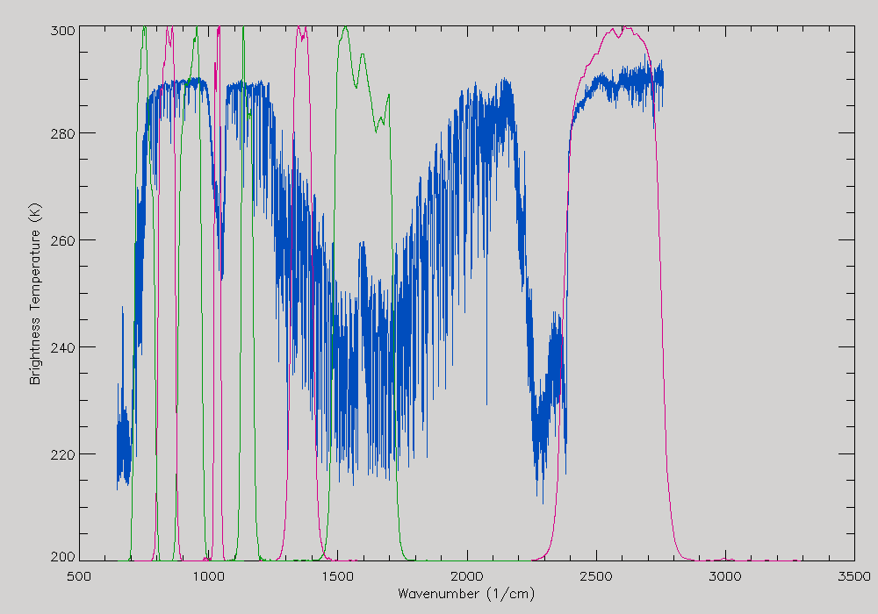
Figure 6: Example radiance spectra measured by IASI (blue), expressed in brightness temperature (K) and Spectral Response Functions of SEVIRI channels 3-11 from right to left (red/green).

Plot Collocation Map

Purpose
When interpreting the inter-calibration results it is often helpful to visualise the distribution of the source data used in the comparison.

General Options
      - This can be achieved by producing a map showing the distribution of collocation targets.

Infrared GEO-LEO inter-satellite/inter-sensor Class
      - The map is produced showing all the GEO-LEO pixels meeting the collocation criteria every day. These points are overlaid on a background image from an infrared window channel of the GEO instrument. This allows the distribution of cloud to be visualised and considered in the interpretation of the results.

SEVIRI-IASI Specific
      - An image is produced of the IR10.8 channel radiance over the GEO FoR on a fixed radiance scale running from 80 mW/m2/st/cm-1 (white) to 140 mW/m2/st/cm-1 (black). The position of the centre of all IASI iFoVs is over-plotted on this image in grey and those pixels meeting the collocation criteria are over-plotted in red, as shown in Figure 7.
      - As v0.1.
      - Av v0.1.
      - As v0.1.

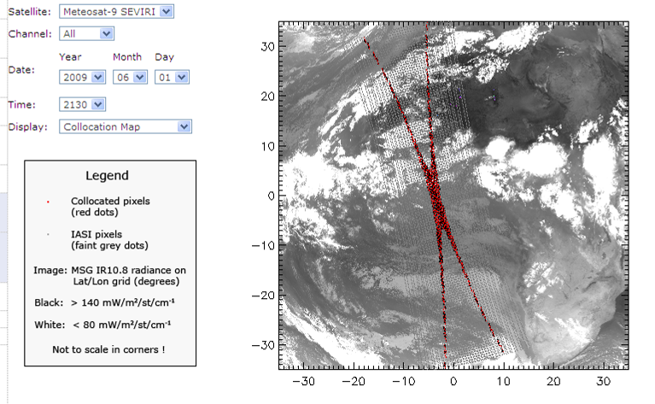
Figure 7: Example collocation map, follow inset legend.

Transform Data
In this step, collocated data are transformed to allow their direct comparison. This includes modifying the spectral, temporal and spatial characteristics of the observations, which requires knowledge of the instruments’ characteristics. The outputs of this step are the best estimates of the channel radiances, together with estimates of their uncertainty.

SRFs, PSFs, …
3. Transforming
Archive ~ 1 year
Comparison Data
Collocated Data
Figure 8: Step 3 of Generic Data Flow, showing inputs and outputs

Convert Radiances

Purpose
Convert observations from both instruments to a common definition of radiance to allow direct comparison.

General Options
      - The instruments’ observations are converted from Level 1.5/1b/1c data to radiances, using pre-defined, published algorithms specific for each instrument.

Infrared GEO-LEO inter-satellite/inter-sensor Class
      - Perform comparison in radiance units: mW/m²/st/cm⁻¹.

SEVIRI-IASI Specific
      - The Meteosat radiance definition applicable to each level 1.5 dataset, described by EUMETSAT [2010], is used, accounting for the instrument’s Spectral Response Functions [EUMETSAT, 2006].
IASI data are converted to radiances using the published algorithm [EUMETSAT, 2008].
      - As v0.1.
      - As v0.1, implemented in the routines read_msg_nc and read_iasi_nc, which read the NetCDF format data.
      - As v0.1.

Spectral Matching

Purpose
Firstly, we must identify which channel sets provide sufficient common information to allow meaningful inter-calibration. These are then transformed into comparable pseudo channels, accounting for the deficiencies in channel matches.

General Options
      - The Spectral Response Functions (SRFs) must be defined for all channels. The observations of channels identified as comparable are then co-averaged using pre-determined weightings to give pseudo channel radiances. A Radiative Transfer Model can be used to account for any differences in the pseudo channels’ characteristics. The uncertainty due to spectral mismatches is then estimated for each channel.

Infrared GEO-LEO inter-satellite/inter-sensor Class
For hyper-spectral instruments, all SRFs are first transformed to a common spectral grid. The LEO hyperspectral channels are then convolved with the GEO channels’ SRFs to create synthetic radiances in pseudo-channels, accounting for the spectral sampling and stability in an error budget.
Equation 5: $R_{\text{GEO}}=\frac{\int{R_{ν}Φ_{ν}dν}}{\int{Φ_{ν}dν}}$
where R_{GEO} is the simulated GEO radiance, R_{ν} is LEO radiance at wave number ν, and Φ_{ν} is GEO spectral response at wave number ν.
In general LEO hyperspectral sounders do not provide complete spectral coverage of the GEO channels either by design (e.g. gaps between detector bands), or by subsequent hardware failure (e.g. broken or noisy channels). The radiances in these gap channels shall be accounted by one of the following techniques:

      - The simplest option is simply to ignore the contribution from the gap channels. This will obviously introduce a bias in the resulting radiances, depending on the specific channels under consideration.
      - A second option is to linearly interpolate for the missing radiance from the adjacent valid channels. This could be a viable option for narrow gaps (e.g., single dead or unstable channel) but would create large bias and uncertainty if the gap is wide and over complex spectral features.
      - Tobin et al. [2006] fills the gap with pre-computed radiance using a radiative transfer model (RTM) and some typical atmospheric profiles. This is a significant improvement over the previous options, but the error can be large at times since spectral radiance is dependent on atmospheric conditions such as clouds, which is not known a priori.
      - The method of Kato [2007] exploits the fact that spectral radiances are normally highly correlated. It fills the gap with pre-computed radiance adjusted by ratio of measured and pre-computed radiances at nearby channels.
      - Gunshor [2007] matches the pre-computed radiance at the beginning and end of the gap. The ratio between the AIRS radiance and simulated radiance is computed at the last channel before a gap and the first channel after the gap, and is linearly interpolated to the channels within the gap. The missing AIRS radiances are then estimated as the simulated radiances multiplied with the ratio linearly interpolated to the missing channel.

      - This is the recommended option. Tahara and Kato [2009] define virtual channels named gap channels to fill the spectral gaps and introduce the spectral compensation method by constrained optimization. The gap channels to fill the AIRS spectral gaps (AIRS gap channels) are defined by 0.5 cm⁻¹ intervals, and are characterized by a unique SRF, whose shape is a Gaussian curve with a sigma of 0.5 cm⁻¹. The gap channels to extend the IASI spectral region (IASI gap channels) are defined by the same intervals (0.25 cm⁻¹) and SRFs as the IASI level 1c channels. The radiances of the missing channels are calculated by regression analysis using radiative transfer simulated radiances with respect to the eight atmospheric model profiles as explanatory variables.
Equation 6: $\text{log}I_{i^{\text{calc}}}=c_{0}+\sum_{k=1}^{K}{c_{k}\text{log}I_{i,k}^{\text{sim}}}\left(i=\text{hyper} \text{and} \text{gap} \text{channels}\right)$,
where $I_{i}^{\text{calc}}$ is the calculated radiance of the hyper channel i, $I_{i,k}^{\text{sim}}$ is the simulated radiance of the hyper channel i with respect to the atmospheric model profile k, $c_{k}\left(k=1,…,K\right)$ are regression coefficients, and K is the number of the atmospheric model profiles. Eq. 6 introduces logarithm radiances as response and explanatory variables in order to increase fitting accuracy and avoid calculation of negative radiance. The regression coefficients $c_{k}$ are independent of the hyper channels, and are generated for each scan position of the hyper sounder. $c_{k}$ are obtained by the least-square method applying a set of validly observed radiances $I_{i}^{\text{obs}}$ in place of $I_{i}^{\text{calc}}$ to Eq. 6,
Equation 7: $\left\{c_{k}\right\}=\text{argmin}\sum_{i=\text{exist}(I_{i}^{\text{obs}})}{{\left\{\text{log}I_{i}^{\text{obs}}−\left(c_{0}+\sum_{k}{c_{k}}\text{log}I_{i,k}^{\text{sim}}\right)\right\}}^{2}}$.
Once the regression coefficients $c_{k}$ are computed, the radiances of the missing channels can be calculated by Eq. 6. It might be possible to apply the observed radiances of all hyper channels to Eq. 7 to compute $c_{k}$ and then calculate the radiances of all missing channels at once. However, this yields a large fitting error in practice. In inter-calibration application, the coefficients $c_{k}$ are computed for each broadband channel spectral region. Eq. 6 and Eq. 7 use the simulated radiances $I_{i,k}^{\text{sim}}$. For the radiance simulation, this study uses the following eight atmospheric model profiles:
1. U.S. standard without cloud,
2. U.S. standard with opaque cloud with tops at 500 hPa altitude,
3. U.S. standard with opaque cloud with tops at 200 hPa altitude,
4. Tropical without cloud,
5. Tropical with opaque cloud with tops at 500 hPa altitude,
6. Tropical with opaque cloud with tops at 200 hPa altitude,
7. Mid-latitude summer without cloud,
8. Mid-latitude winter without cloud.
These profiles include not only clear sky conditions but also cloudy conditions because Eq. 6 should be applicable under any weather conditions. As for radiative transfer code, the line-by-line code LBLRTM (Clough et al., 1995) version 11.1 is used with the HITRAN2004 spectroscopy line parameter database (Rothman et al., 2003) including the AER updates version 2.0 (AER Web page). The emissivities of the surface and clouds are assumed to be one. The benefit of this spectral compensation method is that it does not require radiative transfer computation to be run in inter-calibration operation. This not only speeds up the computation but also prevents super channel radiance computation from introducing biases contained in radiative transfer code and atmospheric state fields.

SEVIRI-IASI Specific
      - IASI channels are assumed to be spectrally stable and contiguously sampled with a spectral resolution of 0.25 cm⁻¹. MSG’s SRFs for an operating temperature of 95K, published by EUMETSAT [2006] are interpolated onto IASI’s spectral grid in wavenumber-space using a bilinear interpolation. Any negative responses in the interpolated SRFs are set to zero. In this version of the algorithm, the pseudo channel radiance calculated from IASI corresponding to SEVIRI’s IR3.9 channel is slightly biased (~0.17K) it is missing a contribution from the short-wave end (>2760 cm⁻¹) of this channel’s passband, which is not observed by IASI.
      - As v0.1.
      - As v0.1. This is implemented in the icesi_convolve routine (see Annex A).
      - As v0.1, but the radiance missing from IASI’s coverage of SEVIRI IR3.9 channel is also estimated following the constrained optimization approach described in 3.b.iii.v0.6 above [Tahara and Kato, 2009], using coefficients specified therein specifically for SEVIRI-IASI. These gap channels to extend the IASI spectral region (IASI gap channels) are defined by the same intervals (0.25 cm⁻¹) and SRFs as the IASI level 1c channels.

Spatial Matching

Purpose
The observations from each instrument are transformed to comparable spatial scales. This involves averaging all the pixels identified in 2 as being within the target and environment areas. The uncertainty due to spatial variability is estimated.

General Options
      - The Point Spread Functions (PSFs) of each instrument are identified. The target area and environment around it were specified in 2. Now the pixels within these areas are identified and their radiances are averaged and their variance calculated to estimate the uncertainty on the average due to spatial variability, accounting for any over-sampling.

Infrared GEO-LEO inter-satellite/inter-sensor Class
      - The target area is defined as the nominal LEO FoV at nadir. The GEO pixels within target area are averaged using a uniform weighting and their variance calculated. The environment is defined by the GEO pixels within 3x radius of the target area from the centre of each LEO FoV.
      - The Point Spread Function (PSF) of the LEO instrument is used to provide a weighting in calculating the average of the GEO pixels.
(Not implemented yet.)

SEVIRI-IASI Specific
      - Based on 3.c.iii.v0.1. The IASI iFoV is defined as a circle of 12km diameter at nadir. The SEVIRI FoV is defined nominally as square pixels with lengths of 3km at SSP, which are assumed to be constant across the swath of each instrument. The target area is defined by arrays of 5x5 SEVIRI pixels closest to centre of each IASI iFoV, as shown in Figure 9. This is somewhat larger than the size of the IASI iFoV at nadir, but smaller at the extreme’s of its scan. The environment is not defined, as it is not used in further analysis.
      - Not implemented.
      - As v0.1, except that SEVIRI and IASI pixels are selected that fall within the same bin of a 2-D histograms with 0.125° lat/lon grid, covering ±35° lat/lon. This is implemented in the routine icesi_collocate (see Annex A) simultaneously with the collocation component (1b).
      - As v0.1, but the environment is defined by a array 9x9 SEVIRI pixels, centred on the IASI iFoV.
IASI iFoV
12km diameter
near nadir
SEVIRI pixels
(3km grid at SSP)
defining one Target Area
+
Figure 9: Definition of Target Area as 5x5 SEVIRI pixels to spatially match an IASI iFoV.

Viewing Geometry Matching

Purpose
Despite the collocation criteria described in 2.c, each instrument can measure radiance from the collocation targets in slightly different viewing geometry. It may be possible to account for small differences by considering simplified a radiative transfer model.

General Options
      - Differences in viewing geometry within the collocation criteria described in 2.c are assumed to be negligible and ignored in further analysis.
      - It may be possible to account for small differences by considering simplified a radiative transfer model.

Infrared GEO-LEO inter-satellite/inter-sensor Class
      - Differences in viewing geometry within the collocation criteria described in 2.c are assumed to be negligible and ignored in further analysis.
      - It may be possible to account for small differences by considering simplified a radiative transfer model. (Not yet implemented.)

SEVIRI-IASI Specific
      - As v0.1 above.
      - As v0.1 above.
      - As v0.1 above.
      - As v0.1 above.

Temporal Matching

Purpose
Different instruments measure radiance from the collocation targets at different times. The impact of this difference can usually be reduced by careful selection, but not completely eliminated. The timing difference between instruments’ observations is established and the uncertainty of the comparison is estimated based on (expected or observed) variability over this timescale.

General Options
      - Each instrument’s sample timings are identified.

Infrared GEO-LEO inter-satellite/inter-sensor Class
      - Only the GEO image closest to the LEO equator crossing time is selected. The time difference between the collocated GEO and LEO observations is neglected and the collocation targets are assumed to be sampled simultaneous, contributing no additional uncertainty to the comparison.
      - Only the GEO image closest to the LEO Equator crossing time is selected. The time difference, Δt, between the collocated GEO and LEO observations is calculated for each collocated pixel. This is compared with the spatial distance between the centroids of the target areas sampled by GEO and LEO, Δx, defined in 3.c using the pre-determined relationship between spatial and temporal scene variability for this channel [Hewison, 2009] and the uncertainty due to temporal variability, σ_{t}, is estimated from that due to spatial variability, σ_{x}, calculated in 3.c.
Equation 7: $σ_{t}=\left(\frac{{\text{RMSD}}_{t}\left(Δt\right)}{{\text{RMSD}}_{x}\left(Δx\right)}\right)σ_{x}$,
where RMSD_{t}(Δt) and RMSD_{x}(Δx) are the r.m.s. differences between the radiances in each channel calculated for sampling period, Δt, and interval, Δx, respectively.
(Not yet implemented.)
      - Sequential GEO images are interpolated to the LEO observation time and weighted according to the time difference between each. The uncertainty of the weighted mean could also be estimated.
(Not yet implemented.)

SEVIRI-IASI Specific
      - As v0.1 above.
      - As v0.1 above.
      - As v0.1 above.
      - As v0.2 above. (Not yet implemented)

Filtering
The collocated and transformed data will be archived for analysis. Before that, the GSICS inter-calibration algorithm reserves the opportunity to remove certain data that should not be analyzed (quality control), and to add auxiliary data that will add further analysis. For example, it may be useful to incorporate land/sea/ice masks and/or cloud flags to better classify the results.

Masks, flags, …
4. Filtering
Archive ~ 1 year
Analysis Data
Comparison Data
Figure 10: Step 4 of Generic Data Flow, showing inputs and outputs.

Uniformity Test

Purpose
Knowledge of scene uniformity is critical in reducing and evaluating inter-calibration uncertainty. To reduce uncertainty in the comparison due to spatial/temporal mismatches, the collocation dataset may be filtered so only observations in homogenous scenes are compared.

General Options
      - The simplest option is to allow all inter-calibration targets, regardless of their uniformity.
      - Another option is to set threshold to allow only relatively uniform scenes for analysis. In this case, the spatial/temporal variability of the scene within the target area is compared with pre-defined thresholds to exclude scenes with greater variance from analysis. This may be performed on a per-channel basis.
      - Another option is to use scene uniformity as weight in further analysis. Comparatively, the threshold option has the theoretical disadvantage of subjectivity but practical advantage of substantially reducing the amount of data to be archived. Recent analysis [Tobin, personal communication, 2009] also indicates that the threshold option is always suboptimal compared to the weight option.

Infrared GEO-LEO inter-satellite/inter-sensor Class
      - The variance of the radiances of all the GEO pixels within each LEO FoV is calculated in 3.c.
      - The interpolation between sequential GEO images may be included in future. (Not yet implemented.)

SEVIRI-IASI Specific
      - No homogeneity filtering is implemented, as found to not change the results significantly. Instead, as suggested in 4.a.ii.v0.3 above, the results rely on inhomogeneous scenes having lower weighting in regression and include the full range of scene radiances.
      - No filtering implemented.
      - An option is included to reject any targets where the standard deviation of the scene radiance is >5% of the standard radiance (see 4b). This is implemented as an option (filter=2) in the routine icesi_analyse (see Annex A).
      - As v0.1.

Outlier Rejection

Purpose
To prevent anomalous observations having undue influence on the results, ‘outliers’ may be identified and rejected on a statistical basis. Small number of anomalous pixels in the environment, even concentrated, may not fail the uniformity test. However, if they appear only in one sensor’s field of view but not the other, it can cause unwanted bias in a single comparison.

General Options
      - The simplest implementation is to include the outliers in the further analysis. Since the anomaly has equal chance to appear in either sensor’s field of view, comparison of large number of samples remains unbiased but has increased noise. This is the recommended approach.
      - The radiances in the target area are compared with those in the surrounding environment, and those targets which are significantly different from the environment (3σ) may be rejected.
For a normally distributed population of size N, mean M, and standard deviation S, the difference between a single sample and M has the probability of ~68% to be less than S, ~95% to be less than 2S, and so forth. Similarly, the difference between the mean of n² samples and M has the probability of ~68% to be less than S/n[(N-n)/(N-1)], ~95% to be less than 2S/n[(N-n)/(N-1)], and so forth. This property is used to test whether the collocation area is an outlier for the otherwise uniform environment:
Equation 8: $\left|\frac{1}{n^{2}}\sum_{i=1}^{n^{2}}{R_{i}}−M\right|≤\frac{S}{n}\frac{N−n}{N−1}\text{Gaussian}\left(3\right)$
where R is radiance from individual pixel, n2 is the number of samples, and Gaussian is a threshold. The probability that the rejected sample is an outlier is 68% if Gaussian=1, 95% if Gaussian=2, and more than 99% if Gaussian=3.

Infrared GEO-LEO inter-satellite/inter-sensor Class
      - All inter-calibration targets are included in further analysis, regardless of whether they are outliers with respect to their environment.
      - The mean GEO radiances within each LEO FoV are compared to the mean of their environment. Targets where this difference is >3 times the standard deviation of the environment’s radiances are rejected.

SEVIRI-IASI Specific
      - No outlier rejection implemented, as recommended in 4.b.iii.v0.1.
      - No outlier rejection implemented, as recommended in 4.b.iii.v0.1.
      - No outlier rejection implemented, as recommended in 4.b.iii.v0.1.
      - No outlier rejection implemented, as recommended in 4.b.iii.v0.1.

Auxiliary Datasets

Purpose
It may be useful to incorporate land/sea/ice masks and/or cloud flags to allow analysis of statistics in terms of other geophysical variables – e.g. land/sea/ice, cloud cover, etc.

It may also be possible to estimate the spatial variability within the LEO FoV from collocated AVHRR observations from the same LEO satellite.

General Options
      - Not yet implemented.

Infrared GEO-LEO inter-satellite/inter-sensor Class
      - Not yet implemented.

SEVIRI-IASI Specific
      - Not yet implemented.

Monitoring
This step includes the actual comparison of the collocated radiances produced in Steps 1-4, the production of statistics summarising the results to be used in the Correcting step, and reporting any differences in ways meaningful to a range of users.

Analysis Data
Plots and Tables
5. Monitoring
Figure 11: Step 5 of Generic Data Flow, showing inputs and outputs.

Define Standard Radiances (Offline)

Purpose
This component provides standard reference scene radiances at which instruments’ inter-calibration bias can be directly compared and conveniently expressed in units understandable by the users. Because biases can be scene-dependent, it is necessary to define channel-specific standard radiances. More than one standard radiance may be needed for different applications – e.g. clear/cloudy, day/night. This component is carried out offline.

General Options
      - A representative Region of Interest (RoI) is selected and histograms of the observed radiances within RoI are calculated for each channel. Histogram peaks are identified corresponding to clear/cloudy scenes to define standard radiances. These are determined a priori from representative sets of observations.
      - The standard radiances should be calculated for each channel a priori using a Radiative Transfer Model (RTM) based on a standard atmospheric profile and surface conditions. The reference radiance should be calculated at nadir, at night for IR channels or at a given solar angle (for vis/nir channels), in a 1976 US Standard Atmosphere, in clear skies, over the sea with a SST=+15C and wind speed (7m/s), using some standard RTM, accounting for the SRF of each channel. This has the advantages of being independent of any instrument biases and provides standard radiances against which we can compare the instruments’ relative biases derived from a number of different inter-calibration techniques.

Infrared GEO-LEO inter-satellite/inter-sensor Class
      - Option 5.a.ii.v0.1 is implemented directly.
      - Option 5.a.ii.v0.1 is implemented directly, the FoR is limited to within 30° latitude/longitude of the GEO sub-satellite point and times limited to night-time LEO overpasses.
      - As v0.2.
      - Option 5.a.ii.v0.2 is implemented directly.

SEVIRI-IASI Specific
      - For option 5.a.ii.v0.1, find the mode of the histogram of each channels’ brightness temperature for collocated pixels in 5 K wide bins from 200 to 300 K. (For bimodal distributions, the mean of the modes is used.)
Ch (μm) | 3.9 | 6.2 | 7.3 | 8.7 | 9.7 | 10.8 | 12.0 | 13.4
T_{bstd} (K) | 290 | 240 | 260 | 290 | 270 | 290 | 290 | 270

      - Define cold standard radiances for high cloud as 220K for all channels.
      - As v0.1.
      - Option 5.a.ii.v0.2 is implemented directly, using RTTOV-9, giving the following results for the IR channels SEVIRI on both Meteosat-8 and -9:
Ch (μm) | 3.9 | 6.2 | 7.3 | 8.7 | 9.7 | 10.8 | 12.0 | 13.4
T_{bstd} (K) | 284 | 236 | 255 | 284 | 261 | 286 | 285 | 267

Regression of Most Recent Results

Purpose
Regression is used as the basis of the systematic comparison of collocated radiances from two instruments. (This comparison may also be done in counts or brightness temperature.) Regression coefficients shall be made available to users to apply the GSICS Correction to the monitored instrument, re-calibrating its radiances to be consistent with those of the reference instrument. Scatterplots of the regression data should also be produced to allow visualisation of the distribution of radiances.
Regressions also allow us to investigate how biases depend on various geophysical variables and provides statistics of any significant dependences, which can used to refine corrections and allows investigation of the possible causes. Such investigations should be carried out offline and may result in future refinements to the ATBD.

General Options
      - The simplest method of comparing two datasets is to calculate the average the differences between collocated radiances. This provides a single scalar quantity for each channel (with an uncertainty estimated statistically from the variances of the datasets). However, this does not correspond to the mechanisms most likely to introduce bias in the instruments.
A weighted average may be used to account for greater uncertainty of collocation with inhomogeneous scene radiances.
      - Similarly, the average ratio of the collocated radiances from a pair of instruments can be calculated. This also provides a single scalar quantity for each channel (with an uncertainty estimated statistically from the variances of the datasets). This corresponds to an inaccurately calibrated gain of one of the instruments, which is a common problem.
A weighted average may be used to account for greater uncertainty of collocation with inhomogeneous scene radiances.
      - The recommended approach is to perform a weighted linear regression of collocated radiances. The inverse of the sum of the spatial and temporal variance of the target radiance and the radiometric noise provide an estimated uncertainty on each dependent point, which is used as a weighting. (Including the radiometric noise ensures that very homogeneous targets scenes where all the pixels give the same radiance do not have undue influence on the weighted regression.)
This method produces estimates of regression coefficients describing the slope and offset of the relationship between the two instruments’ radiances – together with their uncertainties, expressed as a covariance. The problem of correlation between the uncertainties on each coefficient may be reduced by performing the regression on a transformed dataset – for example, by subtracting the mean or reference radiance from each set.
The observations of the reference instrument, x, and monitored instrument, y, are fitted to a straight line model of the form:
Equation 9: $\hat{y}\left(x\right)=a+\text{bx}$
We assume an uncertainty σ_{i} associated with each measurement, y_{i}, is known and that the dependent variable, x_{i} is also known.
To fit the observed data to the above model, we minimise the chi-square merit function:
Equation 10: $χ^{{}_{2}}\left(a,b\right)=\sum_{i=1}^{N}{{\left(\frac{y_{i}−a−{\text{bx}}_{i}}{σ_{i}}\right)}^{2}}$
This can be implemented following the method described in Section 15.2 of Numerical Recipes [Press et al., 1996], which is implemented in the POLY_FIT function of IDL, yielding the following estimates of the regression coefficients:
Equation 11: $a=\frac{\sum_{i=1}^{N}{\frac{x_{i}^{2}}{σ_{i}^{2}}}\sum_{i=1}^{N}{\frac{y_{i}}{σ_{i}^{2}}}−\sum_{i=1}^{N}{\frac{x_{i}}{σ_{i}^{2}}}\sum_{i=1}^{N}{\frac{x_{i}y_{i}}{σ_{i}^{2}}}}{\sum_{i=1}^{N}{\frac{1}{σ_{i}^{2}}}\sum_{i=1}^{N}{\frac{x_{i}^{2}}{σ_{i}^{2}}}−{\left(\sum_{i=1}^{N}{\frac{x_{i}}{σ_{i}^{2}}}\right)}^{2}}$,
Equation 12: $b=\frac{\sum_{i=1}^{N}{\frac{1}{σ_{i}^{2}}}\sum_{i=1}^{N}{\frac{x_{i}y_{i}}{σ_{i}^{2}}}−\sum_{i=1}^{N}{\frac{x_{i}}{σ_{i}^{2}}}\sum_{i=1}^{N}{\frac{y_{i}}{σ_{i}^{2}}}}{\sum_{i=1}^{N}{\frac{1}{σ_{i}^{2}}}\sum_{i=1}^{N}{\frac{x_{i}^{2}}{σ_{i}^{2}}}−{\left(\sum_{i=1}^{N}{\frac{x_{i}}{σ_{i}^{2}}}\right)}^{2}}$,
their uncertainties:
Equation 13: $σ_{a}^{2}=\frac{\sum_{i=1}^{N}{\frac{x_{i}^{2}}{σ_{i}^{2}}}}{\sum_{i=1}^{N}{\frac{1}{σ_{i}^{2}}}\sum_{i=1}^{N}{\frac{x_{i}^{2}}{σ_{i}^{2}}}−{\left(\sum_{i=1}^{N}{\frac{x_{i}}{σ_{i}^{2}}}\right)}^{2}}$,
Equation 14: $σ_{b}^{2}=\frac{\sum_{i=1}^{N}{\frac{1}{σ_{i}^{2}}}}{\sum_{i=1}^{N}{\frac{1}{σ_{i}^{2}}}\sum_{i=1}^{N}{\frac{x_{i}^{2}}{σ_{i}^{2}}}−{\left(\sum_{i=1}^{N}{\frac{x_{i}}{σ_{i}^{2}}}\right)}^{2}}$,
and their covariance:
Equation 15: $\text{cov}\left(a,b\right)=\frac{−\sum_{i=1}^{N}{\frac{x_{i}}{σ_{i}^{2}}}}{\sum_{i=1}^{N}{\frac{1}{σ_{i}^{2}}}\sum_{i=1}^{N}{\frac{x_{i}^{2}}{σ_{i}^{2}}}−{\left(\sum_{i=1}^{N}{\frac{x_{i}}{σ_{i}^{2}}}\right)}^{2}}$.

Infrared GEO-LEO inter-satellite/inter-sensor Class
      - Inter-calibrations are repeated daily using only night-time LEO overpasses. Collocations are weighted by the inverse the sum of the spatial and temporal variance of target radiances and their radiometric noise level in the regression. (The inclusion of the radiometric noise ensures the weights never become infinite due to collocation targets with zero variance.) Scatterplots of the regression data should also be produced to allow visualisation of the distribution of radiances, following the example shown in Figure 12.
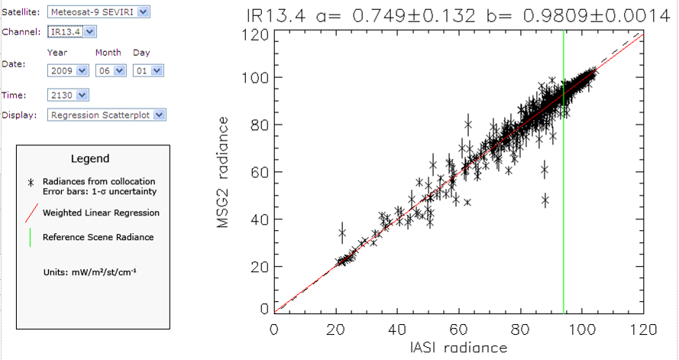
Figure 12: Example scatterplot showing regression of collocated radiances, following legend.

SEVIRI-IASI Specific
      - Implemented as 5.b.ii.v0.3, except the radiometric noise is not added to the scene variance when calculating the weighting for each point. Repeat inter-calibration every 10 days (nights). Only incidence angles <30° are included.
      - Not implemented.
      - Implemented as 5.b.ii.v0.3, except the radiometric noise is not added to the scene variance when calculating the weighting for each point. The range of incidence angles was implicitly extended to <40° by changing the FoR constraints. Inter-calibrations are attempted every day (although only ~½ of cases contain collocations).
This is implemented in the routine icesi_analyse (see Annex A).
      - Implemented as 5.b.ii.v0.3. The temporal variance is assumed to be equal to the spatial variance, so its contribution to the weighting is multiplied by √2 and added in quadrature to the radiometric noise. The radiometric noise for IASI is assumed to be negligible when averaged over all channels within the SRF of each SEVIRI channel. The radiometric noise on each pixel for the SEVIRI channels is given by [EUMETSAT, 2007]. For example, for “ambient calibrations” at 95K:
Channel  IR | 3.9 | 6.2 | 7.3 | 8.7 | 9.7 | 10.8 | 12.0 | 13.4
MSG-1 Noise [K] | 0.013 | 0.045 | 0.065 | 0.070 | 0.115 | 0.065 | 0.120 | 0.185
MSG-2 Noise [K] | 0.090 | 0.050 | 0.050 | 0.075 | 0.100 | 0.070 | 0.100 | 0.205

Bias Calculation

Purpose
Inter-calibration biases should be directly comparable for representative scenes and conveniently expressed in units understandable by the users. Because biases can be scene-dependent, they are evaluated here at the standard radiances defined in 5.a.

General Options
      - Regression coefficients are applied to estimate expected bias, $Δ\hat{y}\left(x_{\text{STD}}\right)$, and uncertainty, $σ_{\hat{y}}\left(x_{\text{STD}}\right)$, for standard radiances, accounting for correlation between regression coefficients.
Equation 16: $Δ\hat{y}\left(x_{\text{STD}}\right)=a+{\text{bx}}_{\text{STD}}−y_{\text{STD}}$ ,
noting that y_{STD} = x_{STD} and
Equation 17: $σ_{\hat{y}}^{2}\left(x_{\text{STD}}\right)=σ_{a}^{2}+σ_{b}^{2}x_{\text{STD}}^{2}+2\text{cov}\left(a,b\right)x_{\text{STD}}$
The results may be expressed in absolute or percentage bias in radiance, or brightness temperature differences.

Infrared GEO-LEO inter-satellite/inter-sensor Class
      - Biases and their uncertainties are converted from radiances to brightness temperatures for visualisation purposes.

SEVIRI-IASI Specific
      - The definition of effective radiance is used in the conversion to brightness temperatures [EUMETSAT, 2010].
      - As v0.1.
      - As v0.1.
      - As v0.1.

Consistency Test

Purpose
The most recent results are tested for statistical consistency with the previous time series of results. Users should be alerted to any sudden changes in the calibration of the instruments, allowing them to investigate potential causes and reset trend statistics calculated in 5.e. The consistency test may be performed in terms of regression coefficients or biases.

General Options
      - The biases calculated for standard radiances from the most recent collocations are compared to the statistics of the biases’ trends calculated in 5.e from previous results. If the most recent result falls outside the 3-σ (99.7%) confidence limits estimated from the trend statistics, an alert should be raised. This alert should trigger the Principle Investigator to check the cause of the change and reset the trends by issuing a trend reset.
Equation 18: $\left|\frac{y_{i}−{\hat{y}}_{i}\left(x_{i}\right)}{σ_{\hat{y}\left(x_{i}\right)}}\right|≥\text{Gaussian}\left(3\right)$
      - The regression coefficients calculated from the most recent collocations are compared to the statistics of the trends calculated from previous regression coefficients. If the most recent result falls outside the 3-σ (99.7%) confidence limits estimated from the trend statistics, an alert should be raised. This has not been implemented yet, due to concerns about correlation between regression coefficients.

Infrared GEO-LEO inter-satellite/inter-sensor Class
      - Implement 5.d.ii.v0.1 as above.

SEVIRI-IASI Specific
      - Not implemented.
      - Not implemented.
      - Implement 5.d.ii.v0.1 as above but with modified threshold to correspond to 2-σ (95%) confidence limits. This does yet generate an excessive number of alerts, given the frequency of successful collocations found by the simple automated orbit selection.
      - It is recommended that this is implemented as 5.d.ii.v0.1 above.

Trend Calculation

Purpose
It is important to establish whether an instrument’s calibration is changing slowly with time. It is possible to establish this from a time-series of inter-comparisons by calculating a trend line using a linear regression with date as the independent variable. Only the portion of the time series since the most recent trend reset is analysed, to allow for step changes in the instruments’ calibration.

General Options
      - The time series of biases evaluated at standard radiances can be regressed against the time (date) as the independent variable. The linear regression can be weighted by the calculated uncertainty on each bias. The regression coefficients including uncertainties (and their covariances) are calculated by the least squares method described in 5.b.ii.v0.2. In this case, the variables, x_{i} and y_{i} are time series of Julian dates and radiance biases estimated in 5.c for each orbit since the most recent trend reset, respectively.
      - It is also possible to perform the trend calculation using the regression coefficients as dependent variables. However, their covariance should also be accounted for and has not been implemented yet.

Infrared GEO-LEO inter-satellite/inter-sensor Class
      - Implement 5.e.ii.v0.1 as above.

SEVIRI-IASI Specific
      - Not implemented.
      - Not implemented.
      - Implemented 5.e.ii.v0.1 as above.
      - Implement 5.e.ii.v0.1 as above.

Report Results

Purpose
The results should be reported quantifying the magnitude of relative biases by inter-calibration. This should allow users to monitor changes in instrument calibration.

General Options
      - Plots and tables of relative biases and uncertainties for standard radiances should be produced. These may show the evolution of the biases and their dependence on geophysical variables. These all results should be uploaded to the GSICS Data and Products server, and made available from the GPRC’s appropriate inter-calibration webpage.

Infrared GEO-LEO inter-satellite/inter-sensor Class
      - Plots should be regularly updated showing the relative brightness temperature biases for the standard radiances in each channel as time series with uncertainties. The trend line and monthly mean biases (and their uncertainties) should be calculated from these time series, following the example in Figure 13. This allows the most recent result to be tested for consistency with the series of previous results. If significant differences are found operators should be alerted, giving them the opportunity to investigate further.
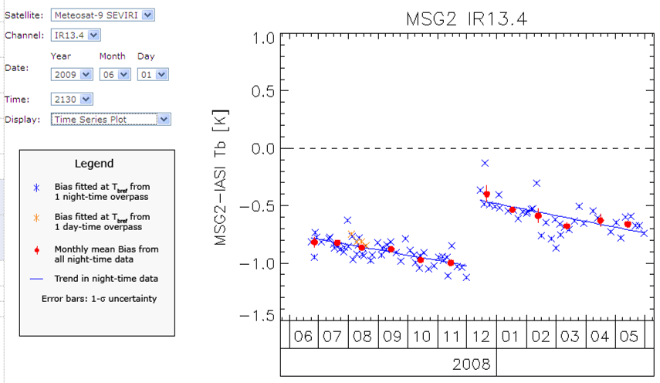
Figure 13: Example of time series plot showing relative bias of IR13.4 channel of Meteosat-9 and IASI at reference radiance following inset legend.

SEVIRI-IASI Specific
      - Time series plots and statistics were produced manually on an ad hoc basis.
      - Not implemented.
      - This is implemented in the routine icesi_plot_bias_ts (see Annex A). The trends and statistics should be reset manually when decontamination procedures performed on MSG.
      - As 5.f.ii.v0.1.

Flow Summary of Step 5 for SEVIRI-IASI
Figure 14: Summary of Recommended Data Flow within Steps 5 and 6 for SEVIRI-IASI
Analysis Data
5. Monitoring
Products
Time Series of
Analysis Data
Latest
‘Analysis Data’
Regression Coefficients
Standard Radiances
Latest Biases
Correction Coeffs
5b. Regression
5c. Calculate Biases
5a. Define Standard Radiances
Bias Time Series
Archive
5e. Trend Calc.
Trend Stats
Trend Resets
(+ Alert)
6a. Define Smoothing Period
Smoothing Period
6b. Smooth Results
Archive
5d. Consistency Test
5f. Plot Time Series of Biases
6. Correcting
Plots and Tables

GSICS Correction
This final step of the algorithm is to calculate the GSICS Correction, allowing the calibration of one instrument’s observed data to be modified to become consistent with that of the reference instrument. The form of the GSICS Correction will be defined offline and can be instrument specific. However, application of the correction relies on the Correction Coefficients supplied by the inter-comparisons performed in the previous steps of the algorithm from the Analysis Data.

6. Correcting
GSICS Correction
e.g. Look-Up Table,
FORTRAN subroutine,
New calibration coefficients, …
Correction Coeffs

Time Series of
Inter-calibration
Regression
Coefficients

Analysis Data
MON Lvl 1 Data

Satellite/Instrument/Ch
Date/Time
Geometry
Radiances/Counts

Re-Cal Data

Corrected Radiances
With Uncertainties

Products
Users
Figure 15: Step 6 of Generic Data Flow, showing inputs and outputs,
and illustrating schematically how the correction could be applied by users.

Define Smoothing Period (Offline)

Purpose
It is possible to combine data from a time series of inter-comparison results to reduce the random component of the uncertainty on the final GSICS Correction. (See 6.a). However, this requires us to define representative periods over which the results can be smoothed without introducing bias due to calibration drifts during the smoothing period. This period can be defined by comparing the observed rate of change of inter-comparison results with a pre-determined threshold, based on the required or achievable accuracy. In general, this definition is performed offline as it requires an in-depth analysis of the instruments’ relative biases and consideration of likely explanatory mechanisms. However, it could also be fine-tuned in near real-time. The following describes the general approaches that should be implemented.

General Options
      - In 5.e.ii.v0.1, time series of radiance biases are regressed against date as the independent variable. This yields an estimate of the rate of change of bias with time, $\frac{dΔ{\hat{y}}_{\text{REF}}}{\text{dt}}$, which can be compared to the threshold Δy_{max} to determine the smoothing period, τ_{s}:
Equation 19: $τ_{s}={Δy}_{\text{max}}{\left(\frac{dΔ{\hat{y}}_{\text{REF}}}{\text{dt}}\right)}^{−1}$
      - This component may not be necessary if the time series is interpolated/extrapolated calculate the GSICS Correction for a particular observation. This would require the regression coefficients to be combined in a time series as suggested in 5.e.ii.v0.2.

Infrared GEO-LEO inter-satellite/inter-sensor Class
      - Implement 6.a.ii.v0.1 as above.

SEVIRI-IASI Specific
      - Not implemented.
      - Not implemented.
      - Biases smoothed into monthly bins for visualisation, effectively setting τ_{s}=30d.
      - Implement 6.a.ii.v0.1 as above.
The threshold value is taken to correspond to the typical uncertainty on the inter-comparison, which is equivalent to Δy_{max}≡0.05 K.
The SEVIRI channel with the highest rate of change is IR13.4,
where $\frac{dΔ{\hat{y}}_{\text{REF}}}{\text{dt}}≈−0\text{.}1K/{\text{month}}$.
This yields the following smoothing periods:
τ_{s}≈14.5 days for the Near Real-Time Correction
τ_{s}≈29 days for the Near Real-Time Correction
(to match the orbital repeat cycle of Metop)

Smooth Results

Purpose
It is possible to combine data from a time series of inter-comparison results to reduce the random component of the uncertainty on the final GSICS Correction. These smoothed coefficients provide the Correction Coefficients used as input to the GSICS Correction, supplied in a netCDF format [defined elsewhere]. The smoothing period defined in 6.a is used.

General Options
      - The rolling average of the time series of regression coefficients is calculated using a rectangular box-car window with a width defined in 5.f. The regression coefficients are first transformed to correspond to datasets of centred radiances, after subtracting the standard radiances. This reduces the correlation between the regression coefficients and allows linear averaging.
      - All the collocation data within the smoothing period is combined and the regression of 5.b repeated on the aggregate dataset. This approach ensures all data is used optimally, with appropriate weighting according to its estimated uncertainty. This is the recommended approach in general for GSICS.
      - Alternatively, the statistical trends of the time series of regression coefficients suggested in 5.e.ii.v0.2 could be extended – after transforming the dataset to account for the finite covariance between the coefficients. This may be achieved by future developments using Kalman Filtering or EOF-based approaches.

Infrared GEO-LEO inter-satellite/inter-sensor Class
      - Implement 6.b.ii.v0.1 as above.

SEVIRI-IASI Specific
      - Not implemented.
      - Not implemented.
      - Biases smoothed into monthly bins for visualisation, effectively setting τ_{s}=30d.
      - Implement 6.b.ii.v0.1 as above.

Re-Calculate Calibration Coefficients

Purpose
This component aims to produce revised sets of calibration coefficients for one instrument following its inter-calibration against a reference instrument using the Analysis Data provided by Step 4. These would allow users to recalibrate data from the monitored instrument to be consistent with the reference instrument. Tables of recalibration coefficients for near-real-time and archive data should also be produced.

General Options
      - The regression coefficients provided as the Analysis Data output from Step 4 are transformed to generate new correction coefficients (together with estimates of their uncertainties as full covariances). These can then be used to convert the observations of the monitored instrument into radiances consistent with the GSICS reference standard.
I_{LEO}
a_{r}
b_{r}
I_{STD}
ΔI_{STD}
I_{GEO}
Figure 16: Relationship between radiances observed by geostationary instrument, I_{GEO} and those observed by reference instrument in low Earth orbit, I_{LEO},
showing relative bias for standard radiance, I_{STD}.

Infrared GEO-LEO inter-satellite/inter-sensor Class
      - Implement 6.c.ii.v0.1 as above.
The regression of the aggregated collocated radiances in Error: Reference source not found yields estimates of the coefficients, a_{r} and b_{r}, required to convert GEO radiances, I_{GEO}, to the reference LEO radiances, I_{LEO} :
Equation 20: $I_{\text{GEO}}=a_{r}+b_{r}I_{\text{LEO}}$
This relationship can be inverted to apply the regression coefficients, a_{r} and b_{r}, to convert GEO radiances, I_{GEO}, into radiances consistent with the LEO reference instrument, ${\hat{I}}_{\text{LEO}}$,
Equation 21: ${\hat{I}}_{\text{LEO}}=−\frac{a_{r}}{b_{r}}+\frac{1}{b_{r}}I_{\text{GEO}}$,
together with the estimated uncertainty:
Equation 22: $σ_{{\hat{I}}_{\text{LEO}}}^{2}={\left(\frac{σ_{a_{r}}}{b_{r}}\right)}^{2}+{\left[\left(I_{\text{GEO}}−a_{r}\right)σ_{b_{r}}\right]}^{2}−2\frac{\left(I_{\text{GEO}}−a_{r}\right)}{b_{r}}σ_{a_{r}b_{r}}$,

SEVIRI-IASI Specific
      - Not implemented.
      - Not implemented.
      - Not implemented.
      - For SEVIRI, we can also implement a variation of 6.c.ii.v0.1 above. Because SEVIRI’s level 1.5 counts are linear with radiance and the calibration coefficients used to convert between the units are constant, we can express the GSICS Correction in terms of modified calibration coefficients.
In this case, the regression coefficient, a_{r} and b_{r}, (and their uncertainties) can be compared with the original calibration coefficients required to convert GEO counts, C_{GEO}, into radiances, I_{GEO}:
Equation 23: $I_{\text{GEO}}=a_{c}+b_{c}C_{\text{GEO}}$
Comparing the two equations above, yields the relationship between the GEO counts and the equivalent radiance of the reference instrument,${\hat{I}}_{\text{LEO}}$:
Equation 24: ${\hat{I}}_{\text{LEO}}=a_{g}+b_{g}C_{\text{GEO}}$, where $a_{g}=\frac{a_{c}−a_{r}}{b_{r}}$and $b_{g}=\frac{b_{c}}{b_{r}}$.
where a_{g} and b_{g} are new calibration coefficients (with uncertainties) which convert GEO counts, C_{GEO}, into radiances consistent with the LEO reference instrument, ${\hat{I}}_{\text{LEO}}$, together with the estimated uncertainty:
Equation 25: $σ_{{\hat{I}}_{\text{LEO}}}^{2}={\left(\frac{σ_{a_{r}}}{b_{r}}\right)}^{2}+{\left[\left(a_{c}−a_{r}+b_{c}C_{\text{GEO}}\right)σ_{b_{r}}\right]}^{2}+2\frac{\left(a_{c}−a_{r}+b_{c}C_{\text{GEO}}\right)}{b_{r}^{3}}σ_{a_{r}b_{r}}$,
Figure 17: Left panel shows relationship between radiances observed by geostationary instrument, I_{GEO} and those observed by reference instrument in low Earth orbit, I_{LEO}.
Right panel shows relationships between the level 1.5 counts and the radiances calculated using the original calibration coefficients (in red) and using the GSICS Corrected coefficients (in blue). The relative bias for standard radiance, I_{STD} is also shown in green.
I_{LEO}
I_{GEO}
a_{r}
b_{r}
C_{GEO}
I_{GEO}
a_{c}
b_{c}
a_{g}
b_{g}
I_{STD}
C_{STD}
ΔI_{STD}
References
Clough, S. A., and M. J. Iacono, 1995: Line-by-line calculations of atmospheric fluxes and cooling rates II: Application to carbon dioxide, ozone, methane, nitrous oxide, and the halocarbons. J. Geophys. Res., 100. 16519-16535.
EUMETSAT, 2006: MSG SEVIRI Spectral Response Characterisation, EUM/MSG/TEN/06/0010.
EUMETSAT, 2007, Typical Radiometric Accuracy and Noise for MSG-1/2, EUM/OPS/TEN/07/0314, http://www.eumetsat.int/idcplg?IdcService=GET_
FILE&dDocName=pdf_typ_radiomet_acc_msg-1-2&RevisionSelectionMethod=LatestReleased
EUMETSAT, 2008: IASI Level 1 Products Guide, Ref.: EUM/OPS-EPS/MAN/04/0032, http://oiswww.eumetsat.org/WEBOPS/eps-pg/IASI-L1/IASIL1-PG-4ProdOverview.htm#TOC411
EUMETSAT, 2010: Effective Radiance and Brightness Temperature Relation for Meteosat 8 and 9, EUM/OPS-MSG/TEN/08/0024.
Hewison, T.J., 2009a: Quantifying the Impact of Scene Variability on Inter-Calibration, GSICS Quarterly, Vol. 3, No. 2, 2009.
Hewison, T. J., 2008a: SEVIRI/IASI Differences in 2007, GSICS Quarterly, Vol.2, No.1, 2008. (Available online).
Hewison, T.J., 2008b: The Inter-calibration of Meteosat and IASI during 2007, EUMETSAT Internal Report, April 2008 (Available online).
Hewison, T.J. and M. König, 2008: Inter-Calibration of Meteosat Imagers and IASI, Proceedings of EUMETSAT Satellite Conference, Darmstadt, Germany, September 2008. (Available online).
König, M., 2007: Inter-Calibration of IASI with MSG-1/2 onboard METEOSAT-8/9, GSICS Quarterly, Vol.1, No.2, August 2007 (Available online).
Minnis, P., A. V. Gambheer, and D. R. Doelling, 2004: Azimuthal anisotropy of longwave and infrared window radiances from CERES TRMM and Terra data. J. Geophys. Res., 109, D08202, doi:10.1029/2003JD004471.
Press, W.H., S.Teukolksy, W.T.Vetterling and B.Flannery, 1995: Numerical recipes: the art of scientific computing, Second edition, Cambridge University Press.
Rothman et al., 2003: The HITRAN molecular spectroscopic database: edition of 2000 including updates through 2001, Journal of Quantitative Spectroscopy and Radiative Transfer. vol. 82, 5-44.
Tahara, Yoshihiko, 2008: New Approach to Intercalibration Using High Spectral Resolution Sounder, Meteorological Satellite Center Technical Note, No. 50, 1-14.
Tahara, Yoshihiko and Koji Kato, 2009: New Spectral Compensation Method for Intercalibration Using High Spectral Resolution Sounder, Meteorological Satellite Center Technical Note, No. 52, 1-37.
Tobin, D. C., H. E. Revercomb, C. C. Moeller, and T. Pagano, 2006: Use of Atmospheric Infrared Sounder high-spectral resolution spectra to assess the calibration of Moderate re solution Imaging Spectroradiometer on EOS Aqua, J. Geophys. Res., 111, D09S05, doi:10.1029/2005JD006095.
Wu, X., 2009: GSICS GOES-AIRS Inter-Calibration Algorithm at NOAA GPRC, Draft version dated January 5, 2009.

Annex A
Inter-Calibration (EUMETSAT) of SEVIRI-IASI (ICESI) v0.3
These routines and NetCDF data formats will be documented in detail in a separate document. This is an extract for information.

Overview of Data Flow

Input Satellite Data – UMARF Standing Order
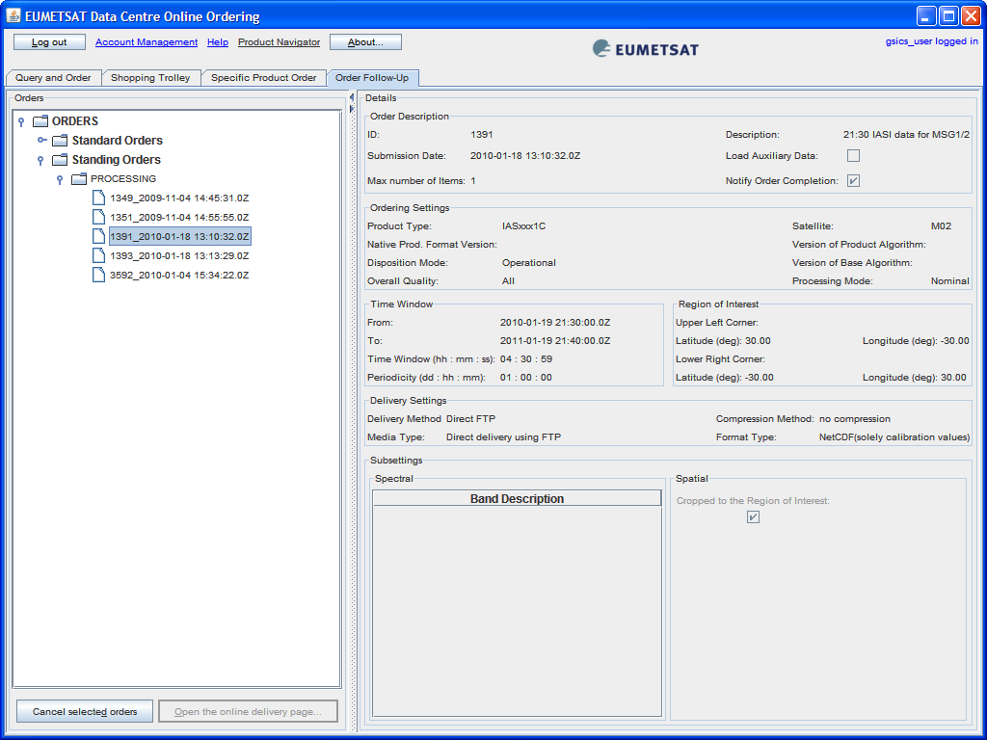

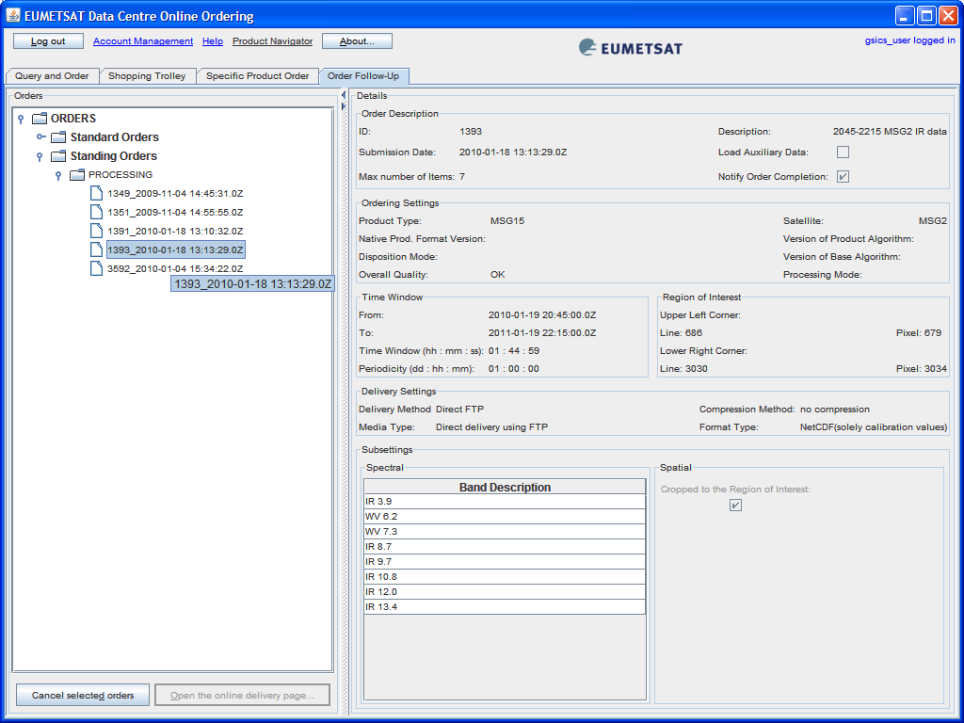

NetCDF format specified in separate document.

Detail of Inter-Calibration Processing ICESI_BATCH

Output Data

Configuration Options
The data saved for each collocation should be comprehensive to facilitate future down selection, analysis, and certain reprocessing (e.g., spectral convolution). It should contain all the GEO and LEO data, as well as the metadata regarding the collocation.

