**Vicarious Calibration of GOES Imager Visible Channel using the Moon**

* **ATBD Outline for GSICS GEO visible channel calibration**

Xiangqiang Wu, Fangfang Yu and Gordana S. Rancic

1. **Introduction**

Vicarious calibration of GOES Imager visible channel using its lunar observation is described in this document, following earlier studies by Kiffer (1997) and Wu et al. (2006).

1. **Collection of GOES Lunar Data**

*2.1 Unscheduled Moon observations*

From a geostationary orbit above the equator, GOES views the Moon in a way similar to that from the Earth’s equator, towards the local zenith, and within a square about 19o wide that is blocked by an inscribed circles, the Earth disk (Fig. 1). The Moon would appear a few times a month in one of the space corners shown in Figure 1. However, because GOES operates on a complicated and variable schedule, and because only unclipped lunar images (more than 100km away from the Earth disk) are used, only 3-5 useful lunar observations are obtained on average each year.

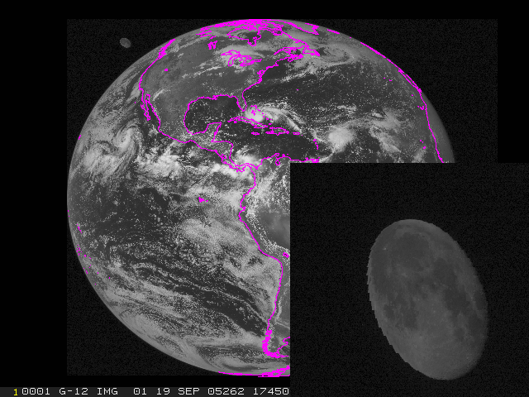

Figure 1. GOES-12 full disk image around 17:45UTC on 09/19/2005. The Moon appears in the upper left corner, and in shown enlarged in the insert.

*2.2 Scheduled Moon observations*

Since the unscheduled observations cannot provide sufficient frequency of lunar images, NOAA has scheduled monthly collection of lunar images, in place of approximately one minute of scheduled star view.

1. **Lunar Irradiance**

*3.1 GOES Lunar Irradiance*

By definition, the lunar irradiance E can be computed from GOES measurements by



where R*i* is the radiance from pixel i on the Moon and ω is the solid angle subtended by that lunar pixel. Note that ω*i* = const and leads to

 (1)

where S is the post-launch calibration coefficients. is the raw count for pixel *i* (instrument response to the radiance from pixel i), and Cs is the space count (instrument response to zero radiance). For GOES Imager, ω=4.48x10-10 sr.

* 1. *Modeled Lunar Irradiance*

The U.S. Geological Survey (USGS) (Stone and Kieffer 2002, Kieffer et al. 2003) established the Robotic Lunar Observatory (ROLO) to characterize the brightness of the Moon in visible to short-wave infrared. The USGS lunar irradiance model was developed from fitting thousands of ROLO lunar measurements and accounts for variations with lunar phase, lunar librations and the location of the Earth-orbiting spacecraft. The irradiance model uses the star Vega for absolute scale and uses measurements of returned Apollo lunar samples as spectral reference standards. It can be written as followed:

 (2)

where A is the disk-equivalent lunar reflectance (albedo) calculated from the fitting function of the ROLO measurements, Ω*M*  is the solid angle of the Moon at standard distance, and E*s* is the solar spectral irradiance for a wavelength band of moonlight.

1. **Analysis**

Every time the GOES captures a Moon image, the lunar irradiance can be computed with the USGS lunar model, Emodel, and derived from the GOES measurements, EGOES. Using Emodel as a reference, the ratio R of these two quantities, in particular the change of R in time t, indicates sensor performance and degradation:

 (3)

1. **Uncertainty Components**

Past research indicated that the relative calibration accuracy of GOES Lunar calibration is about 3-4% (Wu et al. 2006). During the past few years, a set of factors has been identified to contribute to the calibration uncertainty, including the space count, determination of moon edge, stray-light impact, and the varying scan-mirror reflectance which may change with the incident angle and scan-mirror temperature. Evaluation of the identified factors to the calibration uncertainty is currently undergoing.

**References**

Kieffer, H. “Photometric stability of the lunar surface”, *Icarus*, 130, 323-327, doi:10.1006/icar.1997.

Kieffer, H. H. and T. C. Stone, “The Spectral Irradiance of the Moon.” *Astron. J*. **129**, 2887-2901, 2005.

Stone, T. C., H. H. Kieffer, and I. F. Grant. “Potential for calibration of geostationary meteorological imagers using the Moon”. *Proc. SPIE* **5882**, 231-239, 2005.

Wu, X. T.C. Stone, F. Yu and D. Han. “Vicarious calibration of GOES Imager visible channel using the Moon”, *Proc SPIE*, 6296, 62960Z, 2006.