GSICS Annual Meeting 2021: Meeting Minutes Related to the Microwave Subgroup

DAY 1: Plenary Session (1200UTC-1500UTC)

1. GSICS Introduction and Status
There are no microwave products in the GSICS Procedure for Product Acceptance process.

2. KMA Report
Nothing Microwave-related

3. CEOS WGCV Report
Potential Collaboration: The CEOS Working Group on Cal/Val is very interested in engaging with the GSICS Microwave Subgroup. Contact Akihiko KUZE to start the interaction.

ACTION: (Robbie) Reach out to Mark and Qifeng, and get in touch with Akihiko

4. GRWG Report
Potential Collaborations:
- SmallSat/CubeSat Community: Microwave Calibration in the SmallSat/CubeSat era.
- GSICS VISNIR and IR Working Group: Lunar calibration to determine geolocation quality.
- NWP Community: Interaction with NWP community is suggested to link the need for microwave calibration with NWP applications.
- Best practices formulation with CEOS

There will be a “GSICS Recalibration/Reprocessing Workshop” in Late 2021 or 2022.

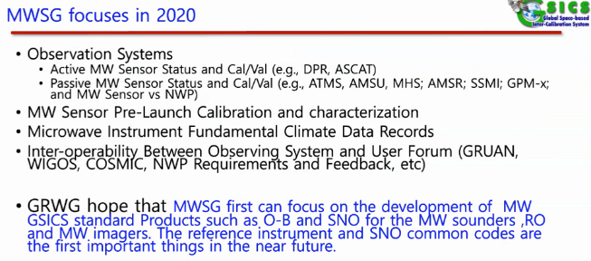

ACTION: (Microwave Subgroup) – Consider the GRWG desire that the Microwave Subgroup can focus on 1) the development of MW GSICS standard products – e.g., O-B and SNO for the microwave sounders, GNSS-RO and microwave imagers, and 2) in the near future the definition of reference instruments and sharing of SNO common codes.

5. ISRO Report
Nothing Microwave-related

6. GDWG Report
Possible Tools that could be used by Microwave Subgroup
- GSICS Plotting Tool at EUMETSAT.
- KMA has established a GitHub to share code.
- GSICS Google Colab Notebook – Python Code, Jupiter Notebooks
- Action tracker on Google Cloud that can read and parse content.
- GSICS Annual Calibration Report Standardization so that information and be reported to CGMS by Mitch.

Note - Google cannot be used by China. Can upload Colab software on the GitHub and run it in your system using Jupiter Notebooks.

ACTION: (Robbie) Get presentation so that the group has the links.

FF. Yu - Will GitHub contain things like spectral response functions or other small data, as well as GDWG tools?
Manik - Yes, we could do that.

7. CMA Report
- Reprocessing of FY-3/Microwave Sounder and Imager
- MWRI FCDR V1/V2 made great progress

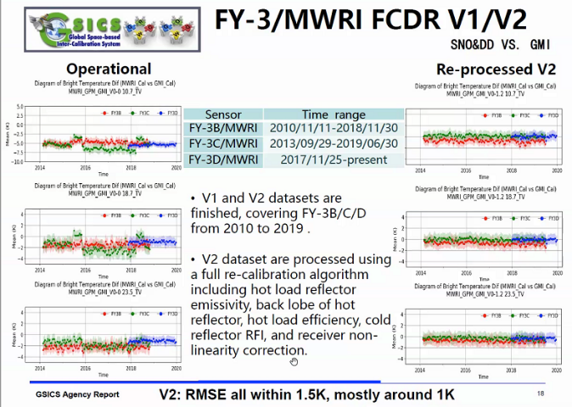

8. ESA Report
- Arctic Weather – A new satellite is planned to be launched that will focus on the Polar Regions. It will contain an instrument that will obtain microwave humidity and temperature soundings (Launch tentatively set at ’23-’24)
- ESA has Small Satellite Missions, but was not clear about which ones.
- FCDR Development - Did not see a microwave time series but the techniques may be useful
- SMOS reprocessing is being performed.

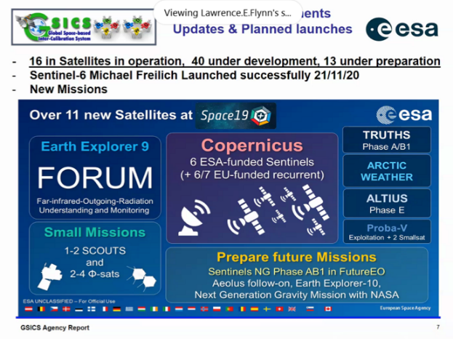

9. CNES Report
Much work on IASI calibration and validation.

10. ISSCP-NG Report
Nothing

DAY 2: Plenary Session (1200UTC-1500UTC)

1. JAXA Agency Report
GOSAT-GW will have AMSR-3, and is to be launch in JFY 2023. It will be the successor of AMSR-2 and have added new high-frequency channels. Its requirements are for long term continuous data set, and to continue real-time forecasting.

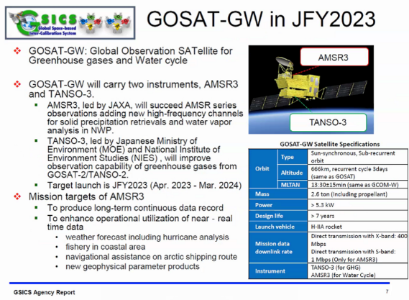

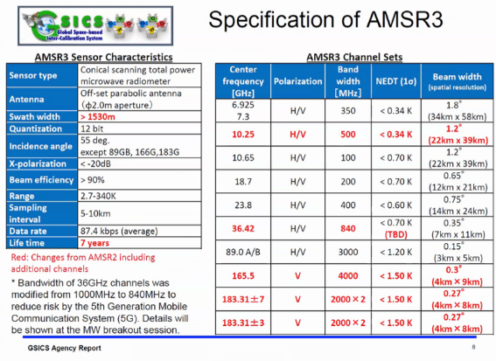

2. JMA agency Report
Nothing Microwave-related

3. ISRO agency Report
Oceansat-3 – Does this contain a microwave instrument?
It has a scatterometer.

4. EUMETSAT Agency Report
METOP-SG A: Will Have Microwave Sounding
METOP-SG B: Will Have Microwave Imagery

Temperatures beyond the blackbody target temperature can have large biases. ‘Hot Land’ biases.

A great deal of work has been performed on FCDRs.
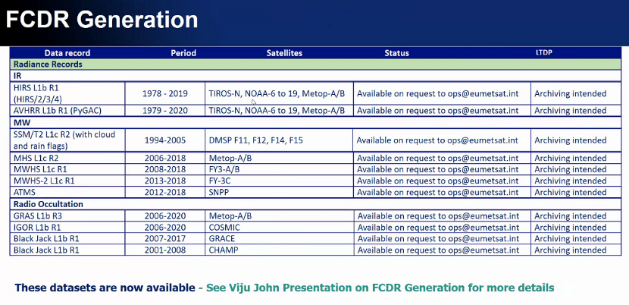

5. Cooperation Between GSICS and NWP
How does GSICS forge links with the NWP community? Want to create more points of contact with the NWP community.

GSICS-NWP Community Commonalies
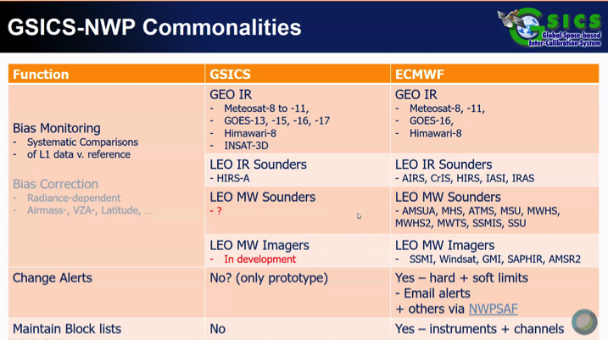

Both GSICS and NWP communities track the radiometric biases.
- GSICS uses reference instruments.
- For NWP the radiance or brightness temperature bias figured using NWP output and radiative transfer. NWP biases contain bias in RTM and NWP output.

It was made clear that bias monitoring in the microwave imagers and sounder GSICS is not being done officially.

Tim makes the point that the NWP community could use GSICS corrected observations without bias correction. Is it possible to do this with the microwave data?

Exchange data.

What can the NWP and GSICS communities work together on?

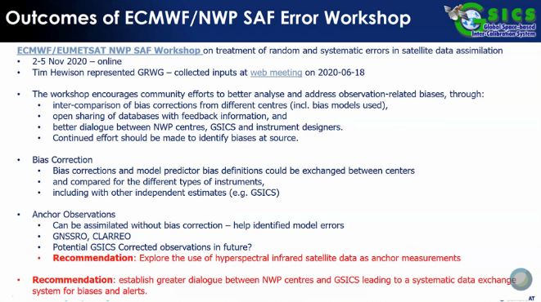

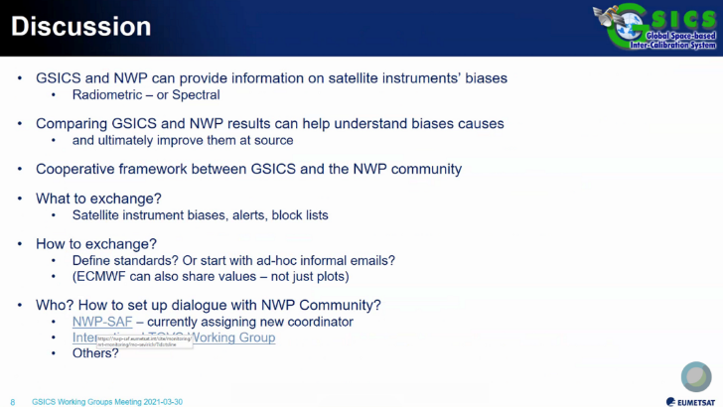

6. FCDR Generation
- Only microwave humidity sounders.
- Uncertainty characterization is determined using FIDUCIO.

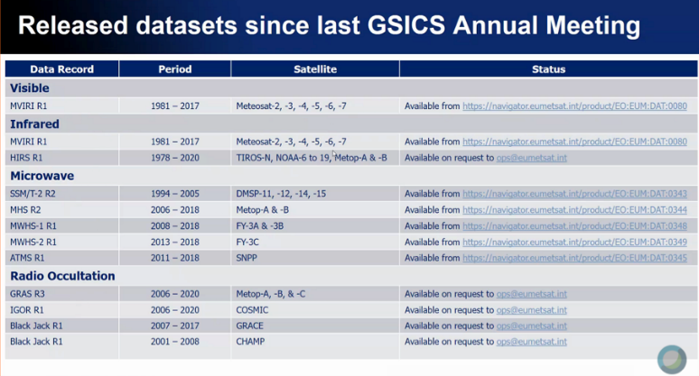

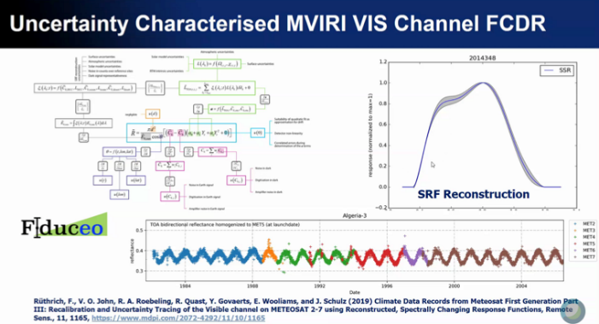

7. ROSHYDROMET Agency Report
METEOR-M has a microwave instrument MTVZA-GY.

8. NIST Agency Report
Nothing Microwave-related

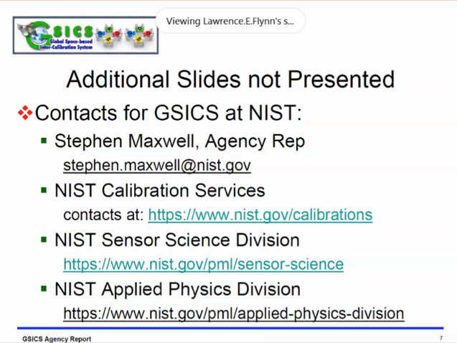

ACTION: Steven Maxwell to connect Robbie with the NIST microwave group.
Completed the same day.

9. NASA Agency Report
CubeSat and SmallSat activities.

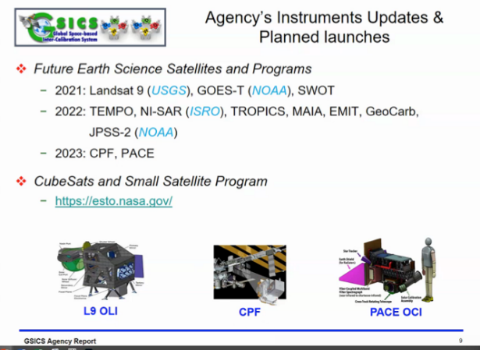

10. NOAA Agency Report

Information about the activities are given that will be repeated in the Microwave Subgroup Breakout Meeting.

DAY 3: Microwave Subgroup Breakout Session (1100UTC-1500UTC)
The agenda, presentations, and meeting minutes can be found at the GSICS Wiki at:
http://gsics.atmos.umd.edu/bin/view/Development/BreakoutMicrowaveSubgroup20210331

DAY 5: Plenary Session (1130UTC-1500UTC)

1. GRWG MW Report Out (Co-Chairs - Qifeng Lu, CMA and Mark Liu, NOAA)

Sebastien Wagner – Mentioned a report that outlined future microwave work in Lunar calibration. He said to refer to that for possible collaborative actions that have already been established. They can be found in the following links:
http://gsics.atmos.umd.edu/pub/Development/LunarCalibrationWS2020/GSICSLunarActivities_Microwave_Memo.pdf
http://gsics.atmos.umd.edu/pub/Development/LunarCalibrationWS2020/Summary%20-%20Virtual%20Third%20Lunar%20Calibration%20Workshop%20-%202020%20for%20distribution.pdf
http://gsics.atmos.umd.edu/bin/view/Development/LunarCalibrationWS2020

Tim Hewison – I did not see any plans to development of near-real time GSICS products. Do you plan to do this?

Mark Liu - We will have a workshop in May or June, and it will be talked about there.

Tim Hewison – This meeting seems to be focused on future sensors?

Mark Liu - It will also cover current sensors.

Tim Hewison – I would like to know more details on the following MWSG action to “Draft review document for on-orbit and near future scatterometers – who will lead this and when? This relates to the following CGMS action:
GSICS, Ocean Surface Vector Winds (OSVW) WGII/4 WGII/A48.10: OSVW to present at next GSICS meeting the potential and potential benefits and issues of cross-calibration of scatterometer data (at the GSICS annual meeting).
2021 Jan: OSVW group to be invited to the next GSICS meeting.
2021 11 Mar: OSVW have been invited?

5. State of the Observing System (Mitch Goldberg, NOAA)

The GSICS State of the Observing System report: Communicates regular status of inter-calibration methods and reference sensors.

This report is getting more complex, so if would be good if it could be broken down. Ideas:
- Could transmit this GSICS State of the Observing System through the GSICS Quarterly Newsletter
  - Each quarterly could focus on a certain class of methods or instruments – e.g., LEO-LEO, GEO-LEO, VISNIR, IR, MW, etc.
  - Each Subgroup could report this information in an article once per year
- Every five years it is thought that we could create a journal paper.

8. GCC Report (Larry Flynn, NOAA)

ACTION: A.GIR.2020319.7 - Manik Bali (NOAA) to review guidance in the definition of time_coverage_start and end variables in the GSICS netCDF convention - needs to be considered by all Subgroup Chairs.

ACTION: Need to update our action items in the Annual Meeting agenda under the GW Breakout tab.

ACTION: Add more info of about Focal Points – e.g., specialty of individuals - on the Focal Point List in the GSICS WMO Web Site.
The process for each GPRC is to contact the GRWG Chair with a list of GRWG members and information about their specialties.

ACTION: Spectral Response Functions: Subgroups need to consider what spectral response information that they need and what they are willing to work with in terms of formats.

