Response to Manik Bali of NOAA, who kindly reviewed JMA’s Himawari-8/AHI Infrared Inter-calibration with Metop/IASI and Aqua/AIRS
First of all, thank you very much for your valuable comments! Please take a look of the following reply in blue.
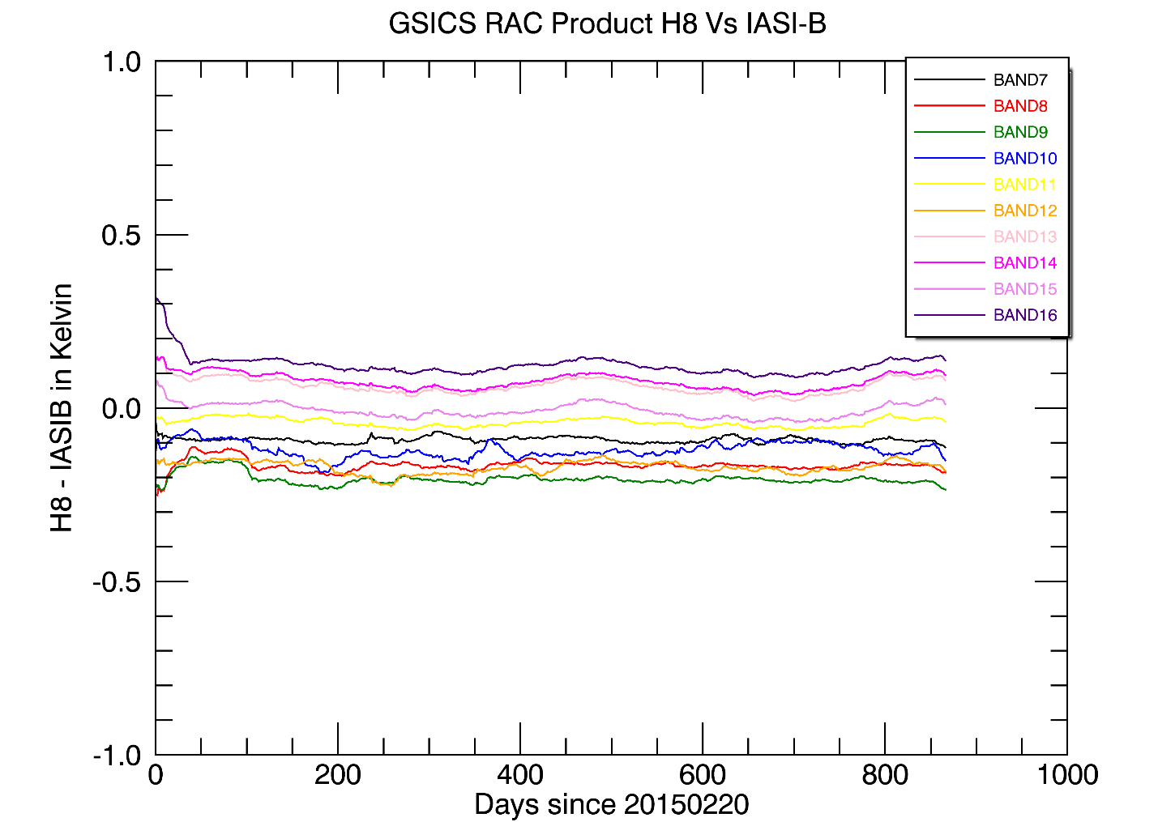
Figure above shows the bias of H8 wrt IASIB on the standard scene. Product captures the biases for all the channels very well.
Thank you!

Filename : Himawari8 or Himawari-8 ( as in OSCAR).
From our discussions on filenaming that you have summarized at (http://gsics.atmos.umd.edu/bin/view/Development/FilenameConvention) we concluded that we either use the OSCAR standard or the agency accepted name. By that argument the Himawari8 that you have used is correct if we take the argument of agency accepted name.
A minus (-) sign has a special meaning in the WMO filenaming convention, so we need to omit the minus from satellite/sensor name. I decided to use Himawari8 in the GSICS Correction’s filenaming because Himawari-8 is the official satellite name.
However the lesson learnt from a recent review of the KMA , COMS product is that future COMS could be COMS-2 and what we recently reviewed is COMS-1. On the OSCAR it is stated as COMS-1. So KMA would have been better off if they used COMS-1( the OSCAR stated) instead of COMS.
So this is not a show stopper but a suggestion to consider.
My understanding is that COMS is the official name even though COMS-1 is used in the OSCAR. For example, please refer to the CGMS Working Paper this year (http://www.cgms-info.org/Agendas/GetWpFile.ashx?wid=aa7379c9-d381-4f44-bbc9-e73f6af9282c&aid=b284c37a-f6ed-40af-a9cf-cfbf593c583a) and KMA’s website: http://nmsc.kma.go.kr/html/homepage/en/ver2/static/selectStaticPage.do?view=satellites.coms.choll_info. Their next GEO satellites are GEO-COMPSAT-2A and -2B (GK-2A and GK-2B). It might be good to ask KMA (Dohyeong Kim) to check the name used in the OSCAR.

date = 1425600000, 1425686400…. seconds
This should be the start date in seconds since 1970-1-1). Seconds calculations from 1970-1-1 to "2015-02-20 yield 1,424,390,400. Which is an offset of -14 days. Also the validity_period= 1424390400 which seems to be correct.
Thank you for pointing this. Our current implementation might be confusing because the timestamp in the filename is a little bit tricky. First of all, Global Attribute window_period represents the period of time for statistics. "P-14D+14D" and "P-14D+0D" are currently used for RAC and NRTC, respectively. This means that the valid periods of the inter-calibration results are:
- From Variable date – 14 days to Variable date + 14 days in the case of RAC, and
- From Variable date – 14 days to Variable date + 0 day in the case of NRTC.
Currently, “Variable date – 14 days” is used for the RAC filenaming whereas “Variable date + 0 day” is used for the NRTC filenaming. In 2013, I asked Aleksandar Jelenak, who was the GDWG chair, and received the following comment. JMA’s current implementation follows his opinion and EUMETSAT implementation.
The possible issue is that this information is not available on the Wiki, and it might not be a consensus of the all GDWG members. I would like to discuss this issue at gsics-dev/web meeting/face-to-face meeting.
-------------------------------------------------------------------------------------------------------------------------------------
Aleksandar Jelenak - NOAA Affiliate <aleksandar.jelenak@noaa.gov> wrote on 2013/06/03 23:10:20:
> From: Aleksandar Jelenak - NOAA Affiliate <aleksandar.jelenak@noaa.gov>
> To: m_takahashi@met.kishou.go.jp,
> Cc: Peter.Miu@eumetsat.int , hosaka@met.kishou.go.jp, Tim.Hewison@eumetsat.int
> Date: 2013/06/03 23:10
> Subject: Re: To combine JMA RAC Products
>
> Hello Masaya,
> On Mon, Jun 3, 2013 at 7:48 AM, <m_takahashi@met.kishou.go.jp> wrote:
> >
> > A) yyyyMMddhhmmss of GSICS netCDF file name
> > [...]
> > It seems that the yyyyMMddhhmmss definition of GSICS Correction netCDF file depends on its
> > producers. Namely, time_coverage_start is used for EUMETSAT and product, while central day of
> > regression is used for JMA product. I could not find the definition on the GSICS wiki, but I think
> > the same yyyyMMddhhmmss is preferable for users to avoid confusion. What do you think about it?
>
> My personal opinion is that the central day of regression is appropriate for files with a single
> correction. If a file have more than one then the time_coverage_start is the best choice.
>
> -Aleksandar
-------------------------------------------------------------------------------------------------------------------------------------

:geospatial_lat_min = -30.f ;
:geospatial_lat_max = 30.f ;
:geospatial_lon_min = 115.f ;
:geospatial_lon_max = 175.f ;
I think the Himawari-8 should be centered around its parking longitude 140 .7E
Yes, Himawari-8 is located around 140.7 E. These Global Attributes represent the applicability region of the file's data by defining a bounding box as a simple lat/lon rectangle. Our current implememtation, +/- 30 degrees from satellitet’s sub-satellite point, is too strict, so I would expand the domain. Namely, geospatial_lat_min: -90.0, geospatial_lat_max: 90.0, geospatial_lon_min: 50.0, and geospatial_lon_max: -140.0 (i.e. SSP +/- 90 degrees).
Just for your information, the values in the SEVIRI GEO-LEO-IR are global (i.e. geospatial_lat_min: -90.0, geospatial_lat_max: 90.0, geospatial_lon_min: -180.0, and geospatial_lon_max: 180.0).

What is correction_info?
This is JMA’s optional variable which show what kinds of quality controls are applied in the collocation and data screening. However, invalid values (i.e. -1) are used at this stage. I would like to decide whether we should keep this variable before applying this product to Pre-Op Phase. If we keep this, we would make a note in the User’s Guide, which will also be prepared before submitting the product to Pre-Op Phase.
:correction_info
missing_value: -1
long_name: unique reference id selection criteria set
standard_name: Ancillary_information_about_corrections
flag_masks: 3, 12, 48, 192, 768, 3072, 12288, 49152, 196608, 786432, 3145728
flag_meanings: smoothing time_of_day lat lon cloudy surface inc_ang azi_ang pol_ang sol_zen_ang sol_azi_ang

Last but not least, the same inter-calibration algorithm is applied to AHI and MTSAT-2/Imager even though their sensor configurations are not the same (e.g. AHI has 10 infrared bands (3.9, 6.2, 6.9, 7.3, 8.6, 9.6, 10.4, 11.2, 12.4, 13.3 micron) whereas MTSAT-2/Imager has 4 channels (3.8, 6.8, 10.8, 12.0 micron)). However, very stable brightness temperature biases in all the AHI infrared bands represents that this inter-calibration algorithm works well for the new spectral domain of AHI.
It should also be noted that the MTSAT-2/Imager GEO-LEO-IR GSICS Correction has been in Demonstration Phase since July 2010. This fact could accelerate the reviewing process of the submission of AHI GEO-LEO-IR to Demonstration Phase.

Sincerely,
Masaya Takahashi, JMA (2017-08-31)

