JET PROPULSION LABORATORY INTEROFFICE MEMORANDUM
AIRS ADF#949
January 28, 2019
To: Tim Hewison (EUMETSAT)
From: T. Pagano
CC: S. Broberg, H. Aumann, E. Manning, W. Mathews, C. Wilson, K. Overoye
Subject: AIRS V5 Radiometric Accuracy Update

This memo provides input to the Global Space-based InterCalibration System (GSICS) community report titled the IR Reference Uncertainty & Traceability Report. The input consists of theoretical basis and current estimates of the radiometric uncertainty of AIRS along with a table in the GSICS community preferred format.
The information can be posted on the GSICS website at
http://gsics.atmos.umd.edu/wiki/Home
Please contact me if you have any questions/revisions.

AIRS
The Atmospheric Infrared Sounder (AIRS) is a hyperspectral infrared grating spectrometer instrument on the EOS Aqua Spacecraft, launched on May 4, 2002. AIRS has 2378 infrared channels ranging from 3.7 μm to 15.4 μm and a 13.5 km footprint. The AIRS instrument incorporates numerous advances in infrared sensing technology to achieve a high level of measurement sensitivity, precision, and accuracy . This includes a temperature-controlled spectrometer (157K) and long-wavelength cutoff HgCdTe infrared detectors cooled by an active-pulse-tube cryogenic cooler. It is this temperature control that is most likely responsible for the observed stability in the instrument. The Focal Plane Assembly (FPA) contains 12 modules with 15 individual PV HgCdTe line arrays of detectors in a 2 x N element arrays where N ranges from 94 to 192 for PV HgCdTe, and 2 PC HgCdTe arrays with 1 x 144, 1 x130 elements. The AIRS acquires 2378 spectral samples at resolutions, λ/Δλ, ranging from 1086 to 1570, in three bands: 3.75 µm to 4.61 µm, 6.20 µm to 8.22 µm, and 8.8 µm to 15.4 µm.
The radiometric accuracy estimate provided here for AIRS assumes spatially uniform and spectrally flat scenes since spatial and spectral errors are scene dependent. Further discussion on these error sources is provided below. The stability of AIRS is much better than the accuracy. For further information on the radiometric stability, please consult the literature.
The radiometric accuracy for AIRS can be determined by combining the error contributions from all the terms in the radiometric transfer equation (conversion of counts to radiance). The radiometric transfer equations are derived from the design of the AIRS instrument and the measurement approach as discussed in the literature. These radiometric transfer equations form the basis of the Level 1B calibration for AIRS. The scene radiance is computed as a second order polynomial in counts with a term in the denominator due to the mirror polarization.
$L_{ev}=L_{o}\left(θ\right)+\frac{c_{1}'\left({dn}_{ev}-{dn}_{sv}\right)+c_{2}{\left({dn}_{ev}-{dn}_{sv}\right)}^{2}}{\left[1+p_{r}p_{t}cos2\left(θ-δ\right)\right]}$ (1)
$L_{o}\left(θ\right)=\frac{L_{sm}p_{r}p_{t}\left[cos2\left(θ-δ\right)+cos2δ\right]}{\left[1+p_{r}p_{t}cos2\left(θ-δ\right)\right]}$ (2)
$c_{1}'=\frac{\left[ε_{obc}P_{obc}-L_{o}\left(180°\right)\right]\left[1+p_{r}p_{t}cos2δ\right]-c_{2}{\left({dn}_{obc}-{dn}_{sv}\right)}^{2}}{\left({dn}_{obc}-{dn}_{sv}\right)}$ (3)
where
L_{ev} = Spectral Radiance in the Earth Viewport (W/m²-sr-μm)
L_{o}(θ) = Polarized Mirror Emission Offset. (W/m²-sr-μm)
c₀ = Instrument offset (W/m²-sr- μm)
c₁ = Instrument gain (W/m²-sr- μm-counts)
c₂ = Instrument nonlinearity (W/m²-sr- μm-counts²)
dn_{ev} = Digital counts while viewing Earth for each footprint and scan (counts)
dn_{sv} = Digital counts while viewing Space for each scan (counts)
p_{r}p_{t} =Product of scan mirror and spectrometer polarization diattenuation (unitless)
θ = Scan Angle measured from nadir (radians)
δ = Phase of spectrometer polarization (radians)
L_{sm} = Spectral Radiance of the Scan Mirror for Unity Emissivity at T_{sm} (W/m²-sr-μm)
ε_{obc} = Effective Emissivity of the blackbody
P_{obc} = Plank Blackbody function of the OBC blackbody at temperature T_{obc} (W/m²-sr-μm)
T_{obc} = Telemetered temperature of the OBC blackbody (K) with correction of +0.3K.
dn_{obc} = Digital number signal from the AIRS while viewing the OBC Blackbody

The method we use to determine the uncertainty of the computed Earth radiance is to numerically compute the change in radiance due to a perturbation of each of the terms in the radiative transfer equation. Each term is perturbed based on the 1-sigma uncertainty for that term for Version 5. The median radiometric uncertainty for each of the AIRS 17 modules vs scene temperature is shown in Figure 1 for the assumptions listed in in Table 1. Also shown in Table 1 is the predicted 1-sigma uncertainty for the module centered at 9.14 μm. Figure 2 shows the contributors to uncertainty for each module.
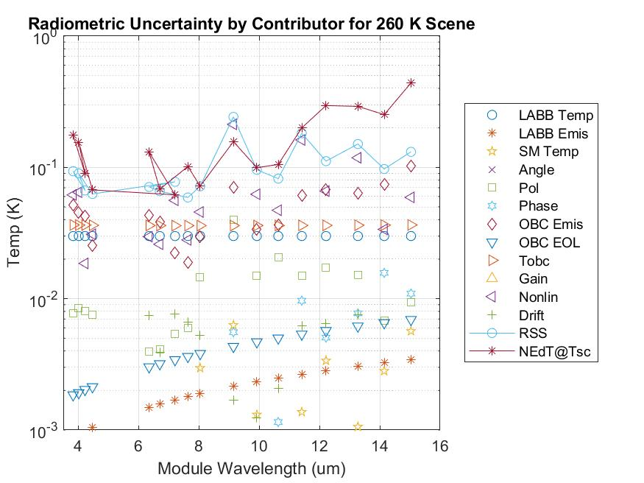
Figure 2: Contribution of each of the error sources at a scene temperature of 260K for each module.
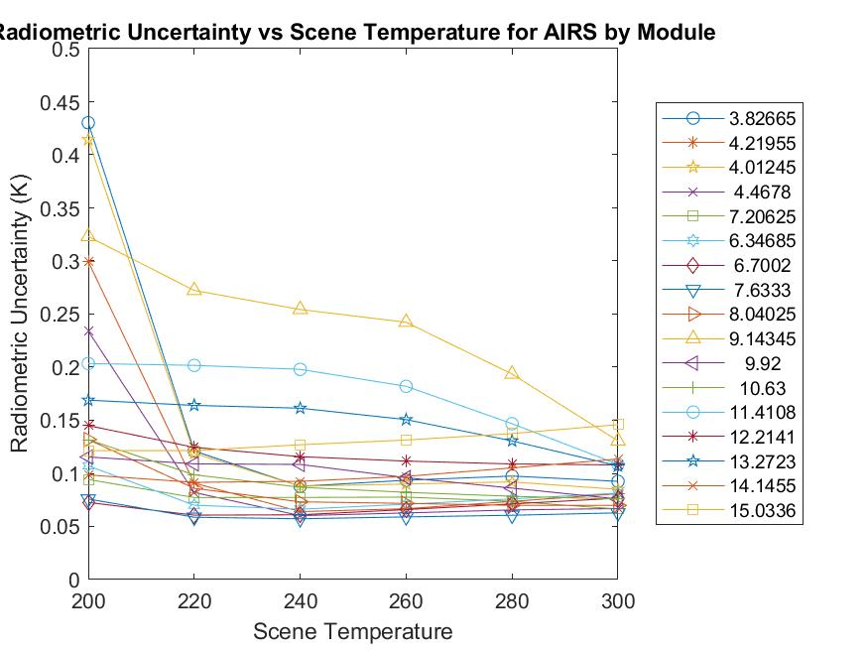
Figure 1: Radiometric Uncertainty vs Temperature for each of the AIRS 17 modules at center wavelength identified in the legend.

Table 1. Contributors to radiometric uncertainty in AIRS and computed uncertainty for the module centered at 9.14 μm for a scene temperature of 260K. All values are 1-sigma
Parameter | 1-σ  Parameter  Uncty | 1-σ  Radiometric  Uncty (K)
Version | V5 | V5
Uncertainty in LABB Temperature | 0.03K | 0.03K
Uncertainty in LABB Emissivity | 0.00005 | 0.002K
Uncertainty in Scan Mirror Temperature | 1.25K | 0.006K
Uncertainty in Polarization Amplitude | .0009 | 0.04K
Uncertainty in Polarization Phase | .08 | 0.005K
Uncertainty in OBC Blackbody Emissivity | .002 | 0.07K
Uncertainty in OBC Blackbody Emissivity (EOL) | 0.0001 | 0.004K
Uncertainty in OBC Blackbody Temperature | 0.05K | .04K
Uncertainty in Nonlinearity | 2.7%* | 0.21K
Uncertainty in drift in space view | 0.04dn | 0.001K
Total Uncertainty at 260K |  | 0.24K
*Expressed as a percentage of the radiance at L_{sat}

Scan Mirror Temperature and Angle
The AIRS scan mirror temperature is monitored using a non-contacting temperature sensor located at the base of the rotating shaft. The uncertainty in the scan mirror temperature is estimated to be about 0.5K 1-sigma by design, although in-flight analysis shows this number could be off by as much as 2.5K. We carry 1.25K 1-sigma to allow for this uncertainty. The radiometric uncertainty analysis assumes a nominal scan angle of 0°. The scan mirror angle uncertainty is 1 part in 2¹⁶ due to the encoder and its contribution to the radiometric uncertainty is negligible.

Mirror reflectivity - including any polarization effect
As reflected in the calibration equations, the AIRS experiences a coupling between the polarization of the scan mirror and the polarization of the spectrometer (dominated by the grating). The coupling modulates the scene radiance slightly (see equation 1), but also leaves a residual error due to the mirror emission that is different when looking in the space view than it is in the Earth view and OBC blackbody view (see equation 2). The correction requires good knowledge of the product of the polarization factor of the scan mirror (p_{r}) and the spectrometer (p_{t}) and the phase angle between them (δ).
For Version 5, we had individual measurements of the polarization of the scan mirror and completed spectrometer as well as a model that computed the polarization from measurements at the component level. The two models agreed well, except in the longest wavelengths. The approach taken for V5 was to average the measured and component results leaving the 1-sigma uncertainty as the difference between the two divided by the square root of 2. The phase in V5 was assumed to be zero. We know now that not to be the case, so we carry our current estimate for the uncertainty of the phase from V5 divided by the square root of 2 as the 1-sigma magnitude of the phase we computed for V7k.

Black body emissivity and temperature
The effective blackbody emissivity is computed by fitting the LABB linearity data preflight and solving for the coefficients c_{i}. The coefficients are then used in equation 3 to solve for the emissivity. The process is performed on 4 tests obtained preflight: A side electronics, B side electronics for the LABB at nadir and at 40°. The data showed high emissivity but no consistency between the A side, B side, nadir or 40°. The uncertainty is the standard deviation of the emissivity over the 4 tests calculated for each channel. The uncertainty calculated this way is less than 0.002 for all cases and is consistent with the theoretical emissivity of the OBC blackbody of 0.9985. The estimated degradation at end of life from our prior analysis is also included in the current radiometric uncertainty estimate and is estimated to be 0.0001 1-sigma. Temperature uncertainty of the OBC is estimated to be <0.05K 1-sigma based on knowledge of the temperature sensor calibration.

Non-linearity
Nonlinearity is computed by fitting the LABB linearity data preflight to a second order polynomial. The nonlinearity was computed for the four test mentioned in the prior section. The uncertainty for each side is the difference between the standard deviation of the nadir and 40° data. For V5, only a single coefficient is used for the A and B sides, so the the nonlinearity uncertainty is taken as the average over both A side and B sides RSS’d with the difference between A and B coefficients.

Drift in the Space View
Since the AIRS instrument calibrates once per scan line, we must consider the drift of the offset between calibrations. A measure of this drift was made during the space view noise special test performed pre-launch and in orbit. The drift is calculated as the space view counts at the end of the period (over 600 scans) minus the counts at the start divided by the number of scans in the test period. Drift counts can be as high as 0.2-0.6 dn, but usually is not a big contributor. Half the measured drift is converted to a radiometric temperature error using the instrument nominal gain.

Pre-launch Validation Tests with external black body
The Large Area Blackbody (LABB) is a wedge cavity design used as a warm target during pre-flight testing. The LABB contributes to the overall AIRS accuracy. The LABB is coated with Aeroglaze Z-302 and the emissivity is estimated to be better than 0.9999. We use 0.00005 1-sigma for the uncertainty in the analysis. The requirement flowed down to the manufacturer (Bomem) in 1996 was a temperature knowledge of 30mK 1-sigma and is achieved for most scene temperatures. The LABB uses NIST traceable 162D PRTs manufactured by Rosemount Aerospace with serial numbers #4218 & #4219.
The Space View Blackbody (SVBB) is of similar construction to the LABB with similar emissivity (0.9999) and somewhat larger temperature uncertainty. Since the SVBB operates at liquid nitrogen temperatures its contribution to the radiometric uncertainty of emissivity and nonlinearity should be small and is ignored in the analysis.
The following factors do not contribute to the radiometric uncertainties stated above.

Radiometric noise (including calibration data)
Noise is not included in the radiometric uncertainty estimate as it averages to zero bias over time. Individual samples must consider the noise. Radiometric sensitivity is expressed as the Noise Equivalent Temperature Difference (NEdT) for a scene temperature of 250K. The NEdT for AIRS are measured by interpolating the noise while viewing cold space and the OBC at 308K. The NEdTs for AIRS are shown in Figure 7 pre-flight and in-orbit. Additional noise characterization is performed by locking the AIRS scan mirror the calibration target for nominally 20 minutes while data are collected. Figure 8 shows the ratio of the uncorrelated noise to the correlated noise. Both random and correlated noise are not included in the radiometric accuracy estimates, but should be considered when using AIRS data for scientific investigations.
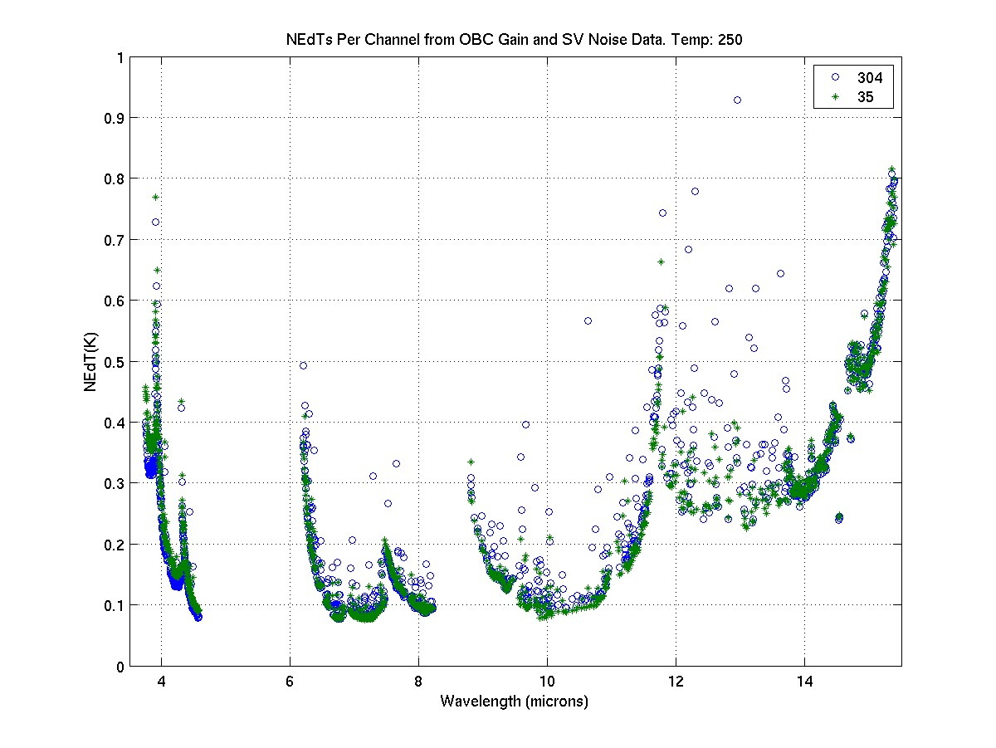
Fig. 7: NEdTs for AIRS at 250K measured pre-launch (304) and in orbit (35)

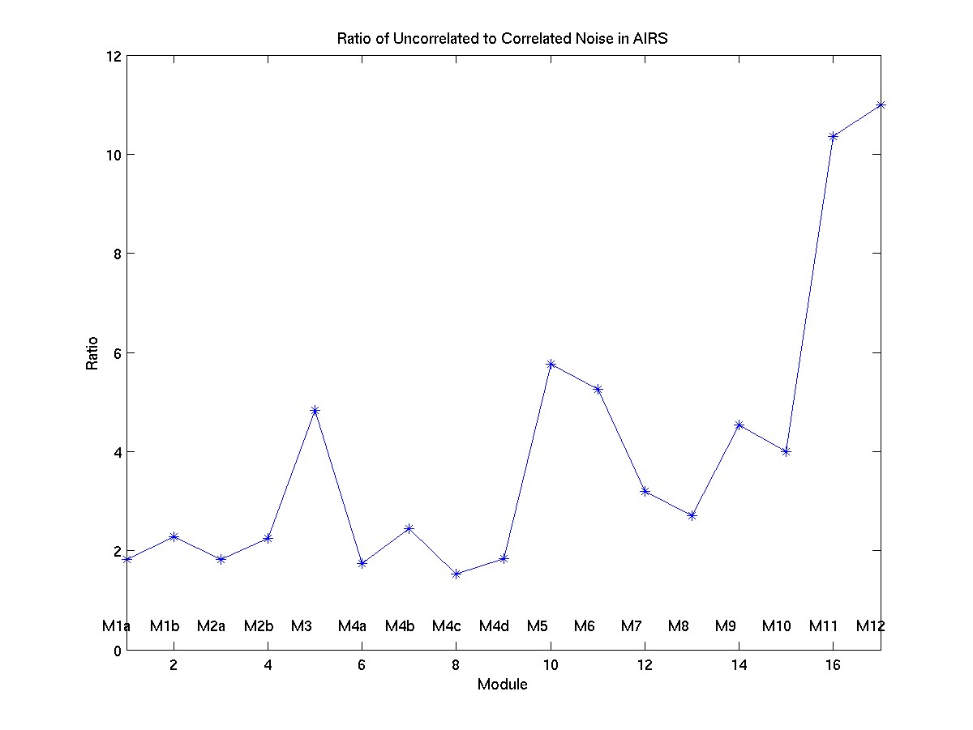
Fig. 8: Ratio of the uncorrelated noise to the correlated noise in the 17 airs arrays.

Spectral Calibration
Radiometric uncertainty stated above for AIRS assumes a spectrally flat scene since spectral errors are scene dependent. Users should be aware of the spectral accuracy of AIRS (<10ppm of the center frequency) as they use the radiances. The AIRS achieves spectral channel definition using a grating spectrometer. As the temperature of the instrument changes, small alignment changes occur between the spectrometer and focal plane that will shift the frequencies of the instrument. The upwelling spectrum provides a wealth of atmospheric absorption lines that have been used to calibrate the spectral shift. The shift as a function of time is performed by correlating the AIRS spectra and spectra computed based on ECMWF model fields. The correlations are performed separately for each AIRS module, with sufficient spectral structure. The final frequency shift is derived from a single module with very high-quality spectral features (a water vapor module) that correlates extremely well with modules only sensitive to carbon dioxide line emission. We see a steady shift in the position of the FPA, covering about 1 μm (or 1% of the width, or about 10 ppm of the center frequency) over the life of the mission, or about 0.5% of the width since the first major shutdown in late 2003. In the last five years the system has been extremely stable showing less than 0.25% of the width shift of the centroids. Frequencies are available at the UMBC Atmospheric Spectroscopy Laboratory website: http://asl.umbc.edu/pub/airs/srf/.
    - Geometric factors
Again, the radiometric uncertainty of the instrument assumes a spatially homogenous overfilled instantaneous field of view of the instrument. In fact, every spectral pixel in AIRS has a slightly different two dimensional spatial response. This can significantly impact the radiances in non-uniform scenes. This effect can be seen as discontinuities in the spectra at channels that overlap from different orders on ends of the modules. If sensitivity to channel coregistration is a concern then use the Sceneinhomogeneous flag, the Rdiff_swindow and Rdiff_lwindow flags and/or the radiances themselves to restrict data selection to uniform scenes where co registration is not an issue.
Geolocation accuracy of the AIRS on the Aqua is estimated to be better than 1km as determined by coastline crossings shortly after launch and confirmed using radiometric techniques later in the mission.
    - Uncertainty Estimate Table
 |  |  | 1-Sigma Uncertainty dTb [K]
Pseudo Channel [cm-1] | Min Freq [cm-1] | Max Freq [cm-1] | 200 | 220 | 240 | 260 | 280 | 300
655 | 650 | 660 | 0.14 | 0.14 | 0.15 | 0.15 | 0.15 | 0.16
665 | 660 | 670 | 0.12 | 0.12 | 0.13 | 0.13 | 0.14 | 0.15
675 | 670 | 680 | 0.10 | 0.11 | 0.11 | 0.12 | 0.13 | 0.13
685 | 680 | 690 | 0.11 | 0.10 | 0.11 | 0.12 | 0.12 | 0.14
695 | 690 | 700 | 0.10 | 0.10 | 0.10 | 0.11 | 0.11 | 0.12
705 | 700 | 710 | 0.10 | 0.09 | 0.09 | 0.10 | 0.10 | 0.11
715 | 710 | 720 | 0.10 | 0.09 | 0.09 | 0.10 | 0.11 | 0.12
725 | 720 | 730 | 0.10 | 0.09 | 0.09 | 0.09 | 0.10 | 0.10
735 | 730 | 740 | 0.17 | 0.16 | 0.15 | 0.14 | 0.11 | 0.09
745 | 740 | 750 | 0.17 | 0.18 | 0.18 | 0.17 | 0.15 | 0.13
755 | 750 | 760 | 0.17 | 0.17 | 0.17 | 0.16 | 0.13 | 0.09
765 | 760 | 770 | 0.14 | 0.14 | 0.14 | 0.13 | 0.11 | 0.10
775 | 770 | 780 | 0.17 | 0.18 | 0.18 | 0.17 | 0.15 | 0.13
785 | 780 | 790 | 0.16 | 0.13 | 0.12 | 0.11 | 0.10 | 0.10
795 | 790 | 800 | 0.19 | 0.15 | 0.13 | 0.12 | 0.12 | 0.12
805 | 800 | 810 | 0.13 | 0.11 | 0.10 | 0.10 | 0.09 | 0.10
815 | 810 | 820 | 0.11 | 0.11 | 0.10 | 0.10 | 0.10 | 0.11
825 | 820 | 830 | 0.10 | 0.10 | 0.10 | 0.11 | 0.10 | 0.10
835 | 830 | 840 | 0.11 | 0.10 | 0.10 | 0.10 | 0.10 | 0.10
845 | 840 | 850 | 0.15 | 0.14 | 0.13 | 0.14 | 0.13 | 0.13
855 | 850 | 860 | 0.31 | 0.28 | 0.27 | 0.25 | 0.21 | 0.17
865 | 860 | 870 | 0.23 | 0.23 | 0.23 | 0.21 | 0.17 | 0.11
875 | 870 | 880 | 0.20 | 0.20 | 0.19 | 0.18 | 0.14 | 0.10
885 | 880 | 890 | 0.14 | 0.15 | 0.15 | 0.14 | 0.11 | 0.09
895 | 890 | 900 | 0.10 | 0.10 | 0.11 | 0.10 | 0.09 | 0.09
905 | 900 | 910 | 0.09 | 0.09 | 0.10 | 0.10 | 0.10 | 0.10
915 | 910 | 920 | 0.09 | 0.07 | 0.06 | 0.06 | 0.06 | 0.07
925 | 920 | 930 | 0.13 | 0.10 | 0.09 | 0.08 | 0.08 | 0.07
935 | 930 | 940 | 0.12 | 0.09 | 0.08 | 0.08 | 0.07 | 0.07
945 | 940 | 950 | 0.14 | 0.10 | 0.09 | 0.08 | 0.08 | 0.08
955 | 950 | 960 | 0.15 | 0.12 | 0.11 | 0.11 | 0.11 | 0.09
965 | 960 | 970 | 0.13 | 0.10 | 0.09 | 0.08 | 0.08 | 0.08
975 | 970 | 980 | 0.10 | 0.08 | 0.07 | 0.07 | 0.07 | 0.07
985 | 980 | 990 | 0.12 | 0.08 | 0.07 | 0.07 | 0.07 | 0.07
995 | 990 | 1000 | 0.10 | 0.07 | 0.07 | 0.06 | 0.06 | 0.06
1005 | 1000 | 1010 | 0.15 | 0.10 | 0.08 | 0.08 | 0.07 | 0.06
1015 | 1010 | 1020 | 0.10 | 0.08 | 0.08 | 0.07 | 0.07 | 0.06
1025 | 1020 | 1030 | 0.07 | 0.07 | 0.08 | 0.08 | 0.07 | 0.07
1035 | 1030 | 1040 | 0.11 | 0.12 | 0.12 | 0.11 | 0.10 | 0.08
1045 | 1040 | 1050 | 0.13 | 0.12 | 0.12 | 0.12 | 0.10 | 0.08
1055 | 1050 | 1060 | 0.47 | 0.33 | 0.28 | 0.25 | 0.19 | 0.13
1065 | 1060 | 1070 | 0.33 | 0.26 | 0.24 | 0.22 | 0.18 | 0.12
1075 | 1070 | 1080 | 0.29 | 0.29 | 0.30 | 0.28 | 0.23 | 0.14
1085 | 1080 | 1090 | 0.23 | 0.22 | 0.23 | 0.22 | 0.18 | 0.12
1095 | 1090 | 1100 | 0.22 | 0.18 | 0.17 | 0.16 | 0.13 | 0.10
1215 | 1210 | 1220 | 0.14 | 0.09 | 0.08 | 0.08 | 0.07 | 0.07
1225 | 1220 | 1230 | 0.14 | 0.09 | 0.07 | 0.07 | 0.07 | 0.07
1235 | 1230 | 1240 | 0.14 | 0.09 | 0.07 | 0.07 | 0.07 | 0.07
1245 | 1240 | 1250 | 0.15 | 0.10 | 0.08 | 0.08 | 0.07 | 0.07
1255 | 1250 | 1260 | 0.13 | 0.09 | 0.08 | 0.08 | 0.07 | 0.07
1265 | 1260 | 1270 | 0.08 | 0.07 | 0.07 | 0.07 | 0.07 | 0.06
1275 | 1270 | 1280 | 0.08 | 0.06 | 0.06 | 0.06 | 0.06 | 0.06
1285 | 1280 | 1290 | 0.08 | 0.06 | 0.05 | 0.06 | 0.06 | 0.06
1295 | 1290 | 1300 | 0.09 | 0.06 | 0.06 | 0.06 | 0.06 | 0.06
1305 | 1300 | 1310 | 0.10 | 0.07 | 0.06 | 0.06 | 0.06 | 0.07
1315 | 1310 | 1320 | 0.10 | 0.07 | 0.06 | 0.06 | 0.06 | 0.06
1325 | 1320 | 1330 | 0.11 | 0.07 | 0.06 | 0.06 | 0.06 | 0.06
1335 | 1330 | 1340 | 0.12 | 0.08 | 0.07 | 0.07 | 0.07 | 0.06
1345 | 1340 | 1350 | 0.13 | 0.08 | 0.07 | 0.07 | 0.07 | 0.07
1355 | 1350 | 1360 | 0.12 | 0.08 | 0.08 | 0.08 | 0.08 | 0.07
1365 | 1360 | 1370 | 0.12 | 0.08 | 0.08 | 0.08 | 0.07 | 0.07
1375 | 1370 | 1380 | 0.12 | 0.09 | 0.08 | 0.08 | 0.07 | 0.06
1385 | 1380 | 1390 | 0.12 | 0.09 | 0.08 | 0.08 | 0.08 | 0.07
1395 | 1390 | 1400 | 0.12 | 0.09 | 0.08 | 0.08 | 0.07 | 0.07
1405 | 1400 | 1410 | 0.11 | 0.08 | 0.07 | 0.07 | 0.07 | 0.06
1415 | 1410 | 1420 | 0.14 | 0.10 | 0.09 | 0.09 | 0.08 | 0.07
1425 | 1420 | 1430 | 0.14 | 0.10 | 0.09 | 0.09 | 0.08 | 0.07
1435 | 1430 | 1440 | 0.13 | 0.08 | 0.08 | 0.07 | 0.07 | 0.07
1445 | 1440 | 1450 | 0.13 | 0.08 | 0.07 | 0.07 | 0.07 | 0.07
1455 | 1450 | 1460 | NaN | NaN | NaN | NaN | NaN | NaN
1465 | 1460 | 1470 | 0.09 | 0.07 | 0.06 | 0.07 | 0.07 | 0.07
1475 | 1470 | 1480 | 0.08 | 0.06 | 0.06 | 0.06 | 0.07 | 0.07
1485 | 1480 | 1490 | 0.07 | 0.06 | 0.06 | 0.06 | 0.07 | 0.07
1495 | 1490 | 1500 | 0.07 | 0.06 | 0.06 | 0.07 | 0.07 | 0.08
1505 | 1500 | 1510 | 0.09 | 0.06 | 0.06 | 0.07 | 0.07 | 0.08
1515 | 1510 | 1520 | 0.11 | 0.07 | 0.07 | 0.08 | 0.08 | 0.08
1525 | 1520 | 1530 | 0.11 | 0.07 | 0.07 | 0.07 | 0.08 | 0.08
1535 | 1530 | 1540 | NaN | NaN | NaN | NaN | NaN | NaN
1545 | 1540 | 1550 | 0.10 | 0.07 | 0.07 | 0.07 | 0.07 | 0.07
1555 | 1550 | 1560 | 0.11 | 0.07 | 0.07 | 0.07 | 0.08 | 0.08
1565 | 1560 | 1570 | 0.11 | 0.07 | 0.07 | 0.07 | 0.08 | 0.08
1575 | 1570 | 1580 | 0.14 | 0.08 | 0.06 | 0.07 | 0.07 | 0.08
1585 | 1580 | 1590 | 0.17 | 0.09 | 0.07 | 0.07 | 0.07 | 0.08
1595 | 1590 | 1600 | 0.19 | 0.09 | 0.07 | 0.07 | 0.07 | 0.08
1605 | 1600 | 1610 | 0.22 | 0.11 | 0.09 | 0.09 | 0.10 | 0.11
2165 | 2160 | 2170 | NaN | NaN | NaN | NaN | NaN | NaN
2175 | 2170 | 2180 | NaN | NaN | NaN | NaN | NaN | NaN
2185 | 2180 | 2190 | 0.28 | 0.09 | 0.07 | 0.07 | 0.07 | 0.07
2195 | 2190 | 2200 | 0.26 | 0.09 | 0.06 | 0.07 | 0.07 | 0.07
2205 | 2200 | 2210 | 0.24 | 0.08 | 0.06 | 0.06 | 0.07 | 0.07
2215 | 2210 | 2220 | 0.30 | 0.10 | 0.06 | 0.06 | 0.07 | 0.07
2225 | 2220 | 2230 | 0.19 | 0.07 | 0.06 | 0.06 | 0.07 | 0.07
2235 | 2230 | 2240 | 0.20 | 0.08 | 0.06 | 0.07 | 0.07 | 0.07
2245 | 2240 | 2250 | 0.19 | 0.07 | 0.06 | 0.06 | 0.07 | 0.07
2255 | 2250 | 2260 | 0.24 | 0.08 | 0.05 | 0.05 | 0.06 | 0.06
2265 | 2260 | 2270 | 0.26 | 0.08 | 0.05 | 0.05 | 0.06 | 0.06
2275 | 2270 | 2280 | 0.29 | 0.09 | 0.05 | 0.05 | 0.06 | 0.06
2285 | 2280 | 2290 | 0.20 | 0.07 | 0.05 | 0.05 | 0.06 | 0.06
2295 | 2290 | 2300 | 0.10 | 0.05 | 0.05 | 0.05 | 0.06 | 0.07
2305 | 2300 | 2310 | 0.14 | 0.06 | 0.06 | 0.07 | 0.07 | 0.08
2315 | 2310 | 2320 | 0.11 | 0.06 | 0.06 | 0.06 | 0.07 | 0.07
2325 | 2320 | 2330 | 0.30 | 0.09 | 0.06 | 0.07 | 0.07 | 0.08
2335 | 2330 | 2340 | 0.22 | 0.08 | 0.07 | 0.07 | 0.08 | 0.09
2345 | 2340 | 2350 | 0.30 | 0.09 | 0.06 | 0.07 | 0.07 | 0.08
2355 | 2350 | 2360 | 0.31 | 0.10 | 0.07 | 0.07 | 0.08 | 0.08
2365 | 2360 | 2370 | 0.38 | 0.11 | 0.06 | 0.06 | 0.07 | 0.08
2375 | 2370 | 2380 | 0.21 | 0.07 | 0.06 | 0.06 | 0.07 | 0.08
2385 | 2380 | 2390 | 0.42 | 0.12 | 0.07 | 0.06 | 0.07 | 0.08
2395 | 2390 | 2400 | 0.28 | 0.09 | 0.06 | 0.07 | 0.08 | 0.09
2405 | 2400 | 2410 | 0.39 | 0.11 | 0.06 | 0.06 | 0.07 | 0.07
2415 | 2410 | 2420 | 0.17 | 0.06 | 0.05 | 0.06 | 0.06 | 0.07
2425 | 2420 | 2430 | 0.27 | 0.08 | 0.06 | 0.06 | 0.07 | 0.08
2435 | 2430 | 2440 | NaN | NaN | NaN | NaN | NaN | NaN
2445 | 2440 | 2450 | 0.46 | 0.13 | 0.08 | 0.08 | 0.08 | 0.07
2455 | 2450 | 2460 | 0.38 | 0.12 | 0.09 | 0.09 | 0.09 | 0.08
2465 | 2460 | 2470 | 0.37 | 0.11 | 0.09 | 0.09 | 0.09 | 0.08
2475 | 2470 | 2480 | 0.22 | 0.09 | 0.08 | 0.08 | 0.08 | 0.09
2485 | 2480 | 2490 | 0.24 | 0.09 | 0.08 | 0.08 | 0.09 | 0.09
2495 | 2490 | 2500 | 0.27 | 0.09 | 0.07 | 0.08 | 0.08 | 0.07
2505 | 2500 | 2510 | 0.28 | 0.09 | 0.08 | 0.08 | 0.08 | 0.07
2515 | 2510 | 2520 | 0.38 | 0.11 | 0.09 | 0.09 | 0.09 | 0.07
2525 | 2520 | 2530 | 0.40 | 0.12 | 0.09 | 0.09 | 0.09 | 0.08
2535 | 2530 | 2540 | 0.33 | 0.12 | 0.11 | 0.11 | 0.11 | 0.09
2545 | 2540 | 2550 | 0.75 | 0.19 | 0.10 | 0.10 | 0.10 | 0.10

© 2019 California Institute of Technology. Government sponsorship acknowledged.

Aumann, H.H., “Radiometric stability in 16 years of AIRS hyperspectral infrared data”, Proc SPIE 10764, August 2018
Pagano, T., Broberg, S., Manning, E., Aumann, H., Strow, L., Weiler, M., “Reducing uncertainty in the AIRS radiometric calibration”, Proc. SPIE, 10764-23, August 2018
Pagano, T.S., Broberg, S., Aumann, H., Elliott, D., Manning, E., Strow, L, “Performance Status of the Atmospheric Infrared Sounder Ten Years after Launch”, Proc. SPIE 8507-02, Kyoto, Japan (2012)
Strow, L. L., S. E. Hannon, S. De-Souza Machado, H. E. Motteler, and D. C. Tobin (2006), “Validation of the Atmospheric Infrared Sounder radiative transfer algorithm”, J. Geophys. Res., 111, D09S06, doi:10.1029/2005JD006146
Pagano, T. S., S. Broberg, M. Weiler, “Recent checks on the radiometric and spatial calibration of AIRS in-orbit”, Proc. SPIE 9972-7, San Diego, CA (2016)

