GSICS Meteosat-IASI Inter-calibration Validation Report for Meteosat-9 and -10

EUMETSAT
Eumetsat-Allee 1, D-64295 Darmstadt, Germany
Tel: +49 6151 807-7
Fax: +49 6151 807 555
http://www.eumetsat.int

Doc.No. | : | EUM/TSS/REP/13/710237
Issue | : | v1 Draft
Date | : | 14 June 2013
WBS | :

Document Signature Table
 | Name | Function | Signature | Date
Prepared by: | Tim Hewison | INRC Calibration Team Leader
Approved by: | Leopold van de Berg | Data Processing Operations Team Leader
Approved by: | Christopher Hanson | Image Navigation, Registration and Calibration Manager

Distribution List
Distribution list
Name | No. of Copies
Tim Hewison, Leopold van de Berg, Christopher Hanson, Knut Dammann, Johannes Mueller | 1 each electronically

Document Change Record
Issue / Revision | Date | DCN. No | Summary of Changes
v1 | 14/06/2013 |  | First version

Table of Contents
1 Introduction 4
1.1 Purpose 4
1.2 Scope 4
1.3 Applicable Documents 4
1.4 Reference Documents 4
1.5 Document Structure 4
2 Validation of GSICS inter-calibration of Meteosat-IASI as implemented on the Cal/Val Facility 5
2.1 Background 5
2.2 File Naming Convention 5
2.3 File Content Syntax 5
2.4 Update Frequency 6
2.5 Comparison of Pre-Operational and Demonstration GSICS Products 6
2.5.1 Meteosat-9/SEVIRI-Metop-A/IASI 6
2.5.2 Meteosat-10/SEVIRI-Metop-A/IASI 9
2.6 Comparison of Demonstration GSICS Near-Real-Time and Re-Analysis Correction 10
2.7 Comparison of Pre-Operational GSICS Near-Real-Time and Re-Analysis Correction 12
3 Conclusions 14

Introduction

Purpose

This report presents the results of the validation of the GSICS GEO-LEO (Meteosat/SEVIRI-Metop-A/IASI) IR inter-calibration system for Meteosat-9 and -10. This system is installed on the EPS Calibration Validation Facility (CVF). The purpose of the validation is to confirm that the Near-Real-Time Correction can be applied to the operational MSG calibration data in near real-time to generate alternative calibration coefficients, so as to make their calibration consistent with that of the GSICS references (currently Metop-A/IASI). These should replace the current alternative calibration coefficients in the L1.5 header.

Scope

The scope of this document is the validation of the GSICS GEO-LEO IR inter-calibration algorithm for Meteosat-9 and Meteosat-10.

Applicable Documents

[AD-1] | ATBD for EUMETSAT Pre-Operational GSICS Inter-Calibration of Meteosat-IASI. | EUM/MET/TEN/11/0268

Reference Documents

N/A.

Document Structure

Section 1 Is the introduction (this section).

Section 2 Describes the results of the validation.

Section 3 Presents the conclusions.

Validation of GSICS inter-calibration of Meteosat-IASI as implemented on the Cal/Val Facility

Background

The GSICS GEO-LEO IR inter-calibration algorithm for Meteosat/SEVIRI based on Hyperspectral Simultaneous Nadir Overpasses has been implemented for routine operational off-line processing and is currently installed on a dedicated platform in the Cal/Val facility.

This currently receives a routine feed of Meteosat data in HRIT format for Meteosat-9 and -10, as well as IASI data in native format for Metop-A and –B. The JMON-X suite subsets these datasets to select collocated observations, based a series of predefined criteria. These collocations are stored in temporary DPX files, which contain full spectral radiances. The GSICS software reads these collocations, filters and analyses them, according to the [AD-1] and generates Re-Analysis Corrections (RAC) and Near-Real-Time Corrections (NRTC), which are written in netCDF format, following the GSICS Convention and uploads these to EUMETSAT’s GSICS Data and Products Server: http://gsics.eumetsat.int.

These results have been reviewed following the GSICS Procedure for Product Acceptance, and have been declared as Pre-Operational GSICS Products.

File Naming Convention

The output file names are consistent with the GSICS File Naming Convention, as checked on 2013-05-15: https://gsics.nesdis.noaa.gov/wiki/Development/FilenameConvention.

This ensures that they are automatically moved to the products correct directory when they are uploaded to the EUMETSAT GSICS Data and Products Server (http://gsics.eumetsat.int/)

File Content Syntax

The following tool was applied to the Pre-Operational RAC and NRTC files CF-Convention to check their compliance with the netCDF CF-Convention (v1.5):
http://titania.badc.rl.ac.uk/cgi-bin/cf-checker.pl

The tool is only capable of checking compliance with CF v1.5, whereas the GSICS Convention is based on CF v1.6.

The results showed only the following slight official non-compliances, which have been approved within the GSICS Convention:

- The attribute _FillValue should have the same type as the variable it represents. However, the test samples used a fixed value of -999999, independent of type.
- The attribute ‘calendar’ is being used in a non-standard way in the variable ‘validity period’.

Update Frequency

Both the NRTC and RAC files are each updated on the server daily, as required.

Comparison of Pre-Operational and Demonstration GSICS Products

These biases evaluated here from the Pre-Operational GSICS Re-Analysis Correction are compared with those from the counterpart Demonstration GSICS product, which is generated from the prototype ICESI (Inter-Calibration at EUMETSAT of SEVIRI-IASI) code running on the TCE. This is based on an independent implementation in IDL of [AD-1], which is slightly different from the Pre-Operational version. The differences have some small impact on the results, which are discussed below.

Meteosat-9/SEVIRI-Metop-A/IASI

Figure 1 compares time series of ~2 years of Demonstration and Pre-Operational Re-Analysis Corrections for Meteosat-9, based on inter-calibration with Metop-A/IASI. These are expressed as the brightness temperature bias for standard scene radiances (standard atmosphere over the sea) and include shaded bands representing the k=2 uncertainty limits calculated from the coefficients’ uncertainties specified in the netCDF files. The following conclusions can be drawn:

- Large jumps and outages found in previous Pre-Op versions have now been eradicated.
- Pre-Op results track Demo results well most of the time for most channels.
- IR3.9 has a systematic difference, expected to be 0.2K, due to Pre-Op version including gap-filling correction after May 2011, which was absent in Demo version.
- IR13.4 shows systematic difference increasing with time for no understood reason, but the Demo version 'jumps' later in time-series, which suggest rogue data was getting through.

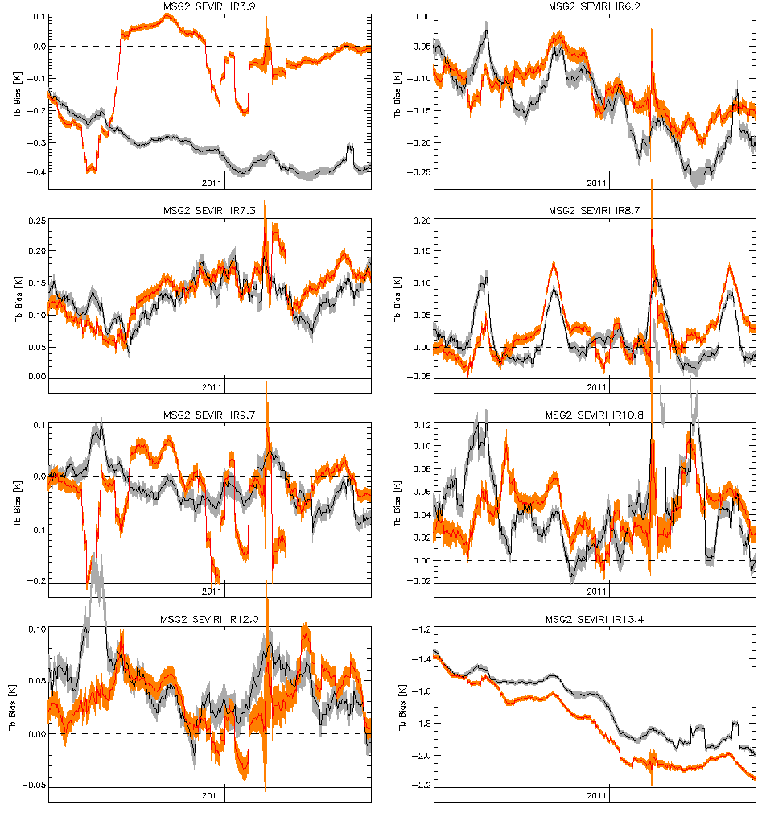
Figure 1 - Time Series of 2 years' Re-Analysis Corrections for Meteosat-9, based on inter-calibration with Metop-A/IASI.
Black line shows standard bias evaluated from Demonstration GSICS Product v3.4.1,
with grey shading representing k=2 uncertainty limits.
Red line shows standard bias evaluated from Pre-Operational GSICS Product v1.1.2,
with orange shading representing k=2 uncertainty limits.

Table 1 shows the summary statistics of the data plotted in Figure 1. This shows:

- The Mean Bias is only significantly different for IR3.9, because Demo version omitted gap-filling, and for IR13.4, the reason for which is not fully understood.
- Standard Deviations (SD) of time series are similar for other channels, showing stable results.
- The median uncertainties derived from the specified uncertainties in the GSICS Correction are very similar.
- Their rolling standard deviations (over 29d windows) are also very similar, confirming the stability of Meteosat-9 as well as the inter-calibration algorithms.

Table 1 – Statistics of 2 years' Re-Analysis Corrections for Meteosat-9, based on inter-calibration with Metop-A/IASI.

Meteosat-10/SEVIRI-Metop-A/IASI

Figure 2 compares time series of ~4 months’ of Demonstration and Pre-Operational Re-Analysis Corrections for Meteosat-10, based on inter-calibration with Metop-A/IASI. These are expressed as the brightness temperature bias for standard scene radiances (standard atmosphere over the sea) and include shaded bands representing the k=2 uncertainty limits calculated from the coefficients’ uncertainties specified in the netCDF files. The following conclusions can be drawn:

- Pre-Op results track Demo results well most of the time for most channels.
- IR3.9 has a systematic difference, expected to be 0.2K, due to Pre-Op version including gap-filling correction, which was absent in Demo version.
- IR13.4 shows systematic difference decreasing with time for no understood reason.

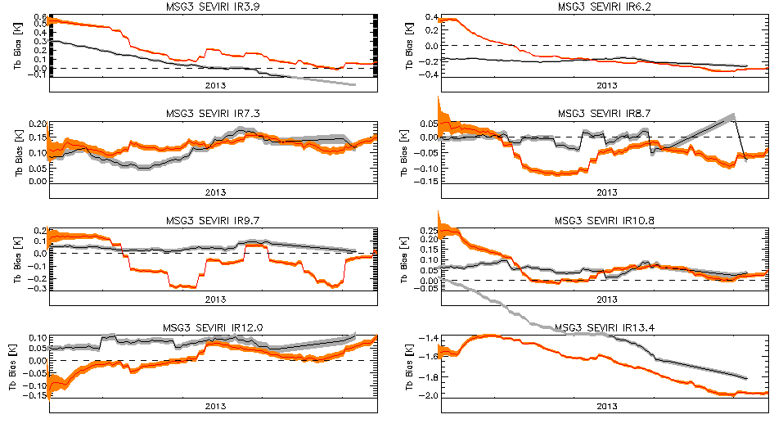
Figure 2 - Time Series of 4 months' Re-Analysis Corrections for Meteosat-10, based on inter-calibration with Metop-A/IASI.
Black line shows standard bias evaluated from Demonstration GSICS Product v3.4.1,
with grey shading representing k=2 uncertainty limits.
Red line shows standard bias evaluated from Pre-Operational GSICS Product v1.1.2,
with orange shading representing k=2 uncertainty limits.

Table 2 shows the summary statistics of the data plotted in Figure 2. This shows:

- The Mean Bias is only significantly different for IR3.9, because Demo version omitted gap-filling, and for IR13.4, the reason for which is not fully understood.
- Standard Deviations (SD) of time series are similar for all channels, showing stable results.
- The median uncertainties derived from the specified uncertainties in the GSICS Correction are very similar.
- Their rolling standard deviations (over 29d windows) are also very similar, confirming the stability of Meteosat-9 as well as the inter-calibration algorithms.

Table 2 – Statistics of 4 months' Re-Analysis Corrections for Meteosat-10, based on inter-calibration with Metop-A/IASI.

Comparison of Demonstration GSICS Near-Real-Time and Re-Analysis Correction

Figure 3 compares time series of ~3 months of Demonstration GSICS Near-Real-Time and Re-Analysis Correction for Meteosat-9, based on inter-calibration with Metop-A/IASI. It shows:

- NRTC lags RAC changes and is more erratic, as expected.
- Both show a clear discontinuity introduced by decontamination in mid February 2013.
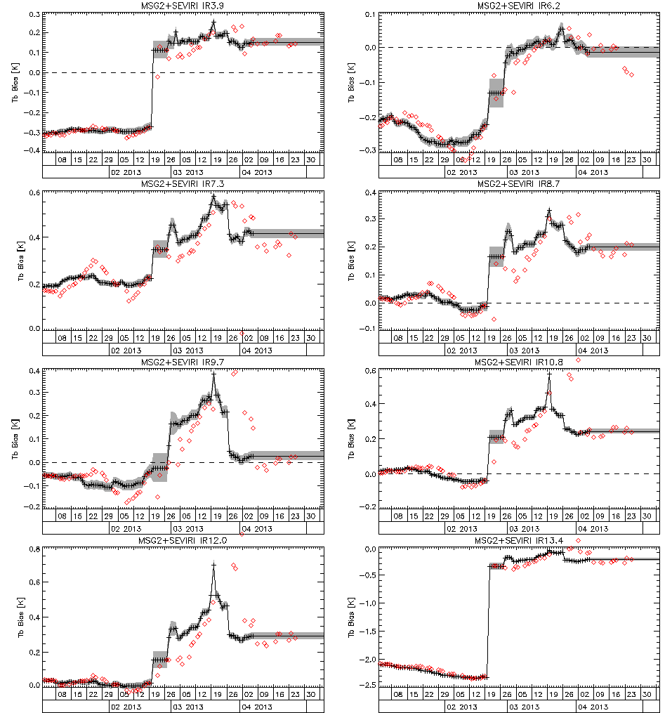
Figure 3 - Time Series of 3 months’ GSICS Corrections for Meteosat-9, based on inter-calibration with Metop-A/IASI.
Red diamonds shows standard bias evaluated from Demonstration Near-Real-Time Correction v3.2.1.
Black line shows standard bias evaluated from Demonstration Re-Analysis Correction v3.4.1,
with grey shading representing k=2 uncertainty limits.

Comparison of Pre-Operational GSICS Near-Real-Time and Re-Analysis Correction

Figure 4 compares time series of ~3 months of Pre-Operational GSICS Near-Real-Time and Re-Analysis Correction for Meteosat-9, based on inter-calibration with Metop-A/IASI. It shows:

- NRTC lags RAC changes and is more erratic, as expected.
- No data after decontamination of 20 Feb 2013, as data feed lost!

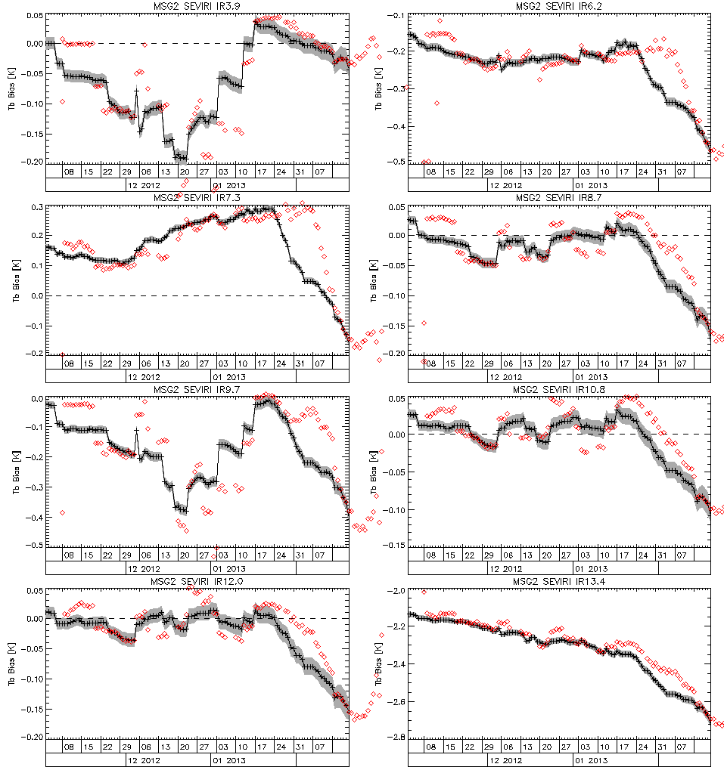
Figure 4 - Time Series of 3 months’ GSICS Corrections for Meteosat-9, based on inter-calibration with Metop-A/IASI.
Red diamonds shows standard bias evaluated from Pre-Operational Near-Real-Time Correction v1.1.2.
Black line shows standard bias evaluated from Pre-Operational Re-Analysis Correction v3.1.2,
with grey shading representing k=2 uncertainty limits.

Conclusions

This report shows the GSICS inter-calibration of Meteosat-IASI implemented on Cal/Val Facility, which generates the Pre-Operational GSICS Corrections, is correctly configured, stable and generates good results consistent with those of the prototype code on the TCE, which generates the Demonstration GSICS Corrections.

It is recommended that the Near-Real-Time Correction is applied to the operational MSG calibration data in near real-time to generate alternative calibration coefficients, to make their calibration consistent with that of the GSICS references (currently Metop-A/IASI), as described in the ReadMe files for the GSICS Corrections. These should replace the current alternative calibration coefficients in the L1.5 header.

