GSICS Algorithm Theoretical Basis Document (ATBD) for GOES-AIRS/IASI Inter-Calibration

Xiangqian Wu (NOAA) and Fangfang Yu (ERT, Inc@NOAA)

Version: 2011-06-15

Incorporating documentation of the NOAA GEO-LEO operational inter-calibration rountines implemented in June 2009 and draft ATBD for Operational Impementation (version 2009-06-25).

Introduction
The overarching goal of the Global Space-based Inter-Calibration System (GSICS) is to ensure the comparability of satellite measurements provided at different times, by different instruments, and under the responsibility of different satellite operators. The primary path for GSICS to contribute to that goal is to enhance the calibration of satellite instruments and validation of satellite observations through inter-calibration. The basic premise of inter-calibration is that measurements by two instruments should be the same if they view the same target at the same time, with the same spectral response and viewing geometry, or any and all such differences have been properly accounted for. Consequently, inter-calibration requires a series of processes that collocate, transform, select, and analyze the measurements by two instruments to produce corrections that homogenize all the observations to a common reference. Ideally, the common reference should be traceable to internationally accepted standard such as SI.

This document describes the theoretical basis of an algorithm that guides the series of processes for a specific inter-calibration between the Imager on Geostationary Operational Environmental Satellite (GOES) and the Atmospheric Infrared Sounder (AIRS) and Infrared Atmospheric with Infrared Atmospheric Sounding Interferometer (IASI) on a Low Earth Orbiting (LEO) satellite. The algorithm is designed and implemented at NOAA GSICS Processing and Research Center (GPRC), in collaboration with GSICS partners. The goal of this inter-calibration is to make GOES measurements traceable to AIRS/IASI. These two LEO hyperspectral instruments are chosen as references in the GSICS GEO-LEO inter-calibration due to the following reasons: (1) radiance of these two instruments are highly calibrated due to the advanced pre-launch and on-board radiometric and spectral calibrations (Pagano et al. 2003, Blumstein et al. 2007), (2) spectral and radiometric calibrations of both instruments are very stable since on-orbit (Pagano et al. 2003, Blumstein et al. 2007), (3) the band-to-band radiometric calibration difference between the two instruments is very small within less than 0.1K difference (Strow et al. 2008, Tobin 2008, Elliot et al. 2009); (4) the hyperspectral measurements can be easily transformed to the pseudo broad channels for the senor-to-sensor inter-calibration (Tobin et al. 2006, Tahara and Kato 2009); and (5) the mean Tb difference of these two hyperspectral Sounder at GOES broad wavelengths is less than 0.1K [Wang et al. 2010], providing more opportunities to monitor the GEO operational calibration and detect the calibration anomaly with two pairs of satellite collocation data. Since spring 2009, NOAA has been routiney generating the GEO-AIRS and GEO-IASI collocation data to monitor and improve the calibration accuracy of the operational GEO instruments (Yu et al. 2009). The traceability of AIRS/IASI to SI is beyond the scope of this inter-calibration.

This document is constructed under a hierarchical structure for all inter-calibrations, in particular for all inter-calibrations between GEO and AIRS/IASI. This hierarchical structure was proposed by the GSICS Data Working Group (GDWG) (November 2009) and adopted by the GSICS Research Working Group (GRWG). It defines the following generic steps:
- Subsetting
- Collocating
- Transforming
- Filtering
- Monitoring
- Correcting

Each step comprises a number of discrete components; each component is defined in the following hierarchical way:
- Describe the purpose of this component
- Provide options for how these may be implemented in general.
- Recommend procedures for the inter-calibration class (e.g. GEO-LEO).
- Provide specific details for each instrument pair (e.g. GOES-AIRS and GOES-IASI).

Each component is defined independently and may exist in different versions. The implementation of the algorithm need only follow the overall logic – so the components need not be executed strictly sequentially. For example, some parts may be performed iteratively, or multiple components may be combined within a single loop in the code.

GSICS aims to define a “baseline” algorithm by identifying one version of each component, against which the performance of other versions may be compared.

Masks, flags, …
SRFs, PSFs, …
2. Collocating
3. Transforming
4. Filtering
6. Correcting
GSICS Correction
Archive ~1 month
Archive ~1 month
Archive ~ 1 year
Archive ~ 1 year
Correction Coeffs
Analysis Data
Comparison Data
Collocated Data
Subset MON Data
Subset REF Data
MON Lvl 1 Data
Re-Cal Data
Plots and Tables
1. Subsetting
Orbital Prediction
Colloc. Criteria
MON Level 1 Data
REF Level 1 Data
Reports
5. Monitoring
7. Diagnosing
Collocation
Transformation
Analysis
Products
Users

Figure 1: Diagram of generic data flow for satellite inter-calibration.

Background
The GSICS Executive Panel originally envisioned a single, consensus algorithm for all inter-calibration between GEO and IASI/AIRS. This led to an algorithm, designated post facto as Version 0, which was conceived at the 1st meeting of the GSICS Research Working Group (GRWG) in January 2007 and distributed as “pseudo code” in May 2007. It was revised at the 2nd GRWG meeting in June 2007, released as Version 1 in November 2007, and presented at the 3rd GRWG meeting in February 2008 (Wu et al. 2008) for further discussion. It was then recognized that optimal inter-calibration between each pair of GEO-LEO may require specific accommodations and be slightly different from the common (or baseline) algorithm, and that future development may lead to further diversification. This document is the Version 2 ATBD for GOES-AIRS/IASI inter-calibration.

Contents
GSICS Algorithm Theoretical Basis Document (ATBD) for GOES-AIRS/IASI Inter-Calibration 1
Xiangqian Wu (NOAA) and Fangfang Yu (ERT, Inc@NOAA) 1
1. Subsetting 6
1.a. Select Orbit 7
2. Find Collocations 9
2.a. Collocation in Space 10
2.b. Concurrent in Time 12
2.c. Alignment in Viewing Geometry 13
2.d. Pre-Select Channels 15
2.e. Plot Collocation Map 16
3.a. Convert Radiances 18
3.b. Spectral Matching 19
3.c. Spatial Matching 22
3.d. Viewing Geometry Matching 23
3.e. Temporal Matching 24
4. Filtering 25
4.b. Uniformity Test 28
4.c. Outlier Rejection 29
4.d. Auxiliary Datasets 30
5. Monitoring 31
5.a. Define Standard Radiances (Offline) 32
5.b. Regression of Most Recent Results 33
5.c. Bias Calculation 36
5.d. Consistency Test 37
5.e. Trend Calculation 38
5.f. Define Smoothing Period (Offline) 39
5.g. Smooth Results 40
5.h. Report Results 41
6. GSICS Correction 43
6.a. Re-Calculate Calibration Coefficients 44

Subsetting

To be completed by a willing volunteer...

Acquisition of raw satellite data is obviously a critical first step in an inter-calibration method based on comparing collocated observations. To facilitate the acquisition of data for the purpose of inter-comparison of satellite instruments, prediction of the time and location of collocation events is also important.

Archive ~1 month
Subset MON Data
Subset REF Data
1. Subsetting
Orbital Prediction
MON Level 1 Data
REF Level 1 Data
Figure 2: Step 1 of Generic Data Flow, showing inputs and outputs. MON refers to the monitored instrument. REF refers to the reference instrument.

Select Orbit

Purpose
We first perform a rough cut to reduce the data volume and only include relevant portions of the dataset (channels, area, time, viewing geometry). The purpose is to select portions of data collected by the two instruments that are likely to produce collocations. This is desirable because typically less than 0.1% of measurement is collocated. The processing time is reduced substantially by excluding measurements unlikely to produce collocations.
Data is selected on a per-orbit or per-image basis. To do this, we need to know how often to do inter-calibration – which is based on the observed rate of change and must be defined iteratively with the results of the inter-calibration process (see 5.f).

General Options
      - The simplest, but inefficient approach is “trial-and-error”, i.e., compare the time and location of all pairs of files within a given time window.
      - A more sophisticated option is to use the observed orbital parameters (such as the Two Line Elements or TLE) with orbit prediction software such as Simplified General Perturbations Satellite Orbit Model 4 (SGP4). For instrument that has fixed or stable scan pattern such that the measurement time and location are determined by the satellite locations, this is very effective.

Infrared GEO-LEO inter-satellite/inter-sensor Class
      - For inter-calibrations between geostationary and sun-synchronous satellites, the orbits provide collocations near the GEO Sub-Satellite Point (SSP) within fixed time windows every day and night. In this case, we adopt the simple approach outlined in general option v0.1.
We define the GEO Field of Regard (FoR) as an area close to the GEO Sub-Satellite Point (SSP), which is viewed by the GEO sensor with a zenith angle less than a threshold. Wu [2009] defined a threshold angular distance from nadir of less than 60° based on geometric considerations, which is the maximum incidence angle of most LEO sounders. This corresponds to ≈ 52° from the GEO SSP. The GEO and LEO data is then subset to only include observations within this FoR within each inter-calibration period.

Mathematically, the GEO FoR is the collection of locations whose arc angle (angular distance) to nadir is less than a threshold or, equivalently, the cosine of this angle is larger than min_cos_arc. We chose the threshold min_cos_arc = 0.5, i.e., angular distance less than 60 degree.

Computationally, with known Earth coordinates of GEO nadir G (0, geo_nad_lon) and granule centre P (gra_ctr_lat, gra_ctr_lon) and approximating the Earth as being spherical, the arc angle between a LEO pixel and LEO nadir can be computed with cosine theorem for a right angle on a sphere (see Figure 2):
Equation 1
If the LEO granule center is outside of GEO FoR, no collocation is considered possible. This is a minor simplification; discussion on improvement is available but omitted here.

Note the arc angle GP on the left panel of Figure 2, which is the same as the angle ∠GOP on the right panel, is smaller than the angle ∠SPZ (right panel), the zenith angle of GEO from the pixel. This means that the instrument zenith angle is always less than 60 degrees for all collocations.

6.63R_{e}
P
G
G
P
R_{e}
Z
O
N
E
S
Figure 2: Computing arc angle to satellite nadir and zenith angle of satellite from Earth location

GOES-AIRS/IASI Specific
GOES Imager may scan any part of its field of regard at any time. While its scan mode is somehow regular, its actual scan location is not always predictable from orbit parameter. Therefore the “trial-and-error” is recommended for GOES-AIR/IASI inter-calibration. Each AIRS/IASI granule is compared with each GOES image in the input data. Only the pairs that are possible to produce collocations (collocated in space and sufficiently close in time) are retained for further analysis.

Find Collocations
A set of observations from a pair of instruments within a common period (e.g. 1 day) is required as input to the algorithm. The first step is to obtain these data from both instruments, select the relevant comparable portions and identify the pixels that are spatially collocated, temporally concurrent, geometrically aligned and spectrally compatible and calculate the mean and variance of these radiances.

2. Collocating
Archive ~1 month
Collocated Data
Subset MON Data
Subset REF Data
Colloc. Criteria
Figure3 : Step 2 of Generic Data Flow, showing inputs and outputs

Collocation in Space

Purpose
The following components of the first step define which pixels can be used in the direct comparison. To do this, we first extract the central location of each instruments’ pixels and determine which pixels is considered to be collocated, based on their centres being separated by less than a pre-determined threshold distance. At the same time we identify the pixels that define the target area (FOV) and environment (ENV) around each collocation. These are later averaged in 3.c.

The target area is defined to be a little larger than the larger Field of View (FoV) of the two instruments so it covers all the contributing radiation in event of small navigation errors, while being large enough to ensure reliable statistics of the variance are available. The exact ratio of the target area to the FoV will be instrument-specific, but in general will range 1 to 3 times the FoV, with a minimum of 9 'independent' pixels.

General Options
      - Each pixel in both instrument’s datasets are tested sequentially to identify those separated by less than a pre-determined threshold. Surrounding pixels are used to define the collocation target area and environment.
      - A more efficient method of searching for collocations is to calculate 2D-histograms of the locations of both instruments’ observations on a common grid in latitude/longitude space. Non-zero elements of both histograms identify the location of collocated pixels and their indices provide the coordinates in observation space (scan line, element, FoV, …).
      - v0.2 does not capture pixel pairs that straddle bin boundaries of the histograms. This may be refined in future by repeating the histograms on 4 staggered grids, offset by half of the grid spacing, and rationalising the list of collocated pixels returned by the 4 independent searches to remove any duplication. (Not implemented yet.)
      - Where an instrument’s pixels follow fixed geographic coordinates, it is possible to use a look-up table to which identify pixels match a given target’s location. This is the most efficient and recommended option where available (often for geostationary instruments).

      - Another option is to read the lat/lon of AIRS pixel and use specialized software (e.g., McIDAS) to find the GOES pixel closest to that location. This can be done efficiently when the satellite orbit and attitude tracking parameters are properly accounted for so that scan line/elem can be geolocated to lat/lon and vice versa.

Infrared GEO-LEO inter-satellite/inter-sensor Class
      - The spatial collocation criterion is based on the nominal radius of the LEO FoV at nadir. This is taken as a threshold for the maximum distance between the centre of the LEO and GEO pixels for them to be considered spatially collocated. However, given the geometry of the already subset data, it is assumed that all LEO pixels within the GEO FoR will be within the threshold distance from a GEO pixel. The GEO pixel closest to the centre of each LEO FoV can be identified using a reverse look-up-table (e.g. using a McIDAS function).

GOES-AIRS/IASI Specific
      - Option 1.b.ii.v0.5 is recommended.

Concurrent in Time

Purpose
Next we need to identify which of those pixels identified in the previous step as spatially collocated are also concurrent in time. Although even collocated measurements at very different times may contribute to the inter-calibration, if treated properly, the capability of processing collocated measurements is limited and the more closely concurrent ones are more valuable for the inter-calibration.

General Options
      - Each pixel identified as being spatially collocated is tested sequentially to check whether the observations from both instruments were sampled sufficiently closely in time – i.e. separated in time by no more than a specific threshold. This threshold should be chosen to allow a sufficient number of collocations, while not introducing excessive noise due to temporal variability of the target radiance relative to its spatial variability on a scale of the collocation target area – see Hewison [2009a].

Infrared GEO-LEO inter-satellite/inter-sensor Class
      - The time at which each collocated pixel of the GEO image was sampled is extracted or calculated and compared to for the collocated LEO pixel. If the difference is greater than a threshold of 300s, the collocation is rejected, otherwise it is retained for further processing.
Equation 2: 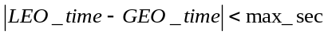, where max_sec=300s
      - The problem with applying a time collocation criteria in the above form is that it will often lead to only a part of the collocated pixels being analysed. As the GEO image is often climatologically asymmetric about the equator, this can lead to the collocated radiances having different distributions, which can affect the results. A possible solution to this problem is to apply the time collocation to the average sample time of both the GEO and LEO data. This would ensure either all or none of the pixels within each overpass are considered to be collocated in time.

GOES-AIRS/IASI Specific
      - Option 1.c.iii.v0.1 is recommended. LEO_time is read or calculated for the AIRS/IASI pixel and GOE_time is the GOES scan line time.

Alignment in Viewing Geometry

Purpose
The next step is to ensure the selected collocated pixels have been observed under comparable conditions. This means they should be aligned such that they view the surface at similar incidence angles (which may include azimuth and polarisation as well as elevation angles) through similar atmospheric paths.

General Options
Each pixel identified as being spatially and temporally collocated is tested sequentially to check whether the viewing geometry of the observations from both instruments was sufficiently close. The criterion for zenith angle is defined in terms of atmospheric path length, according to the difference in the secant of the observations’ zenith angles and the difference in azimuth angles. If these are less than pre-determined thresholds the collocated pixels can be considered to be aligned in viewing geometry and included in further analysis. Otherwise they are rejected.

Infrared GEO-LEO inter-satellite/inter-sensor Class
      - Stringent criterion on the viewing zenith angle is applied for the geometric alignment of infrared GEO-LEO inter-calibration.
Equation 3: 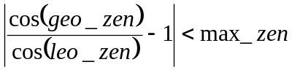
The threshold value for max_zen can be quite large for window channels (e.g., 0.05 for 10.7 μm channel) but must be rather small for more absorptive channels (e.g., <0.02 for 13.3 μm channel). Unless there are particular needs to increase the sample size for window channels, a common threshold value of max_zen=0.01 is recommended for all channels. This results in collocations being distributed approximately symmetrically about the equator mapping out a characteristic slanted hourglass pattern.
Another aspect of viewing geometry alignment is azimuth angle. Similar zenith angle assures similar path length; additional requirement of similar azimuth angle assures similar line-of-sight. Line-of-sight alignment is relevant for IR spectrum in certain cases. For infrared window channels, land surface emission during daytime may be anisotropic [Minnis et al. 2004]. For shortwave IR band (e.g., 4 μm), azimuth angle alignment is required during daytime when solar radiation is considerable. It is, therefore recommended that inter-calibration over land and in this band are limited to night-time only cases – at the expense of limiting the dynamic range of the results.

The azimuth angle [-pi, pi] is defined as the angle rotated clockwise from true north to the satellite line-of-sight projected on the earth surface or, more precisely, the plane tangent on the earth surface at the pixel. It can be computed as illustrated in Figure 2 (left panel). After computing the arc angle GP with Equation 1, one can apply the sine theorem of spherical trigonometry to the arbitrary triangle GPN (the right panel of Figure 2):
Equation 4:
since sin(NG) = 1. Thus:
G
π - ∠GPN
-(π - ∠GPN)
∠GPN
-∠GPN
Figure 3: Computation of azimuth angle.

GOES-IASI Specific
      - Implemented as 2.c.iii.v0.1, however azimuth angle clockwise from truth north is also calculated and archived.

Pre-Select Channels

Purpose
Only broadly comparable channels from both instruments are selected to reduce data volume.

General Options
      - This selection is based on pre-determined criteria for each instrument pair.

Infrared GEO-LEO inter-satellite/inter-sensor Class
      - Only the channels of the GEO and LEO sensors are selected in the thermal infrared range of 3-15µm.

GOES-AIRS/IASI Specific
      - Select the four GOES Imager infrared channels with central wavelength longer than 3μm.

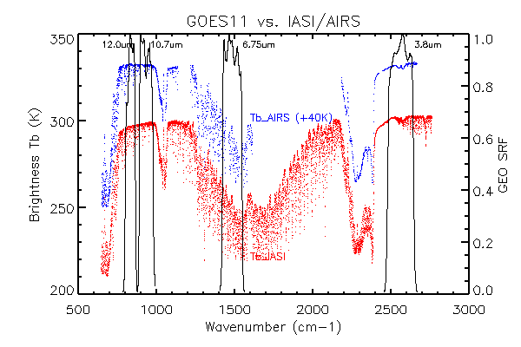
Figure 4: Example radiance spectra measured by IASI (blue, shifted +40K) and AIRS (red), expressed in brightness temperature (K) and Spectral Response Functions of GOES-11 Imager IR channels.

Plot Collocation Map

Purpose
When interpreting the inter-calibration results it is often helpful to visualise the distribution of the source data used in the comparison.

General Options
      - This can be achieved by producing a map showing the distribution of collocation targets.

Infrared GEO-LEO inter-satellite/inter-sensor Class
      - The map is produced showing all the GEO-LEO pixels meeting the collocation criteria every day. These points are overlaid on a background image from an infrared window channel of the GEO instrument. This allows the distribution of cloud to be visualised and considered in the interpretation of the results.

GOES-AIRS/IASI Specific
      - Not routinely produced yet, but will consider.

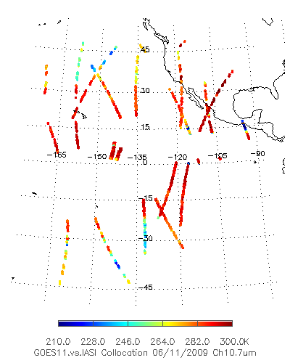
Figure 5: Example of daily collocation GOES-11 Imager vs. IASI map.

- Transform Data
In this step, collocated data are transformed to allow their direct comparison. This includes modifying the spectral, temporal and spatial characteristics of the observations, which requires knowledge of the instruments’ characteristics. The outputs of this step are the best estimates of the channel radiances, together with estimates of their uncertainty.

SRFs, PSFs, …
3. Transforming
Archive ~ 1 year
Comparison Data
Collocated Data
Figure 6: Step 2 of Generic Data Flow, showing inputs and outputs

Convert Radiances

Purpose
Convert observations from both instruments to a common definition of radiance to allow direct comparison.

General Options
      - The instruments’ observations are converted to radiances as prescribed by the agency responsible for the instrument.

Infrared GEO-LEO inter-satellite/inter-sensor Class
      - Perform comparison in radiance units: mW/m²/st/cm⁻¹.

GOES-AIRS/IASI Specific
      - Implemented as 2.a.ii.v0.1.

Spectral Matching

Purpose
Firstly, we must identify which channel sets provide sufficient common information to allow meaningful inter-calibration. These are then transformed into comparable pseudo channels, accounting for the deficiencies in channel matches.

General Options
      - The Spectral Response Functions (SRFs) must be defined for all channels. The observations of channels identified as comparable are then co-averaged using pre-determined weightings to give pseudo channel radiances. A Radiative Transfer Model can be used to account for any differences in the pseudo channels’ characteristics. The uncertainty due to spectral mismatches is then estimated for each channel.

Infrared GEO-LEO inter-satellite/inter-sensor Class
For hyper-spectral instruments, all SRFs are first transformed to a common spectral grid. The LEO hyperspectral channels are then convolved with the GEO channels’ SRFs to create synthetic radiances in pseudo-channels, accounting for the spectral sampling and stability in an error budget.
Equation 5: 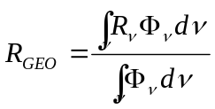
where R_{GEO} is the simulated GEO radiance, R_{ν} is LEO radiance at wavenumber ν, and Φ_{ν} is GEO spectral response at wave number ν.
In general LEO hyperspectral sounders do not provide complete spectral coverage of the GEO channels either by design (e.g. gaps between detector bands), or by subsequent hardware failure (e.g. broken or noisy channels). The radiances in these gap channels shall be accounted by one of the following techniques:

      - The simplest option is simply to ignore the contribution from the gap channels. This will obviously introduce a bias in the resulting radiances, depending on the specific channels under consideration.
      - A second option is to linearly interpolate for the missing radiance from the adjacent valid channels. This could be a viable option for narrow gaps (e.g., single dead or unstable channel) but would create large bias and uncertainty if the gap is wide and over complex spectral features.
      - Tobin et al. [2006] fills the gap with pre-computed radiance using a radiative transfer model (RTM) and some typical atmospheric profiles. This is a significant improvement over the previous options, but the error can be large at times since spectral radiance is dependent on atmospheric conditions such as clouds, which is not known a priori.
      - The method of Kato [2007] exploits the fact that spectral radiances are normally highly correlated. It fills the gap with pre-computed radiance adjusted by ratio of measured and pre-computed radiances at nearby channels.
      - Gunshor [2007] matches the pre-computed radiance at the beginning and end of the gap. The ratio between the AIRS radiance and simulated radiance is computed at the last channel before a gap and the first channel after the gap, and is linearly interpolated to the channels within the gap. The missing AIRS radiances are then estimated as the simulated radiances multiplied with the ratio linearly interpolated to the missing channel.

      - Tahara and Kato [2009] define virtual channels named gap channels to fill the spectral gaps and introduce the spectral compensation method by constrained optimization. The gap channels to fill the AIRS spectral gaps (AIRS gap channels) are defined by 0.5 cm⁻¹ intervals, and are characterized by a unique SRF, whose shape is a Gaussian curve with a sigma of 0.5 cm⁻¹. The gap channels to extend the IASI spectral region (IASI gap channels) are defined by the same intervals (0.25 cm⁻¹) and SRFs as the IASI level 1c channels. The radiances of the missing channels are calculated by regression analysis using radiative transfer simulated radiances with respect to the eight atmospheric model profiles as explanatory variables.
Equation 6: 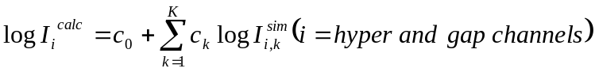,
where 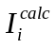 is the calculated radiance of the hyper channel i, 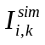 is the simulated radiance of the hyper channel i with respect to the atmospheric model profile k, 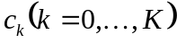 are regression coefficients, and K is the number of the atmospheric model profiles. Eq. 6 introduces logarithm radiances as response and explanatory variables in order to increase fitting accuracy and avoid calculation of negative radiance. The regression coefficients 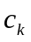 are independent of the hyper channels, and are generated for each scan position of the hyper sounder. are obtained by the least-square method applying a set of validly observed radiances 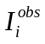 in place of to Eq. 6,
Equation 7: 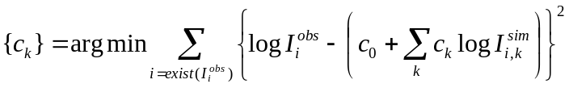.
Once the regression coefficients are computed, the radiances of the missing channels can be calculated by Eq. 6. It might be possible to apply the observed radiances of all hyper channels to Eq. 7 to compute and then calculate the radiances of all missing channels at once. However, this yields a large fitting error in practice. In inter-calibration application, the coefficients are computed for each broadband channel spectral region. Eq. 6 and Eq. 7 use the simulated radiances . For the radiance simulation, this study uses the following eight atmospheric model profiles:
1. U.S. standard without cloud,
2. U.S. standard with opaque cloud with tops at 500 hPa altitude,
3. U.S. standard with opaque cloud with tops at 200 hPa altitude,
4. Tropical without cloud,
5. Tropical with opaque cloud with tops at 500 hPa altitude,
6. Tropical with opaque cloud with tops at 200 hPa altitude,
7. Mid-latitude summer without cloud,
8. Mid-latitude winter without cloud.
These profiles include not only clear sky conditions but also cloudy conditions because Eq. 6 should be applicable under any weather conditions. As for radiative transfer code, the line-by-line code LBLRTM (Clough et al., 1995) version 11.1 is used with the HITRAN2004 spectroscopy line parameter database (Rothman et al., 2003) including the AER updates version 2.0 (AER Web page). The emissivities of the surface and clouds are assumed to be one. The benefit of this spectral compensation method is that it does not require radiative transfer computation to be run in inter-calibration operation. This not only speeds up the computation but also prevents super channel radiance computation from introducing biases contained in radiative transfer code and atmospheric state fields.

GOES-AIRS/IASI Specific
      - Implemented as 2.b.iii.v0.6. AIRS and IASI channels are assumed to be spectrally stable. GOES’s SRFs are linearly interpolated onto AIRS and IASI spectral grid in wavenumber-space. Any negative responses in the interpolated SRFs are set to zero and then the interpolated SRFs are normalized to [0, 1].

Valid AIRS channels are defined per JPL memo via C. Barnett.

The pseudo channel radiance calculated from AIRS/IASI corresponding to Imager’s Ch2 (3.9µm) may be biased due to the missing of contribution from the short-wave end of this channel’s passband, which is not observed by the hyperspectral instruments.

Spatial Matching

Purpose
The observations from each instrument are transformed to comparable spatial scales. This involves averaging all the pixels identified in 2 as being within the target and environment areas. The uncertainty due to spatial variability is estimated.

General Options
      - The Point Spread Functions (PSFs) of each instrument are identified. The target area and environment around it were specified in 2. Now the pixels within these areas are identified and their radiances are averaged and their variance calculated to estimate the uncertainty on the average due to spatial variability.

Infrared GEO-LEO inter-satellite/inter-sensor Class
      - The target area is defined as a GEO array with the nominal LEO FoV at nadir centred at the GEO pixel which is the closest to the centre of the collocated LEO pixel. The target area is considered the pseudo GEO pixel at LEO nominal spatial resolution. The GEO pixels within target area are averaged using a uniform weighting and their variance calculated. Another area, the environment area which is about distance the cloud with nominal wind speed (15-20m/s) may move across the collocated GEO and LEO boundaries is also defined to ensure the homogeneity of the target area within the collocation time threshold (5 minutes). The environment is defined by the GEO pixels within 4x radius of the target area from the centre of each collocated LEO FoV.
      - The Point Spread Function (PSF) of the LEO instrument is used to provide a weighting in calculating the average of the GEO pixels.
(Not implemented yet.)

GOES-AIRS/IASI Specific
      - Implemented as 2.c.iii.v0.1.
Since GOES Imager has oversampling at East-West scanning direction, the target area is an array of 5x3 pixels and the 17x9 array for environment.
.
IASI iFoV
12km diameter
near nadir
GOES Imager IR pixels (5x3 window to account for the E-W oversampling) defining one Target Area
+

Figure 7: Definition of Target Area as 5x3 GOES Imager IR pixels to spatially match an IASI iFoV.

Viewing Geometry Matching

Purpose
Despite the collocation criteria described in 2.c, each instrument can measure radiance from the collocation targets in slightly different viewing geometry. It may be possible to account for small differences by considering simplified a radiative transfer model.

General Options
      - Differences in viewing geometry within the collocation criteria described in 2.c are assumed to be negligible and ignored in further analysis.
      - It may be possible to account for small differences by considering simplified a radiative transfer model.

Infrared GEO-LEO inter-satellite/inter-sensor Class
      - Differences in viewing geometry within the collocation criteria described in 2.c are assumed to be negligible and ignored in further analysis.
      - It may be possible to account for small differences by considering simplified a radiative transfer model. (Not yet implemented.)

GOES-AIRS/IASI Specific
      - Implemented as 2.d.ii.v0.1.

Temporal Matching

Purpose
Different instruments measure radiance from the collocation targets at different times. The impact of this difference can usually be reduced by careful selection, but not completely eliminated. The timing difference between instruments’ observations is established and the uncertainty of the comparison is estimated based on (expected or observed) variability over this timescale.

General Options
      - Each instrument’s sample timings are identified.

Infrared GEO-LEO inter-satellite/inter-sensor Class
      - Only the GEO image closest to the LEO equator crossing time is selected. The time difference between the collocated GEO and LEO observations is neglected and the collocation targets are assumed to be sampled simultaneous, contributing no additional uncertainty to the comparison.
      - Only the GEO image closest to the LEO Equator crossing time is selected. The time difference, Δt, between the collocated GEO and LEO observations is calculated for each collocated pixel. This is compared with the spatial distance between the centroids of the target areas sampled by GEO and LEO, Δx, defined in 3.c using the pre-determined relationship between spatial and temporal scene variability for this channel [Hewison, 2009] and the uncertainty due to temporal variability, σ_{t}, is estimated from that due to spatial variability, σ_{x}, calculated in 3.c.
Equation 7: 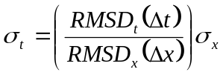,
where RMSD_{t}(Δt) and RMSD_{x}(Δx) are the r.m.s. differences between the radiances in each channel calculated for sampling period, Δt, and interval, Δx, respectively.
(Not yet implemented.)
      - Sequential GEO images are interpolated to the LEO observation time and weighted according to the time difference between each. The uncertainty of the weighted mean could also be estimated.
(Not yet implemented.)
      - Only the GEO image closest to the LEO measurement time is selected. The time difference between the collocated GEO and LEO observations is accounted for indirectly. It is assumed that local change in radiance is negligible with the time window, in other words the temporal change of radiance is dominated by advection. Equivalently, GEO radiance is from an area in the vicinity of LEO FOV, the direction and distance of this area from the LEO FOV depend on the direction and speed of advection. So we weight the collocations later by the spatial variability of the environment.

GOES-AIRS/IASI Specific
      - Implemented as 2.e.iii.v0.4.

Filtering
The collocated and transformed data will be archived for analysis. Before that, the GSICS inter-calibration algorithm reserves the opportunity to remove certain data that should not be analyzed (quality control), and to add auxiliary data that will add further analysis. For example, it may be useful to incorporate land/sea/ice masks and/or cloud flags to better classify the results.

Masks, flags, …
4. Filtering
Archive ~ 1 year
Analysis Data
Comparison Data
Figure 8: Step 4 of Generic Data Flow, showing inputs and outputs.

Time Selection

    - Purpose

The collocation data may range a few hours every day and night. During the period, the difference of collocation radiance may experience some variation related to the changes of solar illumination conditions and satellite orbit positions. For example, the radiance of window IR channels may be affected with the antistrophic surface reflectance (for short-wave channels) or emissivity (long wave IR channels) (Minnis et al. 2004). The effects of stray-light at all GEO instruments and the erroneous midnight calibration responsibility of the three-axis stabilized GEO satellite can resulted in time-dependent degraded GEO radiance. It is therefore necessary to select the optimal time period in a day to maximally reduce the inter-calibration accuracy uncertainty.

    - General Options
4.h.ii.v.0.1. Use all the collocation data in a day for the regression analysis
4.h.ii.v.0.2. Identify a fixed time within a day during which the difference of atmospheric condition and satellite/solar viewing geometries of the two instruments has the least impact on the calibration uncertainty.
4.h.ii.v.0.3. In addition to 4.h.ii.v.0.2, since the instruments, especially the monitored instruments, may have diurnal calibration variation, a time-dependent regression between the collocated radiance should be generated for the whole day’s data correction (not implemented).

Infrared GEO-LEO inter-satellite/inter-sensor class
4.h.iii.v.0.1. Day-time GEO-LEO inter-calibration data is used to avoid the midnight calibration error at the three-axis stabilized GEO instruments. However, this causes problem to correct the short-wave IR channel data due to the solar contamination effect at this channel.
4.h.iii.v.0.2. Night time GEO-IASI collocated data is used.
4.h.iii.v.0.3. Night-time collocation data before the significant impact of erroneous midnight calibration responsivity (10:00pm at satellite local time) is used for the GEO-LEO inter-calibration.

GOES-AIRS/IASI Specific
4.h.iv.v.01. For GOES-AIRS specific: 4.h.iii.v.0.1 is implemented because the AIRS equatorial overpass at night is 1:30am, very close to the peak of GOES midnight calibration anomaly.
Uniformity Test

For GOES-IASI specific: 4.h.iii.v.0.3 is implemented.

Uniformity Test

Purpose
Knowledge of scene uniformity is critical in reducing and evaluating inter-calibration uncertainty. To reduce uncertainty in the comparison due to spatial/temporal mismatches, the collocation dataset may be filtered so only observations in homogenous scenes are compared.

General Options
      - The simplest option is to allow all inter-calibration targets, regardless of their uniformity.
      - Another option is to set threshold to allow only relatively uniform scenes for analysis. In this case, the spatial/temporal variability of the scene within the target area is compared with pre-defined thresholds to exclude scenes with greater variance from analysis. This may be performed on a per-channel basis.
      - Another option is to use scene uniformity as weight in further analysis. Comparatively, the threshold option has the theoretical disadvantage of subjectivity but practical advantage of substantially reducing the amount of data to be archived. Recent analysis [Tobin, personal communication, 2009] also indicates that the threshold option is always suboptimal compared to the weight option.

Infrared GEO-LEO inter-satellite/inter-sensor Class
      - The variance of the radiances of all the GEO pixels within each LEO FoV is calculated in 3.c.
      - The interpolation between sequential GEO images may be included in future. (Not yet implemented.)

GOES-AIRS/IASI Specific
      - Implemented as 3.a.ii.v0.1

Outlier Rejection

Purpose
To prevent anomalous observations having undue influence on the results, ‘outliers’ may be identified and rejected on a statistical basis. Small number of anomalous pixels in the environment, even concentrated, may not fail the uniformity test. However, if they appear only in one sensor’s field of view but not the other, it can cause unwanted bias in a single comparison.

General Options
      - The simplest implementation is to include the outliers in the further analysis. Since the anomaly has equal chance to appear in either sensor’s field of view, comparison of large number of samples remains unbiased but has increased noise. This is the recommended approach.
      - The radiances in the target area are compared with those in the surrounding environment, and those targets which are significantly different from the environment (3σ) may be rejected.
For a normally distributed population of size N, mean M, and standard deviation S, the difference between a single sample and M has the probability of ~68% to be less than S, ~95% to be less than 2S, and so forth. Similarly, the difference between the mean of n² samples and M has the probability of ~68% to be less than S/n[(N-n)/(N-1)], ~95% to be less than 2S/n[(N-n)/(N-1)], and so forth. This property is used to test whether the collocation area is an outlier for the otherwise uniform environment:
Equation 8: 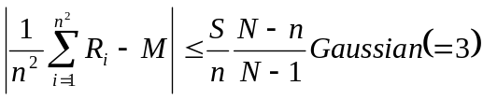
where R is radiance from individual pixel, n is the number of samples, and Gaussian is a threshold. The probability that the rejected sample is an outlier is 68% if Gaussian=1, 95% if Gaussian=2, and more than 99% if Gaussian=3.

      - Recursive filtering: it is assumed that the regression or correction residuals of the collocation scenes are always of Gaussian distribution. A collocated scene is identified as an outlier if its regression residual is beyond a threshold, for example, Gaussian (=2) * square-root of unreduced chi-square goodness-of-fit statistics. This procedure is iteratively applied until all the collocation scenes (samples) residual are within the threshold, or a pre-defined number of iteration loops is met, or more than 3% collocation scenes are rejected as outliers.

The regression residual of a collocated scene i can be written as followed:

Equation 9: 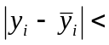Threshold
where y_{i} is the FOV radiance, 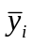 is the expected GEO radiance from the GEO-LEO correction regression.

Infrared GEO-LEO inter-satellite/inter-sensor Class
      - All inter-calibration targets are included in further analysis, regardless of whether they are outliers with respect to their environment.
      - The mean GEO radiances within each LEO FoV are compared to the mean of their environment. Targets where this difference is >3 times the standard deviation of the environment’s radiances are rejected.

GOES-AIRS/IASI Specific
      - Implemented as 3.b.ii.v0.1.

Auxiliary Datasets

Purpose
It may be useful to incorporate land/sea/ice masks and/or cloud flags to allow analysis of statistics in terms of other geophysical variables – e.g. land/sea/ice, cloud cover, etc.

It may also be possible to estimate the spatial variability within the LEO FoV from collocated AVHRR observations from the same LEO satellite.

General Options
      - Not yet implemented.

Infrared GEO-LEO inter-satellite/inter-sensor Class
      - Not yet implemented.

GOES-AIRS/IASI Specific
      - All auxiliary data available at the AIRS Level1B data are retained.

Monitoring
This step includes the actual comparison of the collocated radiances produced in Steps 1-4, the production of statistics summarising the results to be used in the GSICS Correction step.

Analysis Data
Plots and Tables
5. Monitoring
Figure 9: Step 5 of Generic Data Flow, showing inputs and outputs.

Define Standard Radiances (Offline)

Purpose
This component provides standard reference scene radiances at which instruments’ inter-calibration bias can be directly compared and conveniently expressed in units understandable by the users. Because biases can be scene-dependent, it is necessary to define channel-specific standard radiances. More than one standard radiance may be needed for different applications – e.g. clear/cloudy, day/night. This component is carried out offline.

General Options
      - A representative Region of Interest (RoI) is selected and histograms of the observed radiances within RoI are calculated for each channel. Histogram peaks are identified corresponding to clear/cloudy scenes to define standard radiances. These are determined a priori from representative sets of observations.
      - The standard radiances should be calculated for each channel a priori using a Radiative Transfer Model (RTM) based on a standard atmospheric profile and surface conditions. The reference radiance should be calculated at nadir, at night for IR channels or at a given solar angle (for vis/nir channels), in a 1976 US Standard Atmosphere, in clear skies, over the sea with a SST=+15C and wind speed (7m/s), using some standard RTM, accounting for the SRF of each channel. This has the advantages of being independent of any instrument biases and provides standard radiances against which we can compare the instruments’ relative biases derived from a number of different inter-calibration techniques.

Infrared GEO-LEO inter-satellite/inter-sensor Class
      - Option 5.a.ii.v0.1 is implemented directly.
      - Option 5.a.ii.v0.1 is implemented directly, the FoR is limited to within 30° latitude/longitude of the GEO sub-satellite point and times limited to night-time LEO overpasses.
      - As v0.2.
      - Option 5.a.ii.v0.2 is implemented directly.

GOES-AIRS/IASI Specific
      - Implemented 5.a.ii.v0.1.
      - Adopted following recommendation from EUMETSAT, which is based on 5.a.ii.v0.2 using RTTOV-9, giving the following results for the IR channels SEVIRI on both Meteosat-8 and -9:
Ch (μm) | 3.9 | 6.2 | 7.3 | 8.7 | 9.7 | 10.8 | 12.0 | 13.4
T_{bstd} (K) | 284 | 236 | 255 | 284 | 261 | 286 | 285 | 267

Regression of Most Recent Results

Purpose
Regression is used as the basis of the systematic comparison of collocated radiances from two instruments. (This comparison may also be done in counts or brightness temperature.) Regression coefficients shall be made available to users to apply the GSICS Correction to the target instrument, re-calibrating its radiances to be consistent with those of the reference instrument. Scatterplots of the regression data should also be produced to allow visualisation of the distribution of radiances.
Regressions also allow us to investigate how biases depend on various geophysical variables and provide statistics of any significant dependence, which can used to refine corrections and allows investigation of the possible causes. Such investigations should be carried out offline and may result in future refinements to the ATBD.

General Options
      - The simplest method of comparing two datasets is to calculate the average the differences between collocated radiances. This provides a single scalar quantity for each channel (with an uncertainty estimated statistically from the variances of the datasets). However, this does not correspond to the mechanisms most likely to introduce bias in the instruments.
A weighted average may be used to account for greater uncertainty of collocation with inhomogeneous scene radiances.
      - Similarly, the average ratio of the collocated radiances from a pair of instruments can be calculated. This also provides a single scalar quantity for each channel (with an uncertainty estimated statistically from the variances of the datasets). This corresponds to an inaccurately calibrated gain of one of the instruments, which is a common problem.
A weighted average may be used to account for greater uncertainty of collocation with inhomogeneous scene radiances.
      - The recommended approach is to perform a weighted linear regression of collocated radiances. The inverse of the sum of the spatial and temporal variance of the target radiance and the radiometric noise provide an estimated uncertainty on each dependent point, which is used as a weighting. (Including the radiometric noise ensures that very homogeneous targets scenes where all the pixels give the same radiance do not have undue influence on the weighted regression.)
This method produces estimates of regression coefficients describing the slope and offset of the relationship between the two instruments’ radiances – together with their uncertainties, expressed as a covariance. The problem of correlation between the uncertainties on each coefficient may be reduced by performing the regression on a transformed dataset – for example, by subtracting the mean or reference radiance from each set.
The observations of the reference instrument, x, and target instrument, y, are fitted to a straight line model of the form:
Equation 10: 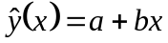
We assume an uncertainty σ_{i} associated with each measurement, y_{i}, is known and that the dependent variable, x_{i} is also known.
To fit the observed data to the above model, we minimise the chi-square merit function:
Equation 11: 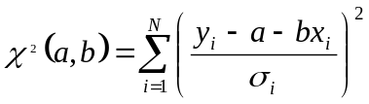
This can be implemented following the method described in Section 15.2 of Numerical Recipes [Press et al., 1996], which is implemented in the POLY_FIT function of IDL, yielding the following estimates of the regression coefficients:
Equation 12: 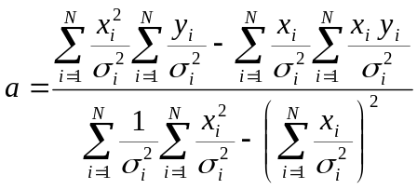,
Equation 13: 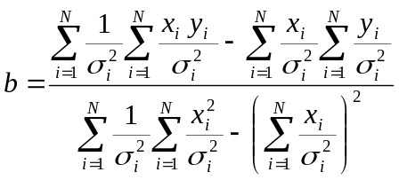,
their uncertainties:
Equation 14: 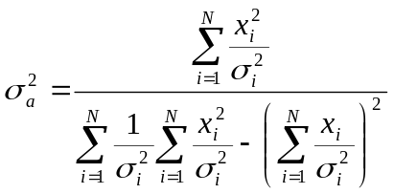,
Equation 15: 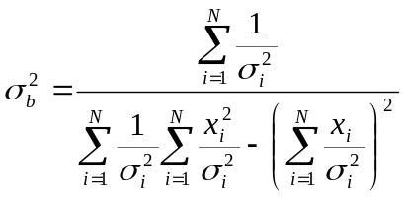,
and their covariance:
Equation 16: 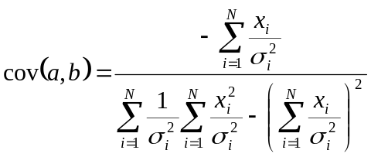.

Infrared GEO-LEO inter-satellite/inter-sensor Class
      - Inter-calibrations are repeated daily using only night-time LEO overpasses. Collocations are weighted by the inverse the sum of the spatial and temporal variance of target radiances and their radiometric noise level in the regression. (The inclusion of the radiometric noise ensures the weights never become infinite due to collocation targets with zero variance.) Scatterplots of the regression data should also be produced to allow visualisation of the distribution of radiances, following the example shown in Figure 10.

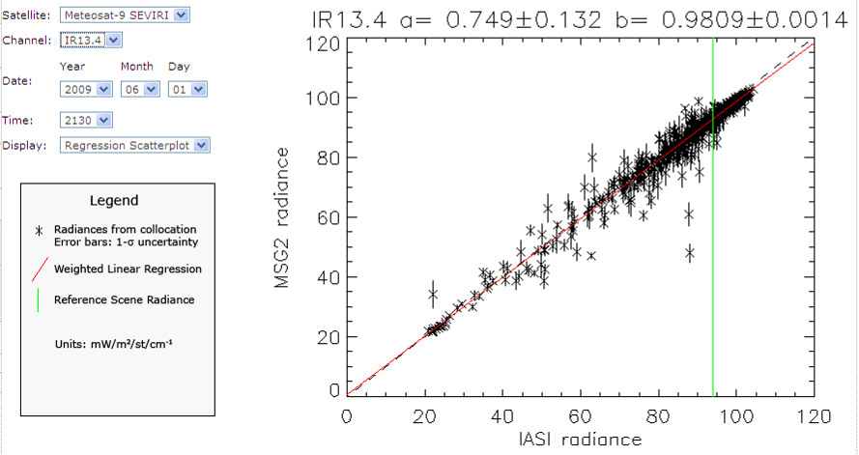
Figure 10: Example scatterplot showing regression of collocated radiances, following legend.

GOES-AIRS/IASI Specific
      - Implemented as 5.b.ii.v0.3, with radiometric noise of GOES added to the scene variance in calculating the weighting for each point. The radiometric noise is calculated with blackbody observation data obtained at early satellite operational mission life (GOES-14 PLT report).
Channel | 3.9 | 6.7 | 10.8 | 12.0 | 13.4
Noise [mW/m²/sr/cm⁻¹] | 0.0047 | 0.039 | 0.123 | 0.308 | -
GOES-12  Noise [mW/m²/sr/cm⁻¹] | 0.0039 | 0.018 | 0.123 | - | 0.178
GOES-13  Noise [mW/m²/sr/cm⁻¹] | 0.0022 | 0.022 | 0.075 | - | 0.117

Bias Calculation

Purpose
Inter-calibration biases should be directly comparable for representative scenes and conveniently expressed in units understandable by the users. Because biases can be scene-dependent, they are evaluated here at the standard radiances defined in 5.a.

General Options
      - Regression coefficients are applied to estimate expected bias, 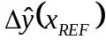, and uncertainty, 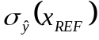, for standard radiances, accounting for correlation between regression coefficients.
Equation 17: 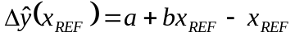
and
Equation 18:
The results may be expressed in absolute or percentage bias in radiance, or brightness temperature differences.

Infrared GEO-LEO inter-satellite/inter-sensor Class
      - Biases and their uncertainties are converted from radiances to brightness temperatures for visualisation purposes.

GOES-AIRS/IASI Specific
      - C.ii.v0.1 is implemented.
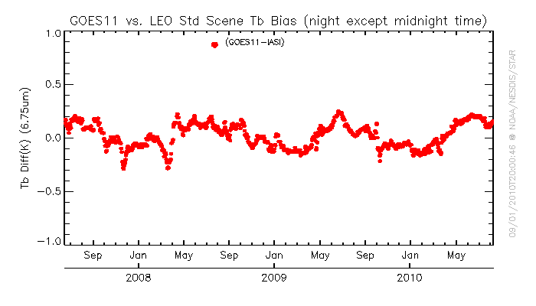
Figure 12. Example of bias monitoring with standard scene for GOES-11 Imager Ch3 (6.75µm).

Consistency Test

Purpose
The most recent results are tested for statistical consistency with the previous time series of results. Users should be alerted to any sudden changes in the calibration of the instruments, allowing them to investigate potential causes and reset trend statistics calculated in 5.e. The consistency test may be performed in terms of regression coefficients or biases.

General Options
      - The biases calculated for standard radiances from the most recent collocations are compared to the statistics of the biases’ trends calculated in 5.e from previous results. If the most recent result falls outside the 3-σ (99.7%) confidence limits estimated from the trend statistics, an alert should be raised. This alert should trigger the Principle Investigator to check the cause of the change and reset the trends by issuing a trend reset.
Equation 19: 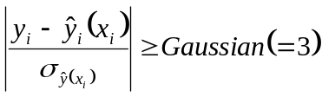
      - The regression coefficients calculated from the most recent collocations are compared to the statistics of the trends calculated from previous regression coefficients. If the most recent result falls outside the 3-σ (99.7%) confidence limits estimated from the trend statistics, an alert should be raised. This has not been implemented yet, due to concerns about correlation between regression coefficients.

Infrared GEO-LEO inter-satellite/inter-sensor Class
      - Implement 5.d.ii.v0.1 as above.

GOES-AIRS/IASI Specific
      - Not implemented.

Trend Calculation

Purpose
It is important to establish whether an instrument’s calibration is changing slowly with time. It is possible to establish this from a time-series of inter-comparisons by calculating a trend line using a linear regression with date as the independent variable. Only the portion of the time series since the most recent trend reset is analysed, to allow for step changes in the instruments’ calibration.

General Options
      - The time series of biases evaluated at standard radiances can be regressed against the time (date) as the independent variable. The linear regression can be weighted by the calculated uncertainty on each bias. The regression coefficients including uncertainties (and their covariances) are calculated by the least squares method described in 5.b.ii.v0.2. In this case, the variables, x_{i} and y_{i} are time series of Julian dates and radiance biases estimated in 5.c for each orbit since the most recent trend reset, respectively.
      - It is also possible to perform the trend calculation using the regression coefficients as dependent variables. However, their covariance should also be accounted for and has not been implemented yet.

Infrared GEO-LEO inter-satellite/inter-sensor Class
      - Implement 5.e.ii.v0.1 as above.

GOES-AIRS/IASI Specific
      - Not implemented.

Define Smoothing Period (Offline)

Purpose
It is possible to combine data from a time series of inter-comparison results to reduce the random component of the uncertainty on the final GSICS Correction. (See 6.a). However, this requires us to define representative periods over which the results can be smoothed without introducing bias due to calibration drifts during the smoothing period. This period can be defined by comparing the observed rate of change of inter-comparison results with a pre-determined threshold, based on the required or achievable accuracy. In general, this definition is performed offline as it requires an in-depth analysis of the instruments’ relative biases and consideration of likely explanatory mechanisms. However, it could also be fine-tuned in near real-time. The following describes the general approaches that should be implemented.

General Options
      - In 5.e.ii.v0.1, time series of radiance biases are regressed against date as the independent variable. This yields an estimate of the rate of change of bias with time, 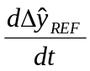, which can be compared to the threshold Δy_{max} to determine the smoothing period, τ_{s}:
Equation 20: 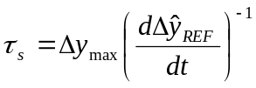
      - This component may not be necessary if the time series is interpolated/extrapolated calculate the GSICS Correction for a particular observation. This would require the regression coefficients to be combined in a time series as suggested in 5.e.ii.v0.2.

Infrared GEO-LEO inter-satellite/inter-sensor Class
      - Implement 5.f.ii.v0.1 as above.

GOES-AIRS/IASI Specific
      - Empirically defined as 30 days. Need to investigate the natural variability of bias and revise accordingly per 4.f.ii.v0.1

Smooth Results

Purpose
It is possible to combine data from a time series of inter-comparison results to reduce the random component of the uncertainty on the final GSICS Correction. These smoothed coefficients provide the Statistical Data used as input to Step 5 (see 6.a), supplied in netCDF format files following the GSICS convention (https://gsics.nesdis.noaa.gov/wiki/Development/WebHome). The smoothing period defined in 5.f is used.

General Options
      - The rolling average of the time series of regression coefficients is calculated using a rectangular box-car window with a width defined in 5.f. The regression coefficients are first transformed to correspond to datasets of centred radiances, after subtracting the standard radiances. This reduces the correlation between the regression coefficients and allows linear averaging.
      - All the collocation data within the smoothing period is combined and the regression of repeated on the aggregate dataset. This approach ensures all data is used optimally, with appropriate weighting according to its estimated uncertainty. This is the recommended approach in general for GSICS.
      - Alternatively, the statistical trends of the time series of regression coefficients suggested in 5.e.ii.v0.2 could be extended – after transforming the dataset to account for the finite covariance between the coefficients. This may be achieved by future developments using Kalman Filtering or EOF-based approaches.

Infrared GEO-LEO inter-satellite/inter-sensor Class
      - Implement 5.g.ii.v0.2 as above.

GOES-AIRS/IASI Specific
      - Implemented as 4.g.ii.v02.

Report Results

Purpose
The results should be reported quantifying the magnitude of relative biases by inter-calibration. This should allow users to monitor changes in instrument calibration.

General Options
      - Plots and tables of relative biases and uncertainties for standard radiances should be produced. These may show the evolution of the biases and their dependence on geophysical variables. These all results should be uploaded to the GSICS Data and Products server, and made available from the GPRC’s appropriate inter-calibration webpage.

Infrared GEO-LEO inter-satellite/inter-sensor Class
      - Plots should be regularly updated showing the relative brightness temperature biases for the standard radiances in each channel as time series with uncertainties. The trend line and monthly mean biases (and their uncertainties) should be calculated from these time series, following the example in Error: Reference source not found. This allows the most recent result to be tested for consistency with the series of previous results. If significant differences are found operators should be alerted, giving them the opportunity to investigate further.
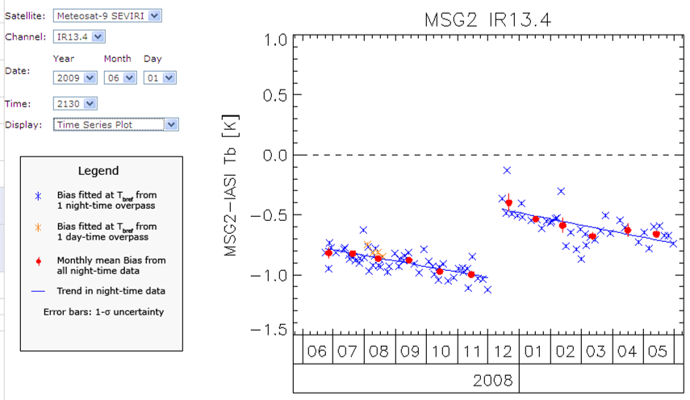
Figure 11: Example of time series plot showing relative bias of IR13.4 channel of Meteosat-9 and IASI at reference radiance following inset legend.

GOES-AIRS/IASI Specific
      - To be implemented.
      - Plot reports are available at NOAA GPRC wiki website .

GSICS Correction
This final step of the algorithm is to calculate the GSICS Correction, modifying its calibration of one instrument’s observed data to be consistent with that of the reference instrument. The form of the GSICS Correction will be defined offline and can be instrument specific. However, application of the correction relies on the coefficients supplied by the inter-comparisons performed in the previous step (Error: Reference source not found) of the algorithm, the so-called Statistical Data.

6. Correcting
GSICS Correction
e.g. Look-Up Table,
FORTRAN subroutine,
New calibration coefficients, …
Correction Coeffs

Time Series of
Inter-calibration
Regression
Coefficients

Analysis Data
MON Lvl 1 Data

Satellite/Instrument/Ch
Date/Time
Geometry
Radiances/Counts

Re-Cal Data

Corrected Radiances
With Uncertainties

Products
Users
Figure 13: Step 5 of Generic Data Flow, showing inputs and outputs,
and illustrating schematically how the correction could be applied by users.

Re-Calculate Calibration Coefficients

Purpose
This component aims to produce revised sets of calibration coefficients for one instrument following its inter-calibration against a reference instrument using the Statistical Data provided by Step 4. These would allow users to recalibrate data from the target instrument to be consistent with the reference instrument. Tables of recalibration coefficients for near-real-time and archive data should also be produced.

General Options
      - The regression coefficients provided as the Analysis Data input to Step 4 are transformed to generate new correction coefficients (together with estimates of their uncertainties as full covariances). These can then be used to convert the observations of the target instrument into radiances consistent with the GSICS reference standard.
I_{LEO}
a_{r}
b_{r}
I_{STD}
ΔI_{STD}
I_{GEO}
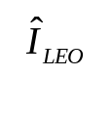
Figure 12: Relationship between radiances observed by geostationary instrument, I_{GEO} and those observed by reference instrument in low Earth orbit, I_{LEO},
showing relative bias for standard radiance, I_{STD}.

Infrared GEO-LEO inter-satellite/inter-sensor Class
      - Implement 6.a.ii.v0.1 as above.
The regression of the aggregated collocated radiances in 5.g.ii.v0.2 yields estimates of the coefficients, a_{r} and b_{r}, required to convert GEO radiances, I_{GEO}, to the reference LEO radiances, I_{LEO} :
Equation 21: 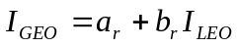
This relationship can be inverted to apply the regression coefficients, a_{r} and b_{r}, to convert GEO radiances, I_{GEO}, into radiances consistent with the LEO reference instrument, 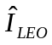,
Equation 22: 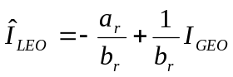,
together with the estimated uncertainty:
Equation 23: 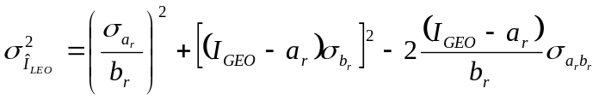,

GOES-AIRS/IASI Specific
      - Implemented the option 6.c.iii.v.1.
      - Not implemented for GOES.

For SEVIRI, we can also implement a variation of 6.a.ii.v0.1 above. Because SEVIRI’s level 1.5 counts are linear with radiance and the calibration coefficients used to convert between the units are constant, we can express the GSICS Correction in terms of modified calibration coefficients.
In this case, the regression coefficient, a_{r} and b_{r}, (and their uncertainties) can be compared with the original calibration coefficients required to convert GEO counts, C_{GEO}, into radiances, I_{GEO}:
Equation 24: 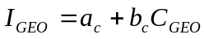
Comparing the two equations above, yields the relationship between the GEO counts and the equivalent radiance of the reference instrument,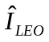:
Equation 25: 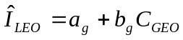, where 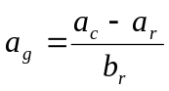and 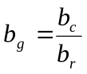.
where a_{g} and b_{g} are new calibration coefficients (with uncertainties) which convert GEO counts, C_{GEO}, into radiances consistent with the LEO reference instrument, , together with the estimated uncertainty:
Equation 26: 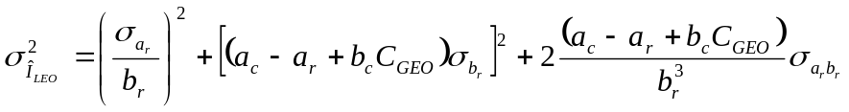,
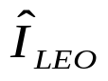
I_{LEO}
I_{GEO}
a_{r}
b_{r}
C_{GEO}
I_{GEO}
a_{c}
b_{c}
a_{g}
b_{g}
I_{STD}
C_{STD}
ΔI_{STD}
Figure 13: Left panel shows relationship between radiances observed by geostationary instrument, I_{GEO} and those observed by reference instrument in low Earth orbit, I_{LEO}.
Right panel shows relationships between the level 1.5 counts and the radiances calculated using the original calibration coefficients (in red) and using the GSICS Corrected coefficients (in blue). The relative bias for standard radiance, I_{STD} is also shown in green.
References
Clough, S. A., and M. J. Iacono, 1995: Line-by-line calculations of atmospheric fluxes and cooling rates II: Application to carbon dioxide, ozone, methane, nitrous oxide, and the halocarbons. J. Geophys. Res., 100. 16519-16535.
Blumstein, D., B. Tournier, F.R. Cayla, T. Phulpin, R. Fjortoft, C. Buil, G. Ponce, 2007: In-flight performance of the infrared atmospheric sounding interferometer (IASI) on Metop-A, Proc. SPIE, vol. 6684, pp. 66840H-66840H-12.
Elloit,D., H. Aumann, L. Strow and S. Hannon, 2009: Two-year comparison of radiances from the Atmospheric Infrared Sounder (AIRS) and the Infrared Atmospheric Sounding Interferometer (IASI), Proc. SPIE, vol. 7456, pp. 75560S.
EUMETSAT, 2005: Spectral Responses of SEVIRI instruments on Meteosat Second Generation http://www.eumetsat.int/groups/ops/documents/file/
zip_msg_seviri_spec_res_char.zip
EUMETSAT, 2007a: A Planned Change to the MSG Level 1.5 Image Product Radiance Definition, Document Ref.: EUM/OPS-MSG/TEN/06/0519 Available online from http://www.eumetsat.int.
EUMETSAT, 2007b, Typical Radiometric Accuracy and Noise for MSG-1/2, EUM/OPS/TEN/07/0314, http://www.eumetsat.int/idcplg?IdcService=GET_
FILE&dDocName=pdf_typ_radiomet_acc_msg-1-2&RevisionSelectionMethod=LatestReleased
EUMETSAT, 2008: IASI Level 1 Products Guide, Ref.: EUM/OPS-EPS/MAN/04/0032, http://oiswww.eumetsat.org/WEBOPS/eps-pg/IASI-L1/IASIL1-PG-4ProdOverview.htm#TOC411
Hewison, T.J., 2009a: Quantifying the Impact of Scene Variability on Inter-Calibration, GSICS Quarterly, Vol. 3, No. 2, 2009.
Hewison, T. J., 2008a: SEVIRI/IASI Differences in 2007, GSICS Quarterly, Vol.2, No.1, 2008. (Available online).
Hewison, T.J., 2008b: The Inter-calibration of Meteosat and IASI during 2007, EUMETSAT Internal Report, April 2008 (Available online).
Hewison, T.J. and M. König, 2008: Inter-Calibration of Meteosat Imagers and IASI, Proceedings of EUMETSAT Satellite Conference, Darmstadt, Germany, September 2008. (Available online).
Johnson, R.X. and M. Weinreb 1996: GOES-8 imager midnight effects and slope correction,” SPIE. Vol. 2812, pp. 596-607.
König, M., 2007: Inter-Calibration of IASI with MSG-1/2 onboard METEOSAT-8/9, GSICS Quarterly, Vol.1, No.2, August 2007 (Available online).
Minnis, P., A. V. Gambheer, and D. R. Doelling, 2004: Azimuthal anisotropy of longwave and infrared window radiances from CERES TRMM and Terra data. J. Geophys. Res., 109, D08202, doi:10.1029/2003JD004471.
Press, W.H., S.Teukolksy, W.T.Vetterling and B.Flannery, 1995: Numerical recipes: the art of scientific computing, Second edition, Cambridge University Press.
Pagano, T.S., H.H. Aymann, D.E. Hagan, and K. Overoye, 2003: Prelaunch and In-flight radiometric calibration of the Atmospheric Infrared Sounder (AIRS), IEEE Trans. Geosci. Remote Sensing, vol. 41, pp. 265-273.
Rothman et al., 2003: The HITRAN molecular spectroscopic database: edition of 2000 including updates through 2001, Journal of Quantitative Spectroscopy and Radiative Transfer. vol. 82, 5-44.
Strow, L., S. Hannon, D. Tobin and H. Revercomb, 2008: Inter-calibration of the AIRS and IASI operational infrared sensors, Proceeding 17th Annual Conference on Characterization and Radiometric Calibration for Remote Sensing (CALCON), Logan, UT, Utah State University Research Foundation.
Tahara, Yoshihiko, 2008: New Approach to Intercalibration Using High Spectral Resolution Sounder, Meteorological Satellite Center Technical Note, No. 50, 1-14.
Tahara, Yoshihiko and Koji Kato, 2009: New Spectral Compensation Method for Intercalibration Using High Spectral Resolution Sounder, Meteorological Satellite Center Technical Note, No. 52, 1-37.
Tobin, D. C., H. E. Revercomb, C. C. Moeller, and T. Pagano, 2006: Use of Atmospheric Infrared Sounder high-spectral resolution spectra to assess the calibration of Moderate re solution Imaging Spectroradiometer on EOS Aqua, J. Geophys. Res., 111, D09S05, doi:10.1029/2005JD006095.
Tobin, D., 2008: An SNO analysis of IASI and AIRS spectral radiance, GSICS Quarterly, Vol. 2, No. 3.
Wang, L., X. Wu, Y. Li, S-H. Sohn, M. Goldberg and C. Cao, 2010: Comparison of AIRS and IASI radiance measurements using GOES Imagers as transfer radiometers, Journal of Applied Meteorology and Climatology, Vol. 49, pp. 478-492.
Wu, X., 2009: GSICS GOES-AIRS Inter-Calibration Algorithm at NOAA GPRC, Draft version dated January 5, 2009.
Yu, F., X. Wu, Y. Li, G. Rancic, L. Wang, M.R. Rama Varma Raja, S.H. Song, F. Weng and M. Goldberg, 2009: GSICS GEO-LEO operation at NOAA/NESDIS, Proc. SPIE, vol. 7456, pp. 74560A-1-74560A-10.
Yu, F., X. Wu, M.K. Rama Varma Raja, L. Wang, Y. Li and M. Goldberg, 2011: Evaluation of the diurnal and scan angle calibration variations of GOES Imager infrared data, IEEE on Geosciences and Remote Sensing. (to be submitted).

To be further defined later in Section …

