Prepared by EUMETSAT
Agenda Item: II/3
Discussed in WGII

Calibration Events Working Group
In response to CGMS recommendation 39.12 (CGMS MR 39): CGMS Satellite Operators to provide regular information on satellite/ instruments events affecting calibration and establish corresponding websites

Prepared by: R.A. Roebeling, E. Bouchez, C. Hanson, H. Rothfuss, P. Miu, S. Wagner, R. Dyer, C. Blake, A. Holmes

The logging of satellite events is an activity that is taken care of by the different space agencies. However, till now this activity is performed with little interaction between the space agencies, or even between the different missions operated by a single space agency. In addition, the aim of logging satellite events is not primary to register events affecting the calibration of the satellites and/or the instruments operated on these satellites. The recommendation made at the 39th meeting of Coordination Group for Meteorological Satellites (CGMS): “CGMS Satellite Operators to provide regular information on satellite/ instruments events affecting calibration and establish corresponding websites”, poses a challenge on satellite operators to go a step further and organize the logging of satellite and instrument from a user’s point of view. This recommendation coincides with the recommendation of the Global Space-based Inter-Calibration System (GSICS) working group, which recommended that “Satellite operators to provide "a log of satellite / instrument events" to support the identification of "spurious" events/trends in calibrated data sets”.

In response to recommendations defined by CGMS and GSICS, EUMETSAT established in 2012 the Calibration Events Working Group. This internal working group will propose guidelines and methods for developing a common approach within EUMETSAT to log satellite and instrument events impacting calibration and data quality, and will propose how to coordinate the adoption of a common approach among satellite operators worldwide. These events comprise Mission Information, Irregular Events and Processing Changes that affect the radiometric and geometric quality of level-1, level-1.5 (geostationary satellites) and level-1b/1c (polar orbiting satellites) data, and Data Outages.

This working paper summarizes the actions taken at EUMETSAT to address the recommendation of CGMS. The terms of reference defined for the working group will be summarized. High level requirements are being defined. Guidelines for a Satellite Events Logging System are being drafted. Requirements for a web interface are being defined.

Action/Recommendation proposed:
- CGMS and GSICS partners to review the proposed Calibration Events Logging System and to suggest how to achieve a common approach across satellite operators;
- Identify Climate Users that are willing to help populate EUMETSAT’s calibration events database with historic events.

Calibration Events Working Group

- INTRODUCTION

At the 39th meeting of Coordination Group for Meteorological Satellites (CGMS) it was recommended that “CGMS Satellite Operators to provide regular information on satellite/ instruments events affecting calibration and establish corresponding websites” (Recommendation 39.12, CGMS MR 39).

This document is the first deliverable covering this action. In Section 2, the Terms of Reference of the Calibration Events working group that was initiated at EUMETSAT are summarized. A review of the current event logging systems at EUMETSAT is presented in Section 3. Section 4 presents the first concept of a common approach to log events affecting radiometric and geometric data quality or data outages, hereinafter referred to as calibration events. This concept proposes i) the type of calibration events that shall be logged, ii) the type of information that shall be provided with each event, iii) the use of common and traceable standards, iv) the manner of populating the calibration events database with near-real time and historic data, and iv) the method to access and display the calibration events database to external users.

- TERMS OF REFERENCE

In response to CGMS recommendation 39.12 (CGMS MR 39), EUMETSAT initiated an internal working group, the Calibration Events Working Group, in spring 2012. This working group will propose guidelines and methods for developing a common approach to log satellite and instrument events within EUMETSAT, and will propose how to coordinate the adoption of the proposed approach among satellite operators worldwide.

The objectives of the Calibration Events Working Group are:
- to define, in line with the overarching requests from CGMS and GSICS, which calibration events should be logged, what information needs to be presented, and how this information should be presented and be made available to external users;
- to propose guidelines and methods for developing a common calibration events logging approach for EUMETSAT, which is attuned to approaches adopted by other satellite operators;
- to follow recommendations on calibration event logging from external authorities, in particular of CGMS, GSICS and WMO;
- to function as the single expert group for all EUMETSAT calibration event logging issues;
- to communicate progress, methods and results regularly to the relevant management lines and to the EUMETSAT participants/representatives in GSICS and CGMS.

The Calibration Events Working Group will address the planning and coordination activities that have been defined as its objectives. The tasks of the Working Group include:
- to make an assessment of existing calibration events logging systems at EUMETSAT;
- to collect requirements for calibration event logging of EUMETSAT programmes and from the EUMETSAT user community;
- to participate in the verification of approaches for logging calibration events;
- to support the definition of necessary changes for building a common approach for logging calibration events;
- to support the definition of necessary changes for populating an event logging system with historic events from EUMETSAT’s geostationary and polar orbiting satellites.

- ASSESSMENT OF CURRENT EVENT LOGGING SYSTENS

This section summarizes the outcome of an assessment of the event logging systems currently used at EUMETSAT. This assessment revealed that the event logging systems currently in place at EUMETSAT contain many useful elements that shall be adopted by the Calibration Events Working group. However, it is not straightforward to use the existing databases for extracting calibration events, i.e., events that seriously affect the radiometric and geometric quality of the data due to satellite/instrument events or post-processing modifications. There several issues that needs to be resolved for defining a calibration event logging system. Below the most important recommendations that resulted from this assessment are listed:
- The system shall be mission independent;
- The system shall have a sophisticated and scalable concept;
- The events shall be categorized in main groups;
- The impact of an event on the data quality shall be traceable;
- The events shall be logged following standard conventions, where applicable ISO standards.

- CONCEPT OF CALIBRATION EVENTS LOGGING SYSTEM

In this section we present the concept of the Calibration Events Logging System to build a calibration events database, i.e., events affecting the radiometric and geometric quality of satellite data or data outages. This concept has been drafted after internal discussions at EUMETSAT. These discussions were held with the in-house designers of the current event logging systems, as well as with the scientists working on research, development and operation of level-1b and level-2 satellite products. Feedback from users (CGMS) and calibration (GSICS) community shall be taken up to allow further modifications of the presented concept.

A schematic representation of the proposed Calibration Events Logging System is shown in Figure 1. The Figure illustrates the hierarchy of the system. It is proposed that the events shall be made available for each satellite mission separately. The Calibration Events Logging System shall provide information into four main categories in the following manner:
- Mission Information
- Irregular Events
- Processing Events
- Data Outages

These main categories have been subdivided in one, two or three sub-categories. It was decided to use main categories and sub-categories to avoid an overload of event reports. The sub-categories shall only report on events that affect the radiometric and geometric quality of the data. In general, the number of events reported per satellite mission will be limited to several reports per year. These sub-categories shall report either static information or more details about the events. The “Mission Information” category is a static category that only provides general information on the missions, the instruments and the sensors. The events reports shall summarize the most relevant information on the event, i.e., the time of occurrence and their impact on the radiometric or geometric quality of the level-1 (e.g. calibration coefficients or post-processing specifications). More information on the event details shall be established through tags to the events reports of the database, and, if available, links to supporting reports.

In the following sub-sections of this document more details about the concept of the sub-categories is given.

  - Mission Information
The main category “Mission Information” provides general information on the platform and instruments operated in the mission that is relevant to all users of the satellite data. This category gathers pieces of information on both the platform and the instrument. Even though it is not strictly speaking related to events affecting the calibration quality, this information is often appreciated by users in order to have a complete overview on a mission and to be aware of changes in the observing system, in particular when new satellites and instruments are positioned and set operational. The information provided in this category includes the launch and operational dates, the satellite, instrument and sensor characteristics, as well as information on the sensors spectral response functions. The information shall either be provided directly via the calibration events database or through links referring to the relevant documents.

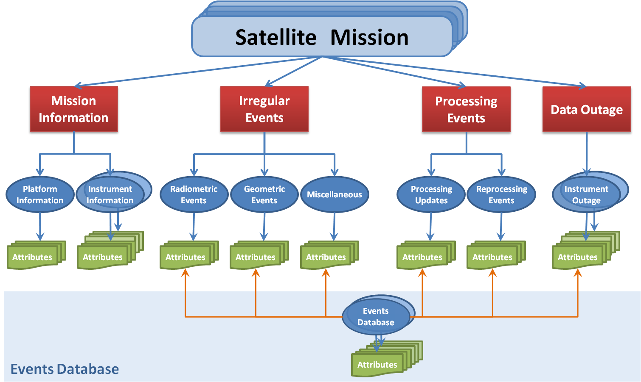

Figure 1: General concept of the Calibration Events Logging System

  - Irregular Events
The main category “Irregular Events” provides information on events that are not occurring systematically and that impact the radiometric or geometric quality of the observations due to instruments calibrations, manoeuvres, ground segment anomalies or miscellaneous. Such events can be either radiometric events (for instance ice decontamination) or geometric events (for instance platform manoeuvres). Because the impact of an event on the radiometric and geometric quality of the observations is not always obvious and fully understood, an additional sub-category for miscellaneous events is recommended to provide more complete information to users. Note that the same event may be tagged in different sub-categories.
It is foreseen to establish for each instrument type a list of events to record. Such lists are elaborated together with the various mission scientists, instrument engineers and satellite engineers.

  - Processing Events
The main category “Processing Events” provides information on updates of the processing algorithms (either onboard or at the ground segment) or reprocessing (at the ground segment) events that affected the radiometric or geometric quality of the observations. Processing changes include software updates and reprocessing activities.

  - Data Outages
The main category “Data Outages” provides information on events that triggered the temporary or definitive end of the data collection. Keeping a log of periods that data were missing is valuable as it gives an overview of actual data availability. Reasons for missing data can be at Platform, Instrument and Processing level.

  - Events Database
The Calibration Events Logging System shall use the existing databases as most important source of information. As illustrated in Figure 1 these databases shall not be directly accessible by users. However, these databases shall be searched in order to filter out events that fit into the sub-categories described above. The exiting databases may use different naming conventions for the same types of events. Therefore, the Calibration Events Logging System supports the use of links to transfer the naming conventions used across the existing databases to a standard naming convention. The Calibration Events Working Group will propose a list of names for satellite events that follow standard naming conventions, and accommodate the adoption of these names in existing events databases. The following main groups of events have been identified:
- Ground segment anomalies;
- Operating mode changes;
- Platform alteration;
- Platform damages;
- Instrument maintenance;
- Instrument alteration;
- Instrument damage;
- Detector configuration.

- EVENTS LOGGING META-DATA STANDARD

To ensure the traceability and uniformity for storing and reporting calibration events, a meta-data standard for describing these events shall be defined globally across the space agencies to ensure interoperability. Ideally the meta-data standard shall be validated by the schema of an existing standard for describing geographic information (i.e. information about the identification, the extent, the quality, the spatial and temporal schema, spatial reference, and distribution of digital geographic data).

The Calibration Events Working Group will collaborate closely with the GSICS Research (GRWG) and Data Management (GDWG) Working Groups in order to provide guidance to international partners and operational centres for logging calibration events.

The description of the calibration events and the identification of the meta-data standards shall be attuned to the common standards used by GSICS and ISO. Where possible, the Calibration Events Logging System shall adopt the standards set by GSICS. The GRWG and GDWG Working Groups of GSICS shall review the prototype approach for classifying, logging and accessing instrument satellite calibration events for its suitability to other organisations/systems.

- POPULATING THE DATABASE

This section describes the efforts that are needed to populate the calibration events database with near real-time evens, as well as historic events covering the entire time-series of satellite observations. The CGMS action requires the population of the calibration events database for near real-time events. The GSICS action requires population of the calibration events database with both near real-time and historic events.

Baseline for populating the calibration events database are the existing events databases that are currently used at the space agencies. As argued above, many of the existing databases contain events that are not relevant from a calibration point of view, and may use different naming conventions. Moreover, these databases may not include all the information required for the calibration events database. An assessment of the existing events databases needs to be made to determine i) which information is available, ii) which information is still missing, iii) which naming conventions are used, and iv) which periods are covered.

To populate the calibration events database requires the search for calibration related events in the existing databases, the conversion of the nomenclature of these events to common naming conventions, and the adding of missing information to the events. The archives available at the space agencies will most likely contain many gaps, especially when going further back in time. Therefore, it may be needed to consult climate users working with historic satellite data and retrieve information on calibration events from their experiences.

- USER INTERFACE AND ANALYSIS TOOLS

The Calibration Events Working Group acknowledged the use of a web-interface tool to access and to display the database of the Calibration Events Logging System to external users. Such an interface should allow users to search/filter and view all logged events, whether current or historic, of the different satellite missions. In addition, the web-interface shall allow the users to plot and analyse time-series of certain events graphically. At EUMETSAT there is ample experience with building web-interfaces for logging events, such as the web-interfaces that have been developed to open up the GSICS database. During the coming year, the Working Group shall use in-house experience to define the recommendations for the web-interface of the Calibration Events Logging System in more detail, and report on these recommendations at the CGMS meeting of 2014. A schematic concept of the relationship between the Satellites Events Database and the User Interface is presented in Figure 2.

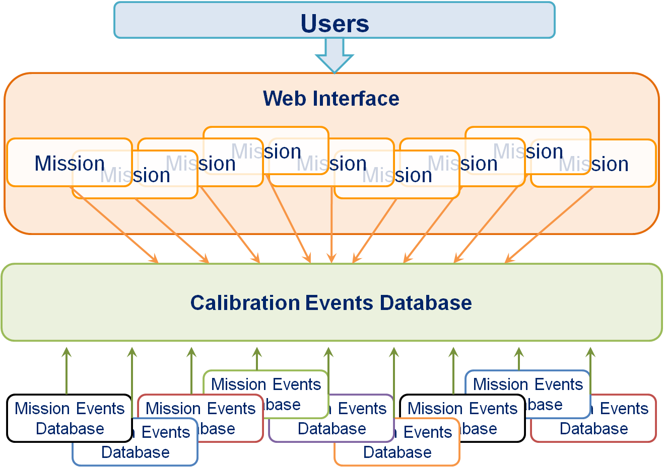

Figure 2: General concept User Interface

- WHAT IS NEXT

This section lists the steps to be taken by EUMETSAT’s Calibration Events Working Group till the 41st CGMS meeting in response to CGMS recommendation 39.12 (CGMS MR 39):
- to ask the CGMS and GSICS partners to review the proposed Calibration Events Logging System and to suggest how to achieve a common approach across satellite operators;
- to draft the user requirements (type of information, period of information, user interface to events database ...);
- to report to the EUMETSATs Climate Monitoring Coordination Group (CMCG) and plan the next implementation steps;
- to consult climate users working with historic data from EUMETSAT satellites and retrieve information on calibration events from their experiences;
- to iterate the plans of the EUMETSAT’s Calibration Events Working Group with GSICS.

