ATBD for EUMETSAT Demonstration Prime GSICS Corrections for Meteosat-SEVIRI

EUMETSAT
Eumetsat-Allee 1, D-64295 Darmstadt, Germany
Tel: +49 6151 807-7
Fax: +49 6151 807 555
http://www.eumetsat.int

Doc.No. | : | EUM/RSP/TEN/14/777892
Issue | : | v1E Draft
Date | : | 21 October 2016
WBS/DBS | :

Document Change Record
Issue / Revision | Date | DCN. No | Changed Pages / Paragraphs
v1A | 25/11/2014 |  | Added ‘inflate=inflate’ after read_rac in code.  Added plots.
v1B | 14/07/2015 |  | Revised example IDL code,  adding –PRIME to filename.
v1C | 10/12/2015 |  | First published version.  Revised text, following review by GSICS Product Acceptance Team.  Updated example IDL code.  Changed Document Signature Table & Reformatted.
v1D | 19/01/2016 |  | Updated example IDL code after bug fixes.
v1E | 21/10/2016 |  | Renamed Primary Reference to Anchor Reference. Added delta correction coefficients to output netCDF and updated example IDL code.
v1F | 11/01/2017 |  | Updated links and signature table

Table of Contents
1 Introduction 5
1.1 Purpose 5
1.2 Scope 6
1.3 Applicable Documents 6
1.4 Reference Documents 6
1.5 Document Structure 7
2 Preliminaries 8
3 Define Delta Correction 9
3.1 Define Delta Correction Uncertainty 9
3.2 Check Delta Correction Consistency 10
3.3 Check Delta Uncertainty Extrapolation 10
4 Apply Delta Correction to Secondary GSICS Corrections 12
4.1 Propagate Uncertainty to Modified Secondary Corrections 12
5 Blend GSICS Corrections from Individual References 14
Appendix A Example IDL Code 17
A.1 Main Program 18
A.2 calc_delta 24
A.3 subset_rac 25
A.4 hypirsno_prime_rac_plot 26

Table of Figures
Figure 1 – Schematic data flow diagram for generating Prime GSICS Correction, merging GSICS Corrections derived from multiple references, after applying Delta Corrections, based on their double differences, to transform them to the common scale of the Anchor GSICS Reference. 5
Figure 2 – Time Series of Radiance Biases (in K) calculated for Standard Radiance Scene from GSICS Re-Analysis Corrections for Meteosat-10/SEVIRI with respect to Metop-A/IASI (black) and Metop-B/IASI (red). 11
Figure 3 – Time series of IASIA-IASIB double differences of biases above (black) with (grey) shading for k=1 uncertainty (inflated by a factor of 2), and equivalent biases calculated from cumulative Delta Correction (red), derived from same data over increasing time periods, with shading for k=1 (orange) k=2 (yellow) uncertainty limits. 11
Figure 4 – Time Series of Radiance Biases (in K) calculated for Standard Radiance Scene from GSICS Re-Analysis Corrections for Meteosat-10/SEVIRI with respect to Metop-A/IASI (black) and Metop-B/IASI (red), Metop-B/IASI after delta correction (green), and Prime GSICS Re-Analysis Correction (blue), which obscures most other lines. 15
Figure 5 – Time Series of k=1 uncertainties (in K) calculated for Standard Radiance Scene from GSICS Re-Analysis Corrections for Meteosat-10/SEVIRI with respect to Metop-A/IASI (black) and Metop-B/IASI (red), Metop-B/IASI after delta correction (green), the delta correction itself (cyan), and the Prime GSICS Re-Analysis Correction (blue), which obscures most other lines. 15
Figure 6 – Time Series of relative weights of GSICS Corrections from anchor reference (red) and transfer reference (green) used to calculate Prime Correction. 16

Introduction

Purpose
This document forms the Algorithm Theoretical Basis Document (ATBD) for the generation of Prime GSICS Corrections, by reading in GSICS corrections derived with different reference instruments, converting them to a common radiometric scale (that of the Anchor GSICS Reference) and merging them to form one contiguous record. This ATBD is based on the Re-Analysis Corrections generated by EUMETSAT for the inter-calibration of Meteosat/SEVIRI images using IASI hyperspectral sounders on Metop-A and -B as reference instruments. This process is illustrated schematically in Figure 1.

Reference
-
1
(Anchor)
Monitored
Instrument
GSICS
Correction, g
1
Mon
➔
1
Reference
-
2
(Transfer)
GSICS
Correction, g
2
Mon
➔
2
Mon
➔
1
Delta
Correction, g
1
/
2
2
➔
1
Derived by
GSICS
Applied
by User
Modified
Correction, g
2
,
1
/
2
Mon
➔
2
➔
1
Prime
GSICS
Correction, g
0
Mon
➔
1
-
<g>
+

Figure 1 – Schematic data flow diagram for generating Prime GSICS Correction,
merging GSICS Corrections derived from multiple references,
after applying Delta Corrections, based on their double differences,
to transform them to the common scale of the Anchor GSICS Reference.

Scope
In future, further refinements will be needed to this ATBD to specifically include second (and third) order transfers for additional reference instruments which do not overlap with the anchor reference instrument. In this case, an iterative series of double differences will be established, using transfer references to transfer the datum of the anchor reference to any arbitrary period.

This ATBD covers the case of generating Prime GSICS Corrections for Re-Analysis applications. It can be modified by a simple extension to cover Near Real-Time applications.

Applicable Documents
AD-1 | GSICS File Naming Convention,  GSICS Development Wiki, 2015-07-06 | http://gsics.atmos.umd.edu/bin/ view/Development/ FilenameConvention
AD-2 | GSICS Data Server Configuration,  GSICS Development Wiki, 2015-04-29 | http://gsics.atmos.umd.edu/bin/ view/Development/ DataServerConf
AD-3 | GSICS netCDF Convention,  GSICS Development Wiki, 2015-07-31 | http://gsics.atmos.umd.edu/bin/ view/Development/ NetcdfConvention

Reference Documents
GSICS Correction ATBD | “ATBD for EUMETSAT Operational GSICS Inter-Calibration of Meteosat-IASI” | EUM/TSS/TEN/15/803179  Available online
Hewison, 2013 | “An Evaluation of the Uncertainty of the GSICS SEVIRI-IASI Inter-Calibration Products" | IEEE Transactions on Geoscience Remote Sensing, Vol. 51, no. 3, Mar. 2013, doi: 10.1109/TGRS.2012.2236330.

Document Structure

This document is structured in sections following the logical steps of the ATBD as follows:

Preliminaries

The initial step is to define the Monitored Satellite/Instrument and the Reference Satellite(s)/Instrument(s), the type of inter-calibration product – i.e. Near Real-Time Correction (NRTC) or Re-Analysis Correction (RAC), and distribution mode of the product – i.e. Demonstration, Pre-operational, Operational. These in turn define the paths and names of the files which are required as inputs and output from the process of generating the Prime GSICS Correction, according to the conventions adopted in the configuration of the GSICS Data and Products Server [GSICS Wiki].

The input data are then read from the input files, following the GSICS netCDF convention defined on the [GSICS Wiki].

The following terminology is used in this ATBD:

GSICS Correction to Reference1 Equation 1

GSICS Correction to Reference2 Equation 2

where
L_{MON} is the radiance of the Monitored instrument in channel j ,
L_{REF1} is the radiance of Reference instrument 1, spectrally matching channel j ,
L_{REF2} is the radiance of Reference instrument 2, spectrally matching channel j ,
g₁ is the GSICS Correction to convert Reference 1 to the monitored instrument,
g₂ is the GSICS Correction to convert Reference 2 to the monitored instrument,
a₁ and b₁ are offset and slope coefficients of a linear function describing g₁,
a₂ and b₂ are offset and slope coefficients of a linear function describing g₂.
(Channel subscripts j are omitted here for clarity.)

The coefficients a and b are read from the current netCDF variables offset and slope, respectively. These have (i, j) dimensions of (date, channel) in the case of the Re-Analysis Correction.

The uncertainties on the coefficients, u(a) and u(b) are also read from variables, offset_se and slope_se, and their covariance u(a, b) is read from the variable covariance. These uncertainties are inflated by a factor of 2 upon reading, following the recommendations of [Hewison, 2013].

n.b. It has been proposed to deprecate these variable names in the future and replace them with the generic names for the coefficients and their covariance. This ATBD will be revised accordingly if needed.

Define Delta Correction

The Delta Correction is used to convert GSICS Corrections derived with one reference instrument to be metrologically consistent with those derived from another reference instrument, for the same monitored instrument.

The Delta Correction is derived from the double difference between pairs of GSICS Corrections derived from different reference instruments. It is defined by all available coincident data derived from the beginning of the overlap period, when data from both reference instruments were first available simultaneously, until the date for which the Prime GSICS Correction is to be defined. In this way, the delta corrections are expected to improve with time, as the overlap period grows and the uncertainty on the delta correction will tend to decrease.

This ensures the Prime GSICS Correction is directly traceable to the Anchor GSICS Reference for this spectral band – denoted here as REF1.

A threshold of a minimum number of 7 days is applied to prevent erratic results during the initial overlap period. This threshold may be revised for specific instruments.

Combining equations (1) and (2), allows us to define the Delta Correction from REF2 to REF1, g_{1/2} as:
Equation 3

where denotes the GSICS Correction with respect to REF1, defined at time step, i,
and <...> denotes the average of these time series.

In the simple case where the GSICS Correction is a linear function of the reference radiance, defined by an offset term, a, and a slope term, b, we can write (3) as:

Equation 4

Define Delta Correction Uncertainty

The uncertainty of the delta correction can be estimated as the standard error of the same time series used to define it, after accounting for over-sampling introduced by smoothing process introduced by applying a rolling window to the collocation data used to define its component GSICS Corrections.

The simplest way to express this uncertainty is in matrix notation, starting with the matrix of the residuals of the delta correction, e_{1/2}:
Equation 5

The covariance of these residuals is then evaluated as E_{1/2:}
Equation 6

This covariance needs to be corrected to account for the oversampling factor, :
Equation 7
where P = Smoothing Period, n = number of samples, and Δt = Overlap Period.

The delta correction uncertainty, , is then estimated from the covariance matrix, E_{1/2}, as:
Equation 8

Check Delta Correction Consistency

However, tests on the Delta Correction are necessary to ensure:
- There are no step changes in the relative difference between the reference instruments,
- There is no significant trend in their difference,
- There are no significant periodic oscillations in their difference.

At present these tests are implemented offline on an ad hoc basis. This part of the ATBD will be developed fully for pre-operational status, based on section 5 of the ATBD describing the generation of the individual GSICS Corrections [ATBD], from which these Prime GSICS Corrections are derived.

For now, it is assumed that there are no significant step changes, trends or oscillations in the time series of the double difference coefficients. So, we can use all the collocations obtained over the entire overlap period when both transfer and anchor references are available to define the delta corrections.

Check Delta Uncertainty Extrapolation

If significant trends or oscillations are found above, the delta correction’s uncertainty should be inflated when it is extrapolated to apply to periods beyond the overlap period when both references are available. As no significant trend or oscillation has been detected in the case of the inter-calibration of SEVIRI with Metop-A/IASI and Metop-B/IASI, it has not been necessary to fully define the methodology for this extrapolation. This step will be defined in future as needed.

Figure 2 shows the biases calculated from the GSICS Corrections from the two references (Metop-A/IASI and Metop-B/IASI), which are almost indistinguishable on this scale for most of the time series (except for occasional jumps in IR6.3 using IASI-B). Figure 3 shows the time series of their double difference, and the delta correction defined cumulatively from it using Equation 4 (after converting to equivalent brightness temperature bias for a standard radiance scene), together with their associated uncertainties. This shows that step changes in either time series increase the uncertainty in the delta correction.

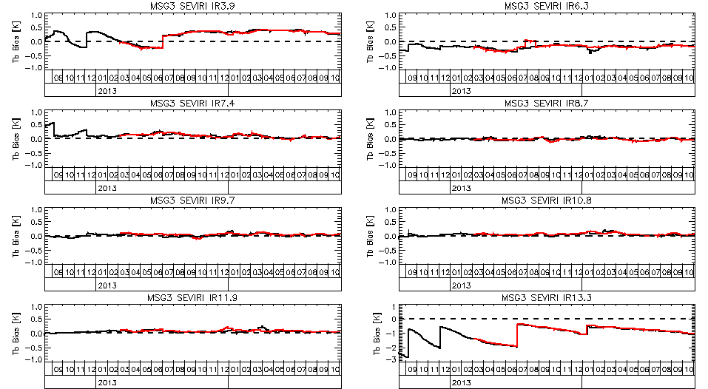
Figure 2 – Time Series of Radiance Biases (in K) calculated for Standard Radiance Scene from GSICS Re-Analysis Corrections for Meteosat-10/SEVIRI with respect to Metop-A/IASI (black) and Metop-B/IASI (red).

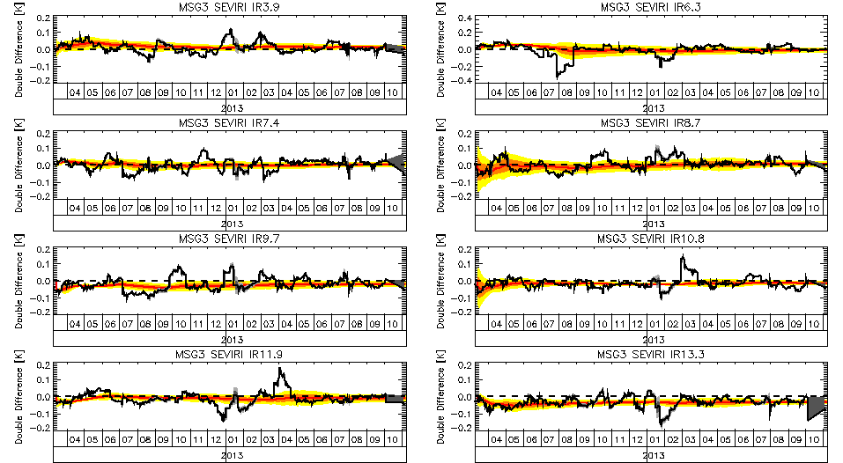
Figure 3 – Time series of IASIA-IASIB double differences of biases above (black) with (grey) shading for k=1 uncertainty (inflated by a factor of 2), and equivalent biases calculated from cumulative Delta Correction (red), derived from same data over increasing time periods, with shading for k=1 (orange) k=2 (yellow) uncertainty limits.

Apply Delta Correction to Secondary GSICS Corrections

Next, we need to apply the delta corrections g_{1/2} to the coefficients of the GSICS Correction derived from transfer reference instrument, g₂, to make them metrologically consistent with those derived from the anchor reference, g₁. This defines a modified GSICS Correction, g_{2,1/2}:
Equation 9

In the case of the simple linear form of the GSICS Correction, this can be written as:

Equation 10
where the coefficients of g_{2,1/2} are:

Propagate Uncertainty to Modified Secondary Corrections

To estimate the uncertainty on the coefficients of the modified secondary corrections, g_{2,1/2}, we perform a normal error propagation on Equation 10, first by defining the partial derivatives of the coefficients:

Partial derivatives of : Equation 11
Partial derivatives of : Equation 12

For simplicity, we assume no correlation between Delta Correction and GSICS Corrections:

Equation 13

These are then combined with the uncertainties on the coefficients, u(a₁), u(b₁), u(a₂), u(b₂):
Equation 14

Equation 15
Similarly, for simplicity, we make the crude approximation that the coefficients’ covariance is proportional to their fractional uncertainty, scaled by the covariance of the secondary correction coefficients:

Equation 16

These equations can be written more concisely in matrix notation:

Equation 17

Equation 18

Equation 19
Equation 20

where U₁, U₂, U_{1/2} and U_{2,1/2} are the covariance matrices of the uncertainties on the coefficients of the GSICS Corrections derived with the prime, secondary, delta, and modified secondary corrections, respectively.

Blend GSICS Corrections from Individual References

The Prime GSICS Correction is defined as a weighted average of the coefficients of the GSICS Corrections derived from all available individual reference instruments, after modifying them to be consistent with the anchor reference.

The relative weightings are defined from the uncertainties from the individual references, if both are available. If only one is available for a given date, it alone will define the Prime GSICS Correction. Hence, the covariance, U₀, of the weighted average for dates when multiple references are available is given by:

If g₁ and g_{2,1/2} available:
If only g₁ available: Equation 21
If only g_{2,1/2} available:

(In the example code given in Appendix A, this switch is implemented by scaling U₁ and U_{2,1/2} by factors of nj1 and nj3 respectively, which are either 0 or 1.)

The Prime GSICS Correction is then given by:

Equation 22

This calculation can be performed iteratively, following the general form described below for the coefficients derived with the anchor reference, g₁, and transfer references, modified as described above, g_{2,1/2}.

A new netCDF file is then created, for the Prime GSICS Correction, following the GSICS file naming convention (GSICS 2013). The coefficients of prime GSICS Correction and delta correction and their uncertainties are then written to this netCDF file and it is transferred to the upload directory of the appropriate GSICS Server as defined on the [GSICS Wiki].

Figure 4 shows the biases calculated from the Prime GSICS Correction for the whole period of this sample dataset. In this case, the GSICS Corrections from the two references (Metop-A/IASI and Metop-B/IASI) are almost indistinguishable on this scale, and the Prime GSICS Correction obscures the other lines, which it overplots, confirming its consistency.

Figure 5 shows the uncertainty in the radiance biases calculated from the GSICS Corrections derived from individual references, and compares these with the uncertainty on the delta correction, which increases the uncertainty on the GSICS Correction from the transfer reference when it is applied. In turn, this reduces its weight in the blended average that makes up the Prime GSICS Correction – so its uncertainty is only a little better than that of the GSICS Correction from the anchor reference.
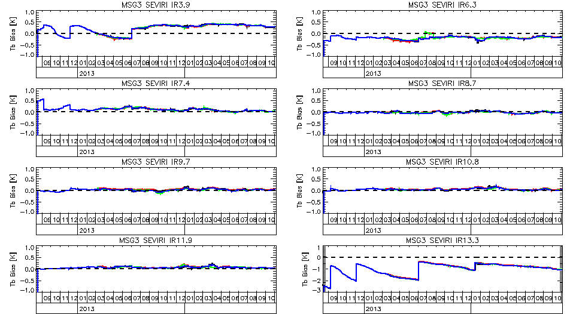
Figure 4 – Time Series of Radiance Biases (in K) calculated for Standard Radiance Scene from GSICS Re-Analysis Corrections for Meteosat-10/SEVIRI with respect to Metop-A/IASI (black) and Metop-B/IASI (red), Metop-B/IASI after delta correction (green), and Prime GSICS Re-Analysis Correction (blue), which obscures most other lines.

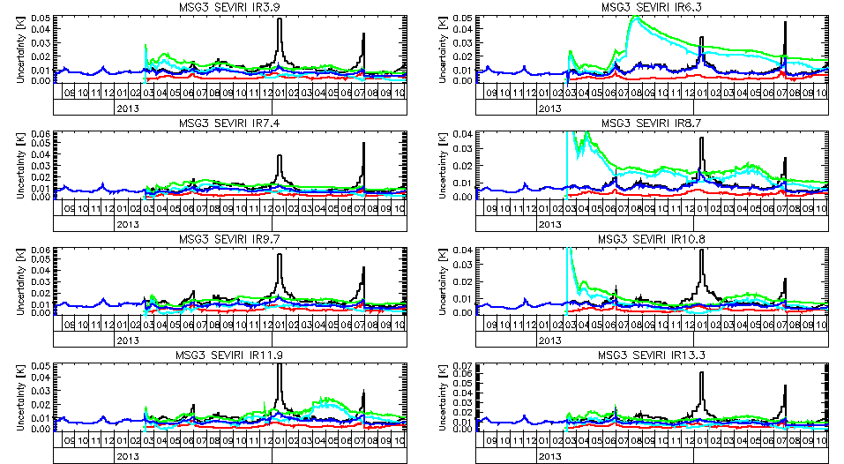
Figure 5 – Time Series of k=1 uncertainties (in K) calculated for Standard Radiance Scene from GSICS Re-Analysis Corrections for Meteosat-10/SEVIRI with respect to Metop-A/IASI (black) and Metop-B/IASI (red), Metop-B/IASI after delta correction (green), the delta correction itself (cyan), and the Prime GSICS Re-Analysis Correction (blue), which obscures most other lines.

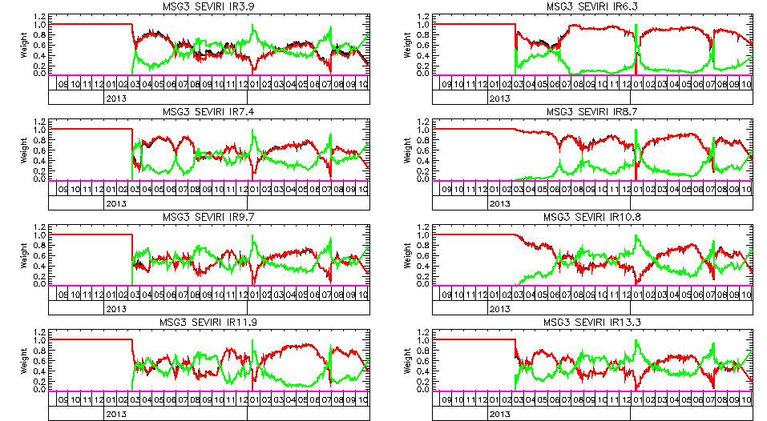
Figure 6 – Time Series of relative weights of GSICS Corrections from anchor reference (red) and transfer reference (green) used to calculate Prime Correction.

Figure 6 shows how the relative weights of the constituent parts of the Prime GSICS Correction vary with time, depending on the relative uncertainty of the GSICS Corrections derived from anchor and transfer references. Initially only the anchor reference is available, so the Prime GSICS Correction is based purely on that. It continues to dominate the transfer reference for most of the remainder of the time series, due to the extra uncertainty introduced by applying the delta correction. However, there are some periods where the GSICS Correction from the transfer reference dominates – for example when an outage in the data feed to this demonstration product from Metop-A/IASI occurred in January 2014.

- Example IDL Code

The example code in this appendix uses variable names which map to the symbols used in this ATBD as follows:

Define GSICS Corrections and Uncertainties in Matrix notation |  |  | g1=[a1,b1]  g2=[a2,b2]  g12=[a12,b12]  g3=[a3,b3]  ug1=[[ua1^2,uab1],$  [uab1,ab1^2]]  ...
Weighted average of RAC1 and RAC2+Delta12  weighted by uncertainties |  |  | ug0=INVERT($  INVERT(u1)+$  INVERT(u3))  g0=ug0#INVERT(ug1)#$  INVERT(ug3)#g3  ua0=SQRT(ug0[0,0])  ub0=SQRT(ug0[1,1])  uab0=ug0[0,1]
Standard Error of Delta Correction  from Ref1 to Ref2 | Matrix of Residuals:  Covariance of Residuals:  Over-sampling Factor:  Delta Correction Uncertainty  (Covariance Matrix): | Matrix of Residuals:  Covariance of Residuals:  Over-sampling Factor:  Delta Correction Uncertainty (Covariance Matrix): | residualMatrix=  [a12-MEAN(a12),  b12-MEAN(b12)]  residualCovar=  (residualMatrix)#  TRANSPOSE (residualMatrix)/n  osf=windowPeriod*n  /(MAX(jd)-MIN(jd))  deltaCovar=  residualCovar/  n*osf  ua12=sqrt($  deltaCovar[0,0])  ub12=sqrt($  deltaCovar[1,1])  uab12=$  deltaCovar[0,1]
Apply Delta Correction to Ref2 GSICS Corrections |  |  | Lmon=a3+b3*Lref1  a3=a2+b2*ma12  b3=b2*mb12

n.b. the coefficients a_{1/2} and b_{1/2} are written as a3 and b3, respectively.
- Main Program

;----------------------------------------------------------------------------
;+
; FILE:
; hypirsno_prime_rac.pro
;
; PURPOSE:
; IDL procedure to calculate Prime GSICS Re-Analysis Correction (RAC)
; by reading in existing RAC files derived from multiple references (in netCDF)
; and output to new netCDF file for upload to GSICS Data and Prodcuts Server
;
; REFERENCE:
; None
;
; COMMON BLOCKS:
; none
;
; DEPENDENCIES: LOTS!!
; Coyote's IDL Library ;Available from http://www.idlcoyote.com/
; subset_rac ;in /tcc1/home/timothyh/idl/
; calc_delta ;in /tcc1/home/timothyh/satcal/hypirsno/
; hypirsno_prime_rac_plot ;in /tcc1/home/timothyh/satcal/hypirsno/
;
; INPUTS:
; cmonp, cmoni ;Monitored platform, instrument
;Given: crefp, crefi ;Reference platform(s), instrument(s)
;
; OUTPUTS:
; result_filename ;NetCDF file of output Prime GSICS Correction
;
; OPTIONS:
; Tb=Tb ;scene brightness temperature(s) (default = standard scene)
; inflate=inflate ;keyword to inflate uncertainties by a given factor
; plotvar=plotvar ;select which variables to plot (if any)
;
; VARIABLES:
; x1 Structure for coefficients of GSICS Correction with Anchor Reference
; x2 Coefficients of GSICS Correction with transfer Reference
; x3 Coefficients of GSICS Correction with transfer Reference after Delta Correction
; n.b. x3 is an abbreviation of x{2,1/2} in the ATBD
; x4 RAC from Anchor Ref, merged with transfer Reference after Delta Correction
; x0 Coefficients of Prime GSICS Correction from all References merged cumulatively
;
; MODIFICATION HISTORY:
; Written by: Tim Hewison 2014-08-29 - Based on ~/satcal/msg-iasi/delta_applied3.pro
; Initially just based on time series when Anchor Reference is available
; Then code up first order transfers
; Eventually need to generalise to cover whole period when any reference available
;
; Comments refer to equation numbers in ATBD for Demo Prime GSICS Correction [EUM/RSP/TEN/14/777892]
;
; See revision_history variable for full version history
;-
;----------------------------------------------------------------------------
pro hypirsno_prime_rac, cmonp, cmoni, result_filename, Tb=Tb, crash=crash, inflate=inflate,daily=daily, preop=preop, clr=clr, plotvar=plotvar, before=before, after=after, ope=ope

revision_history=[$
'v00.00.00 2014-09-03 initial prototype version',$
'v00.00.01 2014-09-04 date_created now preserved from previous output file (if any)',$
'v00.00.02 2014-09-05 changed name from Primary RAC to Prime RAC',$
'v00.01.00 2014-09-05 added revision_history global attribute',$
'v00.01.01 2014-09-05 file path removed from id global attribute',$
'v00.02.00 2014-11-25 fixed missing pass of inflate keyword to read_rac',$
'v00.03.00 2015-07-14 added -PRIME to filename and replaced hhmmdd with ------',$
'v00.03.01 2015-09-01 forced _FillValue attribute to match format of variable',$
'v00.03.02 2015-11-05 Reverted from ------ in the filename to 000000',$
'v00.04.00 2015-12-17 Updated netCDF content following GPAT review and fixed delta_min_days to 1',$
'v00.04.01 2016-01-18 Bug fixes: Add date to x4',$
'v00.04.02 2016-05-13 Bug fixes: Reset delta_min_days to 7',$
'v00.05.00 2016-10-20 added Delta Correction variables',$
'']
;Todo list:
;Check handling end of Ref1, by modifying subset_rac.pro to handle extended periods
;Implement Delta Correction uncertainty growth when extrapolating after Ref1 dies
;Change to netCDF4!
;
;Setup default configurations:
version=STRMID((reverse(revision_history))[1],1,8) ;Use most recent version from list
pathStem=EXPAND_PATH('$PROJ_GSICS/results/')
type='RAC'
mode='demo'
processing_level='demonstration'
IF KEYWORD_SET(preop) THEN mode='preop'
IF KEYWORD_SET(preop) THEN processing_level='preoperational'
IF KEYWORD_SET(ope) THEN mode=''
IF KEYWORD_SET(ope) THEN processing_level='operational'

delta_min_days=7
delim=';'+STRING(10b) ;Delimiter for multiple strings in netCDF global attributes

;Define pecking order for references:
crefp=['metopa','metopb','metopc','snpp', 'jpss', 'aqua']
crefi=['iasi', 'iasi', 'iasi', 'cris', 'cris', 'airs']

IF ~KEYWORD_SET(cmonp) THEN cmonp='msg3'
IF ~KEYWORD_SET(cmoni) THEN cmoni='seviri'

PRINT,'Generating Prime GSICS RAC for ',cmonp,'/',cmoni,'...'

;Define inputs as pair of GSICS Corrections:
;(file1, x1) is for the Anchor Reference, (file2, x2) is for the transfer Reference

file1=FILE_SEARCH(pathStem+'/'+cmoni+'/'+cmonp+'/'+crefi[0]+'/'+crefp[0]+'/*'+type+'*'+mode+'*.nc')

read_rac,file1[0],x1,inflate=inflate ;Read GSICS Correction for Anchor Reference
nch=N_ELEMENTS(x1.central_wavelength) ;Preliminaries...
Lstd=msg_tb2rad(x1.std_scene_tb) ;Standard radiance used to propagate uncertainty

;Filter time series if before and/or after attributes set:
IF KEYWORD_SET(after) THEN $
x1=subset_rac(x1,WHERE(x1.jd GT ymd2jd(after)))
IF KEYWORD_SET(before) THEN $
x1=subset_rac(x1,WHERE(x1.jd LT ymd2jd(before)))

;Initialise Prime GSICS Correction, based on GSICS Correction for Anchor Reference:
x0=x1 ;Itteratively merged with RAC for each ref
file2=STRARR(N_ELEMENTS(crefp)) ;All Secondary Corrections

iRefUsed=0 ;Create list of References Used

;Loop through all transfer References: -
;(higher order transfers implemented iteratively after first order)

FOR k=1,N_ELEMENTS(crefp)-1 DO BEGIN

file2[k]=FILE_SEARCH(pathStem+'/'+cmoni+'/'+cmonp+'/'+crefi[k]+'/'+crefp[k]+'/*'+type+'*'+mode+'*.nc')
IF (file2[k] NE '') THEN BEGIN ;Check if RAC exists for each transfer Ref
iRefUsed=[iRefUsed,k] ;Record that we have used this reference
read_rac,file2[k],x2
x3=x2 ;Secondary Correction after Delta Corrected
jd4=setunion(x0.jd,x2.jd) ;Combine this ref with time series so far
nj4=N_ELEMENTS(jd4)
arr=FLTARR(nch,nj4) ;dummy to define arrays
arrwt=FLTARR(nch,N_ELEMENTS(crefp),nj4)
x4=CREATE_STRUCT(subset_rac(x1,INDGEN(nj4)),$ ;Create structure for merged results
'w0a',arr,'w3a',arr,'w0b',arr,'w3b',arr,'ref_wt',arrwt,$
'delta_offset',arrwt,'delta_slope',arrwt,$ ;v00.05.00
'delta_offset_se',arrwt,'delta_slope_se',arrwt,'delta_covariance',arrwt)
;n.b. will need to be modified when Ref1 is no longer available

FOR j4=0,nj4-1 DO BEGIN ;Loop though all dates with data
ok0=WHERE(x0.jd LE jd4[j4],nok0) ;Identify period up to j4
ok2=WHERE(x2.jd LE jd4[j4],nok2)
j0=(WHERE(x0.jd EQ jd4[j4],nj0))[0] ;Identify first matching timestep
j1=(WHERE(x1.jd EQ jd4[j4],nj1))[0] ;nj0,nj1,nj2,nj3 are either 0 or 1
j2=(WHERE(x2.jd EQ jd4[j4],nj2))[0]
j3=(WHERE(x3.jd EQ jd4[j4],nj3))[0] ;Same as j2 (after delta correction)

IF nok0 GE delta_min_days AND nok2 GE delta_min_days THEN BEGIN ;Only if Ref1 and Ref2 correction present!
a1=x0.offset[*,j0] ;Copy coeffs to temporary vars
ua1=x0.offset_se[*,j0] ;lower-case u prefix = uncertainty
b1=x0.slope[*,j0]
ub1=x0.slope_se[*,j0]
uab1=x0.covariance[*,j0] ;uab=covariance of a and b
a2=x2.offset[*,j2]
ua2=x2.offset_se[*,j2]
b2=x2.slope[*,j2]
ub2=x2.slope_se[*,j2]
uab2=x2.covariance[*,j2]
delta=calc_delta(subset_rac(x0,ok0),subset_rac(x2,ok2)) ;Calc Delta Correction for period to j
a12=delta.coeff[*,0]
ua12=SQRT(delta.covar[*,0,0])
b12=delta.coeff[*,1]
ub12=SQRT(delta.covar[*,1,1])
uab12=delta.covar[*,0,1]
a3 = a2+b2*a12 ;ATBD Eq(10) - n.b. a3=a2,1/2
b3 = b2*b12 ;ATBD Eq(10)
ua3=SQRT(ua2^2+a12^2*ub2^2+b2^2*ua12^2+2*a12*uab2);ATBD Eq(14)
ub3=SQRT(b12^2*ub2^2+b2^2*ub12^2) ;ATBD Eq(15)
uab3=(ua3/ua2)*(ub3/ub2)*uab2 ;ATBD Eq(16) - Crude Approximation!
x3.offset[*,j3] =a3
x3.slope[*,j3] =b3
x3.offset_se[*,j3] =ua3
x3.slope_se[*,j3] =ub3
x3.covariance[*,j3]=uab3

nj0=nj0*(nok0 GE 1) ;Check there is some data
nj3=nj3*(nok2 GE delta_min_days) ;If count<min then ignore

;Calculate x4 as weighted average of x0 and x3, using matrix notation:
;Upper-case U = covariance of uncertainties

FOR i=0,nch-1 DO BEGIN
g0=[x0.offset[i,j0],x0.slope[i,j0]]
U0=[[x0.offset_se[i,j0]^2,x0.covariance[i,j0]],$
[x0.covariance[i,j0],x0.slope_se[i,j0]^2]]
g3=[x3.offset[i,j3],x3.slope[i,j3]]
U3=[[x3.offset_se[i,j3]^2,x3.covariance[i,j3]],$
[x3.covariance[i,j3],x3.slope_se[i,j3]^2]]
U4=INVERT(nj0*INVERT(U0)+nj3*INVERT(U3)) ;ATBD Eq(21)
g4=U4#(nj0*INVERT(U0)#g0+nj3*INVERT(U3)#g3) ;ATBD Eq(22)
x4.offset_se[i,j4]=SQRT(U4[0,0])
x4.slope_se[i,j4] =SQRT(U4[1,1])
x4.covariance[i,j4]=U4[0,1]
x4.offset[i,j4]=g4[0]
x4.slope[i,j4]=g4[1]
x4.w0a[i,j4]=(nj0*INVERT(U0)/INVERT(U4))[0,0] ;Store weights
x4.w0b[i,j4]=(nj0*INVERT(U0)/INVERT(U4))[1,1] ;Store weights
x4.w3a[i,j4]=(nj3*INVERT(U3)/INVERT(U4))[0,0] ;Store weights
x4.w3b[i,j4]=(nj3*INVERT(U3)/INVERT(U4))[1,1] ;Store weights
x4.ref_wt[i,k,j4]=MEAN([x4.w3a[i,j4],x4.w3b[i,j4]]) ;Store mean weight
x4.number_of_collocations[i,j4]=nj0*x0.number_of_collocations[i,j0]+$
nj3*x3.number_of_collocations[i,j3]
ENDFOR ;i:channel

x4.alert[j4]=x0.alert[j0]-x1.alert[j1]+x3.alert[j3]
x4.validity_period[0,j4]=MIN([x0.validity_period[0,j0],x3.validity_period[0,j3]])
x4.validity_period[1,j4]=MAX([x0.validity_period[1,j0],x3.validity_period[1,j3]])
x4.std_scene_tb=x3.std_scene_tb

x4.delta_offset[*,k,j4] =a12 ;Copy delta correction for netCDF output
x4.delta_slope[*,k,j4] =b12 ;for v00.05.00
x4.delta_offset_se[*,k,j4] =ua12 ;Block added 2016-10-20
x4.delta_slope_se[*,k,j4] =ub12
x4.delta_covariance[*,k,j4]=uab12

ENDIF ;>delta_min_days 20160513

ENDFOR ;j4:date

ENDIF ;file2 exists

x0=x4 ;Updated Prime GSICS Correction with merged RACs

ENDFOR ;k:reference

x0.ref_wt[*,0,*]=1.-TOTAL(x4.ref_wt[*,1:*,*],2) ;Calc Anchor Reference weight

;Now go through all channels and evaluate time series of standard biases from Prime RAC:

FOR i=0,nch-1 DO BEGIN
Tbstd=x0[0].std_scene_tb[i]
Rad=(msg_tb2rad(Tbstd,ich=i+1))[0]
dRad=TRANSPOSE(x0.offset[i,*]+(x0.slope[i,*]-1)*Rad)
sdRad=TRANSPOSE(SQRT(x0.offset_se[i,*]^2+x0.slope_se[i,*]^2*Rad^2+2*x0.covariance[i,*]*Rad))
dTb=REFORM(msg_rad2tb(Rad+dRad,ich=i+1)-Tbstd)
x0.std_scene_tb_bias[i,*]=dTb
x0.std_scene_tb_bias_se[i,*]=REFORM(msg_rad2tb(Rad+dRad+sdRad,ich=i+1)-Tbstd-dTb)
ENDFOR ;i (channel)

;Generate optional plots:
IF KEYWORD_SET(plotvar) THEN hypirsno_prime_rac_plot,x0,x1,x2,x3,delta,Tb=Tb,plotvar=plotvar
IF KEYWORD_SET(crash) THEN STOP,'Diagnostic Stop'
;**************************************************************************************
;Output results to Prime GSICS RAC netCDF file:
;Makes extensive use of netCDF methods from Coyote's IDL library

;20160115;Create tag in output structure for date (seconds since 1970):
startdate=jd2ymd(MIN(x0.jd),/hms)

;Create filename to store Prime RAC in netCDF format:
file0=pathStem+'/'+cmoni+'/'+cmonp+'/prime/W_XX-EUMETSAT-Darmstadt,SATCAL+RAC+GEOLEOIR,'+$
STRUPCASE(cmonp+'+'+cmoni)+'-PRIME_C_EUMG_'+startdate+'_'+mode+'_'+STRMID(version,0,2)+'.nc'

;First check whether output file already exists - if so, extract date_created attribute:
IF FILE_SEARCH(file0) THEN BEGIN &$
read_ncdf,file0,xold,/att &$
date_created=xold.date_created &$
ENDIF ELSE BEGIN &$
date_created=jd2iso8601(SYSTIME(/JULIAN,/UTC),/hms) &$
ENDELSE

; Open the source file in read-only mode.
sObj = Obj_New('NCDF_FILE', file1, /TIMESTAMP)
IF Obj_Valid(sObj) EQ 0 THEN Message, 'Source object cannot be created:'+file1

; Open the destination file for writing.
dObj = Obj_New('NCDF_FILE', file0, /CREATE, /CLOBBER, ErrorLoggerName='destinationfilelogger', /TIMESTAMP)
IF Obj_Valid(dObj) EQ 0 THEN Message, 'Destination object cannot be created:'+file0

; Find all the global attributes in the source file and copy them:
attrNames = sObj -> GetGlobalAttrNames(COUNT=attrCount)
FOR j=0,attrCount-1 DO sObj -> CopyGlobalAttrTo, attrNames[j], dObj

; Find all the dimensions in the source file and copy them:
dimNames = sObj -> GetDimNames(COUNT=dimCount)
FOR j=0,dimCount-1 DO sObj -> CopyDimTo, dimNames[j], dObj

; Find all variable definitions, attributes and data in source file and copy them:
varNames = sObj -> GetVarNames(COUNT=varCount)
FOR j=0,varCount-1 DO BEGIN &$
sObj -> CopyVarDefTo, varNames[j], dObj &$
varAttrNames = sObj -> GetVarAttrNames(varNames[j], COUNT=varAttrCount) &$
varType = TYPENAME(sObj -> GetVarData(varNames[j])) &$
FOR k=0,varAttrCount-1 DO BEGIN &$
;2015-09-01 Following clause inserted to fix bug with FillValue
IF (varAttrNames[k] EQ '_FillValue') THEN BEGIN
attrValue = sObj -> GetVarAttrValue(varNames[j],varAttrNames[k],DATATYPE=attrType)
dObj -> WriteVarAttr,varNames[j],varAttrNames[k],attrValue,DATATYPE=varType
ENDIF ELSE BEGIN
sObj -> CopyVarAttrTo, varNames[j], varAttrNames[k], dObj &$
ENDELSE

ENDFOR &$
sObj -> CopyVarDataTo, varNames[j], dObj &$
ENDFOR

;Make changes to the content of the Prime GSICS RAC:
dObj->WriteGlobalAttr,'title',STRUPCASE(cmonp+'+'+cmoni)+' Prime GSICS Re-Analysis Correction'
dObj->WriteGlobalAttr,'date_created',date_created
dObj->WriteGlobalAttr,'date_modified',jd2iso8601(SYSTIME(/JULIAN,/UTC),/hms)
dObj->WriteGlobalAttr,'history',jd2iso8601(SYSTIME(/JULIAN,/UTC),/hms)+' hypirsno_prime_rac, '+$
'inflate='+STRING(KEYWORD_SET(inflate)?inflate:1)+delim+$
'Anchor Reference RAC File: '+file1+delim+$
'Transfer Reference(s) RAC File(s): '+STRJOIN([file2[1:*]+delim])
dObj->WriteGlobalAttr,'processing_level',processing_level+'/v'+version
dObj->WriteGlobalAttr,'time_coverage_start',jd2iso8601(MIN(x0.jd),/hms)
dObj->WriteGlobalAttr,'time_coverage_end',jd2iso8601(MAX(x0.jd),/hms)
dObj->WriteGlobalAttr,'id',(REVERSE(STRSPLIT(file0,'/',/EXTRACT)))[0]
IF (type EQ 'RAC') THEN dObj->WriteGlobalAttr,'window_period','P-14D+14D' ;v00.04.00
IF (type EQ 'NRTC') THEN dObj->WriteGlobalAttr,'window_period','P-14D+0D' ;v00.04.00
dObj->WriteGlobalAttr,'comment','These Prime GSICS Re-Analysis Corrections allow the data from the infrared channels'+$
' of this Meteosat SEVIRI to be corrected to be radiometrically consistent with the Anchor GSICS Reference (MetopA/IASI).'+$
' This is achieved by combining inter-calibration results using different IASIs, as transfer references. '+delim+$
'Use the RAC with the time closest to the time of interest.'+$
' Take great caution when applying it to a date where this difference is greater than the window_period'

dObj->WriteDim,'date',N_ELEMENTS(x0.jd),/unlimited

;v00.04.00
refNames=STRUPCASE(crefp[iRefUsed]+'+'+crefi[iRefUsed])
dObj->WriteDim,'ref',[N_ELEMENTS(refNames)], OBJECT=refObj
dObj->WriteDim,'ref_strlen',[MAX(STRLEN(crefp+'+'+crefi))], OBJECT=ref_strlenObj
dimNames=[ref_strlenObj->GetName(), refObj->GetName()] ;http://www.idlcoyote.com/fileio_tips/fixedlenstr.php
dObj->WriteVarDef, 'reference_name', dimNames, DATATYPE='CHAR';, OBJECT=varObj
dObj->WriteVarAttr,'reference_name','long_name', 'Name of reference instruments (Anchor is first)'
dObj->WriteVarData,'reference_name',refNames

dObj->WriteVarData,'number_of_collocations',x0.number_of_collocations
dObj->WriteVarData,'offset',x0.offset
dObj->WriteVarData,'offset_se',x0.offset_se
dObj->WriteVarData,'slope',x0.slope
dObj->WriteVarData,'slope_se',x0.slope_se
dObj->WriteVarData,'covariance',x0.covariance
dObj->WriteVarData,'std_scene_tb_bias',x0.std_scene_tb_bias
dObj->WriteVarData,'std_scene_tb_bias_se',x0.std_scene_tb_bias_se
dObj->WriteVarData,'date',x0.date
dObj->WriteVarData,'alert',x0.alert
dObj->WriteVarData,'validity_period',x0.validity_period

dObj->WriteVarDef,'reference_weight',['chan','ref','date'],$
DATATYPE='FLOAT',OBJECT=wtObj,/take_first ;v00.04.00 - /take_first keyword workaround for bug?
dObj->WriteVarAttr, wtObj, 'long_name', 'Weightings applied to each channel, reference and date'
dObj->WriteVarAttr, wtObj, 'units', 1
dObj->WriteVarAttr, wtObj, 'valid_min', 0.0
dObj->WriteVarAttr, wtObj, 'valid_max', 1.0
dObj->WriteVarAttr, wtObj, '_FillValue', -99999.0
dObj->WriteVarData, wtObj,x0.ref_wt[*,iRefUsed,*] ;v00.04.00

;v00.05.00 - add delta correction to output netCDF:
dObj->WriteVarDef,'delta_offset',['chan','ref','date'],$
DATATYPE='FLOAT',OBJECT=doffObj,/take_first
dObj->WriteVarAttr, doffObj, 'long_name', 'delta correction offset'
dObj->WriteVarAttr, doffObj, 'units', 'mW m-2 sr-1(cm-1)-1'
dObj->WriteVarAttr, doffObj, 'valid_min', -200.0
dObj->WriteVarAttr, doffObj, 'valid_max', 200.0
dObj->WriteVarAttr, doffObj, '_FillValue', -99999.0
dObj->WriteVarData, doffObj, x0.delta_offset[*,iRefUsed,*]

dObj->WriteVarDef,'delta_slope',['chan','ref','date'],$
DATATYPE='FLOAT',OBJECT=dsloObj,/take_first
dObj->WriteVarAttr, dsloObj, 'long_name', 'delta correction slope'
dObj->WriteVarAttr, dsloObj, 'units', ''
dObj->WriteVarAttr, dsloObj, 'valid_min', -2.0
dObj->WriteVarAttr, dsloObj, 'valid_max', 2.0
dObj->WriteVarAttr, dsloObj, '_FillValue', -99999.0
dObj->WriteVarData, dsloObj, x0.delta_slope[*,iRefUsed,*]

dObj->WriteVarDef,'delta_offset_se',['chan','ref','date'],$
DATATYPE='FLOAT',OBJECT=doseObj,/take_first
dObj->WriteVarAttr, doseObj, 'long_name', 'standard error of delta correction offset'
dObj->WriteVarAttr, doseObj, 'units', 'mW m-2 sr-1(cm-1)-1'
dObj->WriteVarAttr, doseObj, 'valid_min', -200.0
dObj->WriteVarAttr, doseObj, 'valid_max', 200.0
dObj->WriteVarAttr, doseObj, '_FillValue', -99999.0
dObj->WriteVarData, doseObj, x0.delta_offset_se[*,iRefUsed,*]

dObj->WriteVarDef,'delta_slope_se',['chan','ref','date'],$
DATATYPE='FLOAT',OBJECT=dsseObj,/take_first
dObj->WriteVarAttr, dsseObj, 'long_name', 'standard error of delta correction slope'
dObj->WriteVarAttr, dsseObj, 'units', ''
dObj->WriteVarAttr, dsseObj, 'valid_min', -2.0
dObj->WriteVarAttr, dsseObj, 'valid_max', 2.0
dObj->WriteVarAttr, dsseObj, '_FillValue', -99999.0
dObj->WriteVarData, dsseObj, x0.delta_slope_se[*,iRefUsed,*]

dObj->WriteVarDef,'delta_covariance',['chan','ref','date'],$
DATATYPE='FLOAT',OBJECT=dcovObj,/take_first
dObj->WriteVarAttr, dcovObj, 'long_name', 'delta correction coefficients covariance'
dObj->WriteVarAttr, dcovObj, 'units', 'mW m-2 sr-1(cm-1)-1'
dObj->WriteVarAttr, dcovObj, 'valid_min', -200.0
dObj->WriteVarAttr, dcovObj, 'valid_max', 200.0
dObj->WriteVarAttr, dcovObj, '_FillValue', -99999.0
dObj->WriteVarData, dcovObj, x0.delta_covariance[*,iRefUsed,*]

; Sync the destination file.
dObj->Sync

PRINT,'Written Prime GSICS RAC to ',file0,'.'
IF KEYWORD_SET(crash) THEN STOP

; Destroy both the source and destination objects.
Obj_Destroy,dObj
Obj_Destroy,sObj

;**************************************************************************************

result_filename=file0

IF KEYWORD_SET(crash) THEN STOP
;;;;;;;;;;;;;;;;;;;;;;;;;;;;;;;;;;;;;;;;;;;;;;;;;;;;;;;;;;;;;;;;;;;;;;;;;;;;;;;;;;;;;;

RETURN
END

- calc_delta

FUNCTION calc_delta, x1, x2, crash=crash

;IDL Fucntion to calculate Delta Correction from from double-differences
;of two given time series of RACs, x1 and x2
;Returns structure with coefficients and covariance of Delta Correction: delta.coeff, delta.covar
;
;2014-07-10 Written by Tim Hewison
;

jd1=JULDAY(01,01,1970,00,00,00)+x1.date/86400.
jd2=JULDAY(01,01,1970,00,00,00)+x2.date/86400.

nch=N_ELEMENTS(x1.central_wavelength)

;First common dates in both RAC time series:
both=setintersection(jd1,jd2)
ok1=0
ok2=0
FOR i=0,N_ELEMENTS(both)-1 DO BEGIN
o1=WHERE(jd1 eq both[i],no1)
o2=WHERE(jd2 eq both[i],no2)
IF no1 THEN ok1=[ok1,o1]
IF no2 THEN ok2=[ok2,o2]
ENDFOR
IF N_ELEMENTS(ok1) GT 1 THEN ok1=ok1[1:*] ELSE RETURN,0 ;'No Overlap between x1 and x2!'
IF N_ELEMENTS(ok2) GT 1 THEN ok2=ok2[1:*] ELSE RETURN,0 ;'No Overlap between x1 and x2!'
nok1=N_ELEMENTS(ok1)
nok2=N_ELEMENTS(ok2)

deltaCoeff=FLTARR(nch,2)
deltaCovar=FLTARR(nch,2,2)

;Then extract offset and slope terms, calculate mean and covariance of their time series:
FOR i=0,nch-1 DO BEGIN
a1=x1.offset[i,ok1]
a2=x2.offset[i,ok2]
b1=x1.slope[i,ok1]
b2=x2.slope[i,ok2]
a12=(a1-a2)/b2 ;ATBD Eq(4)
b12=b1/b2 ;ATBD Eq(4)
deltaCoeff[i,*]=[MEAN(a12),MEAN(b12)]
residualMatrix=[a12-MEAN(a12),b12-MEAN(b12)] ;ATBD Eq(5)
residualCovar=TRANSPOSE(residualMatrix)##residualMatrix/nok1 ;ATBD Eq(6)
windowPeriod=MEDIAN(x1.validity_period[1,*]-x1.validity_period[0,*])/86400.
osf=windowPeriod*nok2/(MAX(jd2[ok2])-MIN(jd2[ok2])) ;Oversampling Factor - ATBD Eq(7)
deltaCovar[i,*,*]=residualCovar/nok2*osf ;ATBD Eq(8)
ENDFOR

IF KEYWORD_SET(crash) THEN STOP

RETURN, {coeff:deltaCoeff, covar:deltaCovar}
END

- subset_rac

FUNCTION subset_rac, x, ok

;IDL function to subset the coefficients of the GSICS Correction in a structure, x,
;resulting from having having read it from the netCDF file using read_ncdf

;Initiate new structure starting with tag date, subset by indices 'ok':

iDate=WHERE(TAG_NAMES(x) EQ 'DATE') ;Index of DATE tag
nDate=N_ELEMENTS(x.(iDate)) ;Number of dates
IF (iDate EQ 0) THEN BEGIN
y={date:(x.(iDate))[ok]} ;Copy DATE into new structure
ENDIF ELSE BEGIN
cTag=(TAG_NAMES(x))[0] ;Extract this tag name
y=CREATE_STRUCT(cTag,(x.(0))) ;Just copy content if no date dimension
IF (WHERE(SIZE(x.(0)) EQ nDate))[0] NE -1 THEN$
STOP,'Oh dear! Frist tag has dimension DATE!'
ENDELSE

FOR i=1,N_TAGS(x)-1 DO BEGIN
cTag=(TAG_NAMES(x))[i] ;Extract this tag name
FindDate=(WHERE(SIZE(x.(i)) EQ nDate))[0] ;Look for dimension matching DATE
CASE FindDate OF
-1: y=CREATE_STRUCT(y,cTag,(x.(i))) ;Just copy content if no date dimension
1: CASE (SIZE(x.(i)))[0] OF ;How many dimensions is this tag?
1: y=CREATE_STRUCT(y,cTag,(x.(i))[ok]) ;Copy subset content
2: y=CREATE_STRUCT(y,cTag,(x.(i))[ok,*])
3: y=CREATE_STRUCT(y,cTag,(x.(i))[ok,*,*])
4: y=CREATE_STRUCT(y,cTag,(x.(i))[ok,*,*,*])
ENDCASE ;SIZE(x.(i))
2: CASE (SIZE(x.(i)))[0] OF ;How many dimensions is this tag?
2: y=CREATE_STRUCT(y,cTag,(x.(i))[*,ok])
3: y=CREATE_STRUCT(y,cTag,(x.(i))[*,ok,*])
4: y=CREATE_STRUCT(y,cTag,(x.(i))[*,ok,*,*])
ENDCASE ;SIZE(x.(i))
3: CASE (SIZE(x.(i)))[0] OF ;How many dimensions is this tag?
3: y=CREATE_STRUCT(y,cTag,(x.(i))[*,*,ok])
4: y=CREATE_STRUCT(y,cTag,(x.(i))[*,*,ok,*])
ENDCASE ;SIZE(x.(i))
4: CASE (SIZE(x.(i)))[0] OF ;How many dimensions is this tag?
4: y=CREATE_STRUCT(y,cTag,(x.(i))[*,*,*,ok])
ENDCASE ;SIZE(x.(i))
ENDCASE ;FindDate

ENDFOR ;i

RETURN,y
END

- hypirsno_prime_rac_plot

;----------------------------------------------------------------------------
;+
; FILE:
; hypirsno_prime_rac_plot.pro
;
; PURPOSE:
; IDL procedure to plot Prime GSICS Re-Analysis Correction (RAC)
; calculated by hypirsno_prime_rac
;
; REFERENCE:
; None
;
; COMMON BLOCKS:
; none
;
; DEPENDENCIES:
; msg_rad2tb ;in /tcc1/home/timothyh/idl/
; msg_tb2rad ;in /tcc1/home/timothyh/idl/
;
; INPUTS:
; x1 Structure for coefficients of GSICS Correction with Anchor Reference
; x2 Coefficients of GSICS Correction with Transfer Reference
; x3 Coefficients of GSICS Correction with Transfer Reference after Delta Correction
; n.b. x3 is an abbreviation of x{2,1/2} in the ATBD
; x4 RAC from Anchor Ref, merged with Transfer Reference after Delta Correction
; x0 Coefficients of Prime GSICS Correction from all References merged cumulatively
;
; OUTPUTS:
; delta ;NetCDF file of output Prime GSICS Correction
;
; OPTIONS:
; Tb=Tb ;scene brightness temperature(s) (default = standard scene)
; plotvar ;Select what to plot:
; delta=biases from delta correction,
; dTb=biases, dTba=all biases
; dd=double differences of Tb biases,
; ddelta=dd+delta
; unc=uncertainties,
; wt=weights,
; offset(_se), slope(_se), covar,
; ncol
;
; MODIFICATION HISTORY:
; Written by: Tim Hewison 2014-09-03 - Based on ~/satcal/msg-iasi/delta_applied3.pro
; Modified by Tim Hewison 2014-11-25 - to include more plot options
; Modified by Tim Hewison 2015-07-23 - changed date matching for 'dd' to account for gaps
;----------------------------------------------------------------------------
pro hypirsno_prime_rac_plot, x0, x1, x2, x3, delta, Tb=Tb, crash=crash, plotvar=plotvar

if (n_elements(tb) eq 8) then x1[0].std_scene_tb=tb ;Override standard
if (n_elements(tb) eq 8) then x2[0].std_scene_tb=tb ;Override standard

nch=N_ELEMENTS(x1.offset[*,0])

chname=STRCOMPRESS(STRING(x1.central_wavelength*1e6,FORMAT='("IR",f4.1)'),/REMOVE_ALL)

!p.multi=[0,2,4]
date_label = LABEL_DATE(DATE_FORMAT=['%N','%Y'],/ROUND_UP)
!X.TICKFORMAT = ['LABEL_DATE', 'LABEL_DATE']
!X.TICKUNITS = ['Month','Year']
!X.TICKINTERVAL = 1
!X.MINOR=1;4 ;30
!X.TICKLAYOUT = 2
!X.STYLE=1
!P.CHARSIZE=2;4 ;Settings for maximised plotting window
!P.THICK=2
ymax=KEYWORD_SET(tb)?3.0:1.0

FOR i=0,nch-1 DO BEGIN
Tb0=N_ELEMENTS(tb)?tb:x1[0].std_scene_tb[i]
Rad=(msg_tb2rad(Tb0,ich=i+1))[0]
dRad0=TRANSPOSE(x0.offset[i,*]+(x0.slope[i,*]-1)*Rad)
dRad1=TRANSPOSE(x1.offset[i,*]+(x1.slope[i,*]-1)*Rad)
dRad2=TRANSPOSE(x2.offset[i,*]+(x2.slope[i,*]-1)*Rad)
dRad3=TRANSPOSE(x3.offset[i,*]+(x3.slope[i,*]-1)*Rad)
sdRad0=TRANSPOSE(sqrt(x0.offset_se[i,*]^2+x0.slope_se[i,*]^2*Rad^2+2*x0.covariance[i,*]*Rad))
sdRad1=TRANSPOSE(sqrt(x1.offset_se[i,*]^2+x1.slope_se[i,*]^2*Rad^2+2*x1.covariance[i,*]*Rad))
sdRad2=TRANSPOSE(sqrt(x2.offset_se[i,*]^2+x2.slope_se[i,*]^2*Rad^2+2*x2.covariance[i,*]*Rad))
sdRad3=TRANSPOSE(sqrt(x3.offset_se[i,*]^2+x3.slope_se[i,*]^2*Rad^2+2*x3.covariance[i,*]*Rad))
dTb0=REFORM(msg_rad2tb(Rad+dRad0,ich=i+1)-Tb0)
dTb1=REFORM(msg_rad2tb(Rad+dRad1,ich=i+1)-Tb0)
dTb2=REFORM(msg_rad2tb(Rad+dRad2,ich=i+1)-Tb0)
dTb3=REFORM(msg_rad2tb(Rad+dRad3,ich=i+1)-Tb0)
sdTb0=REFORM(msg_rad2tb(Rad+dRad0+sdRad0,ich=i+1)-Tb0-dTb0)
sdTb1=REFORM(msg_rad2tb(Rad+dRad1+sdRad1,ich=i+1)-Tb0-dTb1)
sdTb2=REFORM(msg_rad2tb(Rad+dRad2+sdRad2,ich=i+1)-Tb0-dTb2)
sdTb3=REFORM(msg_rad2tb(Rad+dRad3+sdRad3,ich=i+1)-Tb0-dTb3)
!P.TITLE=x1.monitored_instrument+' '+chname[i]
!Y.TITLE=plotvar
IF plotvar eq 'unc' THEN BEGIN
PLOT,x1.jd,sdtb1,YTITLE='Uncertainty [K]'
OPLOT,x2.jd,sdtb2,COLOR=2
OPLOT,x3.jd,sdtb3,COLOR=3
OPLOT,x3.jd,sdtb3-sdtb2,COLOR=5
OPLOT,x0.jd,sdtb0,COLOR=4
ENDIF
IF STRMID(plotvar,0,3) EQ 'dTb' THEN BEGIN
PLOT,x0.jd,dTb0,YTITLE='Tb Bias [K]',/NODATA,$
YRANGE=[-1,+1]*ymax*(1+(i EQ 7))-(i EQ 7)
OPLOT,x1.jd,dTb1;,PSYM=-1
OPLOT,x2.jd,dTb2,COLOR=2;,PSYM=-4
OPLOT,x0.jd,dTb0*0.,LINESTYLE=2
END
IF plotvar EQ 'dTba' THEN BEGIN
OPLOT,x3.jd,dTb3,COLOR=3;,PSYM=-2
OPLOT,x0.jd,dTb0,COLOR=4;,PSYM=-2
OPLOT,x0.jd,dTb0*0.,LINESTYLE=2
END
IF STRMID(plotvar,0,2) EQ 'dd' THEN BEGIN
MATCH,x1.jd,x2.jd,ok1,ok2 ;NASA GSFC AstroLib
mdd=dTb1[ok1]-dTb2[ok2]
sdd=SQRT((sdTb1[ok1]^2-sdTb2[ok2]^2)>0) ;Catch NANs->0
dmax=max([1.0*abs([mdd+sdd*2,mdd-sdd*2]),0.2*ymax]) ;Re-scale if needed
PLOT,x2.jd[ok2],mdd,YTITLE='Double Difference [K]',YRANGE=[-1,+1]*dmax
POLYFILL,[x2.jd[ok2],REVERSE(x2.jd[ok2])],[mdd+2*sdd,REVERSE(mdd-2*sdd)],color=15
POLYFILL,[x2.jd[ok2],REVERSE(x2.jd[ok2])],[mdd+sdd,REVERSE(mdd-sdd)],color=14
OPLOT,x2.jd[ok2],mdd
OPLOT,x2.jd[ok2],dTb2[ok2]*0.,LINESTYLE=2
END
IF plotvar EQ 'dddelta' THEN BEGIN
mdd=dTb3-dTb2
sdd=SQRT((sdTb3^2-sdTb2^2)>0) ;Catch NANs->0
POLYFILL,[x3.jd,REVERSE(x3.jd)],[mdd+2*sdd,REVERSE(mdd-2*sdd)],color=7
POLYFILL,[x3.jd,REVERSE(x3.jd)],[mdd+sdd,REVERSE(mdd-sdd)],color=8
OPLOT,x3.jd,mdd,COLOR=2
mdd=dTb1[ok1]-dTb2[ok2]
sdd=SQRT((sdTb1[ok1]^2-sdTb2[ok2]^2)>0) ;Catch NANs->0
POLYFILL,[x2.jd[ok2],REVERSE(x2.jd[ok2])],[mdd+2*sdd,REVERSE(mdd-2*sdd)],color=15
POLYFILL,[x2.jd[ok2],REVERSE(x2.jd[ok2])],[mdd+sdd,REVERSE(mdd-sdd)],color=14
OPLOT,x2.jd[ok2],mdd
OPLOT,x2.jd[ok2],dTb2[ok2]*0.,LINESTYLE=2
END
IF plotvar EQ 'delta' THEN BEGIN
mdd=dTb3-dTb2
sdd=SQRT((sdTb3^2-sdTb2^2)>0) ;Catch NANs->0
dmax=max([0.5*abs([mdd+sdd*2,mdd-sdd*2]),0.1*ymax]) ;Re-scale if needed
PLOT,x3.jd,mdd,YTITLE='Delta Correction [K]',YRANGE=[-1,+1]*dmax
POLYFILL,[x3.jd,REVERSE(x3.jd)],[mdd+2*sdd,REVERSE(mdd-2*sdd)],color=15
POLYFILL,[x3.jd,REVERSE(x3.jd)],[mdd+sdd,REVERSE(mdd-sdd)],color=14
OPLOT,x3.jd,mdd
OPLOT,x3.jd,dTb3*0.,LINESTYLE=2
END
IF plotvar eq 'covar' THEN BEGIN
plot,x1.jd,x1.covariance[i,*]
oplot,x2.jd,x2.covariance[i,*],color=2
oplot,x3.jd,x3.covariance[i,*],color=3
oplot,x0.jd,x0.covariance[i,*],color=4
ENDIF
IF plotvar eq 'offset_se' THEN BEGIN
plot,x1.jd,x1.offset_se[i,*]
oplot,x2.jd,x2.offset_se[i,*],color=2
oplot,x3.jd,x3.offset_se[i,*],color=3
oplot,x0.jd,x0.offset_se[i,*],color=4
ENDIF
IF plotvar eq 'slope_se' THEN BEGIN
plot,x1.jd,x1.slope_se[i,*]
oplot,x2.jd,x2.slope_se[i,*],color=2
oplot,x3.jd,x3.slope_se[i,*],color=3
oplot,x0.jd,x0.slope_se[i,*],color=4
ENDIF
IF plotvar eq 'offset' THEN BEGIN
plot,x1.jd,x1.offset[i,*]
oplot,x2.jd,x2.offset[i,*],color=2
oplot,x3.jd,x3.offset[i,*],color=3
oplot,x0.jd,x0.offset[i,*],color=4
ENDIF
IF plotvar eq 'slope' THEN BEGIN
plot,x1.jd,x1.slope[i,*]
oplot,x2.jd,x2.slope[i,*],color=2
oplot,x3.jd,x3.slope[i,*],color=3
oplot,x0.jd,x0.slope[i,*],color=4
ENDIF
IF plotvar eq 'ncol' THEN BEGIN
plot,x1.jd,x1.number_of_collocations[i,*]
oplot,x2.jd,x2.number_of_collocations[i,*],color=2
oplot,x3.jd,x3.number_of_collocations[i,*],color=3
oplot,x0.jd,x0.number_of_collocations[i,*],color=4
ENDIF
IF plotvar EQ 'wt' THEN BEGIN
PLOT, x0.jd,x0.w0a[i,*],YTITLE='Weight',/NO_DATA
FOR k=0,4 DO $
OPLOT,x0.jd,x0.ref_wt[i,k,*],COLOR=2+k
ENDIF
poly_prop,reform(delta.coeff[i,*]),reform(delta.covar[i,*,*]),rad,rad12,srad12
dTb12=REFORM(msg_rad2tb(Rad12,ich=i+1)-Tb0)
sdTb12=REFORM(msg_rad2tb(Rad12+sRad12,ich=i+1)-Tb0-dTb12)
PRINT,chname[i],dTb12,sdTb12,$
FORMAT='(a6," Delta(MetopB-A)=",f6.3," +/-",f6.3)'
ENDFOR

IF KEYWORD_SET(crash) THEN STOP

!P.MULTI=0
!P.TITLE=''
!Y.TITLE=''
!X.TICKFORMAT = ''
!X.TICKUNITS = ''
!X.TICKINTERVAL = 0
!X.MINOR=0 ;30
!X.TICKLAYOUT = 0
!P.CHARSIZE=0
!X.STYLE=0
!P.THICK=0
!P.CHARTHICK=0

;;;;;;;;;;;;;;;;;;;;;;;;;;;;;;;;;;;;;;;;;;;;;;;;;;;;;;;;;;;;;;;;;;;;;;;;;;;;;;;;;;;;;;

RETURN
END

