ATBD for EUMETSAT GSICS Inter-Calibration with_MODIS using Deep Convective Clouds

EUMETSAT
Eumetsat-Allee 1, D-64295 Darmstadt, Germany
Tel: +49 6151 807-7
Fax: +49 6151 807 555
http://www.eumetsat.int

Doc.No. | : | EUM/TSS/TEN/14/762199
Issue | : | v1A Draft
Date | : | 8 July 2014
WBS | :

Document Signature Table
 | Name | Function | Signature | Date
Prepared by: | Sebastien Wagner | Remote Sensing Scientist
Reviewed by:
Approved by:

Distribution List
Distribution list
Name | No. of Copies

Document Change Record
Issue / Revision | Date | DCN. No | Summary of Changes

Table of Contents
1. Introduction 4
1.1 Purpose and scope 4
1.2 Normative documents 4
1.2.1 Applicable documents 4
1.2.2 Reference documents 4
2. Summary of the GSICS DCC algorithm 5
3. EUMETSAT GSICS DCC algorithm 6
3.1 Algorithm outline 6
3.2 Extraction of the DCC pixels from the imagery 8
3.2.1 Applicable data sets 8
3.2.2 Extraction process 9
3.2.2.1 MODIS 10
3.2.2.2 SEVIRI 12
3.2.2.3 MVIRI 14
3.2.3 Intermediate output: the Deep Convective Cloud Archive 16
3.3 Processing of the extracted DCC pixels 18
3.3.1 Data filtering 18
3.3.2 Establishing the Probability Density Function and correcting to overhead sun. 19
3.3.3 Deasonalisation 19
3.3.3.1 Establishing the seasonal factors 20
3.3.3.2 Deseasonalisation 25
3.3.4 Gain/correction calculation and product generation 25
4. Description of the GSICS product 25
5. Further developments 26

Introduction

Purpose and scope
This Algorithm Theoretical Basis Document describes the algorithm that performs the inter-calibration of geostationary satellites warm channels with the Moderate Resolution Imaging Spectroradiometer (MODIS) instrument aboard the Aqua platform. The purpose of this algorithm is to derive and deliver on a regular basis GSICS corrections to the calibration coefficients as provided by EUMETSAT for its geostationary missions. To do so, deep convective clouds are used to transfer the calibration from MODIS to the target instrument(s).
The present ATBD formalizes the implementation into the specific framework of EUMETSAT missions of the official GSICS ATBD for the inter-calibration of geostationary instruments with Aqua MODIS using Deep Convective Clouds (DCC) as transfer targets. The present ATBD currently addresses:
- MVIRI (second series) as available on Meteosat 4, 5, 6 and 7.
- SEVIRI as available on Meteosat 8, 9 and 10.

In particular it addresses the seasonality observed in the data for the 0.0 Latitude / 0.0 Longitude position. This seasonality is thought to be caused by the complexity of the geophysical conditions when Meteosat points at 0.0 Latitude and 0.0 Longitude: ITCZ and convection above oceans and land, aerosols (dust and biomass burning) impacting the cloud structures (and therefore their reflectivity) and the large sampling variations in time observed in the data. These aspects require still further investigations in order to fully understand the limitations of the method and to verify its applicability to other bands and/or other instruments. So these aspects are not covered by the present document.

As such the present document is the baseline for the development of an operational system to provide GSICS corrections and to monitor the stability of the applicable reflective solar bands similarly to the GSICS corrections for infra-red channels ([RD.1])

Normative documents

Applicable documents

[AD 1] | GSICS ATBD | GSICS ATBD for Deep Convective Cloud  technique of calibrating GEO sensors with Aqua-MODIS  D. Doelling, D. Morstad, R. Bhatt, B. Scarino, August 19, 2011, https://gsics.nesdis.noaa.gov/wiki/Development/AtbdCentral

Reference documents

[RD.1] |  | Hewison T.J. et al., GSICS Inter-Calibration of Infrared Channels of  Geostationary Imagers Using Metop/IASI, IEEE TGRS, 51, 1160-1170, 2013
[RD 2] |  | Hu Y. et al., Application of deep convective cloud albedo observation to satellite-based study of the terrestrial atmosphere: monitoring the stability of spaceborne measurements and assessing absorption anomaly. IEEE TGRS, 42, 2594-2599, 2004
[RD 3] | PUB-01-U-0202-REV C | MODIS Level 1B Product User’s Guide
[RD 4] | EUM/MSG/ICD/105 | MSG Level 1.5 Image Data Format Description
[RD 5] | EUM/MTP/SPE/008 | MTP Core Facility – MPEF Interface Control Document

Summary of the GSICS DCC algorithm
This section summarizes the GSICS DCC Algorithm as available in [AD 1]. This method is applicable to reflective solar bands centred or close to 0.6µm. The possibility to extend the approach to other channels is still to be investigated. It is based on the use of DCCs to transfer the calibration from a reference instrument (currently Aqua MODIS) to a target instrument (for the moment geostationary instruments). Under specific viewing and illumination conditions DCCs can be considered as highly reflective pseudo-invariant targets with near-lambertian solar diffuser properties. The high availability of DCCs and the pseudo-invariance in time of the optical properties of the DCCs allow the use of a statistical approach to inter-calibrate several instruments using DCCs as transfer targets.
In order to identify DCCs, the algorithm requires also the availability of an infrared (IR) channel at 11µm. After applying a set of geometrical conditions to fulfil the near-lambertian assumption with the highest reflectivity, all remaining scenes colder that a pre-defined threshold (around 205K, depending on the instrument) are classified as admissible pixels. This series of tests is performed on both the reference and target instrument.
Once the DCC pixels are extracted (counts and radiances), two homogeneity checks are done using the standard deviation of i) the brightness temperature field around each DCC pixel and ii) the radiance in the monitored visible channel. These two checks are meant to remove anvils and cloud edges.
The second part of the algorithm is dedicated to defining the reference radiance and the instrument count from which the GSICS correction is derived. The GSICS DCC is based on the establishment of Probability Distribution Functions (PDFs) representing the typical distribution of radiances or digital counts from DCC targets. However, as the reference instrument and the target instrument are on board different (types of) platforms, the illumination and viewing conditions can be rather different. In order to account for these differences, the data are corrected to an overhead-sun nadir-looking configuration by using a Bidirectional Reflectance Distribution Function (BRDF) model (currently the Hu model as described in [RD 2]). Subsequently, the PDF can be derived and their relevant statistics estimated (among others the variance, standard deviation, mean, mode, skewness, kurtosis and median). The current GSICS ATBD requires the use of the mode for the PDF to estimate the reference radiance and the count from the target instrument. The last adjustment that is required before deriving the gain (or the correction) is to account for the differences between the spectral response functions (SRF) of the reference instrument and the monitored one. The so-called Spectral Band Adjustment Factor (SBAF) is provided by the GSICS Research Working Group for each and every monitored instrument (NASA is the principal investigator). A web site is available for external users: http://www-angler.larc.nasa.gov/cgi-bin/site/showdoc?docid=223.

For instruments with a linear response the gain is then:

${Radiance}_{DCC rReference}^{nadir}∙SBAF={Gain}_{Target}∙\left(K_{DCC mode}^{nadir}-K_{0}\right)$ Eq. 1

Where:
- ${Radiance}_{DCC reference}^{nadir}$ is the radiance as provided by the reference instrument after correction with the BRDF model.
- $SBAF$ is the Spectral Band Adjustment Factor to account for the spectral band differences.
- ${Gain}_{Target}$ is the gain for the target instrument.
- $K_{DCC mode}^{nadir}$ is the typical DCC count of the target instrument after correction with the BRDF model to have an equivalent overhead-sun signal. In the current version of the GSICS DCC ATBD, this value is given by the mode of the corresponding PDF.
- $K_{0}$ is the space count of the target instrument after correction with the BRDF model.

EUMETSAT GSICS DCC algorithm

Algorithm outline
The EUMETSAT GSICS DCC algorithm inter-calibrates the reflective solar bands as available on the past and present geostationary imagers with the MODIS instrument on-board the Aqua satellite. Namely, the algorithm is currently applicable to the VIS band as available for the MVIRI instrument on board Meteosat First Generation, and to the VIS0.6 band as available for the SEVIRI radiometer aboard Meteosat Second Generation. Further investigation is required to check the applicability of the method to the VIS0.8, NIR1.6 and HRVIS bands available on SEVIRI.
The processing is organized in two steps:
- Extraction of the DCC pixels from the rectified and geo-located images (instrument and platform specific).
- Processing of the extracted DCC pixels and derivation of the GSICS corrections.
These two steps are kept separated in order to ease the reprocessing of the data in the eventuality of further enhancements to the methods. At the end of Step 1, DCC data are stored in a specific data structure that is instrument independent so that the remaining part of the algorithm is unique. The algorithm has been conceived to be as generic as possible in order to accommodate without significant modifications all EUMETSAT instruments that can use the DCC method to derive GSICS corrections

Deep Convective Cloud Archive
Pixel extraction
Target identification
Data filtering
Filtering
Build-up of the Probability Density Functions
Data Filtering + Processing
GSICS product
Drift monitoring
Facility
Registered and geolocated images
REFERENCE INSTRUMENT
Registered and geolocated images
TARGET INSTRUMENT
land / sea mask, lat/lon, etc.
Auxiliary data
Pixel extraction
Target identification
Data filtering
Deseasonalisation
Gain calculation + Product generation
Other GSICS VIS/NIR results
Rayleigh, Moon, Deserts, etc.
Step 1
Step 2
Section 3.2.1
Section 3.2.2
Section 3.3
Figure 1: Overview of the data flow for the generation of GSICS corrections for VIS/NIR channels
Figure 1 gives an overview of the algorithm. This section describes the main lines of EUMETSAT’s implementation of the GSICS DCC algorithm and more details are given in the relevant sections.
Input data is provided to the system. The data include the registered and geo-located level 1 images for both the reference and the target instruments. Additional static information can also be provided, such as land/sea mask and pixel geo-locations on reference grids (in particular for geostationary satellites). A first coarse processing is done on the input data in order to extract Deep Convective Clouds from the imagery. The output data is stored in an archive so that observations can be reprocessed if needed.
The subsequent part of the processing consists in filtering further these observations in order to keep exclusively the cloudy pixels that are used for deriving the end results. Once the data are filtered the admissible cloudy observations are corrected using a BRDF model that adjusts the measured radiances and counts to overhead sun geometry. At this point, the probability density functions can be derived.
Currently, the mode of the PDF is the preferred statistic to define the count and reference radiance to be used when deriving the GSICS gain or correction. However, other statistics are provided for cross-check purposes. However, before the gain is derived a deseasonalisation is performed on a cumulated time series including the current processing in order to account and remove seasonal artefacts related to the clouds properties or to the type of scenes under the cloud (land or sea).
Once the data are deseasonalised, the gain is retrieved and the GSICS product can be derived. In the case of reflective solar bands, a GSICS product will actually be a blended result derived from a set of methods. So, results of other GSICS algorithms (as illustrated by the pink data block at the bottom right hand side of Figure 1) are used to consolidate the results derived with the DCC method. The results from the DCC method are also used by the calibration monitoring facility to check the degradation of the target instrument(s).
The following sections provide full details of the two main steps of the processing.

Extraction of the DCC pixels from the imagery

Applicable data sets
Figure 2 illustrates the various sets of data required by the algorithm to estimate the GSICS DCC corrections. The current EUMETSAT implementation of the GSICS DCC algorithm uses Aqua MODIS as a reference instrument. The data sets required by the processing are the following:
- MYD021KM: Level 1B calibrated radiance files at 1km resolution (Collection 6). They provide the radiance in the reflective solar bands. For Band 1 (0.6µm) and 2 (0.8 µm) the 250m data aggregated at 1km are used (EV_250_Aggr1km_RefSB). For the 11µm channel (Band 31) the data are extracted from the EV_1km_Emissive field. Additionally, the Earth-Sun distance (Earth-Sun distance) is retrieved for further use in the processing. The geolocation information available in these files is not considered as it is provided at a 5km resolution.
- MYD03: geolocation files at 1km resolution. They provide the latitudes and longitudes of each pixel (Latitude, Longitude), the solar zenith angles (SolarZenith), the solar azimuth angles (SolarAzimuth), the view zenith angles (SensorZenith), the view azimuth angle (SensorAzimuth) and the land-sea mask (Land/SeaMask)
These files can be found under http://ladsweb.nascom.nasa.gov/data/search.html. A description of their content is given in [RD 3].
For the target EUMETSAT instruments, the data currently processed are:
- MSG Level 1.5 native format for Meteosat 8, 9 and 10 ([RD 4]). They provide the counts in the reflective solar bands and in the infrared, the official calibration coefficients and the space count values.
- MTP Level 1.5 RECT2LP native format for Meteosat 7. They provide the counts in the reflective solar bands and in the infrared.

Figure 2: Applicable data sets
Registered and geolocated images
REFERENCE INSTRUMENT
Registered and geolocated images
TARGET INSTRUMENT
land / sea mask, lat/lon, etc.
Auxiliary data

Extraction process

The extraction process is specific to each instrument. As illustrated by Figure 3, various algorithms are applied to the various instruments in order to build-up an unique database (or archive) of DCCs. The following sub-sections give the details of the extraction process as implemented for MODIS, SEVIRI and MVIRI (second series as available on Meteosat 7).

Deep Convective Cloud Archive
Pixel extraction
Target identification
Data filtering
Pixel extraction
Target identification
Data filtering
Step 1
Registered and geolocated images
REFERENCE INSTRUMENT
Registered and geolocated images
TARGET INSTRUMENT
land / sea mask, lat/lon, etc.
Auxiliary data

Figure 3: The extraction process: a process specific to each instrument...

MODIS

In order to establish a reference dataset of radiances to inter-calibrate the geostationary imagers with Aqua MODIS, Level 1B data Collection 6 were retrieved from the NASA archive (http://modis.gsfc.nasa.gov/). A description of the data format is provided in [RD 3]. Figure 4 illustrates the general processing applied to the MODIS data. The 11µm band (Channel 31) is used to detect the DCC pixels in the infrared. In the visible range, Channels 1 and 2 are processed.

The thresholds implemented for the various filters as applied to Aqua MODIS are detailed in Table 1. The threshold of 205K on the brightness temperature is valid only for Aqua MODIS.

Variable name | Thresholds
Latitude | [-20.0,+20.0]
Longitude | [-20.0,+20.0]
View zenith angle | <40 degrees
Solar zenith angle | <40 degrees
Brightness temperature | <205K
Margin of pixel to measure variability | 1 pixel row and column (block of 3x3 pixels)
Brightness temperature variability | Standard deviation = 1K
Radiance variability | Standard deviation = 0.03 (3%)
Table 1: Thresholds for data filtering as defined for the Aqua MODIS instrument

Get list of available radiance files
Extract data from radiance file (counts) + geolocation file (illumination + viewing geometry, latitudes, longitudes, land / sea mask)
DCC Archive
Filter BT to extract DCCs
Filter the geographical area (latitude/longitude)
For each radiance file
Get geolocation file
Geolocation file available
No
Calibration: convert counts to radiance
Convert IR radiance in brightness temperature (BT)
Filter the illumination + viewing conditions
Estimate the variability of the BT and visible radiance fields
Save results in the database
Yes

Figure 4: Extraction algorithm for MODIS Aqua.

SEVIRI

For the SEVIRI instruments, Level 1.5 data ([RD 4]) are retrieved for the extraction. Figure 5 illustrates the general processing applied to the SEVIRI data. The 10.8µm band (Channel 9) is used to detect the DCC pixels in the infrared. In the visible range, only Channel 1 (VIS06) is processed. The data from Channel 2 (VIS08) and Channels 3 (NIR16) are extracted but are not processed as the applicability of the method to these channels is still discussion in the GSICS Research Working Group. Channel 12 (HRVIS) will be considered at a further stage.

Additional complexity raises as some information required by the processing is not available in the Level 1.5 image files and must be calculated online or retrieved from auxiliary files:

- Pixel latitude and longitude: these quantities can derived online (at a higher cost CPU-wise) or retrieved from auxiliary files that are prepared for the reference grids (at 0.0 degree, 9.4 degrees and 57.0 degrees). This latter option has been implemented.
- Land/sea mask: the mask is retrieved from an auxiliary file established for the sequence of reference grids.
- Illumination and viewing geometries: these quantities must be derived online. As the calculation is CPU expensive, the filters on the brightness temperature and on the latitude/longitude are applied first in order to reduced as much as possible the amount of pixels to process.

The thresholds implemented for the various filters as applied to SEVIRI are detailed in Table 2. Due to spectral and calibration differences between the target and the reference instrument also in the infrared channel, the threshold for detecting DCCs in the IR should be corrected for the target instrument. The threshold value of 205.4K on the brightness temperature is valid only for Meteosat-9. This threshold is provided by NASA and accounts for potential biases in the calibration of the infrared channel. This threshold needs to be adjusted for each satellite. Ultimately, this threshold would be constant for all instruments after using the GEO-LEO IR GSICS corrections against IASI.

Variable name | Thresholds
Latitude | [-20.0,+20.0]
Longitude | [-20.0,+20.0]
View zenith angle | <40 degrees
Solar zenith angle | <40 degrees
Brightness temperature | <205.4K
Margin of pixel to measure variability | 1 pixel row and column (block of 3x3 pixels)
Brightness temperature variability | Standard deviation = 1K
Radiance variability | Standard deviation = 0.03 (3%)
Table 2: Thresholds for data filtering as defined for the SEVIRI instruments

Figure 5: Extraction algorithm for SEVIRI.
Retrieve latitude/longitude and land/sea mask for the current reference grid from auxiliary files
DCC Archive
For each day of the current month
Estimate the Sun-Earth distance
For each hour
Reset coverage of Latitude/Longitude/Landsea mask
Estimate the variability of the BT and visible radiance fields
Save results in the database
Get the list of files to process
For each file
Extract data for IR + RSB (VIS06 and VIS08) + Image header and trailer
Sub-sampled image
No
Yes
Calibrate + convert IR radiance in brightness temperature (BT)
Calculate viewing and illumination geometry
Filter BT to extract DCCs
Filter the geographical area (latitude/longitude)
Calibration: convert counts to radiance for VIS06 and VIS08
Filter the illumination + viewing conditions

MVIRI

For the MVIRI instruments (second series, e.g. Meteosat 7), Level 1.5 data ([RD 5]) are retrieved for the extraction. Figure 6 illustrates the general processing applied to the MVIRI data. The 11.5µm band (Channel 3, the so-called IR band) is used to detect the DCC pixels in the infrared. In the visible range, Channel 1 is processed (VIS, centered at 0.7µm).

Similarly to SEVIRI, additional complexity raises as some information required by the processing is not available in the Level 1.5 image files and must be calculated online or retrieved from auxiliary files:

- Pixel latitude and longitude: these quantities can derived online (at a higher cost CPU-wise) or retrieved from auxiliary files that are prepared for the reference grids (at 0.0 degree, 9.4 degrees and 57.0 degrees). This latter option has been implemented.
- Land/sea mask: the mask is retrieved from an auxiliary file established for the sequence of reference grids.
- Illumination and viewing geometries: these quantities must be derived online. As the calculation is CPU expensive, the filters on the brightness temperature and on the latitude/longitude are applied first in order to reduced as much as possible the amount of pixels to process.

Moreover, the VIS and IR do not have the same spatial resolution. Whereas VIS has a 2.5km pixel resolution at the sub-satellite point, the IR channel has a resolution twice as coarse with 5km at sub-satellite point. In order to ease the mapping of the two channels, a synthetic grid with a 2.5km resolution is derived from the original IR reference image as it is the nominal resolution of the channel to monitor and to inter-calibrate.

The thresholds implemented for the various filters as applied to SEVIRI are detailed in Table 3. Due to spectral and calibration differences between the target and the reference instrument also in the infrared channel, the threshold for detecting DCCs in the IR should be corrected for the target instrument. The threshold value of 203.6K on the brightness temperature is valid only for Meteosat-7.

Variable name | Thresholds
Latitude | [-20.0,+20.0]
Longitude | [-20.0,+20.0]
View zenith angle | <40 degrees
Solar zenith angle | <40 degrees
Brightness temperature | <203.6K
Margin of pixel to measure variability | 1 pixel row and column (block of 3x3 pixels)
Brightness temperature variability | Standard deviation = 1K
Radiance variability | Standard deviation = 0.03 (3%)
Table 3: Thresholds for data filtering as defined for the MVIRI instruments

Retrieve latitude/longitude and land/sea mask for the current reference grid from auxiliary files
GSICS product
For each day of the current month
Estimate the Sun-Earth distance
For each hour
Construction of a high resolution IR image to match the RSB image
Estimate the variability of the BT and visible radiance fields
Save results in the database
Get the list of files to process
For each file
Extract data for IR + RSB (VIS) + Image header and trailer
Calibrate + convert IR radiance in brightness temperature (BT)
Calculate viewing and illumination geometry
Filter BT to extract DCCs
Filter the geographical area (latitude/longitude)
Calibration: convert counts to radiance for VIS
Filter the illumination + viewing conditions

Figure 6: Extraction algorithm for MVIRI

Intermediate output: the Deep Convective Cloud Archive

As a result of the extraction process, the detected convective clouds are stored on a daily basis in order to allow a quicker reprocessing if required. Figure 7 shows more in details the extracted information from Step 1 as originally presented in Figure 1. The Deep Convective Cloud Archive stores daily extracted deep convective cloud observations, plus all required information, for the reference instrument and the target instruments.

Deep Convective Cloud Archive
Reference – Daily files
Target instruments – Daily files

Figure 7: Intermediate output

The structure and the information contained by these daily files are common to all instruments in order to ease the remaining part of the processing. Table 4, Table 5, Table 6 and Table 7 give the list of parameters kept as intermediate data in the DCC Archive.

Field | Description | Data type
Name | Name of intermediate data (e.g. Daily_GEO_PDF) | String
Year | Year of the data | Integer
DayInYear | Day in the year | Integer
stObs_#1 | DCC observations for a given given time t₁ | Structure
... | ... | ...
stObs_#N | DCC observations for a given given time t_{N} | Structure
Table 4: Format of the intermediate DCC data.

Field | Description | Data type
Lev1Bfile | Name of the original processed file | String
fEarthSunDist | Distance Earth – Sun in km | Float
fTime | Time of acquisition of the DCC pixels | Array of floats
fLat | Latitude of the DCC pixels | Array of floats
fLon | Longitude of the DCC pixels | Array of floats
fSZA | Solar Zenith Angle | Array of floats
fVZA | View Zenith Angle | Array of floats
fRAA | Relative Azimuth Angle | Array of floats
fVAA | View Azimuth Angle | Array of floats
fSAA | Solar Azimuth Angle | Array of floats
iLandSeaMask | Land – sea mask | Array of integer
stExtra | Free structure storing additional info for the current processed instrument (for ex. Name of auxiliary files used for the processing) | Structure
iNbVNIRBand | Number of reflective solar bands processed with the DCC method for the current instrument | Integer
stIR | Infrared observations | Structure
stRSB | Reflective Solar Band observations | Structure
Table 5: Format of the structure stObs as in Table 4.

Field | Description | Data type
sName | Name of the IR band used for the processing | String
lNbDCC | Number of DCC | Long
iCount | Counts | Array of integers
fBT | Brightness temperature | Array of floats
fMeanVal | Mean value of the block of pixels around the DCC pixels | Array of floats
fStdDevVal | Standard deviation of the block of pixels around the DCC pixels | Array of floats
Table 6: Format of the structure stIR as in Table 5.

Field | Description | Data type
sName | Name of the RSB band used for the processing | Array of strings
iCount | Counts | Array of integers
fRadiance | Radiances | Array of floats
fMeanVal | Mean value of the block of pixels around the DCC pixels | Array of floats
fStdDevVal | Standard deviation of the block of pixels around the DCC pixels | Array of floats
fSpaceMeanCount | Mean value of the space count | Float
fSpaceStdDev | Standard deviation of the space count | Float
Table 7: Format of the stRSB as in Table 5.

Processing of the extracted DCC pixels
The final step of the algorithm is the processing of the intermediate data and the build-up of the PDF in radiance (for the reference) and in count (for the target instrument) before estimating the final gain. This step is common to all instruments as soon as intermediate unified datasets have been generated as described in Section 3.2.2.

Figure 8: Final step of the GSICS DCC method. The PDFs are established and the gain is estimated.

Filtering
Build-up of the Probability Density Functions
Data Filtering + Processing
GSICS product
Deseasonalisation
Gain calculation + Product generation
Step 2

Data filtering
Before establising the Probability Density Function, the extracted DCC pixels need further filtering, mostly based on homogeneity checks. These homogeneity checks are done following the GSICS DCC ATBD [AD 1]. The first homogeneity filter concerns the brightness temperature field: for each remaining pixel from Step 1, any pixel with a standard deviation in brightness temperature (as set in the data structure described in Table 6) greater than 1K is rejected. Sussessively, any pixel with a standard deviation in radiance (as set in the data structure described in Table 7) greater than 3% is also rejected.
For the SEVIRI instrument, no regridding is done between the infrared and the low resolution solar channels as they have the same spatial pixel resolution.
For MVIRI (second series as for Meteosat-7), the infrared channel is regridded to a resolution equivalent to the visible channel (twice the IR resolution). Each coarse IR pixel brightness temperature value is reported into the grid with the resolution of the visible channel.

Optional filters have been added to the GSICS DCC ATDB [AD 1] to account for Meteosat platform specificities:
- Filter on signal saturation: saturation was observed when processing Meteosat-9 data (the maximum digital count value is reached over very bright DCCs). In order to remove this effect, all pixels with a digital count value equal to 1023 are removed from the processing if the filter is activated.
- Filter on land/sea mask: seasonality is observed in the Meteosat-9 time series. DCC above land and above sea may have different reflectivity. In order to discriminate DCC targets above land from the ones above sea, a filter using the land/sea mask can be applied if specified.

Establishing the Probability Density Function and correcting to overhead sun.
Once all the data have been filtered (including using optional filter if any), the remaining data are corrected to overhead sun by applying the Hu model [RD 2] as provided by NASA. The resulting values are bined to derive the PDF for the current day (using the previous 30 days in the case of Near Real Time Corrections or 15 days before and 15 days after in the case of Re-Analysis Correction, following a similar approach as in [RD.1]). The bin size is adjusted for each instrument. This increment varies depending on the PDF noise and depending on the target availability.

GEO satellite | Instrument | PDF increment (bin size) in counts
Meteosat 6 | MVIRI | N/A
Meteosat 7 | MVIRI | 3
Meteosat 8 | SEVIRI | 4
Meteosat 9 | SEVIRI | 4
Meteosat 10 | SEVIRI | 4
Meteosat 11 | SEVIRI | 4
Table 8: List of increment for the Probability Density Function (in digital counts).
For Aqua MODIS, the bin size is set to 4 W∙m⁻²∙sr⁻¹∙µm⁻¹ (following latest results provided by NASA).

Deasonalisation
In the case of the Meteosat imagers, seasonality occurs when satellites are located at the 0.0 Latitude / 0.0 Longitude. Figure 9 shows the seasonality observed in the Meteosat-9 SEVIRI VIS06 time series for the mode (black and green curves) and the mean (blue and red) statistics. This is thought to be caused by a simultaneous occurence of changes like the number of DCC cells, the nature of the underlying surface (land/sea), the seaonal change of the DCC location and possibly the change of some DCC reflectance properties due to the nature of the clouds (optical thickness, aerosol mixing, etc.). These aspects are still under investigation. The variograms of the time series obtained with Meteosat-9 (see Figure 10) illustrate the regular yearly recurence of the patterns in the mode and the mean statistics. This regularity observed in the timeseries allow a mathematical processing of the seasonality. This approach is the current implemented solution.
The deasonalisation includes two processing steps. The first one is the inference of seasonal factors from the accumulated time series. The second one is the correction of the original time series to remove the seasonal signal by applying the seasonal factors. The following sections describe how these two steps are performed.
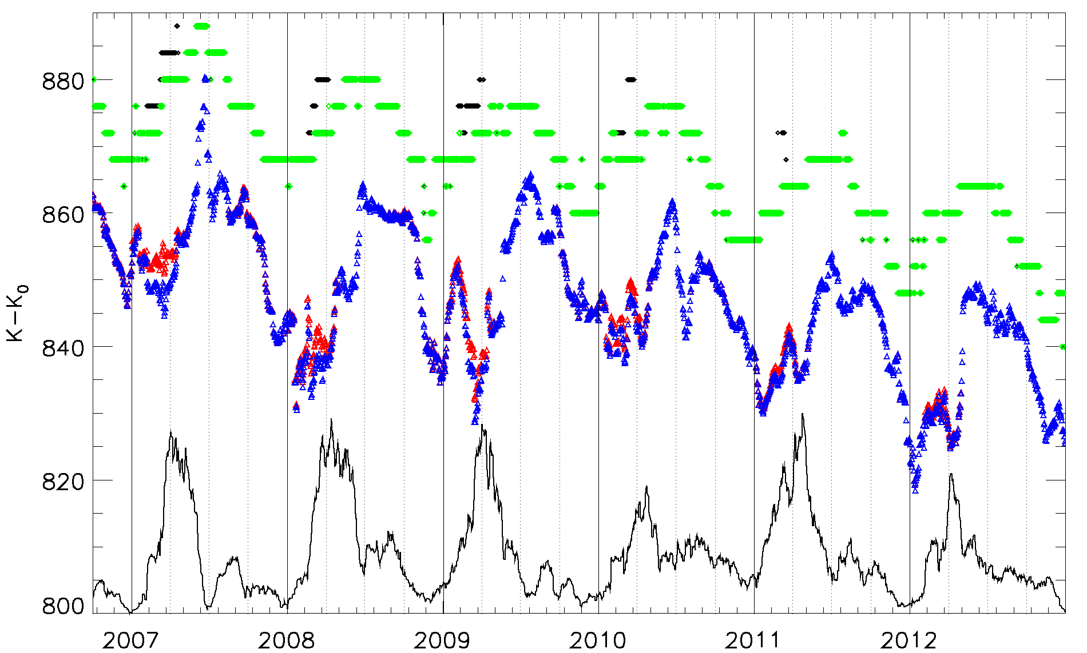
Figure 9: Time series of the extracted reference DCC counts for the Meteosat-9 VIS06 band between 01/10/2006 and 31/12/2012. In black: mode with saturated signal. In green: mode without saturation. In red: the mean with saturation. In blue: the mean without saturated signal. The plain black line represents for illustration the evolution in time of the number of DCC pixels (numbers are rescaled).

Establishing the seasonal factors
The procedure to derive the seasonal factors is done offline once enough data have been accumulated. This process can be automated on a 6-month or yearly basis to ensure robustness of the estimated factors due to the availability of a longer data time series.
The followings steps describe how the seasonal adjustment factors are derived from the processed time series.
For illustration purposes, the case of Meteosat-9 is taken, using the mode statistics as recommanded by [AD 1] (see Figure 11).

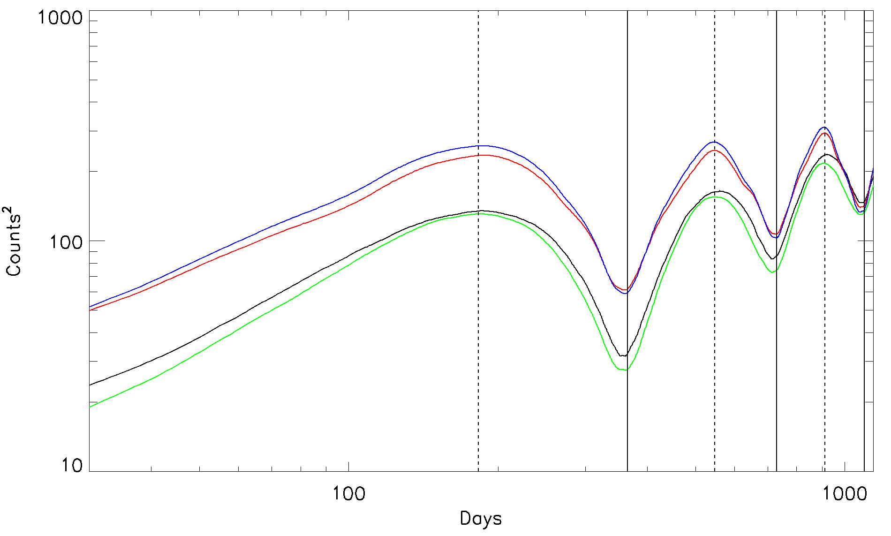
Figure 10: Variograms of the mode and mean count (K-K₀, K₀ being the offset) time series for the Meteosat-9 VIS06 band between 01/10/2006 and 31/12/2012. In black: mode with saturated signal. In green: mode without saturation. In red: the mean with saturation. In blue: the mean without saturated signal.
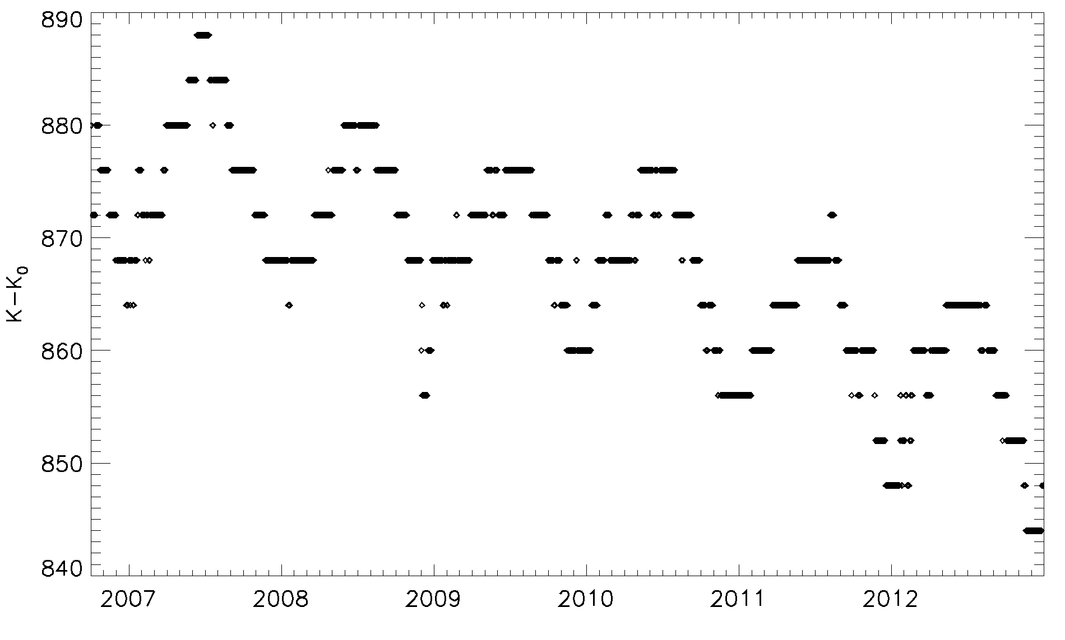
Figure 11: Time series of the non-saturated observed mode for the Meteosat-9 VIS06 band between 01/10/2006 and 31/12/2012.
- Choice of the seasonal model: a multiplicative model is adopted, following Eq. 2.

$Y_{Obs}=Y_{Trend}∙Y_{Seasonal}∙Y_{Variab}$ Eq. 2

Where Y_{Obs} is the observation, Y_{Trend} is the overall trend of the time series, Y_{Seasonal} is the seasonal signal and Y_{Variab} is the remaining variability. As a result, the seasonality is removed from the observation by dividing the signal by the seasonal factor:

$\frac{Y_{Obs}}{Y_{Seasonal}}={\tilde{Y}}_{Deseasonal}=Y_{Trend}∙Y_{Variab}$ Eq. 3

Where ${\tilde{Y}}_{Deseasonal}$ is by definition the deseasonalised observation time series.

- Smoothing of the time series: the variograms provided in Figure 10 show a periodicitity of about one year. Consequently, a smoothed time series is calculated, where each daily point is the centred standard moving average over 365 days. The tails of the time series require specific attention: the current implementation of the smoothing replaces the missing points by replicating the first/last available value as as many times as necessary. The resulting time series (see Figure 12 in grey) is mostly free of seasonal patterns as it is a yearly average.

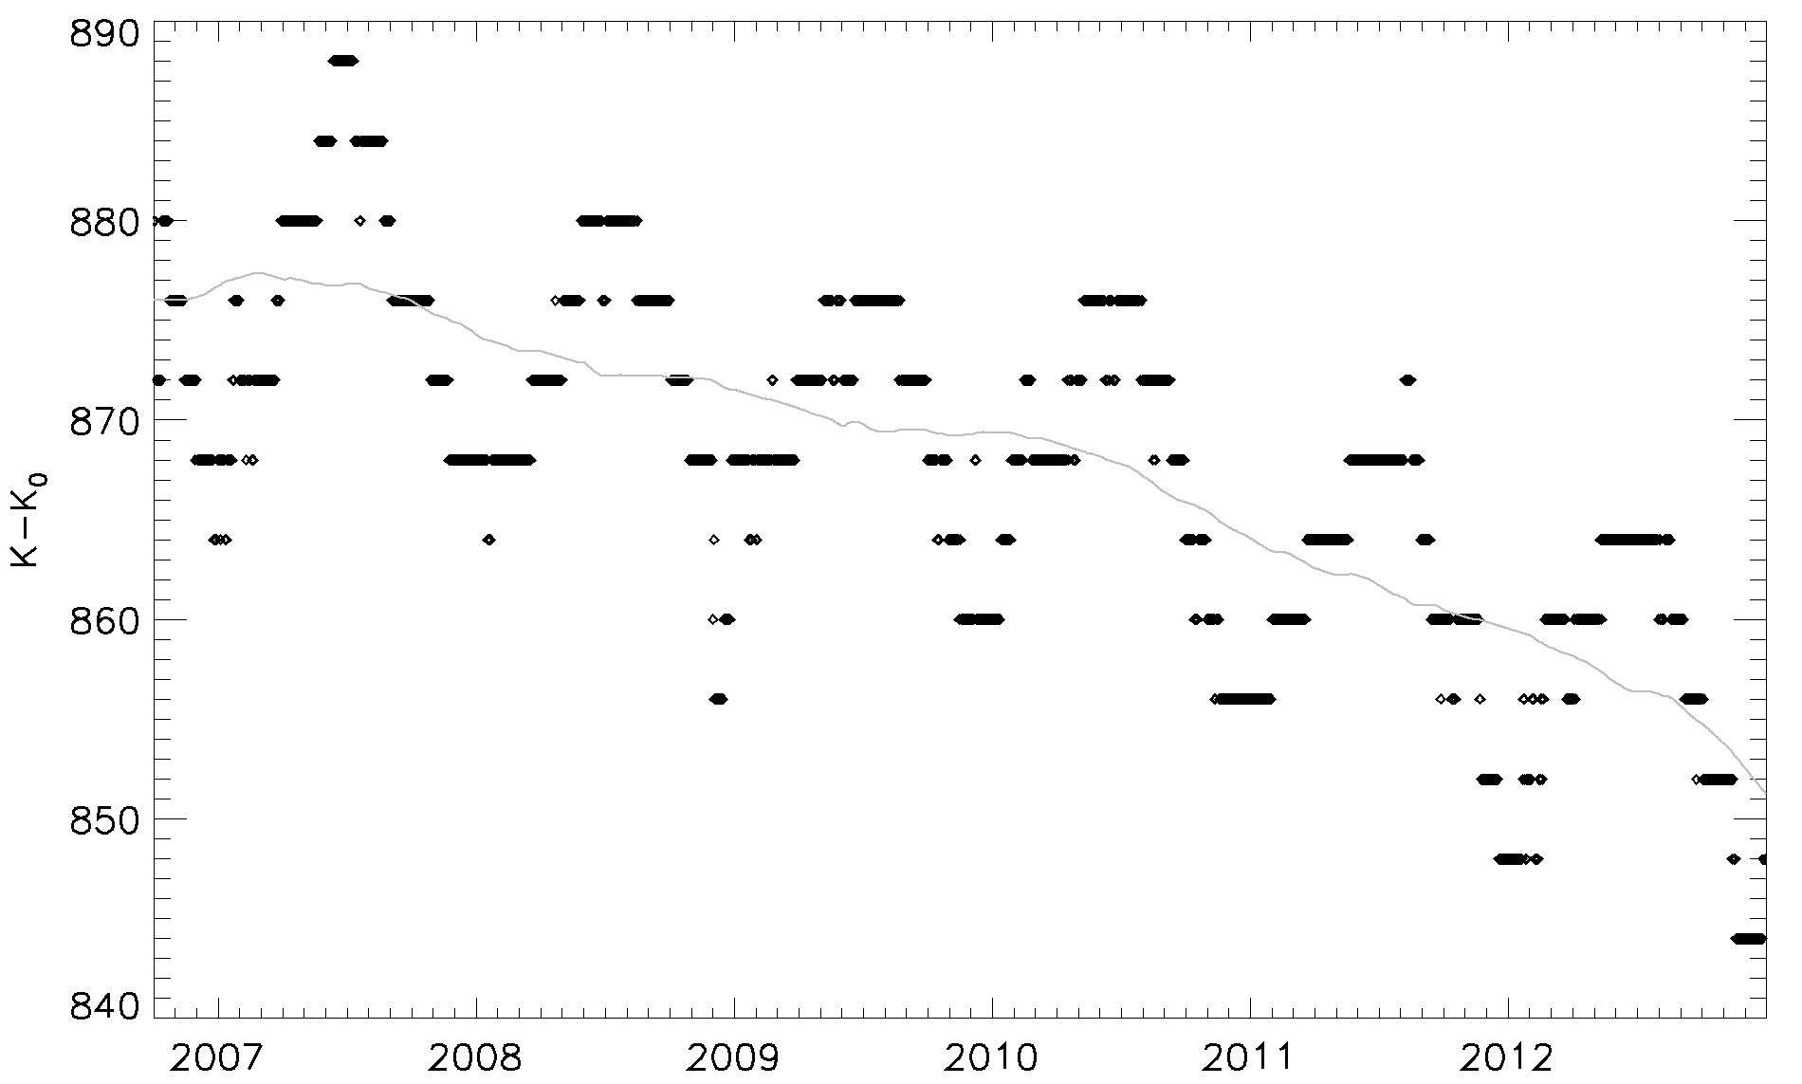
Figure 12: Time series of the non-saturated observed mode for the Meteosat-9 VIS06 band between 01/10/2006 and 31/12/2012. In grey, the smoothed time series (yearly centred average)

- Current observations behaviour with respect to an expected behaviour: the ratio between the mode time series and the smoothed data is calculated. The estimated ratio indicates how the actual observations is doing with respect to a yearly expected behaviour.
- Estimation of the unadjusted seasonal indices: these indices are estimated by making the average for each day of the year of all the ratio values estimed in Step c for that day across the years. For leap years, the time series is ajusted to a perpetual year. The resulting seasonal index series is now over 365 days. The overall average of these indices should be 1. In reality it is not equal to 1. For this reason, this set of indices is called unadjusted seasonal indices. The adjustment of the indices is simply done by a normalisation with respect to the mean value of the time series (see Figure 13).

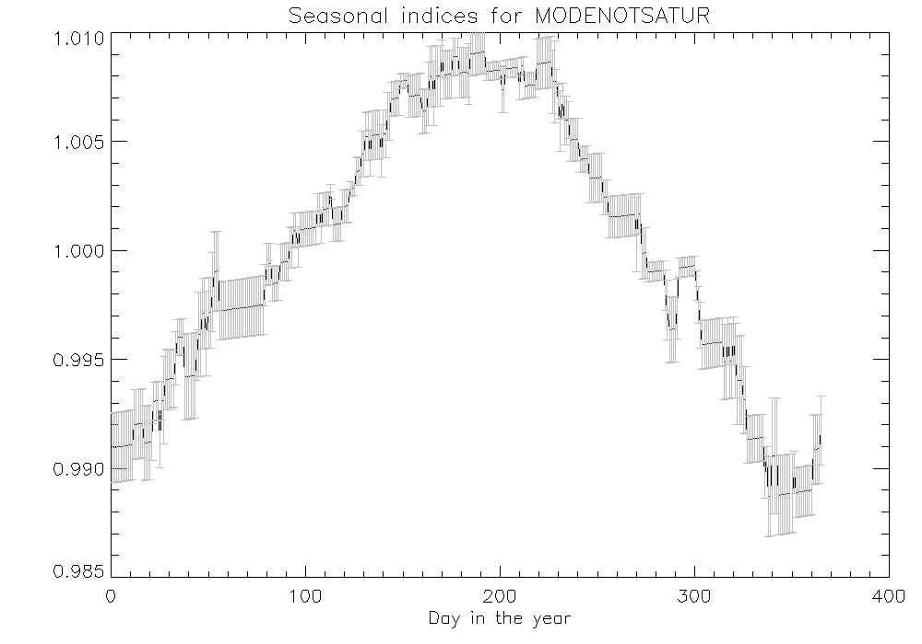
Figure 13: Adjusted seasonal indices, with the estimated uncertainties, derived from the Meteosat-9 unsaturated mode time series between 01/10/2006 and 31/12/2012.
- Finally, the original time series is deseasonalised by dividing the original observation by the seasonal indices following Eq. 3. The example of Meteosat-9 is given in with the red curve as end result for the mode time series in Figure 14.
- The instrument drift is estimated by a linear regression on the deseasonalised dat set.
- As a cross-check of the seasonal model validity, the seasonal factor are applied to the trend, without the natural variability of the time series, as in Eq. 4:

$\frac{Y_{Obs}}{Y_{Variab}}={\tilde{Y}}_{Model}=Y_{Trend}∙Y_{Seasonal}$ Eq. 4
Figure 15 provides time series for the relative difference between the seasonal model and the original time series for Meteosat-9. Overall, the largest relative difference observed between the model and the original data is about 1%.
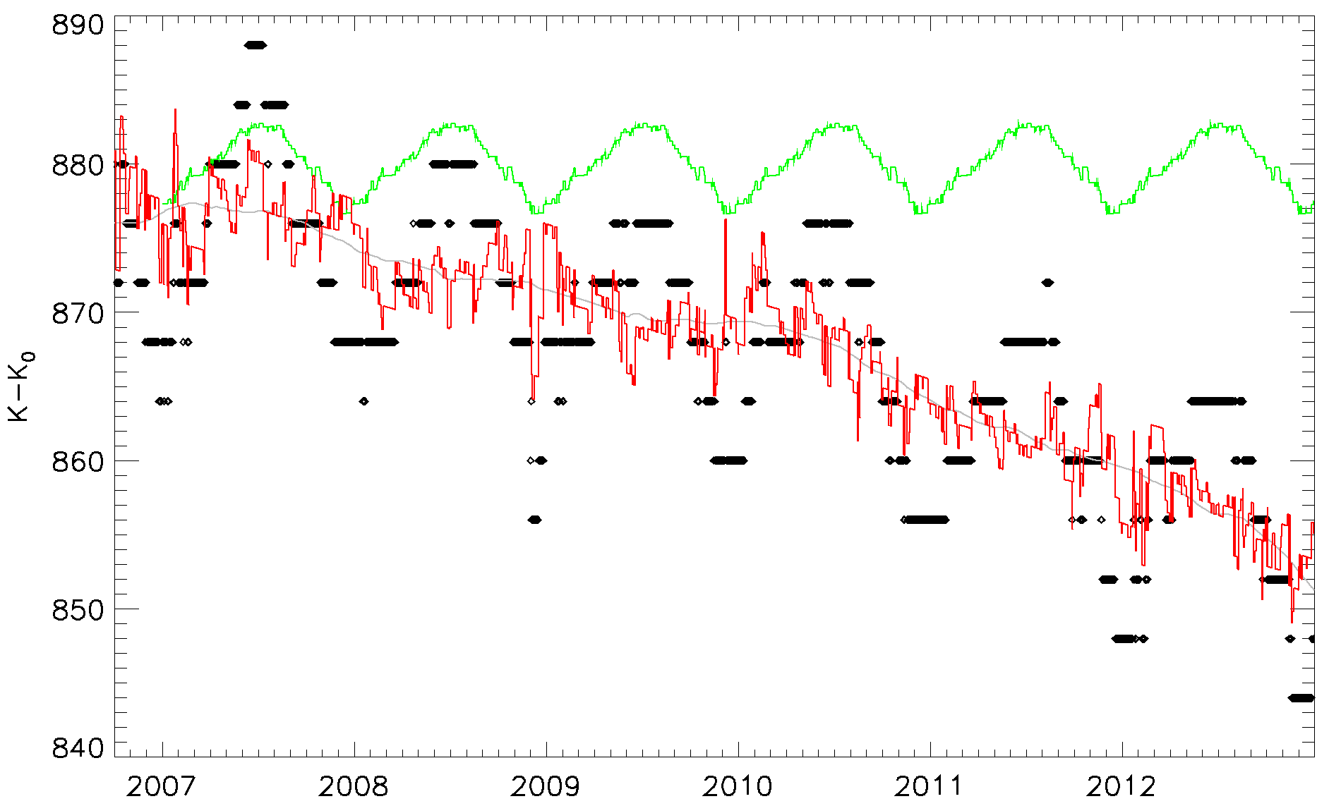
Figure 14: Time series of the non-saturated observed mode for the Meteosat-9 VIS06 band between 01/10/2006 and 31/12/2012. In black, the original mode time series. In red, the deseasonalised data. In green, the yearly seasonal factors duplicated along the data set.

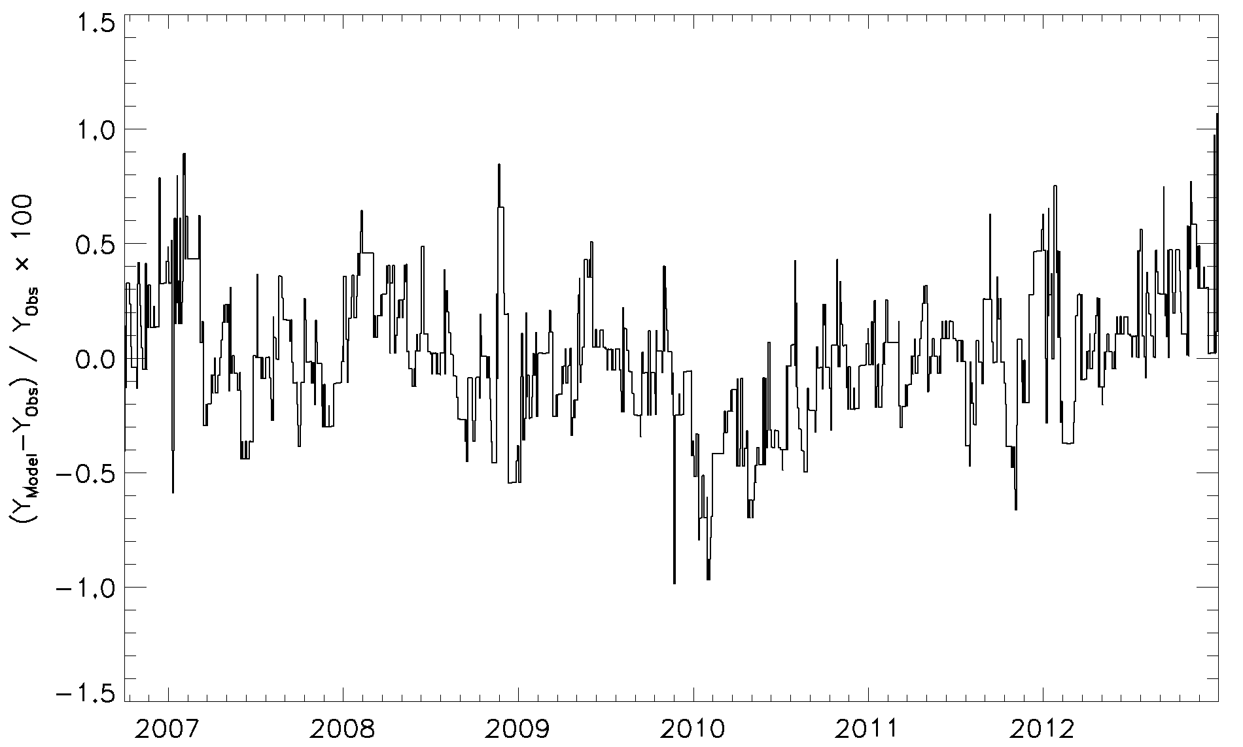
Figure 15: Time series of the relative difference between ${\tilde{Y}}_{Model}$ and Y_{Obs} for the Meteosat-9 VIS06 band between 01/10/2006 and 31/12/2012.

As a result, a set of seasonal factors Y_{Seasonal} is derived every time enough information has been accumulated in time so that the seasonal parameters are inferred in a more robust manner. The verification of the model may lead to an need for upgrading the model itself.
In the case of instruments from a same series (for example SEVIRI for Meteosat-8, -9, -10 and -11) operating in the same geographic domain, the seasonal factors from the previous missions may be used to correct the time series till enough data is available to derive robust information.

Deseasonalisation
Once the seasonal factors are established, they are stored in ancillary files which are instrument and location specific. These files are also archived with the DCC intermediate files. When deriving the GSICS gains/corrections these files are read for each instrument and reference grid (for instance 0.0 Latitude / 0.0 Longitude). The resulting correction is then:

${Mode}_{Deseas}={{Mode}_{Orig}}/{{AdjustFactor}_{Mode}}$ Eq. 5

${Mean}_{Deseas}={{Mean}_{Orig}}/{{AdjustFactor}_{Mean}}$ Eq. 6

If no file is found the adjustment factors are set to 1.

Gain/correction calculation and product generation
The gains are estimated using Eq. 1. The reference radiance is estimated using the mode of the PDF derived from Aqua MODIS data. This daily reference radiance is extracted from a typical year of DCC radiances as observed by MODIS. The spectral adjustment factors for the various Meteosat missions are listed in Table 9.
Corrections are also derived, using the official calibration coefficients provided in the headers of the Level 1.5 imagers for SEVIRI, or by auxiliary data for Meteosat-7.

GEO satellite | Instrument | GEO/Aqua-MODIS SBAF correction (radiance) | SBAF standard error (in %)
Meteosat 6 | MVIRI | N/A | N/A
Meteosat 7 | MVIRI | 0.873 | 0.59
Meteosat 8 | SEVIRI | N/A | N/A
Meteosat 9 | SEVIRI | 1.017 | 0.07
Meteosat 10 | SEVIRI | N/A | N/A
Meteosat 11 | SEVIRI | N/A | N/A
Table 9: Spectral band adjustment factors as provided by NASA

Description of the GSICS product

The GSICS product for VIS/NIR channels is fully described on the GSICS Research and Data Working Group wiki page (https://gsics.nesdis.noaa.gov/wiki/Development/DccWorkArea). This format is based on the CF conventions in netCDF. The product is currently based on the GSICS DCC method only. It is foreseen to develop and implement more methods to derive robust corrections for reflective solar bands by blending the results from this set of method. The blending is planned to be described by a matrix stored in the product itself.
The current product provides absolute gains, corrections and original calibration coefficients in order to address the needs from the user community.

Further developments

The present Algorithm Theoretical Basis Document describes the GSICS Deep Convective Cloud algorithm as implemented at EUMETSAT for the MVIRI and the SEVIRI instruments available on Meteosat First Generation (second series) and Meteosat Second Generation. A seasonal cycle has been observed with Meteosat-9 over the 0.0 Latitude / 0.0 Longitude. It is currently removed by a mathematical analysis of the complete available timeseries. However, a better understanding of the reasons for this seasonality is necessary in order to assess the limitations of the method and its applicability to other reflective solar bands. Additionally, the sensitivity of the method to the BRDF model to correct to overhead sun should be assessed by implementing other .The possibility of using other BRDF models to assess the sensitivity of BRDF models. Finally, a complete uncertainty analysis still need to be performed prior to the release of operational GSICS inter-calibration products.
Currently the method is applied exclusively to the channels centred around 0.6µm. The applicability of the method to other bands needs to be assessed. In order to do so, Suomi NPP VIIRS will be considered instead of Aqua MODIS. This would allow the processing of the VIS08 band for instance (Aqua MODIS saturates about DCCs in this band and therefore no intercalibration can be done for VIS08).
Finally, whenever other inter-calibration methods are available, blended GSICS products should be established. It implies the development of additional and complementary inter-calibration methods, but also the elaboration of robust blending method to derive composite corrections with the associated uncertainties.

