Scientific Validation of SEVIRI-IASI Prime GSICS Corrections

EUMETSAT
Eumetsat-Allee 1, D-64295 Darmstadt, Germany
Tel: +49 6151 807-7
Fax: +49 6151 807 555
http://www.eumetsat.int

Doc.No. | : | EUM/RSP/TEN/16/872396
Issue | : | v1 Draft
Date | : | 29 August 2016
WBS/DBS | :

Document Signature Table
 | Name | Function | Signature | Date
Prepared by: | Tim Hewison | Calibration Team Leader
Reviewed by | Christopher Hanson | Competence Area Manager for INRC
Reviewed by:
Approved by:

Distribution List
Name | Organisation
 | EUMETSAT

Document Change Record
Issue / Revision | Date | DCN. No | Changed Pages / Paragraphs
v1A | 29/08/2017 |  | Initial draft, based on text ATBD, updated to use results from IASI Conference poster: IASI2016 Hewison Poster Prime GSICS Correction

Table of Contents
1 Introduction 5
1.1 Reference Documents 5
2 IASI-A/B Double Difference Analysis 6
3 Conclusions 8

Table of Figures
Figure 1 –Time Series of Radiance Biases (in K) calculated for Standard Radiance Scene from GSICS Re-Analysis Corrections for IR13.4 channel of Meteosat-10/SEVIRI with respect to Metop-A/IASI (red) and Metop-B/IASI (blue). 6
Figure 2 – Radiance-dependence of IASIB-IASIA Double Difference, calculated over 3 years 2013-03/2016-03. The error bars represent k=1 uncertainty on mean difference. Red diamond = standard scene. 7

Introduction

This report provides a preliminary validation of the EUMETSAT implementation of the “Prime GSICS correction” algorithm to inter-calibrate the infrared channels of the geostationary Meteosat/SEVIRI, using comparisons with multiple IASI reference instruments, adjusted to be consistent with Metop-A/IASI, as the Anchor Reference. Double-differences of GSICS Corrections derived using the IASIs on Metop-A and -B are used to define a delta correction, which allows comparisons with multiple references to be combined, based on their relative uncertainties, in a way metrologically consistent with the Anchor Reference. These support the creation of Fundamental Climate Data Records, spanning extended periods with multiple reference instruments.

These results are based on an independent analysis of the results from those presented in the ATBD, which already include a discussion of the product’s quoted uncertainties. Instead the focus here is on the reliability of the product’s generation and distribution, and on its use as a tool for monitoring the relative calibration of different reference instruments – in this case, Metop-A/IASI and Metop-B/IASI.

Reference Documents
PrimeATBD | “ATBD for EUMETSAT Demonstration Prime GSICS Corrections for Meteosat-SEVIRI” | EUM/RSP/TEN/14/777892  Available online
Hewison, 2013 | “Prime GSICS Corrections, using double-differences of IASI-A and -B against the IR channels of Meteosat/SEVIRI” | Poster presented at IASI Conference, Saint Juan-Les-Pins, France, April 2016.

Reliability of product’s generation and distribution

As a candidate demonstration GSICS product, EUMETSAT’s Prime GSICS Corrections for the infrared channels of the Meteosat/SEVIRI imagers are not yet implemented on an operational processing chain. Instead they are routinely generated from automated scripts running in the offline development environment.

The demonstration products are distributed via EUMETSAT’s operational GSICS Data and Products Server (http://gsics.eumetsat.int), labelled as Demonstration Products under the following folders:
MSG1 SEVIRI PRIME CALIBRATION PRODUCT/ |  | --
MSG2 SEVIRI PRIME CALIBRATION PRODUCT/ |  | --
MSG3 SEVIRI PRIME CALIBRATION PRODUCT/

As a demonstration product, the generation of the Prime GSICS Corrections is supported on a best efforts basis. However, it is nominally updated on a daily basis – but currently only in the Re-Analysis Correction, it is not believed to be of interest to near-real-time users, but focuses primarily on the generation of Fundamental Climate Data Records. As such, it is also not currently suitable for inclusion as alternative calibration coefficients in the L1.5 header, in the way currently provided from the traditional GSICS inter-calibration products derived from individual reference instruments.

It is expected that this will be a sufficient rich and robust service to allow interested beta testers to evaluate the product and provide essential feedback needed for its further development and promotion towards operational implementations.

IASI-A/B Double Difference Analysis

Figure 1 shows the biases calculated from the IR13.4 channel of Meteosat-10/SEVIRI using the GSICS Re-Analysis Corrections from the two references (Metop-A/IASI and Metop-B/IASI). The results are almost indistinguishable on this scale.

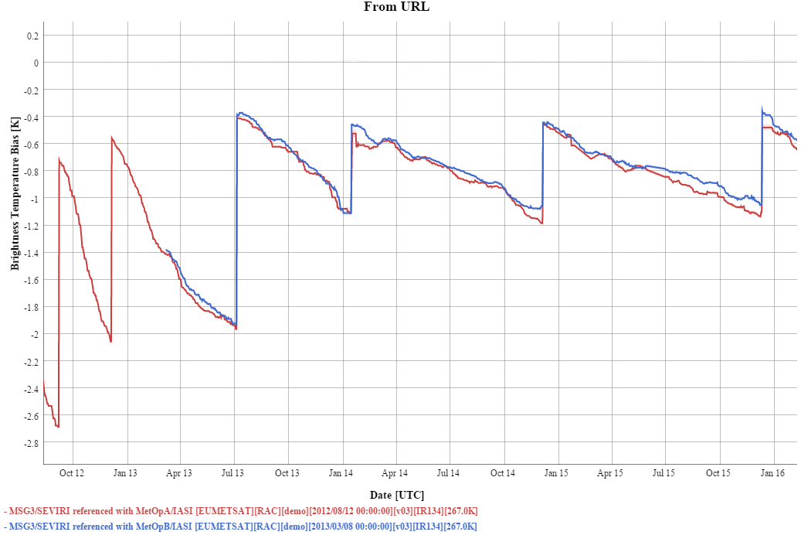
Figure 1 –Time Series of Radiance Biases (in K) calculated for Standard Radiance Scene from GSICS Re-Analysis Corrections for IR13.4 channel of Meteosat-10/SEVIRI with respect to Metop-A/IASI (red) and Metop-B/IASI (blue).

Figure 2 shows the time series of the double difference between the biases calculated from the GSICS Re-Analysis Corrections using Metop-A/IASI and Metop-B/IASI, together with their associated uncertainties (which are very small) for all eight infrared channels of Meteosat-10/SEVIRI. There are no obvious trends over this 3 year period for any of the channels, as shown in Table 1 (within standard uncertainty of 10 mK/yr). Similar results were also obtained from other Meteosats (but are not shown here).

Table 1 – Statistics of double difference of standard scene biases between (MSG3/SEVIRI-MetopA/IASI)-(MSG3/SEVIRI-MetopB/IASI) from GSICS Re-Analysis Correction over period 2013-03/2016-03
Channel | Double Difference Trend [K/yr] |  |  | Mean Double Difference [K]
IR3.9 | -0.016 | + | 0.008 | +0.001 | + | 0.005
IR6.3 | -0.003 | + | 0.015 | -0.015 | + | 0.010
IR7.4 | -0.002 | + | 0.010 | +0.002 | + | 0.007
IR8.7 | +0.002 | + | 0.008 | +0.000 | + | 0.006
IR9.7 | -0.005 | + | 0.011 | -0.027 | + | 0.007
IR10.8 | +0.004 | + | 0.009 | -0.016 | + | 0.006
IR12.0 | -0.009 | + | 0.009 | -0.018 | + | 0.006
IR13.4 | -0.011 | + | 0.008 | -0.042 | + | 0.006

Table 1 also shows there is no statistically significant difference in any channel between IASI-A and -B in short- and mid-wavelength bands. However, small, but significant differences were found in the long-wave band channels.

These differences are found to be larger for colder scenes, as shown for IR13.4 in Figure 2. These results are consistent with those found from CNES’s SIC tool, and are believed to be due to non-linearity differences in the operational processing of data between the IASIs on Metop-A and –B.

This implies great care should be taken when comparing results from different domains – for example the mean brightness temperature differences from polar SNOs should not be expected to match the mean values from globally-distributed “Quasi-SNOs”. Instead the results should be compared in equivalent radiance bins.

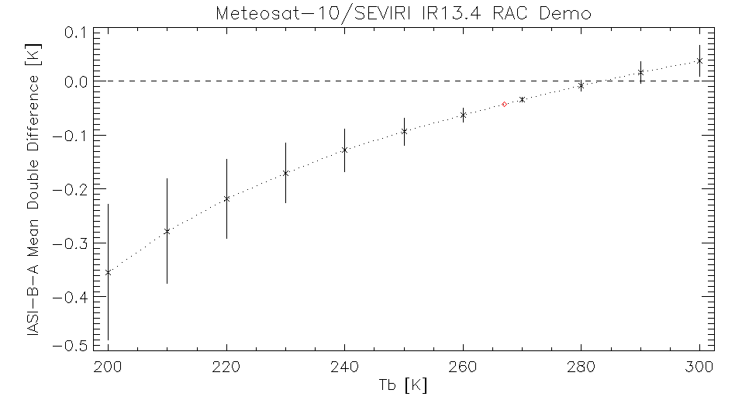
Figure 2 – Radiance-dependence of IASIB-IASIA Double Difference, calculated over 3 years 2013-03/2016-03. The error bars represent k=1 uncertainty on mean difference. Red diamond = standard scene.

Conclusions
These results show no significant differences between the calibration of the mid- and short-wave bands of IASI-A and -B were found over SEVIRI’s relatively broad spectral bands. However, there are small (<0.05K), but statistically significant differences in the long-wave band, where IASI-B is consistently warmer than IASI-A. These differences are radiance-dependent, but stable over a 3 year period starting in March 2013.

