

GSICS Product External Review Form

Version 1.0

GSICS Coordination Center

September 2010

Please remit completed form and supporting documents to:
Bob Iacovazzi, Jr.
GSICS Coordination Center, Deputy Director
E-Mail: Bob.Iacovazzi@noaa.gov
Address: NOAA Science Center, Room 712, Camp Springs, MD, USA 20746
Phone: 1-301-763-8346 x358
GSICS Product External Review Form
Document ID: GSICS_GCC_GPERF_V01.0

Change History
Version | Date (DD/MM/YYYY) | Point of Contact | Change
1.0 | 12/09/2010 | Bob Iacovazzi,  GCC | Baseline

Form Overview.
The GSICS Procedure for Product Acceptance (GPPA) is the
- GSICS product developers’ pathway to obtain a “Stamp of Approval” for a potential product;
- GSICS data users’ window to GSICS product quality and “fitness for purpose”;
- GSICS governing body’s reference for judging GSICS product value and operational readiness.
The GPPA was inspired by the need to find a mechanism to assess GSICS product quality, and by the Quality Assurance Framework for Earth Observations (QA4EO) spearheaded by the Committee on Earth Observation Satellites (CEOS) Working Group on Cal/Val (WGCV). To aid in understanding of the GPPA, the most recent version of the procedure can be found at the GSICS Coordination Center web site at http://www.star.nesdis.noaa.gov/smcd/GCC/qa-gppa.php.

This GSICS Product External Review Form (GPERF) is designed to provide reviewers independent of the GSICS membership a structure from which to review candidate inter-calibration products that are going through the GPPA process. The form is broken into four evaluation components regarding the product: 1) clarity, utility, and reproducibility of methodology; 2) accessibility, availability, and ease of use of data; 3) suitability and reliability in application; and 4) impacts to data user products. These four components are broken down into two sections in this GPERF. The first section covers the review of the draft product algorithm theoretical basis document, while the second section focuses on the results of practical testing of the potential GSICS product.

The feedback that you, the potential user of this inter-calibration product under review, give in this GPERF is of great value to the GPPA. It helps the GSICS Product Acceptance Team, as well as the GSICS Executive Panel, evaluate the potential practicality and merit of a given GSICS product to the community of users of operational weather satellite data. Thank you very much for your time and consideration during this review.

Directions.
Answer the questions in this form as completely as possible, then send it electronically to the GSICS Coordination Center at the e-mail address given on the cover page of this document.

SECTION I. Product Reviewer Information

I.1. Name of Proposed Product being Reviewed | MSG Global Instability Indices (GII) Product
I.2. Point of Contact of Product Reviewer
I.2.A. Name | Dr. Marianne König
I.2.B. E-Mail Address | marianne.koenig@eumetsat.int
I.2.C. Organization | EUMETSAT
I.2.D. Physical Address | Eumetsat Allee 1, 64295 Darmstadt, Germany
I.2.E. Phone | +49 6151 807344

SECTION II. Review of Methodology in Draft Algorithm Theoretical Basis Document

II.1. Method Clarity - Is the method relatively easy to understand, e.g. did it have a relatively logical flow, was there sufficient detail or references to supporting work, were the conclusion well founded, was the text free of grammatical/spelling errors, etc?

The method is generally very well understood, and the application of the GSICS correction to MSG data is straightforward and could be done without any problem.

Note: “ncbrowse” was used as a first quick-look to the data, and we found a problem in the data export of ncbrowse, which is a problem of ncbrowse, not of the GSICS correction. NOAA was contacted accordingly.

II.2. Method Utility – To what degree does the method fulfill its intended purpose?

The method was fully adequate for the tested product.

II.3. Method Reproducibility – Would the conclusions drawn or results obtained from the method be relatively easy to reproduce?

The algorithm is well documented, so it would be no difficulty to reproduce the results.

SECTION III. Testing of the Potential GSICS Inter-Calibration Product

III.1. Data Accessibility, Availability, and Ease of Use - This sub-section allows you to share your thoughts about your experience regarding the logistics of identifying and obtaining data from GSICS servers, as well as understanding and reading data from individual files.

III.1.A. Data Accessibility - How easy was it to find the product and its documentation (ATBD, readme guide, etc)? For example, were the GSICS Collaboration Servers relatively easy to connect to, could data of relevance be found intuitively, and were you able to download data within a time you would consider reasonable?

The relevant documentation and the Data and Products Server were readily available from the EUMETSAT web site. The data access (e.g. date, time, satellite ..) is intuitive, the download extremely fast.

During this work it was noted that a link to “ncbrowse” on the web site would be beneficial – this link has now been provided on the EUMETSAT web site.

III.1.B. Data Availability - Were the data obtainable from the servers when needed and were the terms of use regarding the data clear?

Data access was no problem. “Terms of use” are not clear, e.g. there is no “accept terms and conditions, observe copyright etc.” button. Maybe the GSICS community could think of a generic text of this kind?

III.1.C. Data Ease of Use – Were the metadata in the files adequate to understand the contents of, and the limits to, the data? Could the data be read quickly, and applied to your product processing stream with relative ease?

Applicability of the GSICS correction was ensured, and there were no problems encountered concerning the metadata.

What is missing in the GSICS data is a flag for which version of MSG Level 1.5 data this specific correction is applicable – EUMETSAT will do several cycles of reprocessing the MSG data, i.e. several versions of MSG L1.5 data will exist in the future.

III.2. Data Product Application Suitability and Reliability - This sub-section allows you to expound upon your efforts to implement the potential GSICS inter-calibration product to your product processing stream.

III.2.A. Product Suitability - Did you find it apparent that the product could be applied within your data processing stream as specified in the draft algorithm theoretical basis document?

That was very apparent – we did not find any problems here.

III.2.B. Product Reliability - Did you find the potential inter-calibration product performed with relative stability for the time period designated in the data file metadata?

The applicability period is well described in the provided metadata, so again we found no problem here.

III.3. Product Impact to Data Users’ Product during Testing – This sub-section allows you to share the conclusion of the testing phase of the potential GSICS inter-calibration product.

III.3.A. Were there statistically-significant changes to your products after implementing the potential inter-calibration product? Were these changes a function of time, or global location? Can you show these results in plots or tables?

A full report on the impact of the GSICS correction to the GII product is provided in Annex I to this document.

III.3.B. Other comments?

No other comments.


Darmstadt, 08 March 2011

ANNEX I

Detailed Description of the GSCIS Correction Impact on the Global Instability Indices Product

The GSICS Correction for Meteosat-9 was applied to the GII product (GII stands for Global Instability Indices). GII is one of the operational Meteosat products, derived for clear air and over low clouds, where a number of instability indices, the total precipitable water content and the total column ozone values are derived, using seven of the eight Meteosat infrared channels (only channel IR3.9 is not used within this retrieval).

The retrieval is an optimal estimation technique, where forecasted temperature, humidity and ozone profiles are changed to best fit the observed Meteosat radiances.

Figure 1 and Figure 2 show an example of the result (total precipitable water), for 20 February 2011, 1200 UTC:

The GSICS correction for Meteosat-9 is generally very small (< 0.2 K bias), with the exception of channel IR13.4, where the bias is as large as ~1.5K.
Impact of the GSICS correction is mainly twofold:

- The product derived from the GSICS corrected radiances shows generally “smoother” fields (e.g. red circle in the figures), and
- It provides a somewhat higher coverage (e.g. yellow circle in the figures). This higher coverage is due to less “failed retrievals” for the GSCIS corrected radiances. The higher failure rate in the non-GSICS corrected radiances is mainly due to the large bias in channel IR13.4. In this specific case, the percentage of successful retrievals rose from 86.7% to 89.1% when the GSICS correction was applied. The actual retrieval failure rate thus decreased by approximately 20%.
A third impact, which is not apparent from the figures, is seen by the number of retrievals, where the forecasted profiles are not at all changed, i.e. where the forecast was well in line with the Meteosat observations (which is to be expected in the majority of cases): The percentage of these retrievals increased from 53.4% to 65.9% when the GSICS correction was applied.

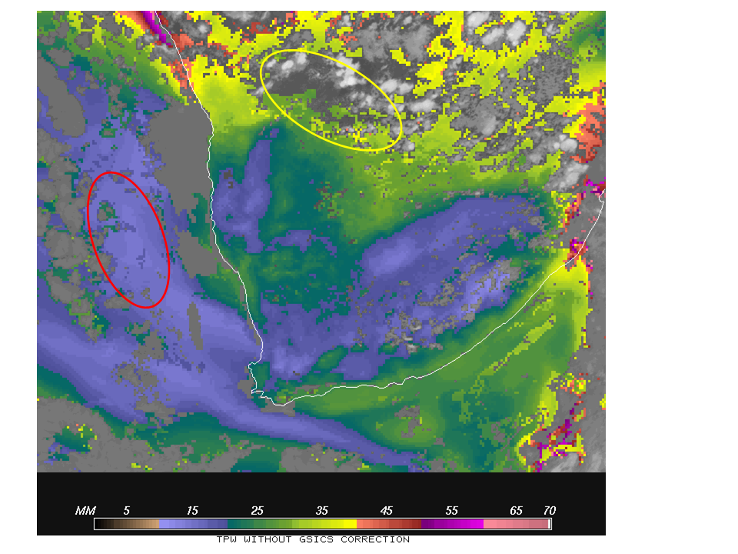
Figure 1: The Total Precipitable Water product, derived from the nominal Meteosat-9 radiances (20 February 2011, 1200 UTC). Shown is the Meteosat image section over the Southern part of Africa. See text for details.

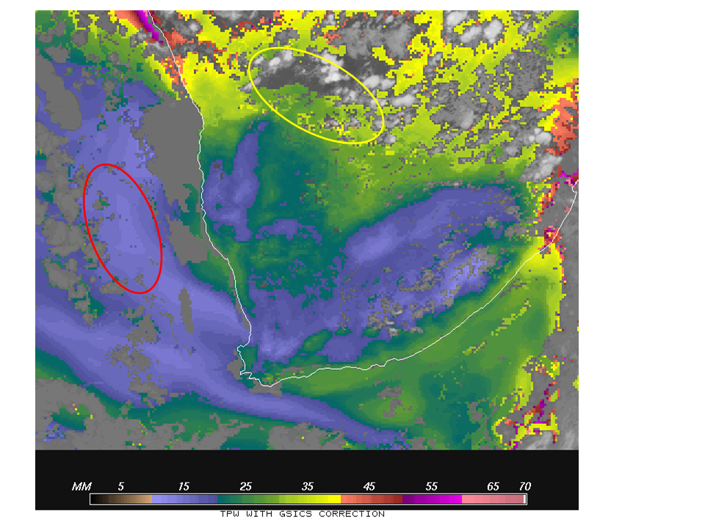
Figure 2: As Figure 1, but now derived from the GSICS corrected radiances.

