GSICS GOES-IASI Inter-Calibration Uncertainty Evaluation
Fangfang Yu¹ and Xiangqian Wu²
1: ERT, Inc. @ NOAA/NESDIS/STAR, Fangfang.Yu@noaa.gov
2: NOAA/NESDIS/STAR, Xiangqian.Wu@noaa.gov
Drafted on: 2012-08-17

Summary
This document presents an analysis of the uncertainties in the GSICS GEO-LEO Infrared (IR) inter-calibration products for the GOES Imager infrared (IR) using Metop-A/IASI as a reference. This document, together with the Algorithm Theoretical Basis Document (ATBD) for the GOES-AIRS/IASI inter-calibration (Wu and Yu, 2010), provides the users’ community with the detailed algorithm and quality indicator for the GEO-LEO inter-calibration products for GOES Imager IR channels. The uncertainties are analyzed through each process of the GSICS GEO-LEO Infrared (IR) inter-calibration model. It mainly follows the uncertainty analysis procedures described in Hewison (2012) for the EUMETSAT SEVIRI vs. Metop-A/IASI inter-calibration correction, which is based on the guidance provided by QA4EO (Fox, 2010) and Guide to the Expression of Uncertainty in Measurement (GUM) (JCCM, 2008). In each process, the systematic and random effects of the key variables process are evaluated separately using the Demonstration phase version 3 GOES-13 correction products. These uncertainties are then combined to produce a Type B error budget on the inter-calibration product and then validated with quoted uncertainty on GSICS correction. Both the Type B error budget and the quoted uncertainty indicate that GOES Imager IR correction uncertainty is less than 0.02K for Ch3(6.5µm), Ch4(10.7µm) and Ch6(13.3µm) corrections at standard scene radiances beyond the midnight calibration anomaly period (before 10:30pm and after 4:00am satellite local time) and instrument radiometric noises are the major causes. For the shortwave channel of Ch2(3.9µm), the correction uncertainty at standard scene radiance is about 0.04K. It is mainly caused by the systematic error caused by the incomplete IASI spectra over the broad-band GEO spectral response function, followed by the instrument noises. Uncertainty of each component at a large temperature range is also presented for the correction beyond the midnight effect time window. Large correction uncertainty is expected during the midnight effect period and the correction uncertainties at standard scene radiances are 0.197K, 0.446K, 1.168K, and 1.278K for Ch3.9µm, Ch6.5µm, Ch10.7µm and Ch13.3µm, respectively.

- Uncertainty Analysis Methodology
For each process, typical differences in sampling variables between the monitored (GOES-13 Imager IR) and reference (Metop-A) instruments are estimated either from the specified limits used to select the collocations (e.g. time sampling), or from the known differences (e.g. in spatial sampling). These differences are referred to as in this document. The sensitivity, referred as, of the radiances in each collocation to perturbations in each variable is estimated either based on the sampling measurements of change rate (temporal, latitudinal and longitudinal mismatch/variability), modeling simulation (geometric mismatch/variability), or our knowledge of instrument performance (spectral mismatch/variability and radiometric noises)
The quantities input to the inter-calibration process are the radiances, L, of each collocation, i. In general, the uncertainty (k=1) on L_{i} due to process j, is:
Equation 1
The GSICS correction of the measurement model, g(L), is based on the regression of collocated radiances observed by the monitored and reference instruments. It is a function which converts a radiance observed by the monitored instrument, L, to be consistent with the calibration of the reference, which is the quantity output from the inter-calibration process:
Equation 2
The observed radiances, L_{i}, are perturbed by u(L_{i}). Then the regression is recalculated to generate a modified function, g’(L), which will produce different corrected radiances, :
Equation 3
This illustrates how errors in the collocated radiances can be propagated through to errors in the GSICS correction applied to different scene radiances. These provide estimates of the uncertainty on the GSICS correction, which are converted into brightness temperatures using the derivative of the Planck function evaluated over a range of scene radiance.
Systematic Error
For processes introducing systematic errors, the radiance of each collocated point is perturbed by an amount representing its estimated uncertainty,
, Equation 4

The regression used to calculated the GSICS correction is recalculated, giving a modified function, g’(L). This function is evaluated for a range of scene radiances and the resulting radiances compared to the corrected radiances generated by the unmodified function, g(L) to provide an estimate of the uncertainty on the corrected radiance due to systematic error introduced by process j:
Equation 5
In this study, the g(L) is a linear regression between the collocated GOES and IASI data.
Random Error
A Monte-Carlo approach is adopted to evaluate the uncertainty on the final correction for processes which introduce random errors. The radiance of each collocated point is perturbed by an uncertainty calculated by multiplying a random number, z_{i}, draw from a distribution consistent with a characteristic difference, Δx^{r}, multiplied by the sensitivity to random perturbations of this process, as follows:
Equation 6
The regression used to calculate the GSICS correction is then re-evaluated with one set of randomly perturbed radiances. The resulting regression coefficients are used to evaluate the radiances bias over a range of scene radiances. This procedure is then repeated a large number (n_{k}) of times to give nk evaluations of g’_{j,k}(L). Each evaluation of which is used to calculate a corrected radiance for each of a range of scene radiances,
The standard deviation ofover the Monte Carlo ensemble is then calculated to provide an estimate of the uncertainty on corrected radiances due to each random process, j:
Equation 7

- Correction ATBD and the GOES scan modes

- GEO-LEO inter-calibration measurement model - ATBD
The collocated criteria of the GSICS GEO-LEO inter-calibration for the GOES Imager IR channels can be summarized as followed (Wu and Yu, 2010): 1) the central pixel of a 5x3 GOES pixel array, which is considered as the pseudo-GEO pixel with similar spatial resolution to the collocated LEO pixel, is less than 4 km from the center of the LEO pixel; 2) the observation time difference is less than 5 minutes; and 3) the secant of the viewing zenith angle difference is less than 1%. Currently no viewing azimuth angle criterion is applied to the collocation data, although it is recognized that the daytime thermal emission for IR window channels might be anisotropic due to differential heating of some of the surface as a result of shadowing [20]. After the spatial and temporal collocation with viewing alignment, the hyperspectral LEO radiance of the collocated scenes are convolved to simulate the broadband GOES measurements. For the bad detectors and missing spectral gaps in the AIRS data, the Japan Meteorological Agency (JMA)’s gap-filling method, which is based on the regression between the valid AIRS measurements and a radiative transfer model result, is applied to compensate for the discontinuities (Tahara and Kato, 2009). Therefore, five systematic and six random uncertainty ingredients are identified to account for the product systematic/random errors, including temporal mismatch/variability, longitudinal mismatch/variability, latitudinal match/variability, geometric match/variability, and spectral mismatch/variability and radiometric noise (random error), as shown in Table 1 and 4.
Unlike the spinning-axis GEO satellite instruments (e.g. SEVIRI) which have relatively consistent diurnal calibration variation (Yu et al. 2012), GOES IR data experience calibration anomaly around the satellite midnight time due to the extra energy reflected to the detectors through the blackbody (BB) (Johnson and Weinreb, 1995). An empirical calibration correction, midnight blackbody calibration correction (MBCC), was developed and implemented to mitigate the midnight calibration anomaly. Recent analyses of the GOES and AIRS/IASI collocation data indicated that the MBCC performance depends on the frequency application of the MBCC calibration coefficients and IR channels (Yu et al. 2012). Beyond the midnight effect time period, the GOES IR calibration is very consistent. Yet apparent calibration variation can be observed at the mid and long-term IR channels around the satellite midnight time. To avoid of the impact of apparent midnight calibration variation as well as the day-time directional reflectance/emissivity, the night-time IASI collocation data before 10:30pm satellite local time (SLT) are used to generate the GEO-LEO inter-calibration coefficients (Wu and Yu, 2010). As the result, the systematic errors caused by the temporal sampling process were discussed in two periods: beyond the midnight effect period (before 10:30pm and after 4:00am at satellite local time (SLT)) and the midnight effect period (10:30pm-4:00am SLT). It is assumed the other uncertainty processes are the same at these two periods.
- Impact of GOES Imager Scan Sector/Schedule on the collocation distribution
The three-axis stablized GEO satellite instruments continuously scan various target areas at scheduled time. For GOES, there are four different routine scan sectors at GOES-East (http://www.ospo.noaa.gov/Operations/GOES/east/imager-routine.html) and GOES-West (http://www.ospo.noaa.gov/Operations/GOES/west/imager-routine.html. As we use GOES-13 as example to assess the product uncertainty in this study, all the following analyses are based on the GOES-East scan sector to determine the sensitivity of radiance change rate at each uncertainty process.
The four scan sectors of GOES-East including North Hemisphere/extended Northern Hemisphere (NH), South Hemisphere (SH), CONtinental US (CONUS), and full disk (FD). More than 80% IASI night collocation scene occur at (08:15pm – 10:30pm SLT, or 01:15-03:30 UTC). During this period, there four NH scans, three SH scans, three CONUS scans and one FD scan (Figure1). And the collocated data are dominated at the NH scan sector (Figure 2).
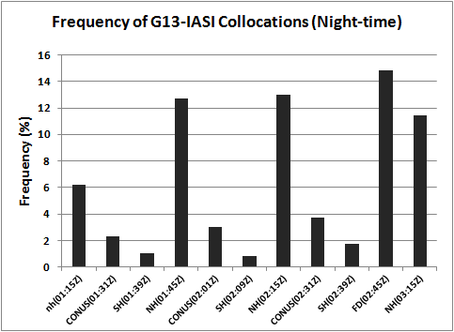
Figure 1. Frequency of G13-IASI collocations located at different scan sectors during the product collocation period (08:15 pm – 10:30pm SLT).
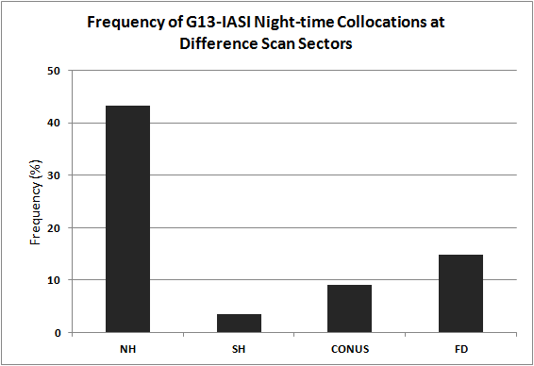

Figure 2. Frequency of GOES13-IASI collocation at each scan sector.

- Data
This analysis is mainly based on the GOES-13 collocation data acquired in July 2012. Data in the other month of 2012 are also used to check the uncertainty variation. Yet the sensitivity of radiance change rates to key variables and their uncertainty results are consistent and vary within one factor.

- Results

- Systematic Errors
Table 1. Summary of systematic errors’ perturbations and sensitivities beyond the midnight effect time.
Systematic Error Type | Δx | Sensitivity, əL_{j}/əx^{s} [mW/m²/Sr/cm⁻¹/Δx]
 |  | Ch2(3.9µm) | Ch3(6.5µm) | Ch4(10.7µm) | Ch6(13.3µm)
Temporal Mismatch | 0.00306hr | -0.0206 | -0.012 | -0.1925 | -0.0330
Latitudinal mismatch | 1530m | 0.0025 | 0.0462 | 0.749 | 0.6862
Longitudinal mismatch | 1530m | -0.0495 | -0.6038 | -0.0077 | -0.0077
Geometric Mismatch | 0.1464º | -0.00028 | -0.00812 | -0.01487 | -0.07178
GEO-LEO Spectral mismatch | 1 | 0.000826 | 0.0000 | 0.0000 | 0.0000
Spectral calibration | 1 | 0.000046 | 0.0000 | 0.0003 | 0.0000

- Temporal Mismatch
There are two components in the systematic errors caused by the temporal mismatch, 1) variation of the observation targets during the collocation period, and 2) instrument diurnal calibration variation. The first term is impacted by the diurnal cycle in the radiances emitted by the Earth’s surface and atmosphere. In the second term, the GEO diurnal calibration variation is referred to the GEO calibration during the collocation period, which ranges from ~7:00pm to 10:30pm.
Temporal mismatch during the collocation period
As reported in ATBD, the temporal collocation criteria is 5 minutes (±Δt_{max} = 300s) and temporal mismatch is distributed uniformly across this collocation criteria. In this study, the mean time difference of the collocation data used in the generation of correction coefficient in July 2012 is used to estimate the uncertainty of Δx (Δx = 11 seconds = 0.00306hr).
As stated previously, the collocations located at different scan sectors with different scan time intervals. Since the GOES collocation data are mainly distributed in the region about ±40º in latitude and ±50º in longitude from the GEO sub-satellite point. We first calculated the diurnal radiance variation at each scan sector falling within the collocation domain (40ºS-40ºN, 135ºW-25ºW). The sensivity of the radiance change to the sampling time is calculated by averaging the radiance change rates at each sector from 01:15UTC-03:30UTC, weighted with the collocation frequency at corresponding scan sector as shown in Figure 3. The results of Δx and the mean sensivity are shown in the first raw of Table 1.

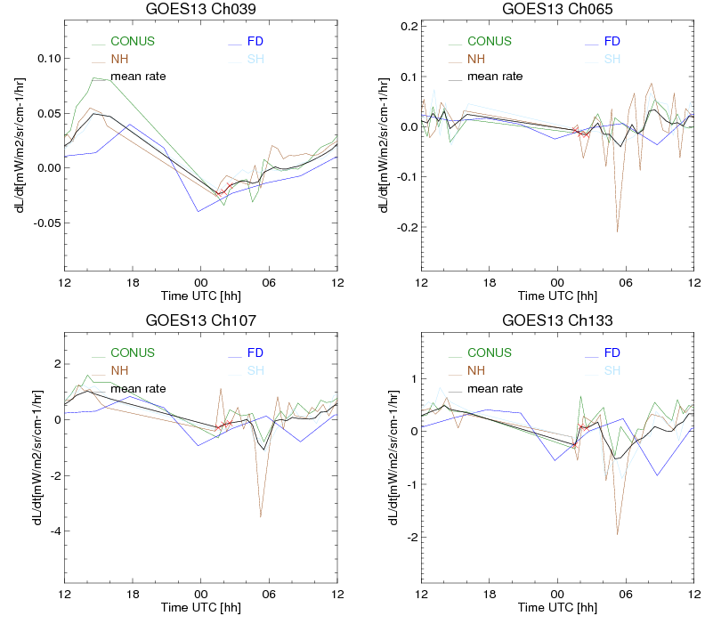
Figure 3. Time-series of mean rate of change of radiances calculated from GOES-13 Imager observations on 2012-07-06.
Impact of the instrument diurnal calibration variation:
Time-series of mean Tb bias with respect to AIRS and IASI was used to evaluate the GOES diurnal calibration variation. Figure 3 shows the diurnal variation of the mean Tb bias with respect to AIRS and IASI at each half-hour time interval. Due to the strong impact of the directional reflectance of day-time shortwave data, the day-time Tb bias is not plotted in Figure 3a. Also, the large Tb bias with respect to AIRS at Figure 3a is due to the missing AIRS spectral coverage for the GOES-13 Imager Ch2 (3.9µm). However, per the analysis in Yu et al. (2012), MBCC is usually intensively applied and it performs very well at Ch2 (3.9µm) with less than 0.15K diurnal calibration variation. The maximum Tb variations, estimated with the maximum difference of Tb bias to AIRS (ΔTb_{max,AIRS}) during the daytime and night-time, are 0.15K, 0.44K, 1.15K and 1.29K for Ch2 (3.9µm), Ch3(6.5µm), Ch4(10.7µm) and Ch6(13.13µm), respectively. As the AIRS and IASI radiance difference (ΔTb_{AIRS, IASI})over the GOES spectral ranges is 0.1K, the uncertainty of GOES diurnal calibration variation traceable to IASI is combined as ΔTb_{max} = (ΔTb²_{max,AIRS}+ΔTb²_{AIRS, IASI}+ ΔTb²_{AIRS, IASI})^{1/2}. The standard uncertainty is calculated as ΔTb = ΔTb_{max}/$\sqrt{3}$. The corresponding systematic errors expressed in radiance at the standard scene radiances and the propagated uncertainties are listed in Table 2.
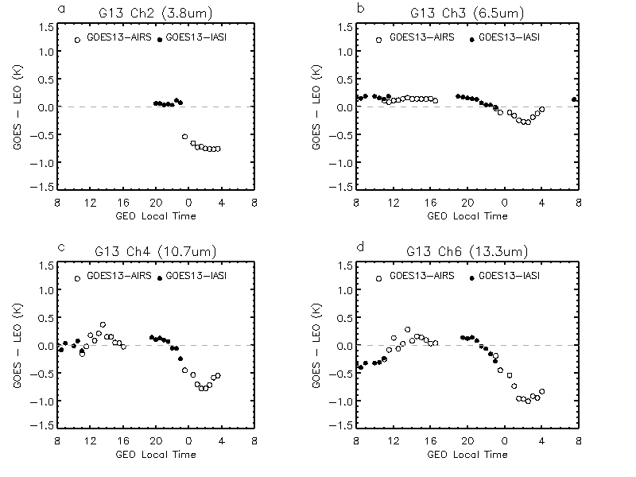
Figure 3. Diurnal variations of the mean Tb bias to AIRS/IASI for GOES-13 in July 2012.

Table 2. System Error caused by the instrument diurnal calibration variation, expressed with radiance and Tb bias at the standard scene.
Systematic Error | Ch2(3.9µm) | Ch3(6.5µm) | Ch4(10.7µm) | Ch6(13.3µm) | unit
Radiance bias at standard scenes | 0.0047 | 0.0802 | 1.7695 | 1.8216 | mW/m²/Sr/cm⁻¹
Tb bias at standard scenes | -0.1928 | -0.4455 | -1.168 | -1.2775 | K

2).Latitudinal and Longitudinal mismatch
Systematic error in the geolocation is introduced by the small latitudinal/longitudinal mean gradients in their radiances over the domain of the collocations. The mean longitudinal gradients are calculated with the mean radiance difference between adjacent scan elements (L_{i,j} and L_{i+1, j}) at each scan sector (j) within the target domain, weighted with the frequency of collocation pixels in the scan sector (f_{j}). Table 1 shows the sensitivity of radiance change at latitudinal/longitudinal direction using the images from 01:15z to 03:45z on July 15, 2012. It is calculated as follows:
Equation 8
GOES Imager navigation and registration (INR) is controlled with the visible channel scanning the stars. According to the GOES NOP Imager and Sounder instrument specification (1996), the specification of GOES NOP Imager navigation is 55µrad and the relative positions of the centroids of the visible and infrared imaging channel IGFOV’s shall be within 50µrad. The combined uncertainty can be estimated at (50 + 55)/=74.26µrad =2.65km. This is equivalent to a standard uncertainty of Δlat/ Δlon=2.65/=1.53km.
Since GOES Imager is oversampled at a factor of 1.75 at the East-West direction. Therefore the nominal adjacent element distance is 2.3km verses to 4.0km at the nominal adjacent line distance. The difference oversampling factors at latitude/longitude (line/element) should be taken care of at the sensitivity analysis.
3). Geometric Mismatch
The GSICS GEO-LEO collocations between the monitored and reference instruments are not exactly aligned in terms of viewing and solar geometry. The viewing and solar geometry difference, although very similar, can affect radiance in terms of absorption along different atmospheric paths and changes in surface emissivity. In this study, we use the actual systematic bias of viewing geometric difference (Δsecθ/secθ=-0.00061), calculated with the mean of night-time collocation data, to estimate the systematic error caused by the geometric mismatch. We use the CRTM model to simulate the radiance change to the zenith angle. The CRTM was run for a diverse set of 100 atmospheric profiles with three cloud configurations (clear tropical sky, uniform cloud with tops at 700 hPa and 300 hPa) to predict the radiances at 27º and 28º incidence angles, as the mean GEO viewing zenith angle in July 2012 was 27.6º.
4). Spectral Mismatch
GEO-LEO spectral mismatch: As shown in Figure 4, IASI cannot cover the full spectral range of GOES-13 Imager Ch2 (3.9µm), which can result in systematic correction error at this channel. We use the LBLRTM (Clough et al., 2005) to simulate the radiance spectra over the full thermal IR range for 9 atmosphere with different cloud amounts. These were convolved with the Ch2 SRF. The integral over the full band is compared with the integral of those truncated SRF. Recent research show that there is a strong linear relation between the AVHRR Channel 3B, which like GOES Ch2 has a truncated SRF over IASI spectra (Rama Varma Raja et al. 2012). A simple linear model is then used to estimate the radiance between the full and truncated SRFs at standard scenes in this study. This radiance difference is assigned as the sensitivity of GEO-LEO spectral mismatch with Δx =1.
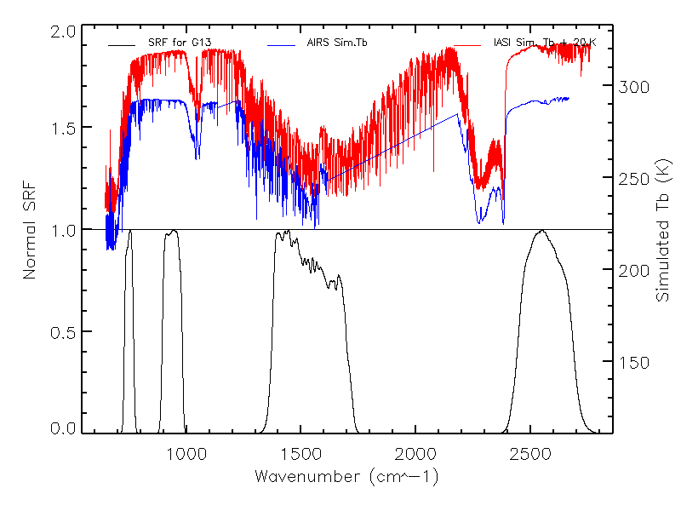
Figure 4. Spectral response function (SRF) of GOES-13 Imager IR channels (lower panel) and the simulated AIRS/IASI brightness temperature (Tb) at clear tropical atmosphere profile.
LEO Spectral Calibration Accuracy: The relative spectral calibration accuracy of IASI is Δv/v=0.5ppm (Blumstein, 2008). As described in Hewison (2012), we use 2ppm to shift the SRF and convoluted the IASI data using the new SRF. The result is shown in Table 1.
GEO SRF interpolation: According to the analyses in Hewison (2012), the impact of the uncertainty of GEO SRF interpolation is very small and negligible (<0.001K at the standard scenes). In addition, GOES IR SRFs are measured at 0.1 cm⁻¹ interval, higher than IASI spectral interval of 0.25cm⁻¹ and a linear interpolation function is used to convert the published SRFs to the IASI wavenumbers. As the result the SRF interpolation effect is also treated as negligible for the GOES products.
5). Combined all systematic errors
All the uncertainties due to systematic process, are added in quadrature to give :
Equation 9
Table 3 shows the uncertainties in the correction evaluated at standard scene radiances. The last raw shows the total systematic uncertainty (k=1), due to all terms combined following equation 9. The contribution of each source of systematic error to the uncertainty of Tb (k=1) at a range of scene temperatures. The results clearly show that the spectral mismatch is the dominant factor causing the relatively large uncertainty at Ch2(3.9µm). It is recommended that the compensated radiance simulated with JMA’s gap-filling method for the incomplete IASI spectra should be used for the Ch2(3.9 µm) correction in the future. The latitudinal mismatch is the major cause to the systematic error in Ch3(6.5µm), 4,(10.7µm) and 6(13.3µm). This is because collocations are largely distributed in the NH sectors which have a relatively larger radiance change rate across the adjacent lines. The increasing uncertainties at the cold scenes are attributed to the less collocation data at cold scenes and the nature of Planck function.
Table 3. Systematic error budget of GSICS correction for GOES13 Imager vs. IASI standard scenes.
Systematic Error Type | Ch2(3.9µm) | Ch3(6.5µm) | Ch4(10.7µm) | Ch6(13.3µm) | Unit
Standard scene temperature | 285.7 | 244.8 | 284.0 | 266.8 | K
Temporal Mismatch | -0.0025 | -0.0002 | -0.0003 | -0.0001 | K
Latitudinal mismatch | 0.0002 | 0.0004 | 0.0007 | 0.0007 | K
Longitudinal mismatch | 0.000793 | 0.001999 | 0.00375 | 0.00372 | K
Geometric Mismatch | -0.0015 | -0.0060 | -0.0013 | -0.0067 | K
GEO-LEO Spectral mismatch | 0.03308 | 0.0000 | 0.0000 | 0.0000 | K
Spectral calibration | 0.0019 | 0.0000 | 0.0003 | 0.0000 | K
Combined Systematic Error | 0.0333 | 0.0075 | 0.0060 | 0.0097 | K

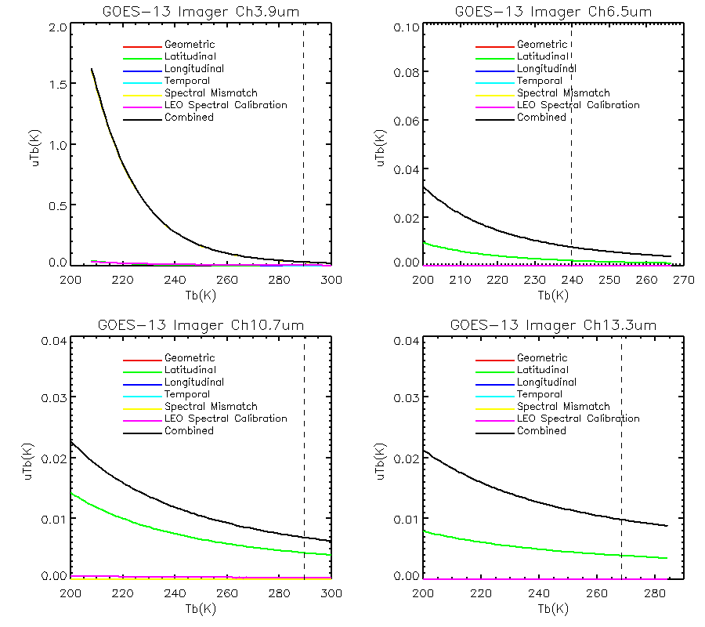
Figure 5. Contribution of each source of systematic error to the (k=1) uncertainty of the brightness temperature (Tb) produced by the GSICS correction for a range of radiances for each GOES-13 Imager IR channels. Dotted vertical line shows standard scene radiance for each channel, corresponding to nadir views of a nadir views of a calm ocean in clear standard atmosphere conditions.

B. Random Errors
Table 4. Summary of Random Errors’ perturbations and sensitivities for the corrections.
Systematic Error Type | Δx | Sensitivity, əL_{j}/əx^{s} [mW/m²/Sr/cm⁻¹/Δx]
 |  | Ch2(3.9µm) | Ch3(6.5µm) | Ch4(10.7µm) | Ch6(13.3µm)
Temporal variability | 5.0 min | 0.0002303 | 3.82001e-05 | 0.006245 | 0.001543
Latitudinal variability | 4.0km | -6.15970e-05 | -0.001037 | -0.009666 | -0.009772
Longitudinal variability | 2.3km | 8.09936e-06 | 9.24451e-05 | 0.0001895 | 0.000636
Geometric variability | 0.14239º | -0.0002833 | -0.008120 | -0.01487 | -0.07179
Spectral variability | 1 | 0.00047 | 0.0000 | 0.0000 | 0.0000
GEO Radiometric noise | 1 | 0.0024 | 0.0022 | 0.0750 | 0.1134
LEO radiometric noise | 1 | 0.0008 | 0.0012 | 0.0178 | 0.0235

1). Temporal variability
Collocated observations from a pair of satellite instruments are not sampled simultaneously. Variations in the atmosphere and surface during the interval between their observations introduce errors when comparing their collocated radiances. The greater this interval, the larger the contribution of the scene’s temporal variability to the total error budget. The uncertainty this introduces to the collocated radiances can be quantified by statistical analysis of a series of GOES Imager scenes described below.
As described previously, GOES Imager has four typical scan sectors and each scan sector interval varies from about half hour (CONUS) to up to three hours (full-disk scan). As most collocation data are located at Northern Hemisphere (NH) scan sector (Figure 2), the temporal variability of GOES images was quantified for each infrared channel using the root mean squared difference (RMSD) between the channels’ radiance of NH scan sectors at various intervals. As seen in Figure 6, the RMSD was found to increase approximately linearly with interval for closely separated time intervals. In this case, the RMSD was calculated starting from 01:15Z using GOES-13 NH images on 2012-07-15. The sensitivity of radiance to time difference is thus estimated with the mean radiance change rate at NH images obtained on 02:15UTC and 02:45UTC. To best reproduce the data used in the inter-calibration, the Imager are first smoothed by applying a 3x5 smoothing window. The RMSD for each infrared channel are shown in the first line of Table 3, expressed as a rate of change of radiance per minute.
The 5minutes (Δx_{max}=5minutes) of sampling interval introduces a temporal collocation error with a uniform distribution. The perturbation is equivalent to an r.m.s. difference between sampling of collocation observations of Δx=5minutes.
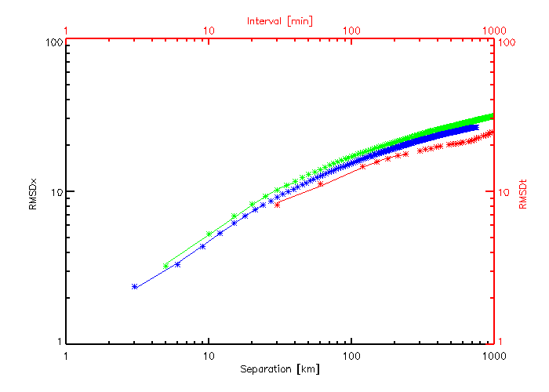
Figure 6. RMSD difference in GOES-13 Imager Ch4(10.7µm) radiance with time intervals from NH (in red) and with spatial separation in North-South direction (in green) and west-east direction (in blue).

- Longitudinal Variability
Similarly, collocated observations from a pairs of satellite instruments are not exactly collocated and spatial variations in the atmosphere and surface introduce errors when comparing their collocated radiances. The greater the separation between their observations, the larger the contribution of the scene’s spatial variability to the total error budget. The uncertainty this introduces to collocated radiances can be quantified by statistical analysis of a representative NH scene described below.
The Imager data is approximately uniform spacing near the sub-satellite point and over the target domain of the collocations, where the median distance between adjacent pixels elements in 3.0km. The Imager IR IGOV is 112µrad, which is over-sampled in the E-W direction at a factor of 1.75, providing an effective resolution in the east-west direction of 2.3km (Menzel and Purdom 1994). It is assumed that the difference longitude between collocated radiance measured by Imager and IASI follows a uniform distribution over ±Δlon = 2.3km.
The spatial variability of a typical Imager image was also quantified for each IR channel. The RMSD between the channels’ radiances was calculated after shifting the images by various latitude and longitude offsets. As seen in Figure 5, the RMSD was found to increase approximately linearly with interval for closely separated spatial intervals.
- Latitudinal Variability
The same methodology is applied to quantify the collocated radiances’ sensitivity to errors in latitude as the RMSD between adjacent scan lines of the same smoothed Imager image, using a median scan line separation of 4.0km. The results are shown in the third line of Table 4.
- Geometric Variability
Random differences between the viewing and solar geometry of the collocations observed by the monitored and reference instruments also introduce random errors to their collocated radiances. Although the infrared radiances are not sensitive to solar and azimuth angles during night-time conditions used in this study, they are affected by the incidence angle – both in term of absorption along different atmospheric paths and changes in surface emissivity. As in the case of systematic geometric mismatches (above), the differences in viewing zenith angle between the two sensors is uniformly distributed with a range corresponding to a <1% difference in atmospheric path difference. Likewise, the sensitivity of the collocated radiances to viewing zenith angles is the same as for systematic geometric mismatches.
- Spectral Variability
Similar as described in Hewison (2012), the spectral calibration accuracy also introduce random errors to the collocated radiances, following a normal distribution with Δv/v=2ppm and the same sensitivity defined for the systematic terms.
- Radiometric Noise
GEO radiometric noise: The GEO radiometric noise was evaluated using the NEdT at blackbody temperature with the data acquired on 07-15-2012. The BB NEdT is converted to standard scene radiance (0.058K, 0.0367K, 0.032K and 0.028K for Ch3.9µm, Ch6.5µm, Ch10.7µm, and Ch13.3µm) and the corresponding variability results are reported in Table 4.
LEO radiometric noise: The LEO radiometric noise was analyzed as described in Hewison (2012), using the IASI noise specification. The effective LEO radiometric noise is evaluated as the mean radiometric noise on the constituent channels divided by the square root of the effective number of LEO channels. These values are estimated as the NEdT at standard scenes (0.033K, 0.010K, 0.018K and 0.018K for Ch3.9µm, Ch6.5µm, Ch10.7µm, and Ch13.3µm). The variability results are shown in Table 4.

- Combining all Random Errors
All the uncertainties due to random processes are added in quandrature to give the total u^{r}(L). The results are reported in Table 5, together with the uncertainty from each process at standard scene. The combined random error and the contributions of each source to the uncertainty (k=1) at a range of scene radiance/temperature is shown in Figure 7.
Equation 10
As shown in Table 5 and Figure 7, the GO radiometric noise is the major source to the random error at all the four IR channels. The increasing uncertainties at the cold scenes are attributed to the less collocation data at cold scenes and the nature of Planck function.

Table 5. Random error budget of GSICS correction for GOES13 Imager vs. IASI standard scenes
 | Ch2(3.9µm) | Ch3(6.5µm) | Ch4(10.7µm) | Ch6(13.3µm) | Unit
Standard Scene temperature | 285.7 | 244.8 | 284.0 | 266.8 | K
Temporal variability | 0.0102 | 0.0002 | 0.0004 | 0.0004 | K
Latitudinal variability | 0.0022 | 0.0050 | 0.0005 | 0.0021 | K
Longitudinal mismatch | 0.0002 | 0.0003 | 0.0000 | 0.0001 | K
Geometric variability | 0.0004 | 0.0014 | 0.0000 | 0.0005 | K
Spectral variability | 0.0004 | 0.0000 | 0.0000 | 0.0000 | K
GEO Radiometric noise | 0.0237 | 0.0152 | 0.0011 | 0.0035 | K
LEO radiometric noise | 0.0075 | 0.0023 | 0.0003 | 0.0015 | K
Combined Random Error | 0.0271 | 0.0163 | 0.0014 | 0.0044 | K
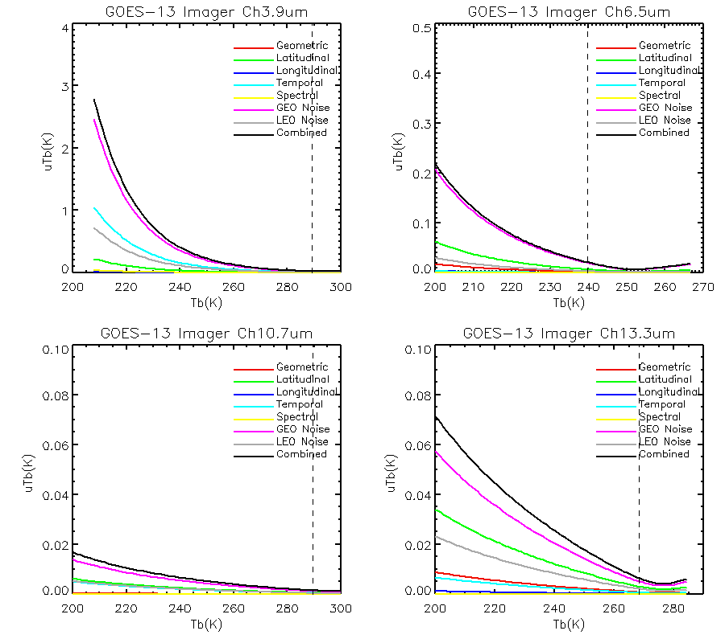
Figure 7. Contribution of each source of random error to the (k=1) uncertainty of Tb produced by the GSICS correction for a range of scene radiances for each GOES-13 Imager IR channel using Metop-A/IASI as reference. Dotted vertical line shows standard scene radiance for each channel.

Combining Systematic And Random Errors
The total uncertainties due to systematic and random processes can then be combined to give the total combined uncertainty, u^{c}, for a given radiance, L. The result is reported in Table 6.

Equation 11

Table 6. Overall Error budget of GSICS correction for GOES-13-IASI and validation of random components.
GOES-13 |  | Ch3.9µm | Ch6.5µm | Ch10.7µm | Ch13.3µm | Unit
Standard scene Temperature |  | 289.08 | 239.72 | 289.59 | 268.47 | K
Random Uncertainty | This analysis | 0.0430 | 0.0179 | 0.0062 | 0.0107 | K
 | Median Quoted Uncertainty from ATBD | 0.0016 | 0.0017 | 0.0016 | 0.0009 | K
 | Rolling SD of Standard bias from observation | 0.0257 | 0.0234 | 0.0209 | 0.0237 | K
Total systematic uncertainty |  | 0.0334 | 0.0076 | 0.0060 | 0.0097 | K
Total Combined uncertainty |  | 0.0272 | 0.0162 | 0.0014 | 0.0044 | K

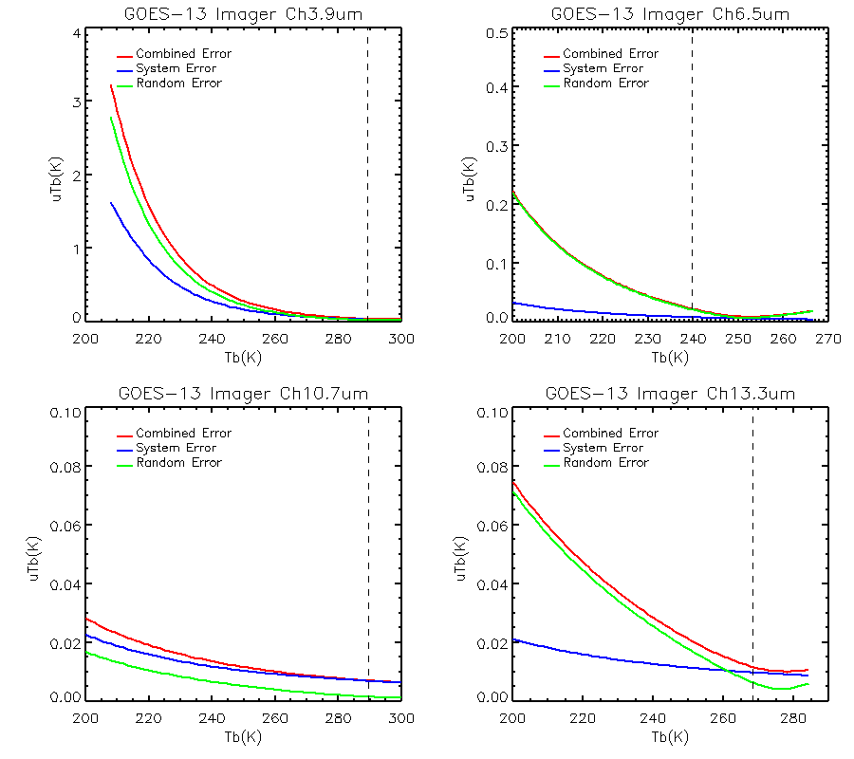
Figure 8. Impact of total systematic and random errors on (k=1) uncertainty of the Tb.

Figure 8 compares the impact of the total systematic and random errors on the uncertainty of the GSICS Correction evaluated over a range of scene radiances. This shows that in most conditions the random components of the uncertainty dominate for Ch3.9µm, Ch6.5µm, and Ch13.3µm. Ch10.7µm has a relatively smaller overall uncertainty with a larger systematic error.

- Uncertainty in the midnight effect time (10:30pm – 4:00am, SLT)
The uncertainty in the midnight effect time (u^{m}(L)) is estimated by combining the correction uncertainty beyond the midnight time window (u^{c}(L)) and the uncertainty caused diurnal calibration variation (U^{d}(L)):
Equation 12

The correction uncertainties at standard scene radiances are 0.1975K, 0.4458K, 1.1680K, and 1.2775K for Ch3.9µm, Ch6.5µm, Ch10.7µm and Ch13.3µm, respectively.

- Comparison of Theory with Statistics and Recommendations

Table 6 compares the total uncertainty due to random errors with the median value of the uncertainty quoted within the demonstration GSICS Re-Analysis Version 3 products evaluated in 2012. The results indicate that the correction uncertainty of this product is about 0.02K at standard scenes for Ch6.5µm, Ch10.7µm, and Ch13.3µm, and about 0.04K for Ch3.9µm.

These uncertainties in the analyses in this study are larger than those of the corresponding channels at SEVIRI. The most possible reason is that although the night-time IASI collocations used to generate the correction are collected before 10:30pm, which avoid of the strongest midnight calibration anomaly. However, as shown in Figure 3, the Tb bias with respect to IASI is very apparent at 10:30pm at GOES-13. It is therefore recommended the collocation should be constrained to the consistent Tb bias time period, for example nighttime yet before 21:30pm.

The large uncertainty at the cold scenes at Ch3.9µm is due to the incomplete IASI spectra. It is recommended applying the compensated radiance generated JMA’s gap filling method for the radiance correction at this channel.

The large correction uncertainty at midnight calibration anomaly time is due to the large diurnal calibration variation observed at the current GOES IR instruments. Unfortunately, the radiance/Tb bias to reference varies greatly at different time, depending on the performance and implementation of the midnight blackbody calibration correction (Yu et al. 2012). With the help of the GSICS project, we become to have a better understanding of the instrument performance and a fundamental correction to the midnight calibration anomaly is strongly recommended.

Acknowledgement: We would like to thank Dr. Haifeng Qian for the help with the CRTM simulations used in the geometric sensitivity analysis.
References
Blumstein, D. 2008. Metop-A IASI Level 1 cal/val at IASI TEC, GSICS Quarterly, 2(2).
Clough, S. A., M. W. Shephard, E. J. Mlawer, J. S. Delamere, M. J. Iacono, K. Cady-Pereira, S. Boukabara, and P. D. Brown, 2005. Atmospheric radiative transfer modeling: a summary of the AER codes, Short Communication, J. Quant. Spectrosc. Radiat. Transfer, 91, 233-244.
JCGM 2008. Evaluation of measurement data – Guide to the expression of uncertainty in measurement, http://www.bipm.org/en/publications/guides/gum.html.
Fox, N. 2010. A Guide to expression of uncertainty of measurements, QA4EO Guideline, QA4EO-QAEO-GEN-DQK-006.
Hewison, T. 2012. An Evaluation of the Uncertainty of the GSICS SEVIRI-IASI inter-calibration products, IEEE Transaction on Geosciences and Remote Sensing, Conditionally accepted with minor revisions.
NASA Goddard Space Flight Center/GOES Project Library, 1996. Performance Specification for GOES-NO/PQ Imager and Sounder Instruments, March 28, 1996.
Menzel, W.P. and J.F.W. Purdom, 1994. Introducing GOES-I: the first of a new generation of geostationary operational environmental satellites. Bull. Ameri. Meteoro. Soc, vol. 75, 757-781.
Tahara, Y. and K. Kato, 2009. New spectral compensation method for inter-calibration using high spectral resolution sounder, Meteorological Satellite Center Technical Note, vol. 52, pp. 1-37.
Rama Varama Raja, M.K., X. Wu, and F. Yu, 2012. Assessment of Metop-A Advanced Very High Resolution Radiometer (AVHRR) short-wave infrared channel measurements using Infrared Atmospheric Sounding Interferometer (IASI) observations and line-by-line radiative transfer model, International Journal of Remote Sensing, vol. 33(160, 5240-5250.
Wu, X. and F. Yu, 2010, GSICS algorithm theoretical basis document (ATBD) for GOES-AIRS/IASI inter-calibration, https://gsics.nesdis.noaa.gov/wiki/GPRC/AtbdCentral.
Yu, F., X. Wu, M.K. Rama Varma Raja, L. Wang, Y. Li and M. Goldberg, 2012. Evaluation of the diurnal and scan angle calibration variations of the GOES Imager Infrared instruments. IEEE-Geosciences and Remote Sensing, in press.

